UNITED STATES

SECURITIES AND EXCHANGE COMMISSION

Washington, D.C. 20549

______________________________

FORM 10-K

______________________________

(Mark One)

- ANNUAL REPORT PURSUANT TO SECTION 13 OR 15(d) OF THE SECURITIES EXCHANGE ACT OF 1934

For the fiscal year ended December 31, 2022

OR

- TRANSITION REPORT PURSUANT TO SECTION 13 OR 15(d) OF THE SECURITIES EXCHANGE ACT OF 1934

For the transition period from ________ to ________

Commission file number 001-40798

______________________________
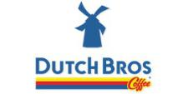

DUTCH BROS INC.

(Exact name of registrant as specified in its charter)

______________________________

 | Delaware |  | 87-1041305
 | (State or other jurisdiction of |  | (I.R.S. Employer Identification No.)
 | incorporation or organization)
 | 110 SW 4th Street
 | Grants Pass, Oregon |  | 97526
(Address of principal executive offices) |  |  |  | (Zip Code)
 | (541) 955-4700
 |  | (Registrant's telephone number, including area code)
 | ______________________________
Securities registered pursuant to Section 12(b) of the Act:
Title of Each Class |  | Trading Symbol |  | Name of Exchange on which Registered
Class A Common Stock,
par value $0.00001 per share |  | BROS |  | The New York Stock Exchange

Securities registered pursuant to section 12(g) of the Act: None

Indicate by check mark if the registrant is a well-known seasoned issuer, as defined in Rule 405 of the Securities Act. Yes ☒ No ☐

Indicate by check mark if the registrant is not required to file reports pursuant to Section 13 or Section 15(d) of the Act. Yes ☐ No ☒

Indicate by check mark whether the registrant: (1) has filed all reports required to be filed by Section 13 or 15(d) of the Securities Exchange Act of 1934 during the preceding 12 months (or for such shorter period that the registrant was required to file such reports); and (2) has been subject to such filing requirements for the past 90 days. Yes ☒ No ☐

Indicate by check mark whether the registrant has submitted electronically every Interactive Data File required to be submitted pursuant to Rule 405 of Regulation S-T (§232.405 of this chapter) during the preceding 12 months (or for such shorter period that the registrant was required to submit such files). Yes ☒ No ☐

Indicate by check mark whether the registrant is a large accelerated filer, an accelerated filer, a non-accelerated filer, a smaller reporting company, or an emerging growth company.

See the definitions of “large accelerated filer,” “accelerated filer,” “smaller reporting company,” and “emerging growth company” in Rule 12b-2 of the Exchange Act.

Large accelerated filer | ☒ | Accelerated filer | ☐
Non-accelerated filer | ☐ | Smaller reporting company | ☐
 |  | Emerging growth company | ☐

If an emerging growth company, indicate by check mark if the registrant has elected not to use the extended transition period for complying with any new or revised financial accounting standards provided pursuant to Section 13(a) of the Exchange Act. ☐

Indicate by check mark whether the registrant has filed a report on and attestation to its management’s assessment of the effectiveness of its internal control over financial reporting under Section 404(b) of the Sarbanes-Oxley Act (15 U.S.C. 7262(b)) by the registered public accounting firm that prepared or issued its audit report. ☒

If securities are registered pursuant to Section 12(b) of the Act, indicate by check mark whether the financial statements of the registrant included in the filing reflect the correction of an error to previously issued financial statements. ☐

Indicate by check mark whether any of those error corrections are restatements that required a recovery analysis of incentive-based compensation received by any of the registrant’s executive officers during the relevant recovery period pursuant to §240.10D-1(b). ☐

Indicate by check mark whether the registrant is a shell company (as defined in Rule 12b-2 of the Act). Yes ☐ No ☒

The aggregate market value of the voting and non-voting stock held by non-affiliates of the Registrant, as of June 30, 2022, the last business day of the registrant's most recently completed second fiscal quarter, was approximately $1.1 billion, computed using the closing price on that day of $31.65.

Dutch Bros Inc.| Form 10-K | 2

As of February 21, 2023, the registrant’s outstanding shares of common stock were as follows:
Class A common stock | 45,663,528
Class B common stock | 64,699,136
Class C common stock | 41,056,429
Class D common stock | 12,411,419

Documents Incorporated by Reference

Portions of the registrant’s definitive proxy statement relating to the 2023 Annual Meeting of Stockholders of Dutch Bros Inc., which will be filed with the Securities and Exchange Commission within 120 days of December 31, 2022, are incorporated by reference in Items 10, 11, 12, 13, and 14 of Part III of this report.

 | DUTCH BROS INC.
 | ANNUAL REPORT ON FORM 10-K
 | TABLE OF CONTENTS
 |  | Page
Glossary |  | 1
Forward-Looking Statements |  | 2
PART I
ITEM 1. | Business | 3
ITEM 1A. | Risk Factors | 15
ITEM 1B. | Unresolved Staff Comments | 58
ITEM 2. | Properties | 59
ITEM 3. | Legal Proceedings | 60
ITEM 4. | Mine Safety Disclosures | 60
PART II
ITEM 5. | Market for Registrant’s Common Equity, Related Stockholder Matters and Issuer Purchases of Equity Securities | 61
ITEM 6. | [Reserved] | 62
ITEM 7. | Management’s Discussion and Analysis of Financial Condition and Results of Operations | 62
ITEM 7A. | Quantitative and Qualitative Disclosures About Market Risk | 83
ITEM 8. | Financial Statements and Supplementary Data | 85
ITEM 9. | Changes in and Disagreements with Accountants on Accounting and Financial Disclosure | 133
ITEM 9A. | Controls and Procedures | 134
ITEM 9B. | Other Information | 138
ITEM 9C. | Disclosure Regarding Foreign Jurisdictions that Prevent Inspections | 138
PART III
ITEM 10. | Directors, Executive Officers and Corporate Governance | 139
ITEM 11. | Executive Compensation | 139
ITEM 12. | Security Ownership of Certain Beneficial Owners and Management and Related Stockholder Matters | 139
ITEM 13. | Certain Relationships and Related Transactions, and Director Independence | 139
ITEM 14. | Principal Accountant Fees and Services | 139
PART IV
ITEM 15. | Exhibits and Financial Statement Schedules | 140
ITEM 16. | Form 10-K Summary | 142
SIGNATURES |  | 143

Table of Contents

GLOSSARY

As used in this Annual Report on Form 10-K (this Form 10-K), the terms identified below have the meanings specified below unless otherwise noted or the context requires otherwise. References in this Form 10-K to “Dutch Bros,” the “Company,” “we,” “us” and “our” refer to Dutch Bros Inc. and its consolidated subsidiaries unless the context indicates otherwise.

TERM |  | DEFINITION
AUV |  | Average Unit Volume
Blocker Companies |  | TSG7 A AIV VI Holdings, LLC and DG Coinvestor Blocker, LLC
BPS or bps |  | Basis points which is used to express differences in rates. One basis point is the equivalent of 1/100 of one percent.
Co-Founder |  | Travis Boersma and affiliated entities over which he maintains voting control.
Common Units |  | The Common Units of Dutch Bros OpCo, as defined in the Second LLC Agreement, issued and outstanding immediately prior to
 |  | recapitalization, as set forth in NOTE 1 — Organization and Background, included elsewhere in this Form 10-K.
Continuing Members |  | The Co-Founder and the Sponsor
Dutch Bros OpCo |  | Dutch Mafia, LLC, a Delaware limited liability company and direct subsidiary of Dutch Bros Inc.
Dutch Bros PubCo |  | Dutch Bros Inc., a Delaware corporation, the Class A common stock of which is publicly traded on the New York Stock Exchange
 |  | under the symbol “BROS”.
Dutch Bros Tax Group |  | The meaning set forth in NOTE 12 — Tax Receivable Agreements to the consolidated financial statements, included elsewhere in
 |  | this Form 10-K.
GAAP |  | U.S. Generally Accepted Accounting Principles
IPO |  | Initial Public Offering
MOB |  | A group of master broistas who travel to help open new locations and markets. They train new broistas on operations and infuse
 |  | them with the culture of the Company.
N/M |  | A not meaningful percentage.
OpCo Units |  | Class A common units, Class B voting units and Class C voting units of Dutch Bros OpCo, each as further defined in the Third
 |  | Amended and Restated Limited Liability Company Agreement of Dutch Bros OpCo, collectively.
Pre-IPO Blocker Holders |  | TSG7 A AIV VI Holdings-A, L.P. and DG Coinvestor Blocker Aggregator, L.P. or their assignees or successors pursuant to the terms
 |  | of the certain Reorganization Tax Receivable Agreement.
QSR |  | Quick Service Restaurant
Reorganization Transactions |  | The meaning set forth in NOTE 1 — Organization and Background to the consolidated financial statements, included elsewhere in
 |  | this Form 10-K.
RSA |  | Restricted Stock Awards
RSU |  | Restricted Stock Units
SEC |  | Securities and Exchange Commission
Sponsor |  | TSG Consumer Partners, L.P. and certain of its affiliates.
Tax Receivable Agreements and TRAs |  | Each have the meaning set forth in NOTE 1 — Organization and Background to the consolidated financial statements, included
 |  | elsewhere in this Form 10-K.
Western United States |  | The collection of states including Arizona, California, Colorado, Idaho, Nevada, New Mexico, Oregon, Utah and Washington.

Dutch Bros, our Windmill logo (), Dutch Bros. Blue Rebel and our other registered and common law trade names, trademarks and service marks are the property of Dutch Bros Inc. All other trademarks, trade names and service marks appearing in this Form 10-K are the property of their respective owners. Solely for convenience, the trademarks and trade names in this Form 10-K may be referred to without the ® and ™ symbols, but such references should not be construed as any indicator that their respective owners will not assert their rights thereto.

Dutch Bros Inc.| Form 10-K | 1

Table of Contents

FORWARD-LOOKING STATEMENTS

Certain statements in this Form 10-K, including the impact of inflation, increased minimum wages, COVID-19, and the war between Russia and Ukraine, on our results of operations, supply chain or liquidity, the potential impact of actions we have taken to mitigate the impact of unforeseen circumstances, taxes and tax rates, our expectations regarding the number of new shops we may open, anticipated future revenues and earnings, anticipated capital expenditures, consumer demand, and our expectations to generate positive cash flow in the foreseeable future, are forward-looking statements as defined in the Private Securities Litigation Reform Act of 1995. We use words such as “anticipate,” “believe,” “could,” “should,” “estimate,” “expect,” “intend,” “may,” “predict,” “project,” “target,” and similar terms and phrases, including references to assumptions, to identify forward-looking statements. These forward-looking statements are based on information available to us as of the date any such statements are made, and we assume no obligation to update these forward-looking statements. These statements are subject to risks and uncertainties that could cause actual results to differ materially from those described in the statements. You should not place undue reliance on forward-looking statements, which speak only as of the date of this Form 10-K.

While we believe that our assumptions are reasonable, we caution that it is very difficult to predict the impact of known factors, and it is impossible for us to anticipate all factors that could affect actual results. You should evaluate all forward-looking statements made in this report in the context of the factors that could cause outcomes to differ materially from expectations. These factors include, but are not limited to, those listed under “Item 1A. Risk Factors” of this report, as such risk factors may be amended, supplemented or superseded from time to time by other reports we file with the Securities and Exchange Commission.

You should read the consolidated financial statements and the related notes in this Form 10-K together with our analysis and discussion of our consolidated financial condition and results of operations and other financial information included elsewhere in this Form 10-K.

Website Disclosure

We use our website as a distribution channel of material company information. Financial and other important information regarding our company is routinely posted on and accessible through our website at https://investors.dutchbros.com. In addition, you may automatically receive email alerts and other information about our company when you subscribe your email address by visiting the “Investor Email Alerts” section of our investor relations page at https://investors.dutchbros.com/resources. The information on our website is not incorporated herein or otherwise a part of this Form 10-K.

Dutch Bros Inc.| Form 10-K | 2

Table of Contents

PART I

ITEM 1. BUSINESS

Dutch Bros Inc. is a Delaware corporation and its Class A common stock trades on the New York Stock Exchange under the symbol “BROS”.

OUR COMPANY

Dutch Bros is a high growth operator and franchisor of drive-thru shops that focus on serving high QUALITY, hand-crafted beverages with unparalleled SPEED and superior SERVICE. Founded in 1992 by brothers Dane and Travis Boersma, Dutch Bros began with a double-head espresso machine and a pushcart in Grants Pass, Oregon. Today, we believe that Dutch Bros is one of the fastest-growing brands in the foodservice and restaurant industry in the United States by location count. As of December 31, 2022, we had 671 shops, of which 396 were company-operated and 275 were franchise, across 14 states as shown in the graphic below. For additional information regarding company-operated and franchise shops by state, refer to Part I, Item 2 Properties of this Form 10-K.
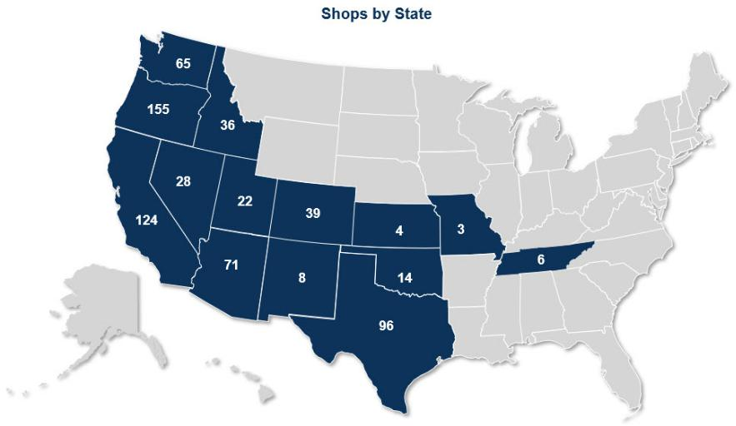

Dutch Bros Inc.| Form 10-K | 3

Table of Contents

The Dutch Bros Experience


Dutch Bros is more than just the products we

serve: we are dedicated to making

differences in the lives of our employees,

customers, and the communities in which we

operate. Our people are the key to our

success, and our broistas are the face of

Dutch Bros, delivering on the Company’s

core values of QUALITY, SPEED, and

SERVICE.

- QUALITY: Our broistas are provided with the resources and training to provide high-quality hand-crafted beverages to our customers.

- SPEED: When our shops are busy, a “runner” broista leaves the shop and greets our customers before they reach the drive-thru window. This runner explains the menu and helps customers personalize their orders. Using tablets, our runners take orders, sending them to broistas inside the shop, who utilize our flexible systems to handcraft custom beverages. This system, in combination with “escape lanes” that allow customers to receive their drinks and exit before reaching the window if their drinks are ready, helps our team manage throughput all day.

- SERVICE: We embrace a customer-first attitude and use every interaction during the drive-thru experience to connect with our customers and strive to deliver an experience that exceeds our customers’ expectations.

The combination of hand-crafted and high-quality beverages, our unique drive-thru experience and our community-driven, people-first culture has allowed us to successfully open new shops and continue to share the “Dutch Luv”. To achieve these experiences and create meaningful differentiation in our industry, we and our franchise partners are committed to attracting and retaining broistas who go all out to deliver an experience that exceeds our customers’ expectations, every day. We empower our broistas to take the extra step to make each customer interaction remarkable.

Our Menu

We sell a wide range of customizable hot, iced, and blended beverages.

- Coffee: coffee-based beverages make up ~50%¹ of our menu mix. Coffee-based beverages include our espresso-based custom drinks, cold brew, and our proprietary “Freeze” blended beverages. Our Private Reserve coffee is a 100% Arabica three-bean blend, roasted in our Grant’s Pass facility. In our shops, we utilize premium La Marzocco machines to extract the coffee and deliver shots of smooth, full-bodied espresso.

- Energy: ~25%¹ of our menu mix is based upon our proprietary Blue Rebel energy drink, which is highly customizable with flavors and modifiers and can be served blended or over ice. Our energy platform helps unlock the afternoon daypart and helps us appeal to a diverse customer base.

- Other: the remaining ~25%¹ of our menu mix is a wide variety of teas, lemonades, sodas, and smoothies.

_________________

- Based on number of drinks sold across our system in 2022.

Dutch Bros Inc.| Form 10-K | 4

Table of Contents

Customers are encouraged to explore our robust “secret”

menu and customize beverages through the addition of flavors

and other modifiers. Many of our customers add “soft-top,” a

sweet, creamy whipped topping that can be added to almost

any order. High-levels of customization encourage innovation,

creating a competitive moat and helping drive a broad

demographic appeal.

Our Dutch Rewards Loyalty Program


In February 2021, we released our app-based digital loyalty program (Dutch Rewards) which has grown to 5.2 million registered members as of December 31, 2022.

We utilize Dutch Rewards to interact directly with our customers, applying 1:1 marketing to offer targeted messaging, offers, and rewards that enhance the Dutch Bros experience. Dutch Rewards uses a spend-based model, where customers collect points that can be redeemed for rewards. These rewards can be utilized to receive free drinks or shared with others. Points and rewards generally expire after six months.

Further, we offer members the ability to preload funds on their account and pay through our app, a function we call Dutch Pass. In addition to being convenient for customers, Dutch Pass enables us to increase our speed of service by reducing the payment collection time. Our Dutch Pass functionality also allows users to purchase and share digital gift cards, providing more customers the opportunity to share in the Dutch Bros Experience.

Our Shops

We are a drive-thru focused business: over 90% of our business is conducted through the drive-thru. We believe that our drive-thru business model places a premium on customer convenience without sacrificing the personal experience. Our shops and our real estate strategy are designed from the ground up to support the drive-thru business.

Our shops typically have a smaller footprint than other drive-thru formats - our shops are typically 865 to 950 square feet. This compact footprint allows us greater flexibility to place locations on more parcels. We typically target lots that are at least 25,000 square feet to handle substantial car volume. Except for a handful of legacy “coffee houses”, all our shops deploy either a single or double drive-thru window with multiple feeder lanes for traffic flow. Most of our shops also have walk-up ordering windows and “escape lanes” that enable customers to exit the line after a runner delivers their drink before reaching the window, helping increase throughput and reducing congestion. For illustration of our shop model, see the graphic below.

Dutch Bros Inc.| Form 10-K | 5

Table of Contents
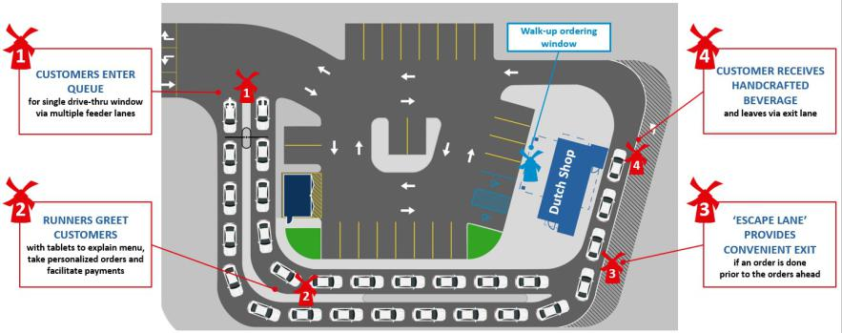

Our Long-Term Franchise Partners

Historically, we used a franchising strategy alongside company-operated shop development to drive growth in select markets. Over time, as we decided to grow more from within, we only offered franchise partnership opportunities to the highest-quality employees within our network. In 2008, we stopped selling franchises to people that did not come from within our system. In 2017, we shifted to a company-operated strategy with all operators recruited from within our system. While we maintain great relationships with our existing franchise partners and they continue to open new shops as they look to infill their high-demand markets, we anticipate approximately 90% of new shops we open each year will be company-operated shops.

OUR GROWTH STRATEGIES TO SHARE THE “DUTCH LUV”

We are in the early stages of our growth story. We will expand our business to positively impact our communities through the following growth strategies:


Develop our People, Who are our Growth Capital


- 100% of our Regional Operators began their Dutch Bros journey as broistas. We must attract and retain great people at the top of our funnel to sustain long-term growth.

- Provide robust internal training and career advancement programs, which help develop a high-quality talent pool of candidates seeking larger roles within the Company.

- Maintain the Dutch Bros culture as we scale. We design our people systems with culture in mind, enabling us to continue making a positive impact in new communities and providing career development opportunities for employees.

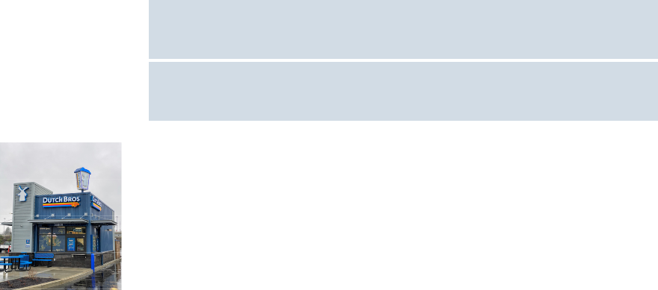

Place Shops Wherever People Want Great Beverages


- Target 4,000 total shop addressable market (TAM)¹ within the next 10-15 years. Maintain and grow people development systems and new shop pipeline, which is fully-populated for 2023.

- Utilize “fortressing” strategy to rapidly build scale within markets by proactively opening new shops. We believe this strategy improves customer experience and promotes long-term brand loyalty by alleviating capacity constraints and reducing barriers for increased customer frequency.


Dutch Bros Inc.| Form 10-K | 6

Table of Contents


Increase Brand Awareness and Encourage Deeper Customer Engagement

- Engage through social media platforms, prioritizing social impact and developing deep connections withing the communities we serve.

- Utilize targeted in-app marketing promotions and grassroots campaigns. We believe the Dutch Rewards program enables us to serve customers unique beverage-focused content, information related to our social impact initiatives and new ways to engage with Dutch Bros.

- Leverage strong word-of-mouth advocacy, one of the strongest drivers of Dutch Bros brand awareness. Our commitment to our people encourages them to become enthusiastic brand ambassadors, and we believe that their visible love for the brand is infectious.

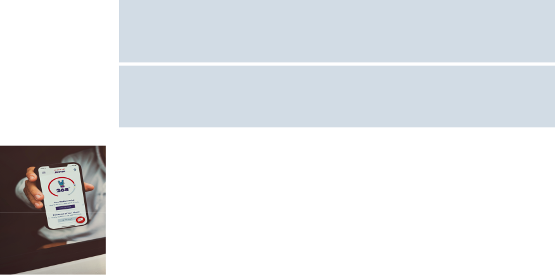

Utilize Digital Technology that Enhances the Employee and Customer

Experience

- Meet customer speed expectations by investing in, and integrating technology.

- Utilize technology to reduce friction in customer interactions, providing opportunities to create deeper connections and better service.

- Utilize data-driven insights to refine menu offerings, drive frequency, and increase guest spend.

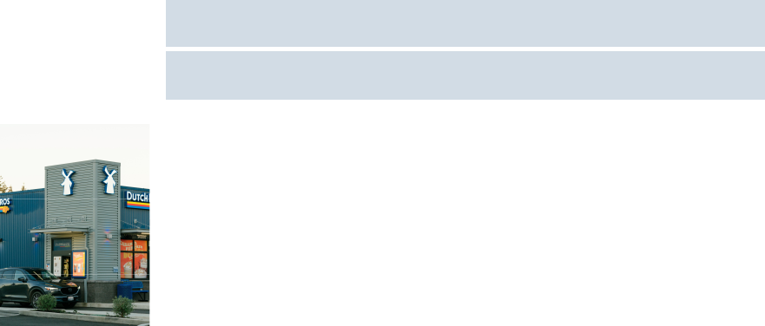

Expand Margins Through Operating Leverage

- Deploy a resourceful and flexible approach to product design and procurement, optimized for adaptability and scalability.

- Invest in state-of-the-art roasting facility in Texas to support our expansion strategy and long-term supply chain requirements in a cost-advantaged manner.

- Achieve structural selling, general, and administrative cost leverage as our selling, general and administrative costs grow at a slower rate than our shop base and revenue.


_________________

- Internal analysis conducted by Dutch Bros, along with third-party analysis by Quantitative Analysis.

Operations

Sourcing and Supply Chain

We pride ourselves on the quality of our coffee. To ensure we are able to consistently deliver high-quality coffee across our 671 shops in our system, we are actively involved in the sourcing, roasting, packaging, and distribution of coffee beans to our and our franchise partners’ shops.

- We partner with third-party importers and exporters to purchase and import our green coffee beans. Through this relationship, we source high-quality coffee beans from across Central and South America. We typically purchase coffee contracts 18-24 months in advance of when we take physical delivery of the beans, allowing us to lock in pricing and to manage our input costs. This practice also allows us to be a good partner to our coffee producers, providing security of future business.

Dutch Bros Inc.| Form 10-K | 7

Table of Contents

- We currently roast all our coffee in our roasting facility in Grants Pass, Oregon. We roast our coffee bean varietals to specific profiles designed to highlight each of the coffee bean’s unique flavors and aromas. After the coffee beans are roasted, we blend them to create our signature Private Reserve espresso.

- We package and ship our Private Reserve, Decaf and White Coffee espresso blends to 14 distribution centers that supply all our company-operated and franchised locations.

We designed our supply chain to be flexible in response to changes in the market. On average, we typically have approximately four months of green coffee bean inventory stored at our two ports of entry in the United States or at our roasting facility in Grants Pass, Oregon. In the event of a supply disruption in any one of our production origins, we have identified alternate coffee beans with substantially similar flavor profiles that can be sourced and incorporated to produce our blend.

We have taken several steps to increase our diversity of supply and reduce transportation costs as we expand company-operated shops eastward within the United States. We broke ground on a second state-of-the-art coffee roasting facility in Texas. We anticipate the new roasting facility will be operational in 2024.

We also manufacture our own proprietary Dutch Bros. Blue Rebel Energy Drink via a co-bottling and co-packaging relationship. Beginning in 2023, we anticipate beginning to distribute a portion of our Blue Rebel Energy drink, along with our cold brew coffee, via a “bag in a box” system for use in shop beverage taps. We believe this will help us reduce our dependence on aluminum cans. Additionally, in 2022 we hired an industry veteran as our first Vice President of Procurement to help support our supply chain initiatives as we continue to scale.

Quality, Health, and Safety

We and our franchise partners strive to maintain a safe, healthy environment at each shop through the careful training and supervision of personnel and by following rigorous quality standards. Our Quality Assurance team informs, monitors, and reports on standards for preparation and cleaning, as well as inspects every shop in the system on a quarterly basis. As part of our people-first culture, the health of our employees is our highest priority, and we provide them with appropriate resources.

Our commitment to beverage and food safety is strengthened through the direct relationship between our supply chain, culinary, and quality assurance teams. We review our supply partners’ material decisions regarding ingredients, and we reserve the right to conduct spot-checks. We examine each suppliers’ safety and quality records and verify insurance coverage. We believe that our established requirement for franchise partners to purchase certain supplies and equipment from approved vendors further enhances safety and quality within our system.

People

Our people are the driving force of our mission and are a fundamental driver of our success. One of the most important relationships we have is with our employees, who are key members of the communities we love and support. We attract and seek out potential employees by identifying people with a love for life, a natural ability to connect with folks from all walks of life, and most of all, a big smile!

As of December 31, 2022, we and our franchise partners have approximately 22,000 employees, of which 14,000 employees are in our company-operated shops and headquarters.

The chart below provides the approximate percentage of systemwide employees by shop type and by state location:

Dutch Bros Inc.| Form 10-K | 8

Table of Contents
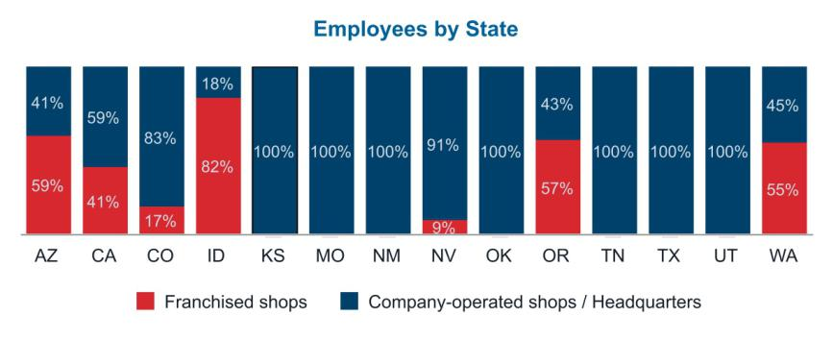

The charts below provide the approximate percentages of our company-operated shop and headquarters employees by gender and ethnicity:
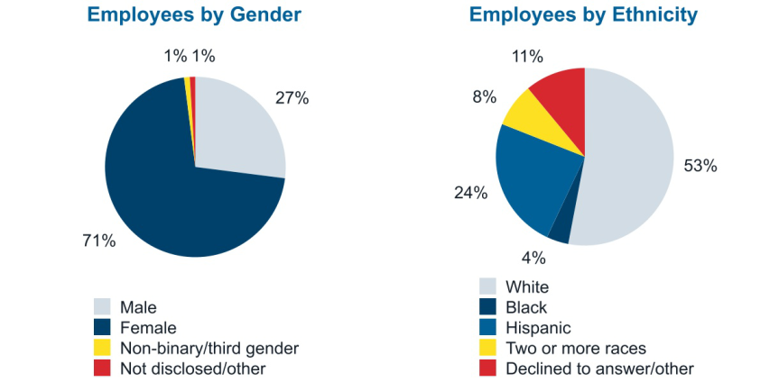

Diversity, Equity, and Inclusion

We are committed to DEI (Diversity, Equity, and Inclusion) in our Company, at the window and in our communities, cultivating an inclusive environment of love, acceptance, and kindness. Our DEI commitment strives to ensure all customers, crews, and communities are welcomed, honored, and loved. We are actively working to develop a holistic DEI program that can be a resource for everyone we serve. The events of the past several years have offered another reminder of how critically important our efforts have become, and as a result we have taken real, meaningful steps toward advancement of our DEI program including, but not limited to, the following:

- hired three female executives in the past 18 months including our President, Chief Legal Officer, and Chief Technology Officer. In total, as of the filing of this Form 10-K, 50% of our executive leadership team is female;

Dutch Bros Inc.| Form 10-K | 9

Table of Contents

- appointed an additional female member to our Board of Directors in 2022. In total, as of the filing of this Form 10-K, 44% of our Board of Directors is female;

- hired an industry professional to serve as Director of DEI and developing long term programs;

- offering DEI training to headquarters employees and field leadership;

- launching employee resource groups at our headquarters for leaders of color and for our female leaders; and

- reviewing our policies to make sure they are promoting equity, as well as supporting a diverse and inclusive workplace for everyone.

Total Rewards

We offer competitive salaries and wages with continual assessment by location of the business environment and labor market. We are continually making enhancements to our total rewards program to attract and retain top talent as part of our expanding growth strategy. We offer a comprehensive suite of benefits to our broistas, shop management, and headquarters employees, such as:

- company-wide minimum wage of at least $10.00 per hour across all markets;

- company paid medical, dental, vision, and life insurance for all full-time employees;

- company paid parental leave of more than eight weeks, after one full year of employment for shop management and headquarters employees;

- wellness program to help employees live their best lives;

- access to free drinks and Dutch Bros swag for employees to show off their “Dutch Luv”;

- tuition assistance toward employees’ professional development after one full year of employment;

- flexible working arrangements for headquarters employees, including on-site, hybrid, and remote options;

- up to 16 hours of paid volunteer hours to use when helping out the community, which is available to all employees; and

- team focused culture with growth and leadership opportunities for career advancement.

Training and Development

We are committed to inspiring and facilitating personal and professional growth for our people as they fulfill their dreams and contribute to their communities. As part of this commitment, we provide resources to train and develop our people.

Broista Training

- 2 day cultural immersion, history, and fundamental knowledge

- 10 shifts of on-the-job training

- Review of “Manifesto” and employee handbook, and have proficiency tests twice per year

Dutch Bros Inc.| Form 10-K | 10

Table of Contents

Leadership Pathways

We exclusively source regional operators, who we view as the linchpins of our field organization and lead between 3-7 shops at scale, from within our organization. For our continued growth, it is critical that we consistently train and develop new leaders. Our leadership development program outlines shop growth opportunities at all levels of the organization and furthers our philosophy of hiring and developing leaders from within. This program provides ample opportunities for our shop broistas to create their own pathway, which can be a mix of Path A and B, to reach their potential goals.

 |  |  | Broista
 |  |  | ê
 |  |  | Shift Lead
í |  |  | î
 | Path A: Shop Level Operations |  |  | Path B: Shop Opening Team
 | Assistant Manager |  |  | Master of Broistas (MOB)
 | Manager |  |  | Assistant Lead MOB
 | Regional Manager |  |  | Lead MOB
î |  |  | í


Regional Operator

This leadership program develops a pipeline of home-grown talent, which we believe will be sufficient for our new shop growth over the next several years.

Planet

We aim to be good stewards of all that is available to us. We have committed to various initiatives to reduce our impact on the planet and its resources, such as:

- purchased renewable energy credits to offset approximately all of our electricity usage at headquarters buildings and company-operated shops;

- improved instrument cleaning process to reduce the number of water-consuming “dipper wells” required in our new shops;

- began testing a beverage tap system for cold brew and Blue Rebel, which will reduce pallet size and weight with liquid not shipped;

- utilized modular construction, which reduces construction material waste and raw material inventory; and

- broke ground on our new roasting facility in Texas, which will help reduce our transportation costs and carbon emissions impact.

Dutch Bros Inc.| Form 10-K | 11

Table of Contents

Philanthropy

Since our inception, we have been dedicated to giving back to the communities in which we serve, and we consider our brand to be a powerful platform for social impact. Our philanthropic efforts support local and national causes. A culture of philanthropy and giving back to build better communities permeates the entire Dutch Bros organization, energizing both our broistas and customers alike.

We host three company-wide givebacks days each year. The Company, along with our franchise partners and Dutch Bros Foundation (the Foundation) provide donations for funds raised in each of these giveback days.




“Dutch Luv” “Drink One for Dane” “Buck for Kids”

Every February, we donate $1 from every drink sold to local organizations working to fight food insecurity in our communities.

Every May, in honor of our co-founder Dane Boersma, we raise funds for the Muscular Dystrophy Association to find a cause and cure for ALS (Amyotrophic Lateral Sclerosis), or Lou Gehrig’s disease.

Every September, we dedicate a day to give $1 from every drink sold to nonprofit organizations helping create brighter futures for local kids.

2022 Donations

More than $0.8 million |  | More than $2.3 million |  | More than $1.1 million

Additionally, our operators and franchise partners are empowered to create their own local, shop-specific giveback programs that help support and build relationships within their communities. In addition to the 2022 donations noted above, the Company, along with our franchise partners and the Foundation donated more than $2.0 million in 2022 to various organizations through our local giveback days.

Competition

The beverage industry is highly competitive and fragmented, and our shops compete on a variety of factors, including convenience, taste, price, quality, service, and location. We believe our primary competitors include national and regional coffee chains, local specialty coffee shops, regional drive-thru coffee chains, and drive-thru quick service restaurants with coffee and other beverage programs. Our competitors operate company-operated, franchised, and mixed business models. In addition, due to our proprietary Dutch Bros. Blue Rebel energy beverages, we also compete with convenience stores.

Intellectual Property

We own many registered trademarks and service marks in the United States, the most important of which might be our trademarked Windmill logo. Other important trademarks include our “Dutch Bros,” “Dutch Bros Coffee,” “Dutch Bros Rebel,” and “Dutch Bros. Blue Rebel” word marks and our recognizable Dutch Bros sign logo. We believe the Dutch Bros name and the many distinctive marks associated with it are of significant value and are very important to our business. Accordingly, as a general policy, we pursue registration and monitor the use of our marks in the United States and challenge any unauthorized use.

Dutch Bros Inc.| Form 10-K | 12

Table of Contents

We license the use of our marks to franchise partners, third-party vendors and others through franchise agreements, vendor agreements and licensing agreements. These agreements typically restrict third parties’ activities with respect to use of the marks and impose brand standards requirements, and require licensees to inform us of any potential infringement of the marks.

We register some of our copyrighted material and otherwise rely on common law protection of our copyrighted works. Such copyrighted materials are not material to our business.

Government Regulation and Environmental Matters

We are subject to extensive federal, state, local and foreign laws and regulations, as well as other statutory and regulatory requirements, including those related to, among others, nutritional content labeling and disclosure requirements, food safety regulations, local licensure, building and zoning regulations, employment regulations, and laws and regulations related to our licensed operations. New laws and regulations or new interpretations of existing laws and regulations may also impact our business. The costs of compliance with these laws and regulations are high, are likely to increase in the future, and any failure on our part to comply with these laws may subject us to significant liabilities and other penalties. See "Regulatory and Legal Risks" in Item 1A, Risk Factors for more information.

We are not aware of any federal, state, or local provisions that have been enacted or adopted regulating the discharge of materials into the environment, or otherwise relating to the protection of the environment, that have materially affected, or are reasonably expected to materially affect, our results of operations, competitive position, or capital expenditures.

Seasonality

Our business is subject to seasonal fluctuations that impact our revenue and company-operated shop gross profit margins. We typically experience higher nominal system sales in the summer months, which impacts revenue and company-operated shop gross profit margins in our second and third quarters of our fiscal year.

Information About our Executive Officers

The executive officers of Dutch Bros Inc. as of the filing of this Form 10-K, are as follows:

Travis Boersma, 52 Co-founder and Executive Chairman of the Board

Mr. Boersma is our Co-Founder and has served as our Executive Chairman since August 2021 and as the Executive Chairman of Dutch Bros OpCo since February 2021. Prior to serving as our Executive Chairman, he served as the Chief Executive Officer from February 2019 to February 2021 of Dutch Bros OpCo. Mr. Boersma has led us as Co-Founder since 1992. Mr. Boersma attended Southern Oregon University.

Jonathan “Joth” Ricci, 54 Chief Executive Officer

Mr. Ricci has served as our Chief Executive Officer and a member of our board of directors since August 2021, our President from August 2021 to February 2023, the Chief Executive Officer of Dutch Bros OpCo since February 2021, and the President of Dutch Bros OpCo from January 2019 to February 2023. Since January 2020, Mr. Ricci has served as Chairman of the board of directors of Dutch Bros Foundation, our philanthropic arm. From April 2017 to January 2019, he served as President and Chief Executive Officer of Adelsheim Vineyard. From February 2013 to April 2017, Mr. Ricci served as President of Stumptown Coffee Roasters, a coffee company. In addition to his senior management experience, Mr. Ricci has served on various boards of directors in the beverage industry and civic organizations since January 2012. Mr. Ricci received a B.S. in Business Education from Oregon State University.

Dutch Bros Inc.| Form 10-K | 13

Table of Contents

Christine Barone, 49 President

Ms. Barone has served as our President and the President of Dutch Bros OpCo since February 2023. Ms. Barone has worked in the food service and beverage industries for more than a decade, and most recently served as Chief Executive Officer at True Food Kitchen, a high growth restaurant and lifestyle brand, from August 2016 to February 2023. Prior to that, she served in various leadership roles at Starbucks Corporation (Nasdaq: SBUX). Earlier in her career, she held positions with Bain & Company and Raymond James. Ms. Barone holds a B.A. in Applied Mathematics and an M.B.A. from Harvard University.

Charles Jemley, 59 Chief Financial Officer

Mr. Jemley has served as our Chief Financial Officer since August 2021 and the Chief Financial Officer of Dutch Bros OpCo since January 2020. Since June 2017, Mr. Jemley has served as a member of the board of directors of Four Corners Property Trust Inc., a real estate investment trust (NYSE: FCPT), where he chairs the Audit Committee and serves as a member of the Nominating and Governance Committee. From July 2018 to December 2019, he served as the Chief Financial Officer of CKE Restaurant Holdings, Inc., a quick service restaurant company. From February 2006 to January 2018, Mr. Jemley served in various senior management positions at Starbucks Corporation (Nasdaq: SBUX), most recently as Senior Vice President Finance, Starbucks Reserve & Roastery, Global Digital & Store Development. From April 1990 to January 2006, Mr. Jemley served in various positions in finance and store development at Yum! Brands, Inc. (NYSE: YUM) including most recently as the Chief Financial Officer of Yum Restaurants China from December 2003 to January 2006. Mr. Jemley received an M.B.A. from the Michael G. Foster School of Business at the University of Washington and a B.B.A in Accounting from the University of Louisville.

Brian Maxwell, 51 Chief Operating Officer

Mr. Maxwell has served as our Chief Operating Officer since August 2021 and the Chief Operating Officer of Dutch Bros OpCo since January 2017, and previously served in various roles at Dutch Bros OpCo, including as the Vice President and General Manager from April 2009 to December 2016, Vice President of Growth from January 2004 to March 2009 and Franchise Coordinator from January 1999 to December 2003. Prior to joining Dutch Bros, Mr. Maxwell worked in finance and investment advising. Mr. Maxwell studied at Lewis & Clark College.

Christine Schmidt, 46 Chief Administrative Officer

Ms. Schmidt has served as our Chief Administrative Officer since August 2021, and the Chief Administrative Officer of Dutch Bros OpCo since September 2019, leading the administrative teams that serve as an integral part of business operations. After starting as a "broista" at the original coffee house in Grants Pass, Oregon in 1996, she joined headquarters in 1999. Prior to her role as Chief Administrative Officer, Ms. Schmidt served in various roles at Dutch Bros OpCo, including most recently as chief financial officer from May 2016 to September 2019, and prior to that, as vice president of finance and in a variety of other positions supporting and growing marketing, finance, and operations.

Victoria Tullett, 55 Chief Legal Officer

Ms. Tullett has served as our Chief Legal Officer since September 2022 and has more than 20 years of experience helping diverse organizations manage operational risk and achieve record levels of growth, compliance, and profitability. Prior to joining Dutch Bros, she served Papa Murphy’s International, a franchise model take-and-bake pizza company, for more than 20 years in various roles, including most recently as Senior Vice President, General Counsel, and head of new store Development from May 2019 to August 2022, and from May 2014 to May 2019, as Chief Legal Officer while the company was publicly traded on the Nasdaq. Her experience with high growth companies, risk management, and franchisee relations align with the next stage of Dutch Bros’ development. In addition to her role at Dutch Bros, Ms. Tullett serves on the Board of Directors for Vancouver Symphony Orchestra. Ms. Tullett is a graduate of Lewis & Clark, Northwestern School of Law in Portland, Oregon.

Dutch Bros Inc.| Form 10-K | 14

Table of Contents

Leigh Gower, 53 Chief Technology Officer

Ms. Gower has served as our Chief Technology Officer since December 2021 and has more than 20 years of experience helping companies transform customer experience through technology. Prior to joining Dutch Bros in December 2021, she served as Vice President, Technology at Blue Nile Inc., a digitally native, disruptive fine jewelry retailer, from October 2020 to November 2021, as a Product & Technology leader at T-Mobile USA, a global mobile telecommunications company, from September 2012 to August 2020, most recently as Senior Director from July 2018, and as Management Consultant at Slalom Consulting, a business and technology consulting firm, from December 2003 to September 2012. In addition, Ms. Gower serves on the Board of Directors of the Technology Association of Oregon. Ms. Gower earned a B.S. in Economics and Spanish from University of Puget Sound, and professional certificates from Villanova University, University of California, Berkeley, and University of Washington.

Available Information

Our website address is dutchbros.com. Our Form 10-K, Quarterly Reports on Form 10-Q, Current Reports on Form 8-K, and other filings with the Securities and Exchange Commission (the SEC), and all amendments to these filings, can be obtained free of charge from our website at https://investors.dutchbros.com/financials/sec-filings/default.aspx or by contacting our Investor Relations department at our office address listed above as soon as reasonably practical following our filing or furnishing of any of these reports with the SEC. The SEC maintains a website that contains reports, proxy and information statements, and other information regarding issuers that file electronically with the SEC at www.sec.gov. We also routinely use the investor relations page on our website as a channel of distribution for important Company information, including press releases, analyst presentations, and financial and corporate governance information. The contents of these websites are not incorporated into this filing. Further, the Company’s references to the URLs for these websites are intended to be inactive textual references only.

ITEM 1A. RISK FACTORS

Summary of Risk Factors

Below is a summary of the principal factors that make an investment in our Class A common stock speculative or risky. This summary does not address all of the risks that we face. Additional discussion of the risks summarized in this summary, and other risks that we face, can be found below under the heading “Risk Factors” and should be carefully considered, together with other information in this Form 10-K and our other filings with the SEC before making investment decisions regarding our Class A common stock.

- Evolving consumer preferences and tastes or changes in consumer spending may adversely affect our business.

- Our financial condition and quarterly results of operations are subject to, and may be adversely affected by, a number of factors, many of which are also largely outside our control and as such our results may fluctuate significantly and may not fully reflect the underlying performance of our business.

- We may not be able to compete successfully with other shops, QSRs and convenience shops, including the growing number of coffee delivery options. Intense competition in the food service and restaurant industry could make it more difficult to expand our business and could also have a negative impact on our operating results if customers favor our competitors.

- Our failure to manage our growth effectively could harm our business and operating results.

- Our inability to identify, recruit and retain qualified individuals for our shops could slow our growth and adversely impact our ability to operate.

Dutch Bros Inc.| Form 10-K | 15

Table of Contents

- Our shops are geographically concentrated in the Western United States, and we could be negatively affected by conditions specific to that region.

- Interruption of our supply chain of coffee, flavored syrups or other ingredients, coffee machines and other restaurant equipment or packaging could affect our ability to produce or deliver our products and could negatively impact our business and profitability.

- Increases in the cost of high-quality arabica coffee beans, dairy or other commodities or decreases in the availability of high-quality arabica coffee beans, dairy or other commodities could have an adverse impact on our business and financial results.

- Pandemics or disease outbreaks have had, and may continue to have, an effect on our business and results of operations.

- Our success depends substantially on the value of our brand and failure to preserve its value could have a negative impact on our financial results.

- Food safety and quality concerns may negatively impact our brand, business and profitability, our internal operational controls and standards may not always be met and our employees may not always act professionally, responsibly and in our and our customers’ best interests. Any possible instances or reports, whether true or not, of food and/or beverage-borne illness could reduce our sales.

- Changes in the availability of and the cost of labor could harm our business.

- Our culture has contributed to our success, and if we cannot maintain this culture as we grow, we could lose the high employee engagement fostered by our culture, which could harm our business.

- Our Co-Founder and Sponsor continue to have significant influence over us, which could limit your ability to influence the outcome of matters submitted to stockholders for a vote.

- We are a “controlled company” within the meaning of the New York Stock Exchange rules and, as a result, qualify for, and rely on, exemptions and relief from certain corporate governance requirements. You do not have the same protections afforded to stockholders of companies that are subject to such requirements.

- Our growth strategy depends in part on opening new shops in existing and new markets. We may be unsuccessful in opening new shops or establishing new markets, which could adversely affect our growth.

- Our operating results and growth strategies are closely tied to the success of our franchise partners, and we have limited control with respect to their operations. Additionally, our franchise partners’ interests may conflict or diverge with our interests in the future, which could have a negative impact on our business.

- We have identified material weaknesses in our internal control over financial reporting. If we are unable to remedy our material weaknesses, or if we fail to establish and maintain effective internal controls, we may be unable to produce timely and accurate financial statements, and we may conclude that our internal control over financial reporting is not effective, which could adversely impact our investors’ confidence and our Class A common stock price.

Dutch Bros Inc.| Form 10-K | 16

Table of Contents

Risk Factors

You should carefully consider the risks described below in addition to the other information set forth in this Form 10-K, including “Management’s Discussion and Analysis of Financial Condition and Results of Operations,” “Quantitative and Qualitative Disclosures about Market Risk,” our consolidated financial statements and related notes in this Form 10-K, before making an investment decision. If any of the risks and uncertainties described below occur, it could have a material adverse impact on our business, reputation, financial position, results of operations or cash flows, and the trading price of our Class A common stock. Although it is not possible to predict or identify all such risks and uncertainties, they may include, but are not limited to, the factors discussed below. The risks described herein are not the only risks we may face. Additional risks and uncertainties not currently known to us or that we currently deem to be immaterial may become material and adversely affect our business, reputation, financial condition, results of operations or cash flows or the trading price of our Class A common stock.

Risks Related to Our Business

Evolving consumer preferences and tastes or changes in consumer spending may adversely affect our business.

Dutch Bros’ continued success depends on our ability to attract and retain customers. Our financial results could be adversely affected by a shift in consumer spending away from outside-the-home beverages, decreases in general discretionary consumer spending (including due to higher gas prices, inflation or lack of consumer confidence), lack of customer acceptance of new products (including due to price increases necessary to cover the costs of new beverages or higher input costs), brand perception (such as the existence or expansion of our competitors), platforms (such as features of our mobile application and changes in our loyalty rewards programs and initiatives), a reduction in individual car ownership, which in turn may reduce the usefulness and convenience of our drive-thru shops, or customers reducing their demand for our current offerings as new beverages are introduced. In addition, most of our beverages contain sugar, caffeine, dairy products, and other compounds, such as taurine and artificial coloring, the health effects of which are the subject of public and regulatory scrutiny, including the suggestion of linkages to a variety of adverse health effects. There is increasing consumer awareness of health risks that are attributed to ingredients we use, particularly in the United States, including obesity, increased blood pressure and heart rate, anxiety and insomnia, as well as increased consumer litigation based on alleged adverse health impacts attributed to the consumption of various food and beverage products. While we offer alternatives, including reduced sugar and sugar-free items, negative publicity or an unfavorable perception of the health effects of sugar, caffeine, or other ingredients in our products could significantly reduce the demand for our beverages and could harm our business.

Our financial condition and results of operations are subject to, and may be adversely affected by, a number of factors, many of which are also largely outside our control.

Our results of operations will be subject to a number of factors and may vary significantly in the future as they have in the past, many of which are outside of our control, and may not fully reflect the underlying performance of our business. Factors that may cause fluctuations in our results of operations and key metrics include, without limitation, those listed elsewhere in this Risk Factors section and those listed below. Any one or more of the factors listed below or described elsewhere in this section could harm our business:

- increases in real estate or labor costs in certain markets;

- changes in consumer preferences;

- disruptions in our supply chain;

- the impact of shortages or inflation on our cost of goods or labor, including construction labor, which we have recently seen;

Dutch Bros Inc.| Form 10-K | 17

Table of Contents

- changes in governmental laws and rules, including those regarding minimum wage, and approaches to taxation;

- severe weather or other natural or man-made disasters affecting a large market or several closely located markets that may temporarily but significantly affect our business in such markets, including the price or availability of goods;

- labor discord or disruption, geopolitical events, social unrest, war, including repercussions of the war between Russia and Ukraine, terrorism, political instability, acts of public violence, boycotts, hostilities and social unrest, COVID-19 variants and other epidemics; and

- adverse outcomes of litigation.

Our marketing programs may not be successful, and our new menu items and advertising campaigns may not generate increased revenues or profits.

We incur costs and expend resources in our marketing efforts on new menu items and advertising campaigns to raise brand awareness and attract and retain customers. These initiatives may not be successful, resulting in expenses incurred without the benefit of higher revenue. Additionally, some of our competitors have substantially greater financial resources than we do, which enable them to spend significantly more on marketing, advertising, pricing and other initiatives. Should our competitors increase spending on marketing and advertising and other initiatives or our marketing funds decrease for any reason, or should our advertising, promotions and new menu items fail to reach our customers effectively and efficiently, for example if our marketing efforts do not continue to appeal to our current customers or are perceived negatively, there could be an adverse effect on our revenues and profits could decrease.

We may not be able to compete successfully with other coffee shops, QSRs and convenience shops, including the growing number of coffee delivery options. Intense competition in the food service and restaurant industry could make it more difficult to expand our business and could also have a negative impact on our operating results if customers favor our competitors.

The food service and restaurant industry is intensely competitive. We expect competition in this market to continue to be intense as we compete on a variety of fronts, including convenience, taste, price, quality, service, and location. If our company-operated and franchised shops cannot compete successfully with other beverage and coffee shops, including Dunkin’ Donuts, Starbucks, other specialty coffee shops, drive-thru QSRs, and the growing number of coffee delivery options in new and existing markets, we could lose customers and our revenue could decline. Our company-operated and franchised shops compete with national, regional, and local coffee chains, QSRs, and convenience shops for customers, shop locations, and qualified management and other staff. Compared to us, some of our competitors have substantially greater financial and other resources, have been in business longer, have greater brand recognition, or are better established in the markets where our shops are located or are planned to be located. In some markets that we may grow into, there are already well-funded competitors in the drive-thru coffee or beverage business that may challenge our ability to grow into those regions. Any of these competitive factors may harm our business.

Additionally, if our competitors begin to evolve their business strategies and adopt aspects of the Dutch Bros business model, such as our drive-thru convenience, digital ordering, and similar product offerings or branding, our customers may be drawn to those competitors for their beverage needs and our business could be harmed.

Dutch Bros Inc.| Form 10-K | 18

Table of Contents

Our strategic initiatives and growth strategy may be unsuccessful which could adversely affect our business and financial results.

As of December 31, 2022, Dutch Bros had 671 shops across 14 states, of which 396 were company-operated and 275 were franchised. One of the key means to achieving our growth strategy will be through opening new shops and operating those shops on a profitable basis. During the year ended December 31, 2022, we opened 120 new company-operated shops. Our ability to open new shops is dependent upon a number of factors, many of which are beyond our control, including our and our franchise partners’ ability to:

- identify available and suitable sites, specifically for drive-thru locations;

- compete for such sites;

- reach acceptable agreements regarding the lease of locations;

- obtain or have available the financing required to acquire and operate a shop, including construction and opening costs, which includes access to build-to-suit leases and ground lease construction arrangements;

- respond to unforeseen engineering or environmental problems with leased premises;

- avoid the impact of inclement weather, natural disasters, and other calamities;

- hire, train and retain the skilled management and other employees necessary to meet staffing needs;

- obtain, in a timely manner and for an acceptable cost, required licenses, permits, and regulatory approvals and respond effectively to any changes in local, state, or federal law and regulations, such as regulatory bans on new drive-thru businesses, that adversely affect our and our franchise partners’ costs or ability to open new shops; and

- control construction and equipment cost increases for new shops and secure the services of qualified contractors and subcontractors in an increasingly competitive environment.

There is no guarantee that a sufficient number of suitable sites for shops will be available in desirable areas or on terms that are acceptable to us in order to achieve our growth plan. If we are unable to open new shops, or if existing franchise partners do not open new shops, or if shop openings are significantly delayed, our revenue or earnings growth could be adversely affected and our business may be harmed.

As part of our longer term growth strategy, we expect to enter into geographic markets in which we have little or no prior operating experience. The challenges of entering new markets include: adapting to local regulations or restrictions that may limit our ability to open new shops, restrictions on the use of certain branding, or increases in the cost of development; difficulties in hiring qualified personnel; unfamiliarity with local real estate markets and demographics; consumer unfamiliarity with our brand; and different competitive and economic conditions, consumer tastes, and discretionary spending patterns that are more difficult to predict or satisfy than in our existing markets. Consumer recognition of our brand has been important in the success of our shops in our existing markets, and we will need to build this recognition in new markets. Shops we open in new markets may take longer to reach expected sales and profit levels on a consistent basis and may have higher construction, occupancy, and operating costs than existing shops, thereby affecting our overall profitability. Any failure on our part to recognize or respond to these challenges may adversely affect the success of any new shops.

Dutch Bros Inc.| Form 10-K | 19

Table of Contents

New shops, once opened, may not be profitable or may close, and the increases in average per shop revenue and comparable sales that we have experienced in the past may not be indicative of future results.

We plan to open additional company-operated Dutch Bros shops in markets, including in markets where we have little or no operating experience. The target customer base of our shops varies by location, depending on a number of factors, including population density, other local coffee and convenience beverage distributors, area demographics, and geography. Our results have been, and in the future may continue to be, significantly impacted by the timing of new shop openings, which is subject to a number of factors, many of which are outside of our control, including landlord delays, delays due to scarcity of construction labor, associated pre-opening costs, and operating inefficiencies, as well as changes in our geographic concentration due to the opening of new shops. We have typically incurred the most significant portion of pre-opening expenses associated with a given shop within the three months preceding the opening of the shop. Our experience has been that labor and operating costs associated with a newly opened shop for the first several months of operation are materially greater than what can be expected after that time, both in aggregate dollars and as a percentage of sales. Our new shops commonly take three months or more to reach planned operating levels due to inefficiencies typically associated with new shops, including the training of new personnel, new market learning curves, inability to hire sufficient qualified staff, and other factors. We may incur additional costs in new markets, particularly for transportation and distribution, which may impact sales and the profitability of those shops. Accordingly, the volume and timing of new shop openings may have a material adverse impact on our profitability.

Some of Dutch Bros’ shops open with an initial start-up period of higher than normal sales volumes and related costs, which subsequently decrease to stabilized levels. In new markets, the length of time before average sales for new shops stabilize is less predictable and can be longer as a result of our limited knowledge of these markets and consumers’ limited awareness of our brand. In addition, our AUV and comparable sales may not increase at the rates achieved over the past several years. Our ability to operate new shops profitably and increase average shop revenue and comparable shop sales will depend on many factors, some of which are beyond our control, including:

- consumer awareness and understanding of the Dutch Bros brand;

- general economic conditions, such as inflation, which can affect shop traffic, local labor costs, and prices we pay for the beverage and other supplies we use;

- consumption patterns and beverage preferences that differ from region to region;

- changes in consumer preferences and discretionary spending;

- difficulties obtaining or maintaining adequate relationships with distributors or suppliers in new markets;

- increases in prices for commodities, including coffee, milk and flavored syrups;

- inefficiency in our labor costs as the staff gains experience;

- competition, either from our competitors in the food service and restaurant industry or our own shops;

- temporary and permanent site characteristics of new shops;

- changes in government regulation;

- our ability to hire, motivate, and retain qualified employees who share our values; and

- other unanticipated increases in costs, including costs of construction materials and trade labor, any of which could give rise to delays or cost overruns.

Dutch Bros Inc.| Form 10-K | 20

Table of Contents

If our new shops do not perform as planned or close, our business and future prospects could be harmed. In addition, an inability to achieve our expected average shop revenue could harm our business.

Additionally, opening new shops in existing markets may negatively impact sales at our, and our franchise partners’, existing shops, even if it increases overall AUV in a region. The consumer target area of our shops varies by location, depending on a number of factors, including population density, other local retail and business attractions, area demographics, and geography. Our core business strategy anticipates achieving an ideal AUV through multiple mid-volume shops in a single region to infill and reduce the number of high-volume shops in order to provide continued efficient service. However, existing shops could also make it more difficult to build our and our franchise partners’ consumer base for a new shop in the same market. Sales transfer between our shops may become significant in the future as we continue to expand our operations and could affect our sales growth, which could, in turn, harm our business.

As we expand, we may not be able to maintain our current average shop sales and our business may be harmed. Although we target specified operating and financial metrics, new shops may never meet these targets or may take longer than anticipated to do so. Any new shop we open may never become profitable or achieve operating results similar to those of our existing shops, which could adversely affect our business, financial condition, or results of operations.

Our failure to manage our growth effectively could harm our business and operating results.

We have experienced rapid growth. The growth and expansion of our business may place a significant strain on our management, operational, and financial resources. As we expand our business, it is important that we continue to maintain a high level of customer service and satisfaction which may place a significant strain on our management, sales and marketing, administrative, financial, and other resources. We may not be able to respond in a timely basis to all the changing demands that our planned expansion will impose on management and on our existing infrastructure, or be able to hire or retain the necessary management and broistas, which could harm our business. Further, if we are not able to continue to provide high quality customer service as a result of these demands, our reputation, as well as our business, could be harmed, including by a decline in financial performance. If we experience a decline in financial performance, we may decrease the number of or discontinue new Dutch Bros shop openings, or we may decide to close shops that we are unable to operate in a profitable manner.

We are required to manage multiple relationships with various strategic partners, our franchise partners, customers, and other third parties. In the event of further growth of our operations or in the number of our third-party relationships, our existing management systems, financial and management controls and information systems may not be adequate to support our planned expansion and we may face challenges of integrating, developing, training, and motivating a rapidly growing employee base in our various shops and maintaining our company culture across multiple offices and shops. Our ability to manage our growth effectively will require us to continue to enhance our systems, procedures and controls and to locate, hire, train and retain management and broistas, particularly in new markets which may require significant capital expenditures.

Damage to our brand or reputation or negative publicity could negatively impact our business.

Our reputation and the quality of our Dutch Bros brand are critical to our business and success in existing markets and will be critical to our success as we enter new markets. We believe that we have built our reputation on the high quality of our hand-crafted beverages and service, our commitment to our customers and our strong employee culture, and we must protect and grow the value of our brand in order for us to continue to be successful. Any incident that erodes consumer loyalty for our brand could significantly reduce its value and damage our business.

We may, from time to time, be faced with negative publicity, regardless of its accuracy, relating to: beverage quality; pricing; the safety, sanitation and welfare of our shops; customer complaints or litigation alleging illness or injury; health inspection scores; integrity of our or our suppliers’ or franchise partners’ food processing, employment practices, and other policies, practices and procedures; or employee

Dutch Bros Inc.| Form 10-K | 21

Table of Contents

relationships and welfare; the appearance of our shops on third-party delivery platforms that may contain inaccurate menu pricing and extended delivery times; or other matters. Negative publicity may adversely affect us, regardless of whether the allegations are substantiated or whether we are determined to be responsible. In addition, the negative impact of adverse publicity relating to one shop may extend far beyond the shop involved, to affect some or all of our other shops, including our franchise partner shops. The risk of negative publicity is particularly great with respect to our franchise partner shops because we are limited in the manner in which we can regulate them, especially on a real-time basis, and negative publicity from our franchise partners’ shops may also significantly impact company-operated shops. A similar risk exists with respect to beverage businesses unrelated to us if customers mistakenly associate such unrelated businesses with our operations. Employee claims against us based on, among other things, wage and hour violations, discrimination, harassment or wrongful termination may also create not only legal and financial liability but also negative publicity that could adversely affect us and divert our financial and management resources that would otherwise be used to benefit the future performance of our operations. These types of employee claims could also be asserted against us, on a co-employer theory, by employees of our franchise partners. A significant increase in the number of these claims or an increase in the number of successful claims could harm our business.

Additionally, there has been a marked increase in the use of social media platforms and similar devices, including blogs, social media websites and other forms of internet-based communications that provide individuals with access to a broad audience of consumers and other interested persons. The availability of information on social media platforms is virtually immediate as is its impact. Many social media platforms immediately publish the content their subscribers and participants can post, often without filters or checks on accuracy of the content posted. The opportunity for dissemination of information, including inaccurate information, is seemingly limitless and readily available. Information concerning us may be posted on such platforms at any time. Information posted may be adverse to our interests or may be inaccurate, each of which may harm our performance, prospects, or business. The harm may be immediate without affording us an opportunity for redress or correction.

Ultimately, the risks associated with any such negative publicity or incorrect information cannot be completely eliminated or mitigated and may harm our business.

Our inability to identify, recruit and retain qualified individuals for our shops could slow our growth and adversely impact our ability to operate.

Our success also depends substantially on the contributions and abilities of our broistas on whom we rely to give customers a superior experience and elevate our brand. At Dutch Bros, it’s about having fun and giving customers our special brand of “Dutch Luv,” growing our people, and forming genuine relationships with our customers. Accordingly, our success depends in part upon our ability to attract, motivate, and retain a sufficient number of qualified operators, all of whom come from within our system, and broistas to meet the needs of our existing shops and to staff new shops. Some of our broistas advance to become operators and when they do, their prior positions need to be filled. We aim to hire warm, friendly, motivated, caring, self-aware, and intellectually curious individuals, who are excited and committed to championship performance, remarkable and enriching hospitality, embodying our culture and actively growing themselves and our brand. A sufficient number of qualified individuals to fill these positions and qualifications may be in short supply in some communities. Competition in these communities for qualified staff is high and may require us to pay higher wages and provide greater benefits, especially if there is improvement in regional or national economic conditions. We place a heavy emphasis on the qualification and training of our personnel and spend a significant amount of time and money on training our employees. Any inability to recruit and retain qualified individuals may result in higher turnover and increased labor costs, and could compromise the quality of our service, all of which could adversely affect our business. Any such inability could also delay the planned openings of new shops and could adversely impact our existing shops. Any such inability to retain or recruit qualified employees, increased costs of attracting qualified employees or delays in shop openings could harm our business.

Dutch Bros Inc.| Form 10-K | 22

Table of Contents

We are subject to the risks associated with leasing space subject to long-term non-cancelable leases and, with respect to the real property that we own, owning real estate.

Our leases generally have initial terms of 15 years with renewal options. Shop leases provide for a specified annual rent, typically at a fixed rate for the first five years, with incremental escalations thereafter, and which may contain Consumer Price Index increases and other escalators. Generally, our leases are “net” leases, which require us to pay all the cost of insurance, taxes, maintenance and utilities. We generally cannot terminate these leases without incurring substantial costs. Additional sites that we lease are likely to be subject to similar long-term non-cancelable leases. If an existing or future shop is not profitable, and we decide to close it, we may nonetheless be committed to perform our obligations under the applicable lease including, among other things, paying the base rent for the balance of the lease term. In addition, as each of our leases expires, we may fail to negotiate renewals, either on commercially acceptable terms or at all, which could cause us to close shops in desirable locations. Also, because we sometimes purchase real property for various shop locations, we're subject to all the risks generally associated with owning real estate, including changes in the investment climate for real estate, demographic trends and supply or demand for the use of the shops, which may result from competition from similar restaurants in the area as well as strict, joint and several liability for environmental contamination at or from the property, regardless of fault.

Our operating results and growth strategies are closely tied to the success of our franchise partners and we have limited control with respect to their operations.

Additionally, our franchise partners’ interests may conflict or diverge with our interests in the future, which could have a negative impact on our business.

As of December 31, 2022, approximately 41% of our shops were operated by Dutch Bros’ franchise partners and, because of this, we depend on the financial success and cooperation of our franchise partners for our success. Our franchise partners are independent business operators and are not our employees, and as such we have limited control over how our franchise partners run their businesses, and their inability to operate successfully could adversely affect our operating results.

We receive royalties, franchise fees, contributions to our marketing development fund, and other fees from our franchise partners. Additionally, we sell proprietary products to our franchise partners at a markup over our cost to produce. We have established operational standards and guidelines for our franchise partners; however, we have limited control over how our franchise partners’ businesses are run, including day to day operations. Even with these operation standards and guidelines, the quality of franchised Dutch Bros shops may be diminished by any number of factors beyond our control. Consequently, our franchise partners may not successfully operate shops in a manner consistent with our standards and requirements, such as quality, service and cleanliness, or may not hire and train qualified shop managers, broistas and other shop personnel or may not implement marketing programs and major initiatives such as shop remodels or equipment or technology upgrades, which may require financial investment. Even if such unsuccessful operations do not rise to the level of breaching the related franchise documents, they may be attributed by customers to our Dutch Bros brand and could have a negative impact on our business.

Our franchise partners may not be able to secure adequate financing to open or continue operating their Dutch Bros shops. If they incur too much debt or if economic or sales trends deteriorate such that they are unable to repay existing debt, our franchise partners could experience financial distress or even bankruptcy. If a significant number of our franchise partners become financially distressed, it could harm our operating results through reduced royalty revenue, marketing fees, and proprietary product sales, and the impact on our profitability could be greater than the percentage decrease in these revenue streams.

While we are responsible for ensuring the success of our entire system of shops and for taking a longer term view with respect to system improvements, our franchise partners have individual business strategies and objectives, which might conflict with our interests. Our franchise partners may from time to time disagree with us and our strategies and objectives regarding the business or our interpretation of our

Dutch Bros Inc.| Form 10-K | 23

Table of Contents

respective rights and obligations under the franchise agreement and the terms and conditions of the franchise partner relationship. This may lead to disputes with our franchise partners and we expect such disputes to occur from time to time in the future as we continue to have franchises. Such disputes may result in legal action against us. To the extent we have such disputes, the attention, time and financial resources of our management and our franchise partners will be diverted from our shops, which could harm our business even if we have a successful outcome in the dispute.

Actions or omissions by our franchise partners in violation of various laws may be attributed to us or result in negative publicity that affects our overall brand image, which may decrease consumer demand for our products. Franchise partners may engage in online activity via social media or activity in their personal lives that negatively impacts public perception of our franchise partners, our operations or our brand as a whole. This activity may negatively affect franchise partners’ sales and in turn impact our revenue.

In addition, various state and federal laws govern our relationship with our franchise partners and our potential sale of a franchise. A franchise partner and/or a government agency may bring legal action against us based on the franchisee/franchisor relationships that could result in the award of damages to franchise partners and/or the imposition of fines or other penalties against us.

Our shops are geographically concentrated in the Western United States, and we could be negatively affected by conditions specific to that region.

As of December 31, 2022, our company-operated and franchised shops in the Western United States represent approximately 80% of our total shops. Adverse changes in demographic, unemployment, economic, regulatory or weather conditions in the Western United States, including recent significant increases in gas prices, have harmed, and may continue to harm, our business. As a result of our concentration in this market, we have been, and in the future may be, disproportionately affected by these adverse conditions compared to other chain beverage shops with a national footprint. For example, in recent years, wildfires spread across most western states causing poor air quality which reduced consumers’ willingness to venture outside their homes and reduced our AUVs, and any future wildfires may have a similar impact. If we experience wildfires, such wildfires may also damage shops and the communities in which they operate which could decrease demand for our products. For example, in 2018 a wildfire partially destroyed the town of Surprise, California and damaged one of our shops. In addition to rebuilding costs, prolonged economic recovery within affected communities may have a negative impact on our results of operations. In addition, until our roasting facility in Texas is operational, our roasting operations are concentrated in this region and may experience closures or be subject to damage due to adverse weather conditions occurring in the Western United States. For example, in 2022 our roasting facility was temporarily under a “Level 1 - Be Ready” evacuation alert due to the Rum Creek Fire. Future wildfires may result in actual evacuations and closures, which would disrupt our operations and may harm our business.

Interruption of our supply chain of coffee, flavored syrups or other ingredients, coffee machines and other restaurant equipment or packaging could affect our ability to produce or deliver our products and could negatively impact our business and profitability.

Any material interruption in our supply chain, such as material interruption of the supply of coffee, flavored syrups, dairy, coffee machines, cans for our Dutch Bros. Blue Rebel energy drink, and other restaurant equipment or packaging, including any packaging for our for our proprietary products, for any reason, including: the casualty loss of our roasting facility; interruptions in service by our third-party logistic service providers or common carriers that ship goods within our distribution channels; trade restrictions, such as increased tariffs or quotas, embargoes or customs restrictions; pandemics; social or labor unrest; acts of terrorism; natural disasters; or political disputes and military conflicts could have a negative material impact on our business and our profitability. For example, in 2005, our roasting facility burned and our costs increased as we replaced these operations by purchasing coffee from other roasters and paying for contract roasting to cover for the shortage in our own supply, and in 2021, there were global delays in shipping due in part to the COVID-19 pandemic.

Dutch Bros Inc.| Form 10-K | 24

Table of Contents

Additionally, most of our beverage and other products are sourced from a wide variety of domestic and international business partners and we rely on these suppliers to provide high quality products and to comply with applicable laws. For certain products, we may rely on one or very few suppliers, such as for our proprietary Dutch Bros. Blue Rebel energy drinks, where we rely on relationships with our co-packers, Portland Bottling Co. and Lieb Foods, LLC to blend, package, label, and warehouse these drinks. Sales of Dutch Bros. Blue Rebel accounted for approximately 26% of our systemwide net sales in the year ended December 31, 2022. Failures by our co-packers or any of our other suppliers or distributors to meet our standards, provide products in a timely and efficient manner, or comply with applicable laws is beyond our control. Failures by a supplier could have a direct negative impact that would harm our business by reducing our and our franchise partners’ sales, which would reduce income from direct sales and royalties.

We have experienced disruptions in our supply chain for certain products including cups, canning supplies, lids, espresso machines and restaurant equipment parts, and certain building materials and supplies. While we have, to this point, been able to find acceptable replacements or substitutes or prepurchase certain materials or items, this may not always be possible, especially if supply chains continue to suffer disruptions for extended periods of time. If we are unable to source critical or proprietary supplies, it will negatively affect or business and profitability. If we are unable to locate sufficient building or construction materials, we may not be able to achieve our stated growth objectives.

Increases in the cost of high-quality arabica coffee beans, dairy or other commodities or decreases in the availability of high-quality arabica coffee beans, dairy or other commodities could have an adverse impact on our business and financial results.

The availability and prices of coffee beans, dairy, and other commodities are subject to significant volatility. We purchase, roast, and sell high-quality whole bean arabica coffee beans and related coffee products. The high-quality arabica coffee of the quality we seek tends to trade on a negotiated basis at a premium above the “C” price. This premium depends upon the supply and demand at the time of purchase and the amount of the premium can vary significantly. Increases in the “C” coffee commodity price increase the price of high-quality arabica coffee and also impact our ability to enter into fixed-price purchase commitments. We frequently enter into supply contracts whereby the quality, quantity, delivery period, and other negotiated terms are agreed upon, but the date, and therefore price, at which the base “C” coffee commodity price component will be fixed has not yet been established.

The supply and price of coffee we purchase can also be affected by multiple factors in the producing countries, such as weather (including the potential effects of climate change), natural disasters, crop disease, general increase in farm inputs and costs of production, inventory levels, political and economic conditions, and the actions of certain organizations and associations that have historically attempted to influence prices of green coffee through agreements establishing export quotas or by restricting coffee supplies. Speculative trading in coffee commodities can also influence coffee prices. The price of coffee continued to increase significantly during the year ended December 31, 2022. Because of the significance of coffee beans to our operations, combined with our ability to only partially mitigate future price risk through purchasing practices and hedging activities, increases in the cost of high-quality arabica coffee beans could have a material adverse impact on our profitability. In addition, if we are not able to purchase sufficient quantities of green coffee due to any of the above factors or to a worldwide or regional shortage, we may not be able to fulfill the demand for our coffee, which could have a material adverse impact on our profitability.

We also purchase significant amounts of dairy products, particularly milk, to support the needs of our shops. For example, the cost of dairy products continued to increase significantly during the year ended December 31, 2022, and we continue to see such increased costs. If these increased dairy costs are sustained or further increased, this could harm our business. Additionally, and although less significant to our operations than coffee or dairy, other commodities, including but not limited to plant-based “milks,” tea, sugar, syrups, energy and packaging material, such as plastics, corrugate, and canning materials,

Dutch Bros Inc.| Form 10-K | 25

Table of Contents

are important to our operations, and may be subject to increased costs, which could negatively impact our margins.

Increases in the cost of other commodities, such as petroleum, may increase the cost of our packing materials, or lack of availability, whether due to supply shortages, delays or interruptions in processing, may impact consumer spending, or could otherwise harm our business. For example, during the year ended December 31, 2022, we believe fluctuating increases in gas prices negatively impacted consumer discretionary spending, particularly in the Western United States where such increases were relatively higher and where our shops are geographically concentrated.

If we fail to offer high-quality customer experience, our business and reputation will suffer.

Numerous factors may impact a customer’s experience which may in turn impact the likelihood of such customer returning. Those factors include service, convenience, taste, price, quality, location of our shops, and brand image. In addition to providing high quality hand-crafted beverages, we empower our employees to provide an enhanced customer experience. Our broistas put customer needs first and we give them the flexibility required to build genuine, meaningful connections that keep our customers returning for more. From remembering our regulars by name and knowing their customary order, to having treats ready for the four-legged members of the family, or by offering a free drink to someone having a rough day—there is a hint of magic in the details of the Dutch Bros experience that leads to recurring, loyal customers. As we grow, it may be difficult for us to identify, recruit, train, and manage enough people with the right skills, talent, and attitude to provide this enhanced customer experience.

If we fail to maintain adequate operational and financial resources, particularly if we continue to grow rapidly, we may be unable to execute our business plan or maintain high levels of service and customer satisfaction.

Our continuous growth and expansion have placed, and may continue to place, significant demands on our management and our operational and financial resources and in connection therewith. Our organizational structure is becoming more complex as we scale our operational, financial, and management controls, as well as our reporting systems and procedures. As we continue to grow, we face challenges of integrating, developing, training, and motivating a rapidly growing employee base in our various shops and maintaining our company culture across multiple offices and shops, and within our hybrid remote and remote workforce. Certain members of our management have not previously worked together for an extended period of time, and some do not have prior experience managing a public company, which may affect how they manage our growth. If we fail to manage our anticipated growth and change in a manner that preserves the key aspects of our corporate culture, the quality of our beverages and services may suffer, which could negatively affect our brand and reputation and harm our ability to attract users, employees, and organizations.

To manage growth in our operations and personnel, we need to continue to grow and improve our operational, financial, and management controls and our reporting systems and procedures. We will require significant capital expenditures and the allocation of valuable management resources to grow and change in these areas. Our expansion has placed, and our expected future growth will continue to place, a significant strain on our management, customer experience, research and development, sales and marketing, administrative, financial, and other resources.

In addition, as we expand our business, it is important that we continue to maintain a high level of customer service and satisfaction. As our customer base continues to grow, we will need to expand our customer service and other personnel, which will require more complex management and systems. If we are not able to continue to provide high levels of customer service, our reputation, as well as our business could be harmed.

We have a limited history of operating with a substantial remote workforce and the long-term impact on our financial results and business operations are uncertain.

Dutch Bros Inc.| Form 10-K | 26

Table of Contents

We have an increasing number of employees who work fully remote or hybrid remote. Remote work has become the primary experience for a large number of our employees, and our intention is for our workforce to continue to have remote work opportunities into the future. However, we have a limited history of operating with a large remote workforce and the impact on our financial results and business operations remains uncertain, particularly in the near term. Additionally, there is no guarantee that we will realize any anticipated benefits to our business from our remote and hybrid remote workforce, such as any cost savings or operational efficiencies.

Our continuing support of a growing remote and hybrid workforce may make it increasingly difficult to manage our business and adequately oversee our employees and business functions, potentially resulting in harm to our company culture, increased employee attrition, the loss of key personnel, difficulty in properly classifying employees, and harm to the growth of our business. We may also experience an increased risk of privacy and data security breaches and incidents involving our information technology networks and systems and data processing. The mobility of our remote workers may also subject us to an increased risk of regulatory claims if our remote employees establish a nexus for our business in unanticipated jurisdictions. This could cause us to be subject to tax and employment claims in the applicable jurisdiction. Any of these factors could adversely affect our financial condition and operating results.

We are increasingly dependent on information technology and our ability to process data in order to operate and sell our products, and if we (or our vendors) are unable to protect against software and hardware vulnerabilities, service interruptions, data corruption, cyber-based attacks, ransomware, fraud, or security breaches, or if we fail to comply with our commitments and assurances regarding the privacy and security of such data, our operations could be disrupted, our ability to provide our products could be interrupted, our reputation may be harmed and we may be exposed to liability and loss of customers and business.

We rely on information technology networks and systems and data processing: to market; to sell and deliver our products; to fulfill orders; to collect, receive, store, process, generate, use, transfer, disclose, make accessible, protect, secure, dispose of and share (Process or Processing) personal information, confidential or proprietary information, financial information and other sensitive information (collectively, Sensitive Information); to manage a variety of business processes and activities; for financial reporting purposes; to operate our business; to process orders; to accept payments using credit cards and debit cards; to accept payments using the Dutch Rewards mobile app; for legal and marketing purposes; and to comply with regulatory, legal and tax requirements.

Our (and those of the third parties upon which we rely) information technology networks and systems, and the Processing of Sensitive Information they perform, may be vulnerable to data security and privacy threats, cyber and otherwise. These threats are becoming increasingly difficult to detect and come from a variety of sources, including traditional computer “hackers,” threat actors, “hacktivists,” personnel (such as through theft or misuse), organized criminal threat actors, sophisticated nation states, and nation-state supported actors. Some threat actors now engage and are expected to continue to engage in cyberattacks, including without limitation nation-state actors for geopolitical reasons and in conjunction with military conflicts and defense activities. During times of war and other major conflicts, we and the third parties upon which we rely may be vulnerable to a heightened risk of these attacks, including retaliatory cyberattacks that could materially disrupt our systems and operations, supply chain, and ability to market, produce, sell, and distribute our products.

The risk of unauthorized circumvention of our security measures or those of our third parties on whom we rely has been heightened by advances in computer and software capabilities and the increasing sophistication of actors who employ complex techniques, including, without limitation, “phishing” or social engineering incidents, ransomware, extortion, account takeover attacks, personnel misconduct or error, denial or degradation of service attacks, malicious code (such as viruses or worms), supply-chain attacks, software bugs, adware, or malware. In particular, severe ransomware attacks are becoming increasingly prevalent and can lead to significant interruptions in our operations, loss of Sensitive Information and

Dutch Bros Inc.| Form 10-K | 27

Table of Contents

income, reputational harm, and diversion of funds. Extortion payments may alleviate the negative impact of a ransomware attack, but we may be unwilling or unable to make such payments due to, for example, applicable laws or regulations prohibiting such payments. We may also experience server malfunctions, software or hardware failures, telecommunications failures, or loss of data or other information technology assets. Further, security incidents experienced by other companies may also be leveraged against us. For example, credential stuffing attacks are becoming increasingly common and sophisticated actors can mask their attacks, making them increasingly difficult to identify and prevent.

Additionally, our remote workforce poses increased risks to our information technology network and systems and data, as more of our employees work remotely, utilizing network connections outside our premises or network, including working at home, while in transit, and in public locations.

We rely upon third-party service providers and technologies to operate critical business systems to process Sensitive Information in a variety of contexts, including, without limitation, third-party payment processors, point of sale and order management systems, encryption and authentication technology, human resources systems including scheduling, payroll and compliance systems, internet service providers, enterprise resource planning and financial systems, document management and storage, employee email, our Dutch Rewards mobile app, and other functions. Our ability to monitor these third parties’ information security practices is limited, and these third parties may not have adequate information security measures in place. If our third-party service providers experience a security incident or other interruption, we could experience adverse consequences. While we may be entitled to damages if our third-party service providers fail to satisfy their privacy or security-related obligations to us, any award may be insufficient to cover our damages, or we may be unable to recover such award. In addition, supply-chain attacks have increased in frequency and severity, and we cannot guarantee that third parties’ infrastructure in our supply chain or our third-party partners’ supply chains have not been compromised.

Any of the previously identified or similar threats could cause a security incident or other interruption. A security incident or other interruption could result in unauthorized, unlawful, or accidental acquisition, modification, destruction, loss, alteration, encryption, disclosure of, or access to Sensitive Information or our information technology networks and systems (or those of the third parties upon which we rely).

We may expend significant resources or modify our business activities to try to protect against such security incidents and/or fraud. Certain data privacy and security obligations may require us to implement and maintain specific security measures, industry-standard, or reasonable security measures to protect our information technology networks and systems and Sensitive Information. Despite our efforts to protect our information technology networks and systems, and our Processing of Sensitive Information, no security solution, strategy, or measures can address all possible security threats and/or fraud. While we take steps to detect and remediate vulnerabilities, our security measures (and those of the third parties upon which we rely) may not be adequate to prevent or detect service interruption, system failure data loss, fraud or theft, or other material adverse consequences because the threats and techniques used to exploit vulnerabilities change frequently and are often sophisticated in nature. Therefore, such vulnerabilities could be exploited but may not be detected until after a security incident has occurred and we may not be able to anticipate or to implement effective preventative and remedial measures against all vulnerabilities. These vulnerabilities pose material risks to our business. Furthermore, there may be delays in developing and deploying patches and other remedial measures to adequately address vulnerabilities, and taking such remedial steps could adversely impact or disrupt our operations. We expect similar issues to arise in the future as the Dutch Rewards mobile app is more widely adopted, and as we continue to expand the features and functionality of the Dutch Rewards mobile app.

Dutch Bros Inc.| Form 10-K | 28

Table of Contents

Applicable data privacy and security obligations may require us to notify relevant stakeholders of security incidents including affected individuals, customers, and regulators. Such disclosures are costly, and the disclosure or the failure to comply with such requirements could lead to adverse consequences. If we or a third party upon whom we rely experience a security incident or are perceived to have experienced a security incident, we may experience adverse consequences, including reputational harm, costly litigation (including class action litigation), material contract breaches, liability, settlement costs, loss of sales, disruption in our ability (or that of third parties upon whom we rely) to process payments, regulatory scrutiny, actions or investigations, a loss of confidence in our business, systems and Processing of Sensitive Information, a diversion of management’s time and attention, and significant fines, penalties, assessments, fees and expenses.

Additionally, the costs to respond to a security incident and/or to mitigate any security vulnerabilities that may be identified could be significant, and our efforts to address these problems may not be successful. These costs include, but are not limited to, retaining the services of cybersecurity providers; compliance costs arising out of existing and future cybersecurity, data protection and privacy laws and regulations; and costs related to maintaining redundant networks, data backups and other damage-mitigation measures. We could be required to fundamentally change our business activities and practices in response to a security incident or related regulatory actions or litigation, which could have an adverse effect on our business.

We may not have adequate insurance coverage for handling security incidents or breaches, including fines, judgments, settlements, penalties, costs, attorney fees and other impacts that arise out of incidents or breaches. If the impacts of a security incident or breach, or the successful assertion of one or more large claims against us that exceeds our available insurance coverage, or results in changes to our insurance policies (including premium increases or the imposition of large deductible or co-insurance requirements), it could harm our business. In addition, we cannot be sure that our existing insurance coverage will continue to be available on acceptable terms or that our insurers will not deny coverage as to all or part of any future claim or loss. Our contracts may not contain limitations of liability, and even where they do, there can be no assurance that limitations of liability in our contracts are sufficient to protect us from liabilities, damages, or claims related to our data privacy and security obligations. Moreover, our privacy risks are likely to increase as we continue to expand, grow our customer base, and process, store, and transmit increasingly large amounts of personal and/or Sensitive Information.

Pandemics or disease outbreaks have had, and may continue to have, an effect on our business and results of operations.

Pandemics or disease outbreaks such as the COVID-19 pandemic have impacted and are likely to continue to impact customer traffic at our Dutch Bros shops and may make it more difficult to staff our shops and, in more severe cases, may cause a temporary inability to obtain supplies and may increase commodity costs. The extent of the impact of pandemics or disease outbreaks, including the COVID-19 pandemic, on our business, operations, and development timelines and plans remains uncertain and will depend on future developments that cannot be predicted at this time. Such developments include the potential emergence of variants that may prove especially contagious, virulent, or vaccine-resistant.

Our operations have been and we expect will be disrupted when employees or employees of our franchise partners were suspected of having COVID-19 or other illnesses since this required us or our franchise partners to quarantine some or all such employees and close and disinfect our impacted shops. If a significant percentage of our workforce or the workforce of our franchise partners are unable to work, including because of illness or travel or government restrictions, like quarantine requirements, in connection with pandemics or disease outbreaks, our operations may be negatively impacted, potentially materially adversely affecting our business, liquidity, financial condition, or results of operations.

Dutch Bros Inc.| Form 10-K | 29

Table of Contents

Our success is heavily reliant on our franchise partners and the COVID-19 pandemic has caused and may continue to cause financial distress for certain franchise partners that have been or will be impacted. As a result of this distress, our franchise partners may not be able to meet their financial obligations as they come due, including the payment of royalties, rent, or other amounts due to us. For example, in the past, this has led to write-offs of amounts we had due from our franchise partners beyond amounts we have reserved, as well as decreased future collections from franchise partners. Franchise partners’ financial distress has also led to, and may continue to lead to, permanent shop closures and delayed or reduced new franchise partner development which would further harm our results and liquidity going forward. Further, in some cases, we are contingently liable for franchise partner lease obligations, and a failure by a franchise partner to perform its obligations under such lease could result in direct payment obligations for us.

The ultimate impact of the COVID-19 pandemic or a similar health epidemic on our business, operations, or the global economy as a whole remains highly uncertain. While we have developed and continue to develop plans to help mitigate the potential negative impact of the COVID-19 pandemic, these efforts may not be effective, and any protracted economic downturn will likely limit the effectiveness of our efforts. Accordingly, it is not possible for us to predict the duration and extent to which this will affect our business at this time. There is no guarantee that a future outbreak of this or any other widespread epidemics will not occur, or that the global economy will recover, either of which could seriously harm our business.

Unstable market and economic conditions may have serious adverse consequences on our business and financial condition.

The global credit and financial markets have experienced extreme volatility and disruptions (including as a result of the COVID-19 pandemic and actual or perceived changes in interest rates and economic inflation), which has included severely diminished liquidity and credit availability, declines in consumer confidence, prolonged weak consumer demand, a decrease in consumer discretionary spending, declines in economic growth, high inflation, uncertainty about economic stability, and increases in unemployment rates. The financial markets and the global economy may also be adversely affected by the current or anticipated impact of military conflict, including the war between Russia and Ukraine, terrorism, or other geopolitical events. Sanctions imposed by the United States and other countries in response to such conflicts, including the war in Ukraine, may also continue to adversely impact the financial markets and the global economy, and any economic countermeasures by the affected countries or others could exacerbate market and economic instability. There can be no assurance that further deterioration in credit and financial markets and confidence in economic conditions will not occur. Our general business strategy may be adversely affected by any such economic downturn, volatile business environment, or continued unpredictable and unstable market conditions, including disruption to customer demand and our ability to purchase necessary supplies on acceptable terms, if at all. If the current equity and credit markets deteriorate, it may make any necessary debt or equity financing more difficult, more costly, and more dilutive. Failure to secure any necessary financing in a timely manner and on favorable terms could have a material adverse effect on our growth strategy, financial performance, and stock price, and could require us to delay or abandon growth plans. In addition, there is a risk that one or more of our current suppliers, manufacturers, or other partners may not survive an economic downturn, which could directly affect our ability to attain our operating goals on schedule and on budget.

Risks Related to Our Brand

Our success depends substantially on the value of our brand and failure to preserve its value could have a negative impact on our financial results.

Our success depends in large part upon our and our franchise partners’ ability to maintain and enhance our corporate reputation and the value and perception of our brand. Brand value is based in part on consumer perceptions on a variety of subjective qualities. To be successful in the future, particularly outside of the Western United States where the Dutch Bros brand may be less well-known, we believe we must preserve, grow, and leverage the value of our brand across interactions.

Dutch Bros Inc.| Form 10-K | 30

Table of Contents

Business incidents, whether isolated or recurring and whether originating from us or our business partners, that erode consumer trust can significantly reduce brand value, potentially trigger boycotts of our shops, or result in civil or criminal liability and can have a negative impact on our financial results. Such incidents include actual or perceived breaches of privacy, contaminated products, broistas infected with communicable diseases, such as COVID-19, or other potential incidents discussed in this Risk Factors section. The impact of such incidents may be exacerbated if they receive considerable publicity, including rapidly through social or digital media (including for malicious reasons), or result in litigation. Consumer demand for our products and our brand equity could diminish significantly if we, our employees, franchise partners, or other business partners fail to preserve the quality of our products, act or are perceived to act in an unethical, illegal, racially-biased, unequal or socially irresponsible manner, including with respect to the sourcing, content or sale of our products, service and treatment of customers at Dutch Bros shops, or the use of customer data for general or direct marketing or other purposes. Additionally, if we fail to comply with laws and regulations, publicly take controversial positions or actions or fail to deliver a consistently positive consumer experience in each of our markets, including by failing to invest in the right balance of wages and benefits to attract and retain employees that represent the brand well or foster an inclusive and diverse environment, our brand value may be diminished.

Moreover, our success depends in large part upon our ability to maintain our corporate reputation. For example, the reputation of our Dutch Bros brand could be damaged by claims or perceptions about the quality or safety of our ingredients or beverages or the quality or reputation of our suppliers, distributors or franchise partners or by claims or perceptions that we, our franchise partners or other business partners have acted or are acting in an unethical, illegal, racially-biased, or socially irresponsible manner or are not fostering an inclusive and diverse environment, regardless of whether such claims or perceptions are substantiated. Our corporate reputation could also suffer from negative publicity or consumer sentiment regarding Dutch Bros action or inaction or brand imagery, or a real or perceived failure of corporate governance or misconduct by any officer or any employee or representative of us or a franchise partner. Any such incidents (even if resulting from actions of a competitor or franchise partner) could cause a decline directly or indirectly in consumer confidence in, or the perception of, our Dutch Bros brand and/or our products and reduce consumer demand for our products, which would likely result in lower revenue and profits.

There has been an increased public focus, including from the United States federal and state governments, on environmental sustainability matters, including with respect to climate change, greenhouse gases, water resources, packaging and waste, animal health and welfare, deforestation, and land use. We endeavor to conduct our business in a manner which reflects our priority of sustainable stewardship, including with respect to environmental sustainability matters, and we are working to manage the risks and costs to us, our franchise partners and our supply chain associated with these types of environmental sustainability matters. In addition, as the result of such heightened public focus on environmental sustainability matters, we may face increased pressure to provide expanded disclosure, make or expand commitments, set targets, or establish additional goals and take actions to meet such goals, in connection with such environmental sustainability matters. These matters and our efforts to address them could expose us to market, operational, reputational and execution costs or risks.

We may not be able to adequately protect our intellectual property, including trademarks, trade names, and service marks, which, in turn, could harm the value of our brand and adversely affect our business.

Our ability to implement our business plan successfully depends in part on our ability to further build brand recognition using our trademarks, service marks, proprietary products, and other intellectual property, including our name and logos and the unique character and atmosphere of our Dutch Bros shops. We rely on U.S. and foreign trademark, copyright, and trade secret laws, as well as license agreements, nondisclosure agreements, and confidentiality and other contractual provisions to protect our intellectual property. Nevertheless, our competitors may develop similar marks, menu items, and concepts, and adequate remedies may not be available in the event of an unauthorized use or disclosure of our trade secrets and other intellectual property.

Dutch Bros Inc.| Form 10-K | 31

Table of Contents

The success of our business depends on our continued ability to use our existing trademarks, trade names, and service marks to increase brand awareness and further develop our brand as we expand into new markets. We have registered and applied to register trademarks and service marks in the United States and in foreign jurisdictions. We may not be able to adequately protect our trademarks and service marks, and our competitors and others may successfully challenge the validity and/or enforceability of our trademarks and service marks and other intellectual property. There can also be no assurance that pending or future trademark applications will be approved in a timely manner or at all, or that such registrations will effectively protect our brand names and trademarks.

Additionally, the steps we have taken to protect our intellectual property in the United States and internationally may not be adequate. If our efforts to maintain and protect our intellectual property are inadequate, or if any third party misappropriates, dilutes, or infringes on our intellectual property, the value of our brand may be harmed, which could have a material adverse effect on our business and might prevent our brand from achieving or maintaining market acceptance. Even with our own franchise partners, whose activities are monitored and regulated through our franchise agreements, we face risk that they may refer to or make statements about our Dutch Bros brand that do not make proper use of our trademarks or required designations, that improperly alter trademarks or branding, or that are critical of our brand or place our brand in a context that may tarnish our reputation. This may result in dilution of, or harm to, our intellectual property or the value of our brand.

We may also from time to time be required to institute enforcement action, including litigation, to enforce and preserve the value of our trademarks, service marks and other intellectual property. Such litigation could result in substantial costs and diversion of resources and could negatively affect our sales, business, profitability, and prospects regardless of whether we can successfully enforce our rights.

Third parties may oppose our trademark and service mark applications, or otherwise challenge our use of the trademarks and service marks. This risk may increase as we enter new markets with localized competitors. In the event that these or other intellectual property rights are successfully challenged, we could experience brand dilution or be forced to rebrand our products, which would result in loss of brand recognition and would require us to devote resources to advertising and marketing new brands. Third parties may also assert that we infringe, misappropriate, or otherwise violate their intellectual property and may sue us for intellectual property infringement. Even if we are successful in these proceedings, we may incur substantial costs, and the time and attention of our management and other personnel may be diverted in pursuing these proceedings. If a court finds that we infringe a third party's intellectual property, we may be required to pay damages and/or be subject to an injunction. With respect to any third party intellectual property that we use or wish to use in our business (whether or not asserted against us in litigation), we may not be able to enter into licensing or other arrangements with the owner of such intellectual property at a reasonable cost or on reasonable terms.

Food safety and quality concerns may negatively impact our brand, business, and profitability, our internal operational controls and standards may not always be met, and our employees may not always act professionally, responsibly and in our and our customers’ best interests. Any possible instances or reports, whether true or not, of food and/or beverage-borne illness could negatively affect our brand and reduce our sales.

Incidents or reports, whether true or not, of food-borne or water-borne illness or other food safety issues, food contamination or tampering, employee hygiene and cleanliness failures, or improper employee conduct at our shops could lead to product liability or other claims. Such incidents or reports could negatively affect our brand and reputation as well as our business, revenue, and profits. Similar incidents or reports occurring at coffee and convenience shops unrelated to us could likewise create negative publicity, which could negatively impact consumer behavior towards us.

We cannot guarantee to customers that our internal controls and training will be fully effective in preventing all food-borne illnesses. New illnesses resistant to our current precautions may develop in the future, or diseases with long incubation periods could arise, that could give rise to claims or allegations on

Dutch Bros Inc.| Form 10-K | 32

Table of Contents

a retroactive basis. One or more instances of food-borne illness in one of our company-operated or franchised shops could negatively affect sales at all our shops if highly publicized. This risk exists even if it were later determined that the illness was wrongly attributed to one of our shops. Additionally, even if food-borne illnesses were not identified at our shops, our sales could be adversely affected if instances of food-borne illnesses at other coffee and beverage chains were highly publicized.

If we, our franchise partners, or our vendors are unable to protect our customers’ credit and debit card data or confidential information in connection with processing the same or confidential employee information, we could be exposed to data loss, litigation, liability, and reputational damage.

Our business requires the collection, transmission and retention of large volumes of customer and employee data, including credit and debit card numbers and other personally identifiable information, in various information technology systems that we maintain and in those maintained by third parties with whom we contract to provide services. The integrity and protection of that customer and employee data is critical to us. Further, our customers and employees have a high expectation that we and our service providers will adequately protect their personal information.

We are subject to rules governing electronic funds transfers, including the Payment Card Industry Data Security Standard as discussed further below. Such rules could change or be reinterpreted to make it difficult or impossible for us to comply. If we (or a third party processing payment card transactions on our behalf) suffer a security breach affecting payment card information, we may have to pay onerous and significant fines, penalties and assessments arising out of the major card brands’ rules and regulations, contractual indemnifications or liability contained in merchant agreements and similar contracts, and we may lose our ability to accept payment cards as payment for transactions, which could materially impact our operations and financial performance.

The information, security and privacy requirements imposed by governmental regulation are increasingly demanding. Our systems may not be able to satisfy these changing requirements and customer and employee expectations or may require significant additional investments or time in order to do so. Efforts to hack or breach security measures, failures of systems or software to operate as designed or intended, viruses, operator error or inadvertent releases of data all threaten our and our service providers' information systems and records. A breach in the security of our information technology systems or those of our service providers could lead to an interruption in the operation of our systems, resulting in operational inefficiencies and a loss of profits. For example, in 2014, our online store and our customers were the victims of a security breach and as a result a few thousand of our customer’s personal information records were exposed. Additionally, a significant theft, loss or misappropriation of, or access to, customers’ or other proprietary data or other breach of our information technology systems could result in fines, legal claims or proceedings, including regulatory investigations and actions, or liability for failure to comply with privacy and information security laws, which could disrupt our operations, damage our reputation and expose us to claims from customers and employees, any of which could harm our business.

We are subject to payment-related fraud and an increase in or failure to deal effectively with fraud, fraudulent activities, fictitious transactions, or illegal transactions would materially and adversely affect our business, results of operations, and financial condition.

We process a significant volume of credit and debit card transactions on a daily basis through our point of sale and order management systems and our Dutch Rewards mobile app. We have in the past, and may again in the future, be the victim of fraudulent transactions arising out of the actual or alleged theft of credit or debit card information through such systems. Such instances have and can lead to the reversal of payments received by us for such payments, referred to as a “chargeback.” We have been and will likely continue to be liable for chargebacks and other costs and fees related to fraudulent transactions. Our ability to detect and combat such fraudulent transactions, which have become increasingly common and sophisticated, could be adversely impacted by the emergence and innovation of new technology

Dutch Bros Inc.| Form 10-K | 33

Table of Contents

platforms, including mobile and other devices. We expect that technically knowledgeable criminals will continue to attempt to circumvent our anti-fraud systems. In addition, the payment card networks have rules around acceptable chargeback ratios. If we are unable to effectively combat the use of fraudulent or stolen credit cards, we may be subject to fines and higher transaction fees or be unable to continue to accept card payments because payment card networks have revoked our access to their networks, any of which would materially adversely impact our business, results of operations, and financial condition. We may also be subject to lawsuits, regulatory investigations, or other proceedings relating to these types of incidents.

Further, payments systems we use are susceptible to potentially illegal or improper uses, including money laundering, transactions in violation of economic and trade sanctions, corruption and bribery, terrorist financing, customer account takeovers, or the facilitation of other illegal activity. Use of our payments systems for illegal or improper uses could subject us to claims, lawsuits, and government and regulatory investigations, inquiries, or requests, which could result in liability and reputational harm for us. We have taken measures to detect and reduce fraud and illegal activities, but these measures need to be continually improved and may add friction to our payment processes. These measures may also not be effective against fraud and illegal activities, particularly new and continually evolving forms of circumvention. If these measures do not succeed in reducing fraud, our business, results of operations, and financial condition would be materially and adversely affected.

Risks Related to People and Culture

Changes in the availability of and the cost of labor could harm our business.

Our business could be harmed by increases in labor costs, including those increases triggered by inflation, regulatory actions regarding wages, scheduling and benefits, and increased health care and workers’ compensation insurance costs, which, in a retail business such as ours, are some of our most significant costs. In particular, our broistas are paid wage rates at or based on the applicable federal, state, or local minimum wage, and increases in the applicable minimum wage have in the past and will increase labor costs. From time to time, legislative proposals are made to increase the minimum wage at the federal, state, and local level, such as the California Fast Food Accountability and Standards Recovery Act, passed in September 2022, which would create a council to establish, among other things, minimum wages in the broadly-defined fast food industry. As federal, state, or other applicable minimum wage rates increase, we may be required to increase not only the wage rates of minimum wage broistas or other employees, but also the wages paid to other hourly employees. As part of our focus on building long-term customer loyalty, we do not expect our customers to bear the entire burden of increased labor and commodity costs and, when possible, we do not increase prices in order to pass increased labor or commodity costs on to customers, as we believe such price increases would negatively impact our brand and consumer loyalty. If we do not increase prices to cover increased labor or commodity costs, this is likely to result in lower revenue, and may also reduce margins.

Furthermore, the successful operation of our business depends upon our, and our franchise partners’, ability to attract, motivate, and retain a sufficient number of qualified employees. From time to time, there may be a shortage of qualified employees in certain of the communities in which we operate or expand to. Shortages may make it increasingly difficult and expensive to attract, train, and retain the services of a satisfactory number of qualified employees, which could delay the planned openings of new company-operated and franchised shops and adversely impact the operations and profitability of existing shops. Furthermore, competition for qualified employees, particularly in markets where such shortages exist, could require us to pay higher wages, which could result in higher labor costs. Accordingly, if we and our franchise partners are unable to recruit and retain sufficiently qualified individuals, our business could be harmed.

Additionally, the growth of our business can make it increasingly difficult to locate and hire sufficient numbers of key employees, to maintain an effective system of internal controls for a dispersed chain, and to train employees to deliver consistently high-quality hand-crafted beverages and customer experiences,

Dutch Bros Inc.| Form 10-K | 34

Table of Contents

which could materially harm our business and results of operations. In addition, growth and the addition of new shops may result in inefficiencies in our staffing, which can increase overtime costs or otherwise impact profitability.

We depend on our executive officers and other key employees, and the loss of one or more of these employees or an inability to attract and retain other highly skilled employees could harm our business.

Our success depends largely upon the continued services of our executive officers and other key employees, and the hiring and retention of additional executives and other key personnel. We rely on our leadership team in the areas of marketing, sales, customer experience, and selling, general and administrative. From time to time, we expect there will be changes in our executive management team resulting from the hiring or departure of executives, which could disrupt our business. The loss of one or more of our executive officers or key employees could harm our business. Changes in our executive management team may also cause disruptions in, and harm to, our business.

Dutch Bros continues to be led by our Executive Chairman and Co-Founder, Travis Boersma, who plays an important role in driving our culture, determining the strategy, and executing against that strategy across the Company. If Mr. Boersma’s services became unavailable to Dutch Bros for any reason, it may be difficult or impossible for us to find an adequate replacement, which could cause us to be less successful in maintaining our culture and developing and effectively executing on our company strategies.

Our culture has contributed to our success, and if we cannot maintain this culture as we grow, we could lose the high employee engagement fostered by our culture, which could harm our business.

At Dutch Bros, we believe our people-first culture is a critical component of our success and customer loyalty. The success of this differentiated people-first culture and serving hand-crafted, high-quality beverages through the convenience of a premium drive-thru experience has helped us enter new markets and rapidly open new shops. We have invested substantial time and resources in developing pathways for our employees to create their own compelling future, which we believe has fostered the positive, people-first culture that defines our organization and is enjoyed by our customers. We have built out our leadership team with an expectation of protecting this culture, an emphasis on shared values and a commitment to diversity and inclusion. As we continue to develop the infrastructure to support our growth, we will need to maintain our culture among a larger number of employees dispersed in various geographic regions. Any failure to preserve our culture could negatively affect our future success, including our ability to retain and recruit personnel, and loss of customer loyalty.

Unionization activities may disrupt our operations and affect our profitability.

Although none of our employees are currently covered under collective bargaining agreements, our employees may elect to be represented by labor unions in the future. If a significant number of our employees were to become unionized and collective bargaining agreement terms were significantly different from our current compensation arrangements, it could adversely affect our business, financial condition, or results of operations. In addition, a labor dispute involving some or all of our employees may harm our reputation, disrupt our operations and reduce our revenue, and resolution of disputes may increase our costs. Further, if we enter into a new market with unionized construction companies, or the construction companies in our current markets become unionized, construction and build out costs for new shops in such markets could materially increase.

Dutch Bros Inc.| Form 10-K | 35

Table of Contents

Risks Related to Regulation and Litigation

Changes in statutory, regulatory, accounting, and other legal requirements, including changes in accounting principles generally accepted in the United States, could potentially impact our operating and financial results.

We are subject to numerous statutory, regulatory, and legal requirements. Our operating results could be negatively impacted by developments in these areas due to the costs of compliance in addition to possible government penalties and litigation in the event of deemed noncompliance. Changes in the regulatory environment in the area of food safety, privacy and information security, wage and hour laws, among others, could potentially impact our operations and financial results.

Generally accepted accounting principles in the United States (GAAP) are subject to interpretation by the Financial Accounting Standards Board, the American Institute of Certified Public Accountants, the SEC, and various bodies formed to promulgate and interpret appropriate accounting principles. A change in these principles or interpretations could have a significant effect on our reported financial results, and could affect the reporting of transactions completed before the announcement of a change.

Moreover, while we believe that we maintain insurance customary for businesses of our size and type, there are types of losses we may incur that cannot be insured against or that we believe are not economically reasonable to insure. Such losses could harm our business.

Federal regulators and some state governments in states in which we do business have indicated that they will be imposing vaccination and testing mandates for employers. While the exact contours of these rules and regulations are not yet known, if vaccinations are mandated it will negatively impact our ability to recruit and retain sufficient employees to meet our growth goals and operate existing shops in some areas. In addition, if these mandates impose the cost of testing of wages for time spent testing on employers this will have a material impact on our business and profitability.

Until the end of the COVID-19 pandemic, we may be made subject to additional burdensome employment and health and safety laws and regulations passed or adopted by legislatures and regulators in an effort to end the pandemic or mitigate its effects. Any future pandemics could have similar impacts.

Fluctuations in our tax obligations and effective tax rate and realization of our deferred tax assets may result in volatility of our operating results and adversely affect our financial condition.

We are subject to taxes by the U.S. federal, state, and local tax authorities, and our tax liabilities will be affected by the allocation of expenses to differing jurisdictions. We record tax expense based on our estimates of future payments, which may include reserves for uncertain tax positions in multiple tax jurisdictions, and valuation allowances related to certain net deferred tax assets. At any one time, many tax years may be subject to audit by various taxing jurisdictions. The results of these audits and negotiations with taxing authorities may affect the ultimate settlement of these issues. We expect that throughout the year there could be ongoing variability in our quarterly tax rates as events occur and exposures are evaluated. Our future effective tax rates could be subject to volatility or adversely affected by a number of factors, including:

- changes in the valuation of our deferred tax assets and liabilities;

- expected timing and amount of the release of any tax valuation allowance;

- changes in tax laws, regulations, or interpretations thereof; or

- future earnings being lower than anticipated in jurisdictions where we have lower statutory tax rates and higher than anticipated earnings in jurisdictions where we have higher statutory tax rates.

In addition, our effective tax rate in a given financial statement period may be materially impacted by a variety of factors including but not limited to changes in the mix and level of earnings, varying tax rates in

Dutch Bros Inc.| Form 10-K | 36

Table of Contents

the different jurisdictions in which we operate, fluctuations in the valuation allowance, or by changes to existing accounting rules or regulations. Further, tax legislation may be enacted in the future which could negatively impact our current or future tax structure and effective tax rates. We may be subject to audits of our income, sales, and other transaction taxes by U.S. federal, state, and local taxing authorities. Outcomes from these audits could have an adverse effect on our operating results and financial condition.

We are subject to many federal, state, and local laws with which compliance is both costly and complex.

The food service and restaurant industry is subject to extensive federal, state, and local laws and regulations, including those relating to health care reform, building and zoning requirements, and the preparation and sale of food and beverages for consumption. Such laws and regulations are subject to change from time to time. The failure to comply with these laws and regulations could adversely affect our operating results. Typically, licenses, permits, and approvals under such laws and regulations must be renewed annually and may be revoked, suspended, or denied renewal for cause at any time if governmental authorities determine that our conduct violates applicable regulations. Difficulties or failure to maintain or obtain the required licenses, permits, and approvals could adversely affect our existing shops and delay or result in our decision to cancel the opening of new shops, which would adversely affect our business.

The development and operation of a shop depends, to a significant extent, on the selection of suitable sites for drive-thrus, which are subject to unique permitting, zoning, land use, environmental, traffic, and other regulations and requirements. We are also subject to licensing and regulation by state and local authorities relating to health, sanitation, safety, and fire standards.

We are subject to the Fair Labor Standards Act and various other federal, state and local laws that regulate the wages and hours of employees. These laws commonly apply a strict liability standard so that even inadvertent noncompliance can lead to claims, government enforcement actions, and litigation. These laws vary from state to state and are subject to frequent amendments and judicial interpretations that can require rapid adjustments to operations. Insurance coverage for violations of these laws is costly and sometimes is not available. Changes to these laws can adversely affect our business by increasing labor and compliance costs. The failure to comply with these laws could adversely affect our business as a result of costly litigation or government enforcement actions.

We are also subject to a variety of other employee relations laws including Family and Medical Leave Act of 1933 and state leave laws, employment discrimination laws, predictive scheduling laws, occupational health and safety laws and regulations, and the National Labor Relations Act of 1935, to name a few. Together, these many laws and regulations present a thicket of compliance obligations and liability risks. As we grow, we will need to continue to increase our compliance efforts in these areas, which may affect our results from operations. Changes to these laws and regulations may increase these costs beyond our expectations or predictions, which would adversely affect our business operations and financial results. Violations of these laws could lead to costly litigation or governmental investigation or proceedings.

We are subject to compliance obligations of the Food Safety Modernization Acts (FSMA). Under FSMA, we are required to develop and implement a Food Safety Plan for our roasting operations. While we are not currently required to implement a FSMA Food Safety Plan or a Hazard Analysis and Critical Points system (HACCP) in our shops, many states have required restaurants to develop and implement HACCP, and the United States government continues to expand the sectors of the food industry that must adopt and implement HACCP. Additionally, our suppliers may initiate or otherwise be subject to food recalls that may impact the availability of certain products, result in adverse publicity or require us to take actions that could be costly for us or otherwise impact our business.

We are subject to the Americans with Disabilities Act (the ADA), which, among other things, requires our shops to meet federally mandated requirements for the disabled. The ADA prohibits discrimination in employment and public accommodations on the basis of disability. Under the ADA, we could be required

Dutch Bros Inc.| Form 10-K | 37

Table of Contents

to expend funds to modify our shops to provide service to, or make reasonable accommodations for the employment of, disabled persons. In addition, our employment practices are subject to the requirements of the Immigration and Naturalization Service relating to citizenship and residency.

In addition, our franchise activities are subject to laws enacted by a number of states and rules and regulations promulgated by the Franchise Trade Commission (the FTC). Failure to comply with new or existing franchise laws, rules, and regulations in any jurisdiction or to obtain required government approvals could negatively affect our franchising activities and our relationships with our franchisees.

The impact of current laws and regulations, the effect of future changes in laws or regulations that impose additional requirements and the consequences of litigation relating to current or future laws and regulations, or our inability to respond effectively to significant regulatory or public policy issues, could increase our compliance and other costs of doing business and, therefore, have an adverse effect on our results of operations. Failure to comply with the laws and regulatory requirements of federal, state, and local authorities could result in, among other things, revocation of required licenses, administrative enforcement actions, fines, and civil and criminal liability. In addition, certain laws, including the ADA, could require us to expend significant funds to make modifications to our shops if we failed to comply with applicable standards. Compliance with all these laws and regulations can be costly and can increase our exposure to litigation or governmental investigations or proceedings.

We (and our vendors) are subject to stringent and changing laws, regulations, industry standards, contractual obligations, policies, and other obligations related to data privacy and security. The actual or perceived failure by us or our vendors to comply with such obligations, may harm our business, financial condition and results of operations, and prospects.

We Process Sensitive Information necessary to provide our products and services and other business functions. Our Processing activities may subject us to numerous data privacy and security obligations, such as various laws, regulations, guidance, industry standards, external and internal privacy and security policies, contracts, and other obligations that govern data privacy, security, and Processing of personal information by us and on our behalf.

Data privacy and security have become a significant issue in the United States. The legal and regulatory framework for data privacy and security issues is rapidly evolving and is expected to increase our compliance costs and exposure to liability. The number and scope of data privacy and security obligations is changing, subject to differing applications and interpretations, and may be inconsistent among jurisdictions, or in conflict with other obligations. We expect that there will continue to be new data privacy and security obligations, and any significant change to data privacy and security obligations.

In the United States, federal, state, and local governments have enacted numerous data privacy and security laws, including data breach notification laws, personal data privacy laws, consumer protection laws (e.g., Section 5 of the Federal Trade Commission Act), and other similar laws (e.g., wiretapping laws). For example, these include the Telephone Consumer Protection Act (TCPA), the Electronic Communications Privacy Act, the Computer Fraud and Abuse Act, the California Consumer Privacy Act (the CCPA), other state, local, and federal laws relating to data privacy and security, and rules and regulations promulgated under the authority of the Federal Trade Commission. The CCPA provides individual privacy rights for California residents and places increased privacy and security obligations on covered businesses Processing personal information. The CCPA requires covered businesses to provide new disclosures to California residents and provide such individuals with ways to opt-out of certain sales of personal information. The CCPA also provides a private right of action and statutory damages for violations (up to $7,500 per violation), including for data breaches. In addition, the California Privacy Rights Act of 2020 (CPRA) applies to personal information of consumers, business representatives and employees and establishes a new California Privacy Protection Agency to implement and enforce the law.

Moreover, across the United States, laws and regulations governing data privacy and security continue to develop and evolve. For example, Virginia passed the Consumer Data Protection Act (CDPA), Colorado

Dutch Bros Inc.| Form 10-K | 38

Table of Contents

passed the Colorado Privacy Act (CPA), Connecticut passed the Connecticut Data Privacy Act (CTDPA), and Utah passed the Utah Consumer Privacy Act (UCPA), all of which become effective in 2023. In addition, data privacy and security laws have been proposed at the federal, state, and local levels in recent years, which could further complicate compliance efforts. Compliance with data privacy and security laws or regulations may be challenging and cost- and time-intensive, and may require us to modify our data processing practices and policies and to incur substantial costs and potential liability in an effort to comply with such legislation.

In addition, we are subject to the terms of our external and internal privacy and security policies, marketing materials, and other statements, such as compliance with certain certifications, industry standards, publications and frameworks and contractual obligations to third parties related to data privacy, security and Processing of Sensitive Information. If these policies, materials or statements are found to be deficient, lacking in transparency, deceptive, unfair, or misrepresentative of our practices, we may be subject to investigation, enforcement actions by regulators or other adverse consequences.

We are also contractually subject to data privacy and security obligations, including contractual obligations to indemnify and hold harmless third parties from the costs or consequences of non-compliance with data privacy laws or other obligations and to comply with industry standards adopted by industry groups. We may become subject to new data privacy and security contractual obligations in the future. Additionally, because we accept payments using credit cards and debit cards, we are subject to the Payment Card Industry Data Security Standard (PCI DSS). The PCI DSS requires companies to adopt certain measures to ensure the security of cardholder information, including using and maintaining firewalls, adopting proper password protections for certain devices and software, and restricting data access. Noncompliance with PCI-DSS can result in penalties ranging from $ 5,000 to $100,000 per month by credit card companies, litigation, damage to our reputation, and revenue losses. We may also rely on vendors to process payment card data, and those vendors may be subject to PCI DSS, and our business may be negatively affected if our vendors are fined or suffer other consequences as a result of PCI DSS noncompliance (or perceived noncompliance).

Furthermore, we rely on a variety of marketing techniques and practices, including email and social media marketing, online targeted advertising, and cookie-based Processing, to sell our products and services and to attract new customers. We, and our vendors, may be subject to various current and future obligations that govern marketing and advertising practices. For example, the Controlling the Assault of Non-Solicited Pornography and Marketing Act of 2003 (CAN-SPAM) and the TCPA impose specific requirements on communications with customers. For example, the TCPA imposes various consumer consent requirements and other restrictions on certain telemarketing activity and other communications with consumers by phone, fax or text message. TCPA violations can result in significant financial penalties, including penalties or criminal fines imposed by the Federal Communications Commission or fines of up to $1,500 per violation imposed through private litigation or by state authorities.

We strive to comply with applicable data privacy and security obligations to the extent possible, but we may at times fail to do so, or may be perceived to have failed to do so. Moreover, despite our efforts, we may not be successful in achieving compliance if our employees, partners or vendors do not comply with applicable data privacy and security obligations. Any failure by us or a third-party processor to comply with applicable data privacy and security obligations could subject us to litigation, claims, proceedings, actions or investigations by governmental entities, authorities, private parties, or regulators; additional reporting requirements and/or oversight; bans on Processing personal data; and orders to destroy or not use personal data, which could result in an adverse consequences, including increase our compliance and operational costs; limit our ability to market our products or services and attract new and retain current customers; result in reputational harm; lead to a loss of customers; reduce the use of our products or services; cause us to incur significant costs, expenses, and fees (including attorney fees); cause a material adverse impact to business operations or financial results; and otherwise result in other material harm to our business.

Dutch Bros Inc.| Form 10-K | 39

Table of Contents

We and our franchise partners are subject to extensive government regulations that could result in claims leading to increased costs and restrict our ability to operate franchises.

We and our franchise partners are subject to extensive government regulation at the federal, state and local government levels, including by the FTC. These include, but are not limited to, regulations relating to the preparation and sale of beverages, zoning and building codes, franchising, land use, and employee, health, sanitation and safety matters. We and our franchise partners are required to obtain and maintain a wide variety of governmental licenses, permits and approvals. Local authorities may suspend or deny renewal of our governmental licenses if they determine that our operations do not meet the standards for initial grant or renewal. Difficulty or failure in obtaining them in the future could result in delaying or canceling the opening of new shops and thus could harm our business. Any such failure could also subject us to liability from our franchise partners.

Additionally, governmental authorities may adopt broad standards for determining when two or more entities may be deemed joint employers of the same employees. For example, Congress has a legislation proposal in process that could shift more liability for franchise partner employment practices onto franchisors. The federal PROAct would codify the Browning-Ferris decision that redefined joint employment to include a broader category of conduct by the franchisor. In addition, the National Labor Relations Board proposed a rule in September 2022 that could broaden the standards applicable to establishing a joint employer relationship. If these or similar laws or rules come into effect, it could increase the possibility of Dutch Bros being held liable for our franchise partners’ employment practices.

Beverage and restaurant companies have been the target of class action lawsuits and other proceedings that are costly, divert management attention and, if successful, could result in our payment of substantial damages or settlement costs.

Our business is subject to the risk of litigation by employees, customers, competitors, landlords, or neighboring businesses, suppliers, franchise partners, stockholders, or others through private actions, class actions, administrative proceedings, regulatory actions, or other litigation. The outcome of litigation, particularly class action and regulatory actions, is difficult to assess or quantify. In recent years, beverage and restaurant companies have been subject to lawsuits, including class action lawsuits, alleging violations of federal and state laws regarding workplace and employment matters, discrimination, and similar matters. A number of these lawsuits have resulted in the payment of substantial damages by the defendants. Similar lawsuits have been instituted from time to time alleging violations of various federal and state wage and hour laws regarding, among other things, employee meal deductions, overtime eligibility of assistant managers and failure to pay for all hours worked. Any such lawsuits in which Dutch Bros, Dutch Bros OpCo, or any subsidiary thereof is named as a party may result in substantial expenses and/or damages.

Occasionally, our customers file complaints or lawsuits against us alleging that we are responsible for some illness or injury they suffered at or after a visit to one of our shops, including actions seeking damages resulting from food-borne illness or accidents in our shops. We also could be subject to a variety of other claims from third parties arising in the ordinary course of our business, including contract claims. The food service and restaurant industry has also been subject to a growing number of claims that their menus and actions have led to the obesity of certain of their customers.

Occasionally, we and our franchise partners are involved in disputes with neighbors, government officials, and landlords over the lines of cars attempting to visit our shops. These disputes have led to and could lead to the loss or changing of locations, changes to hours and operations, and costly litigation. If we are unable to reach agreement in future disputes or to alleviate pressure on certain shops by building additional shops or making operational changes, we may be required to close locations or alter operations at some locations. Lost sales and royalty payments caused by such closures or alterations, plus increased expenses from litigation, would harm our business.

Dutch Bros Inc.| Form 10-K | 40

Table of Contents

Regardless of whether any claims against us are valid or whether we are liable, claims may be expensive to defend and may divert time and money away from our operations. In addition, they may generate negative publicity, which could reduce customer traffic and sales. Although we maintain what we believe to be adequate levels of insurance, insurance may not be available at all or in sufficient amounts to cover any liabilities with respect to these or other matters. A judgment or other liability in excess of our insurance coverage for any claims or any adverse publicity resulting from claims could harm our business.

Legislation and regulations requiring the display and provision of nutritional information for our menu offerings, and new information or attitudes regarding diet and health or adverse opinions about the health effects of consuming our menu offerings, could affect consumer preferences and negatively impact our business, financial condition, and results of operations.

Government regulation and consumer eating habits may impact our business as a result of changes in attitudes regarding diet and health or new information regarding the health effects of consuming our menu offerings. These changes have resulted in, and may continue to result in, the enactment of laws and regulations that impact the ingredients and nutritional content of our menu offerings, or laws and regulations requiring us to disclose the nutritional content of our food offerings.

For example, a number of states, counties, and cities have enacted menu labeling laws requiring multi-unit restaurant operators to disclose certain nutritional information to customers, or have enacted legislation restricting the use of certain types of ingredients in food sold at restaurants. Furthermore, the Patient Protection and Affordable Care Act of 2010 (the PPACA) establishes a uniform, federal requirement for certain restaurants to post certain nutritional information on their menus. Specifically, the PPACA amended the Federal Food, Drug and Cosmetic Act to require certain chain restaurants to publish the total number of calories of standard menu items on menus and menu boards, along with a statement that puts this calorie information in the context of a total daily calorie intake. The PPACA also requires covered restaurants to provide to consumers, upon request, a written summary of detailed nutritional information for each standard menu item, and to provide a statement on menus and menu boards about the availability of this information. The PPACA further permits the FDA to require covered restaurants to make additional nutrient disclosures, such as disclosure of trans-fat content. An unfavorable report on, or reaction to, our menu ingredients, the size of our portions or the nutritional content of our menu items could negatively influence the demand for our offerings.

We cannot make any assurances regarding our ability to effectively respond to changes in consumer health perceptions or our ability to successfully implement the nutrient content disclosure requirements and to adapt our menu offerings to trends in drinking and consumption habits. The imposition of menu-labeling laws could have an adverse effect on our results of operations and financial position, as well as the food service and restaurant industry in general.

Risks Related to Our Organizational Structure

Dutch Bros Inc. is a holding company, and its only material asset is its interest in Dutch Bros OpCo. Accordingly, Dutch Bros Inc. is dependent upon distributions from Dutch Bros OpCo to pay its taxes and expenses (including payments under the Tax Receivable Agreements) and to pay dividends.

Dutch Bros Inc. is a holding company, and has no material assets other than its ownership of OpCo Units. Dutch Bros Inc. has no independent means of generating revenue or cash flow, and its ability to pay taxes, operating expenses and dividends in the future, if any, will be dependent upon the financial results and cash flows of Dutch Bros OpCo and its subsidiaries and distributions received from Dutch Bros OpCo. There can be no assurance that Dutch Bros OpCo and its subsidiaries will generate sufficient cash flow to make such distributions, or that applicable state law and contractual restrictions, including negative covenants in our debt instruments, will permit such distributions.

Dutch Bros Inc.| Form 10-K | 41

Table of Contents

We anticipate that Dutch Bros OpCo will continue to be treated as a partnership for U.S. federal income tax purposes and, as such, generally will not be subject to any entity-level U.S. federal income tax. Instead, taxable income will be allocated to holders of Dutch Bros OpCo Class A common units. Accordingly, Dutch Bros Inc. will incur income taxes on its allocable share of any net taxable income of Dutch Bros OpCo and will also incur expenses related to its operations, including payments under the Tax Receivable Agreements, which we expect could be significant. Furthermore, Dutch Bros Inc.’s allocable share of Dutch Bros OpCo’s net taxable income will increase over time as the Continuing Members redeem or exchange their Dutch Bros OpCo Class A common units for shares of Class A common stock or cash.

We intend, through Dutch Bros Inc.’s role as managing member, to cause Dutch Bros OpCo to make cash distributions to the holders of Dutch Bros OpCo Class A common units, including Dutch Bros Inc., in an amount sufficient to (i) fund each holder’s tax obligations in respect of allocations of taxable income from Dutch Bros OpCo and (ii) cover Dutch Bros Inc.’s operating expenses, including payments under the Tax Receivable Agreements. However, Dutch Bros OpCo’s ability to make such distributions may be subject to various limitations and restrictions, such as restrictions on distributions that would either violate any contract or agreement to which Dutch Bros OpCo is then a party, including debt agreements, or any applicable law, or that would have the effect of rendering Dutch Bros OpCo insolvent. In addition, for taxable years beginning after December 31, 2017, liability for adjustments to a partnership’s tax return can be imposed on the partnership itself in certain circumstances, absent an election to the contrary. Dutch Bros OpCo could be subject to material liabilities pursuant to adjustments to its partnership tax returns if, for example, its calculations or allocations of taxable income or loss are incorrect, which also could limit its ability to make distributions to us.

If Dutch Bros Inc. does not have sufficient funds to pay taxes or other liabilities or to fund its operations, we may have to borrow funds, which could materially adversely affect our liquidity and financial condition and subject us to various restrictions imposed by any such lenders. To the extent that Dutch Bros Inc. is unable to make payments under the Tax Receivable Agreements for any reason, such payments generally will be deferred and will accrue interest until paid; provided, however, that nonpayment for a specified period may constitute a material breach of a material obligation under the Tax Receivable Agreements and therefore accelerate payments due under the Tax Receivable Agreements. In addition, if Dutch Bros OpCo does not have sufficient funds to make distributions, Dutch Bros Inc.’s ability to declare and pay cash dividends will also be restricted or impaired.

Dutch Bros OpCo may make distributions of cash to Dutch Bros Inc. in excess of the amounts used by Dutch Bros Inc. to make distributions to its stockholders and pay its expenses (including taxes and payments under the Tax Receivable Agreements). To the extent Dutch Bros Inc. does not distribute such excess cash as dividends on Class A and Class D common stock, the Continuing Members would benefit from any value attributable to such cash as a result of their ownership of Class A common stock upon a redemption or exchange of their Dutch Bros OpCo Class A common units.

Distributions from Dutch Bros OpCo may in certain periods exceed Dutch Bros Inc.’s liabilities, including tax liabilities, obligations to make payments under the Tax Receivable Agreements, and other expenses. Dutch Bros Inc.’s board of directors, in its sole discretion, will make any determination from time to time with respect to the use of any such excess cash so accumulated, which may include, among other uses, to pay dividends on its Class A common stock and Class D common stock. Dutch Bros Inc. will have no obligation to distribute such cash (or other available cash other than any declared dividend) to its stockholders.

Dutch Bros Inc.| Form 10-K | 42

Table of Contents

No adjustments to the exchange ratio of Dutch Bros OpCo Class A common units for shares of Class A common stock will be made as a result of either (i) any cash distribution by Dutch Bros Inc. or (ii) any cash that Dutch Bros Inc. retains and does not distribute to its stockholders. To the extent Dutch Bros Inc. does not distribute such cash as dividends on Class A and Class D common stock and instead, for example, holds such cash balances, buys additional Dutch Bros OpCo Class A common units or lends such cash to Dutch Bros OpCo, this may result in shares of Class A common stock increasing in value relative to the Dutch Bros OpCo Class A common units. The holders of Dutch Bros OpCo Class A common units may benefit from any value attributable to such cash balances if they receive shares of Class A common stock on redemption or exchange of their Dutch Bros OpCo Class A common units or if Dutch Bros Inc. acquires additional Dutch Bros OpCo Class A common units (whether from Dutch Bros OpCo or from holders of Dutch Bros OpCo Class A common units) at a price based on the market price of our Class A common stock at the time.

The Tax Receivable Agreements with the Continuing Members and Pre-IPO Blocker Holders require Dutch Bros Inc. to make cash payments to them in respect of certain tax benefits to which it may become entitled, and such payments may be substantial.

In connection with the IPO, Dutch Bros Inc. entered into the Tax Receivable Agreements with the Continuing Members and the Pre-IPO Blocker Holders, as applicable. These Tax Receivable Agreements provide for the payment by Dutch Bros Inc. to such Continuing Members and Pre-IPO Blocker Holders of 85% of the benefits, if any, that Dutch Bros Inc. is deemed to realize (calculated using certain assumptions) as a result of certain tax attributes and benefits covered by the Tax Receivable Agreements. The Exchange Tax Receivable Agreement provides for the payment by Dutch Bros Inc. to the Continuing Members of 85% of the benefits, if any, that Dutch Bros Inc. is deemed to realize (calculated using certain assumptions) as a result of (i) Dutch Bros Inc.’s allocable share of existing tax basis attributable to certain assets of Dutch Bros OpCo and its subsidiaries (including assets that will eventually be subject to depreciation or amortization once placed in service) at the time of any redemption or exchange of Dutch Bros OpCo Class A common units (including certain transactions in connection with the IPO) which tax basis is allocated to such redeemed or exchanged Dutch Bros OpCo Class A common units acquired by Dutch Bros Inc., (ii) adjustments that will increase the tax basis of the tangible and intangible assets of the Dutch Bros OpCo and its subsidiaries as a result of Dutch Bros Inc.’s taxable acquisition of Dutch Bros OpCo Class A common units from the Continuing Members in connection with the IPO and in connection with future redemptions or exchanges of Dutch Bros OpCo Class A common units for shares of Class A common stock (or a corresponding amount of cash), (iii) disproportionate allocations (if any) of tax benefits to Dutch Bros Inc. under Section 704(c) of the Internal Revenue Code of 1986, as amended (the Code), as a result of Dutch Bros Inc.’s earlier acquisition of other Dutch Bros OpCo Class A common units in connection with the IPO and (iv) certain other tax benefits, including tax benefits attributable to payments under the Exchange Tax Receivable Agreement. The Reorganization Tax Receivable Agreement provides for the payment by Dutch Bros Inc. to Pre-IPO Blocker Holders of 85% of the benefits, if any, that Dutch Bros Inc. is deemed to realize (calculated using certain assumptions) as a result of (i) existing tax basis and certain adjustments to the tax basis of certain assets of Dutch Bros OpCo and its subsidiaries, in each case, that are attributable to Dutch Bros OpCo Class A common units acquired by Dutch Bros Inc. from the Blocker Companies in connection with the IPO, (ii) certain tax attributes of the Blocker Companies (including net operating losses, capital losses, research and development credits, work opportunity tax credits, excess Section 163(j) limitation carryforwards, charitable deductions, foreign Tax credits and any Tax attributes subject to carryforward under Section 381 of the Code), and (iii) certain other tax benefits, including tax benefits attributable to payments under the Reorganization Tax Receivable Agreement.

In each case, these increases in Dutch Bros Inc.’s allocable share of existing tax basis, the tax basis adjustments generated over time, and the application of Section 704(c) of the Code, may increase (for tax purposes) depreciation and amortization deductions allocated to Dutch Bros Inc. and, therefore, may reduce the amount of tax that Dutch Bros Inc. would otherwise be required to pay in the future. Actual tax benefits realized by Dutch Bros Inc. may differ from tax benefits calculated under the Tax Receivable

Dutch Bros Inc.| Form 10-K | 43

Table of Contents

Agreements as a result of the use of certain assumptions in the Tax Receivable Agreements, including the use of an assumed weighted-average state and local income tax rate to calculate tax benefits. The payment obligations under the Tax Receivable Agreements are an obligation of Dutch Bros Inc., but not of Dutch Bros OpCo. While the amount of existing tax basis, the anticipated tax basis adjustments, the application of Section 704(c) of the Code, and the actual amount and utilization of tax attributes, as well as the amount and timing of any payments under the Tax Receivable Agreements, will vary depending upon a number of factors, including the timing of redemptions and exchanges, the price of shares of our Class A common stock at the time of redemptions and exchanges, the extent to which such redemptions and exchanges are taxable, and the amount and timing of our income, we expect that as a result of the size of the transfers and increases in the tax basis of the tangible and intangible assets of Dutch Bros OpCo and our possible utilization of tax attributes, including existing tax basis attributable to Dutch Bros OpCo Class A common units acquired in connection with the IPO, the payments that Dutch Bros Inc. may make under the Tax Receivable Agreements may be substantial. The payments under the Tax Receivable Agreements are not conditioned upon continued ownership of Dutch Bros Inc. by the exchanging holders of Dutch Bros OpCo Class A common units or the Pre-IPO Blocker Holders.

Payments under the Tax Receivable Agreements will be based on the tax reporting positions that we determine, and the Internal Revenue Service (IRS) or another tax authority may challenge all or part of the tax basis increases, as well as other related tax positions we take, and a court could sustain such challenge. The Continuing Members and Pre-IPO Blocker Holders will not reimburse Dutch Bros Inc. for any payments previously made under the Tax Receivable Agreements if such basis increases or other tax benefits are subsequently disallowed, except that any excess payments made by Dutch Bros Inc. to the Continuing Members and Pre-IPO Blocker Holders will be netted against future payments that it might otherwise be required to make to them under the applicable Tax Receivable Agreements. However, a challenge to any tax benefits initially claimed may not arise for a number of years following the initial time of such payment or, even if challenged early, such excess cash payment may be greater than the amount of future cash payments that Dutch Bros Inc. might otherwise be required to make under the terms of the Tax Receivable Agreements and, as a result, there might not be sufficient future cash payments against which the prior payments can be fully netted. The applicable U.S. federal income tax rules are complex and factual in nature, and there can be no assurance that the IRS or a court will not disagree with our tax reporting positions. As a result, in certain circumstances Dutch Bros Inc. may make payments to the Continuing Members and Pre-IPO Blocker Holders under the Tax Receivable Agreements in excess of its actual cash tax savings. Therefore, payments could be made under the Tax Receivable Agreements in excess of the tax savings that we realize in respect of the tax attributes with respect to the Continuing Members and Pre-IPO Blocker Holders that are the subject of the Tax Receivable Agreements.

In certain cases, payments under the Tax Receivable Agreements may be accelerated and/or significantly exceed the actual benefits Dutch Bros Inc. realizes in respect of the tax attributes subject to the Tax Receivable Agreements.

Dutch Bros Inc.’s payment obligations under the Tax Receivable Agreements may be accelerated in the event of certain changes of control or certain material breaches of material obligations and will be accelerated in the event it elects to terminate the Tax Receivable Agreements early. The accelerated payments will relate to all relevant tax attributes that may subsequently be available to Dutch Bros Inc. The accelerated payments required in such circumstances will be calculated by reference to the present value (at a discount rate equal to the lesser of (i) 6.5% per annum and (ii) one year LIBOR, or its successor rate, plus 100 “basis points”) of all future payments that the Continuing Members and Pre-IPO Blocker Holders would have been entitled to receive under the Tax Receivable Agreements, and such accelerated payments and any other future payments under the Tax Receivable Agreements will utilize certain valuation assumptions, including that Dutch Bros Inc. will have sufficient taxable income to fully utilize the deductions arising from the increased tax deductions and tax basis and other benefits related to entering into the Tax Receivable Agreements and sufficient taxable income to fully utilize any remaining net operating losses subject to the Tax Receivable Agreements on a straight line basis over the shorter of

Dutch Bros Inc.| Form 10-K | 44

Table of Contents

the statutory expiration period for such net operating losses and the five-year period after the early termination or change of control.

Accordingly, it is possible that the actual cash tax benefits realized by Dutch Bros Inc. may be significantly less than the corresponding Tax Receivable Agreement payments or that payments under the Tax Receivable Agreements may be made years in advance of the actual realization, if any, of the anticipated future tax benefits. There may be a material negative effect on our liquidity if the payments under the Tax Receivable Agreements exceed the actual cash tax benefits that Dutch Bros Inc. realizes in respect of the tax attributes subject to the Tax Receivable Agreements and/or payments to us from Dutch Bros OpCo are not sufficient to permit Dutch Bros Inc. to make payments under the Tax Receivable Agreements after it has paid taxes and other expenses. We may need to incur additional indebtedness to finance payments under the Tax Receivable Agreements to the extent our cash resources are insufficient to meet our obligations under the Tax Receivable Agreements as a result of timing discrepancies or otherwise, and these obligations could have the effect of delaying, deferring or preventing certain mergers, asset sales, other forms of business combinations, or other changes of control.

The acceleration of payments under the Tax Receivable Agreements in the case of certain changes of control may impair our ability to consummate change of control transactions or negatively impact the value received by owners of our Class A common stock.

The Tax Receivable Agreements provide that upon certain mergers, asset sales or other forms of business combination, or certain other changes of control, Dutch Bros Inc.’s (or its successor’s) obligations with respect to the Tax Receivable Agreements would be based on certain assumptions, including that we (or our successor) would have sufficient taxable income to fully utilize the benefits arising from the increased tax deductions and tax basis and other benefits covered by the Tax Receivable Agreements. Consequently, it is possible, in these circumstances, that the actual cash tax savings realized by us may be significantly less than the corresponding tax benefit payments under the Tax Receivable Agreements. Dutch Bros Inc.’s accelerated payment obligations and/or assumptions adopted under the Tax Receivable Agreements in the case of a change of control may impair our ability to consummate a change of control transactions or negatively impact the value received by owners of our Class A common stock in a change of control transaction.

If we were deemed to be an investment company under the Investment Company Act of 1940, as amended (the 1940 Act), as a result of our ownership of Dutch Bros OpCo, applicable restrictions could make it impractical for us to continue our business as contemplated and could have a material adverse effect on our business.

Under Sections 3(a)(1)(A) and (C) of the 1940 Act, a company generally will be deemed to be an “investment company” for purposes of the 1940 Act if (i) it is, or holds itself out as being, engaged primarily, or proposes to engage primarily, in the business of investing, reinvesting or trading in securities or (ii) it engages, or proposes to engage, in the business of investing, reinvesting, owning, holding or trading in securities and it owns or proposes to acquire investment securities having a value exceeding 40% of the value of its total assets (exclusive of U.S. government securities and cash items) on an unconsolidated basis. We do not believe that we are an “investment company,” as such term is defined in either of those sections of the 1940 Act.

As the sole managing member of Dutch Bros OpCo, we control and operate Dutch Bros OpCo. On that basis, we believe that our interest in Dutch Bros OpCo is not an “investment security” as that term is used in the 1940 Act. However, if we were to cease participation in the management of Dutch Bros OpCo or if Dutch Bros OpCo itself becomes an investment company, our interest in Dutch Bros OpCo, as applicable, could be deemed an “investment security” for purposes of the 1940 Act.

We and Dutch Bros OpCo intend to conduct our operations so that we will not be deemed an investment company. If it were established that we were an unregistered investment company, there would be a risk that we would be subject to monetary penalties and injunctive relief in an action brought by the SEC, that

Dutch Bros Inc.| Form 10-K | 45

Table of Contents

we would be unable to enforce contracts with third parties, and that third parties could seek to obtain rescission of transactions undertaken during the period it was established that we were an unregistered investment company. If we were required to register as an investment company, restrictions imposed by the 1940 Act, including limitations on our capital structure and our ability to transact with affiliates, could make it impractical for us to continue our business as contemplated and could have a material adverse effect on our business.

Risks Related to Ownership of Our Class A Common Stock

Additional stock issuances (including pursuant to the redemption of Dutch Bros OpCo Class A common units from our Continuing Members) could result in significant dilution to our stockholders and cause the trading price of our Class A common stock to decline.

We may issue our capital stock or securities convertible into our capital stock from time to time in connection with a financing, acquisition, investments or otherwise (including pursuant to the redemption of Dutch Bros OpCo Class A common units from our Continuing Members). Additional issuances of our stock will result in dilution to existing holders of our stock. Any such issuances could result in substantial dilution to our existing stockholders and cause the trading price of our Class A common stock to decline.

In particular, following the issuance of shares of Class A common stock in connection with the redemption of Dutch Bros OpCo Class A common units from our Continuing Members and the related cancellation of shares of our Class B common stock or Class C common stock, such shares of Class A common stock will have the same economic rights as other shares of Class A common stock.

The trading price of our Class A common stock may be volatile, and you could lose all or part of your investment.

The price of our Class A common stock may be volatile and could be subject to fluctuations in response to various factors, some of which are beyond our control. These fluctuations could cause you to lose all or part of your investment in our Class A common stock. Factors that could cause fluctuations in the trading price of our Class A common stock include the risk factors set forth in this section as well as the following:

- price and volume fluctuations in the overall stock market from time to time;

- volatility in the trading prices and trading volumes of competitors’ stocks;

- changes in operating performance and stock market valuations of other companies generally, or those in our industry in particular;

- sales of shares of our Class A common stock by us or our stockholders, including the Continuing Members;

- failure of securities analysts to maintain coverage of us, changes in financial estimates by securities analysts who follow our company, or our failure to meet these estimates or the expectations of investors;

- changes in our financial, operating or other metrics, regardless of whether we consider those metrics as reflective of the current state or long-term prospects of our business, and how those results compare to securities analyst expectations, including whether those results fail to meet, exceed or significantly exceed securities analyst expectations, particularly in light of the significant portion of our revenue derived from a limited number of customers;

- announcements by us or our competitors of new products or services;

- the public’s reaction to our press releases, other public announcements, and filings with the SEC;

- rumors and market speculation involving us or other companies in our industry;

Dutch Bros Inc.| Form 10-K | 46

Table of Contents

- actual or anticipated changes in our results of operations or fluctuations in our results of operations;

- actual or anticipated developments in our business, our competitors’ businesses, or the competitive landscape generally;

- litigation involving us, our industry or both, or investigations by regulators into our operations or those of our competitors;

- actual or perceived privacy or data security incidents;

- developments or disputes concerning our intellectual property or other proprietary rights;

- announced or completed acquisitions of businesses, franchises or other assets by us or our competitors;

- new laws or regulations or new interpretations of existing laws or regulations applicable to our business;

- changes in accounting standards, policies, guidelines, interpretations or principles;

- any significant change in our management; and

- general political and economic conditions and slow or negative growth of our markets.

In addition, in the past, following periods of volatility in the overall market and in the market price of a particular company’s securities, securities class action litigation has often been instituted against these companies. This litigation, if instituted against us, could result in substantial costs and a diversion of our management’s attention and resources.

The multi-class structure of our common stock has the effect of concentrating voting control with Continuing Members, limiting your ability to influence corporate matters.

Each share of our Class A common stock entitles its holder to one vote on all matters on which stockholders are entitled to vote generally. Our shares of Class B common stock have no economic rights but each share will entitle its holder to ten votes (or such lower number as required to prevent the holders of Class B common stock from holding, in the aggregate, 80% or more of the aggregate voting power of Dutch Bros Inc. at any time) for so long as the aggregate number of outstanding shares of our Class B common stock represents at least 5% of the total outstanding shares of common stock, and thereafter, one vote per share on all matters on which stockholders are entitled to vote generally. All of our Class B common stock are held by certain Continuing Members affiliated with our Co-Founder. Our shares of Class C common stock and Class D common stock entitle its holder to three votes for each share (for so long as the aggregate number of outstanding shares of our Class C common stock and Class D common stock represents at least 5% of the total outstanding shares of common stock, and thereafter, one vote per share) on all matters on which stockholders are entitled to vote generally. Our shares of Class C common stock have no economic rights but Class D common stock have the same economic rights as shares of Class A common stock. All of our Class C common stock are held by certain Continuing Members affiliated with our Sponsor and all our Class D common stock are held by the Pre-IPO Blocker Holders.

The difference in voting rights could adversely affect the value of our Class A common stock by, for example, delaying or deferring a change of control or if investors view, or any potential future purchaser of our company views, the superior voting rights of the Class B common stock, Class C common stock and Class D common stock to have value. Because of the ten-to-one voting ratio between our Class B common stock and our Class A common stock, and the three-to-one voting ratio between our Class C common stock and Class D common stock, on the one hand, and our Class A common stock on the other hand, the holders of our Class B common stock, Class C common stock and Class D common stock collectively will continue to control a majority of the combined voting power of our common stock and

Dutch Bros Inc.| Form 10-K | 47

Table of Contents

therefore be able to control all matters submitted to our stockholders so long as they collectively represent at least a majority of the total voting power. This concentrated control will limit or preclude the ability of holders of Class A common stock to influence corporate matters for the foreseeable future.

As a public company utilizing a multi-class capital structure, FTSE Russell and Standard & Poor’s will not include our stock in their indices. Affected indices include the Russell 2000 and the S&P 500, S&P MidCap 400 and S&P SmallCap 600, which together make up the S&P Composite 1500. Our multi-class capital structure makes us ineligible for inclusion in certain indices, and as a result, mutual funds, exchange-traded funds and other investment vehicles that attempt to passively track these indices will not be investing in our Class A common stock. In addition, we cannot assure you that other stock indices will not take similar actions. Given the sustained flow of investment funds into passive strategies that seek to track certain indices, exclusion from certain stock indices would likely preclude investment by many of these funds and would make our Class A common stock less attractive to other investors. As a result, the trading price and volume of our Class A common stock could be adversely affected.

Our Co-Founder and Sponsor have significant influence over us, which could limit your ability to influence the outcome of matters submitted to stockholders for a vote.

Certain affiliates of our Co-Founder beneficially own approximately 75.9% of the combined voting power of our Class A common stock, Class B common stock, Class C common stock and Class D common stock, and our Sponsor, directly and through affiliated investment funds, beneficially owns approximately 18.8% of the combined voting power of our Class A common stock, Class B common stock, Class C common stock and Class D common stock. Each share of Class A common stock entitles the holder to one vote, each share of Class B common stock entitles the holder to ten votes (for so long as the aggregate number of outstanding shares of our Class B common stock represents at least 5% of the total outstanding common stock, and thereafter, one vote per share, provided that the number of votes per share may be adjusted from time to time in accordance with our amended and restated certificate of incorporation, as required to prevent the holders of Class B common stock from holding, in the aggregate, 80% or more of the aggregate voting power of Dutch Bros Inc. at any time) and each share of Class C common stock and Class D common stock entitles the holder to three votes (for so long as the aggregate number of outstanding shares of our Class C common stock and Class D common stock represents at least 5% of the total outstanding common stock, and thereafter, one vote per share) on all matters on which stockholders are entitled to vote generally. Thus our Co-Founder and our Sponsor exercise control over all corporate actions requiring stockholder approval, irrespective of how our other stockholders may vote, including the election and removal of directors and the size of our board of directors, any amendment of our certificate of incorporation or bylaws or the approval of any merger or other significant corporate transaction, including a sale of substantially all our assets.

In addition, our amended and restated certificate of incorporation provides that the holders of Class C common stock, which our Sponsor and its affiliates hold all of, are entitled to elect up to two members of our board of directors, voting as a separate class. The Stockholders Agreement similarly provides that we will agree to nominate to our board of directors individuals designated by our Sponsor, which will retain the right to designate up to two members of the board of directors for so long as the holders of shares of Class C common stock are entitled to elect one or more members to the board of directors pursuant to our amended and restated certificate of incorporation. Our Sponsor may therefore have influence over management and substantial control over matters requiring stockholder approval, including the annual election of directors and significant corporate transactions, such as a merger or other sale of our company or its assets, for the foreseeable future. It is possible that our Co-Founder’s and our Sponsor’s interests may not align with the interests of our other stockholders.

Our Co-Founder and Sponsor own approximately 64.6% of the Dutch Bros OpCo Class A common units. Because they hold their ownership interest in our business directly in Dutch Bros OpCo, rather than through Dutch Bros Inc., the Continuing Members may have conflicting interests with holders of shares of our Class A common stock. For example, if Dutch Bros OpCo makes distributions to us, the non-managing members of Dutch Bros OpCo will also be entitled to receive such distributions pro rata in

Dutch Bros Inc.| Form 10-K | 48

Table of Contents

accordance with their ownership of Dutch Bros OpCo Class A common units and their preferences as to the timing and amount of any such distributions may differ from those of our public stockholders. The Continuing Members may also have different tax positions from Dutch Bros Inc. that could influence their decisions regarding whether and when to dispose of assets, especially in light of the existence of the Tax Receivable Agreements, whether and when to incur new or refinance existing indebtedness and whether and when Dutch Bros Inc. should terminate the Tax Receivable Agreements and accelerate its obligations thereunder. In addition, the structuring of future transactions may take into consideration our pre-IPO owners’ (pre-IPO Dutch Bros OpCo unitholders and Pre-IPO Blocker Holders) tax or other considerations even where no similar benefit would accrue to us.

We are a “controlled company” within the meaning of the New York Stock Exchange rules and, as a result, qualify for, and rely on, exemptions and relief from certain corporate governance requirements. You do not have the same protections afforded to stockholders of companies that are subject to such requirements.

Certain affiliates of our Co-Founder beneficially own approximately 75.9% of the combined voting power of our Class A common stock, Class B common stock, Class C common stock and Class D common stock. As a result, we are a “controlled company” within the meaning of the New York Stock Exchange corporate governance standards. Under these corporate governance standards, a company of which more than 50% of the voting power in the election of directors is held by an individual, group or another company is a “controlled company” and may elect not to comply with certain corporate governance requirements. For example, controlled companies are not required to have:

- a board that is composed of a majority of “independent directors,” as defined under the New York Stock Exchange rules;

- a compensation committee that is composed entirely of independent directors; and

- director nominations be made, or recommended to the full board of directors, by its independent directors, or by a nominations/governance committee that is composed entirely of independent directors.

We intend to continue to utilize these exemptions until we are no longer eligible for them. Accordingly, you do not have the same protections afforded to stockholders of companies that are subject to all the corporate governance requirements of the New York Stock Exchange.

Certain of our directors have relationships with our Sponsor, which may cause conflicts of interest with respect to our business.

One of our directors is affiliated with our Sponsor. Our Sponsor-affiliated director has fiduciary duties to us and, in addition, has duties to our Sponsor. As a result, this director may face real or apparent conflicts of interest with respect to matters affecting both us and our Sponsor, whose interests may be adverse to ours in some circumstances.

Additionally, our amended and restated certificate of incorporation provides that we renounce any interest or expectancy in, or in being offered an opportunity to participate in, business opportunities that are from time to time available to Sponsor and of its officers, directors, agents, stockholders, members, partners, affiliates and subsidiaries and each such party shall not have any obligation to offer us those opportunities unless presented to one of our directors or officers in his or her capacity as a director or officer.

Future sales of shares of our Class A or Class D common stock cause the market price of our Class A common stock to decline.

Sales of a substantial number of shares of our Class A or Class D common stock (after converting to Class A common stock) in the public market, or the perception that these redemptions, exchanges or sales might occur, could depress the market price of our Class A common stock and could impair our

Dutch Bros Inc.| Form 10-K | 49

Table of Contents

ability to raise capital through the sale of additional equity securities. Many of our existing equity holders have substantial unrecognized gains on the value of the equity they hold based upon the price per share of the IPO, and therefore they may take steps to sell their shares or otherwise secure the unrecognized gains on those shares.

Subject to the terms of the Amended and Restated Limited Liability Company Agreement of Dutch Bros OpCo, an aggregate of 105,755,565 Dutch Bros OpCo Class A common units may be redeemed in exchange for shares of our Class A common stock and an aggregate of 12,411,419 shares of Class D common stock may be converted into shares of our Class A common stock. Any shares we issue upon redemption or exchange of Dutch Bros OpCo Class A common units or upon the conversion of shares of Class D common stock, as applicable, will be “restricted securities” as defined in Rule 144 and may not be sold in the absence of registration under the Securities Act of 1933, as amended (Securities Act) unless an exemption from registration is available, including the exemptions contained in Rule 144.

However, all such shares are now eligible for resale in the public market, subject, in the case of shares held by our affiliates, to volume, manner of sale, and other limitations under Rule 144.

Our trading price and trading volume could decline if securities or industry analysts do not publish research about our business, or if they publish unfavorable research.

The trading market for our Class A common stock relies in part on the research and reports that equity research analysts publish about us or our business. A lack of adequate research coverage may harm the liquidity and trading price of our Class A common stock. We do not have any control over the content and opinions included in their reports. The trading price of our Class A common stock could decline if one or more equity research analysts downgrade our stock or publish other unfavorable commentary or research. If one or more equity research analysts cease coverage of our company, or fail to regularly publish reports on us, the demand for our Class A common stock could decrease, which in turn could cause our trading price or trading volume to decline.

We are no longer qualified as an “emerging growth company” as of December 31, 2022, and, as a result, we will no longer be able to avail ourselves of certain reduced reporting and disclosure requirements.

Based on the market value of our Class A common stock held by non-affiliates as of June 30, 2022, we ceased to qualify, effective as of December 31, 2022, as an “emerging growth company,” as defined in the Jumpstart Our Business Startups Act (the JOBS Act). We previously have taken advantage of certain exemptions from various reporting requirements that are applicable to other public companies that are not “emerging growth companies,” including the auditor attestation requirements of Section 404 of the Sarbanes-Oxley Act (Section 404), reduced disclosure obligations regarding executive compensation in our periodic reports and proxy statements, and exemptions from the requirements of holding a nonbinding advisory vote on executive compensation, and stockholder approval of any golden parachute payments not previously approved.

We are no longer able to take advantage of any of the exemptions from various reporting requirements that are applicable to other public companies that are not “emerging growth companies” as described above, and we are no longer able to use the extended transition period for complying with new or revised accounting standards. We expect that the loss of our “emerging growth company” status and compliance with these additional requirements will substantially increase our legal and financial compliance costs. In addition, any failure to comply with these additional requirements in a timely manner, or at all, could have an adverse effect on our business and results of operations and could cause a decline in the price of our Class A common stock.

Dutch Bros Inc.| Form 10-K | 50

Table of Contents

General Risks

Our results may fluctuate significantly and may not meet our expectations or those of investors or securities analysts.

Our results of operations, including the levels of our revenue, deferred revenue, working capital, and cash flows, may vary significantly in the future, such that period-to-period comparisons of our results of operations may not be meaningful. Our financial results may fluctuate due to a variety of factors, many of which are outside of our control and may be difficult to predict, including, but not limited to:

- changes in consumer tastes and nutritional and dietary trends;

- successful identification and acquisition of appropriate sites to timely develop and expand our number of profitable shops;

- protection of our brand and reputation;

- dependence on a small number of suppliers, including for roasting;

- expectations regarding our future operating and financial performance;

- the size of our addressable markets, market share, and market trends;

- effective management and continued growth of our workforce and operations;

- our ability to attract, retain, and motivate skilled personnel, including key members of our senior management;

- generation of projected same shop sales growth;

- the sufficiency of our cash, cash equivalents, and investments to meet our liquidity needs;

- dependence on long-term non-cancelable leases;

- our employees and the status of our workers;

- our inability to maintain good relationships with our franchising partners;

- the timing and amount of deferred expenses related to the maintenance of company-operated shops;

- the effects of seasonal trends on our results of operations;

- our vulnerability to global financial market conditions, including the continuing effects from the recent recession;

- adverse weather conditions in local or regional areas where our shops are located; and

- our realization of any benefit from our organizational structure net of expenses associated with the same (including our obligations under the Tax Receivable Agreements).

Any one or more of the factors above may result in significant fluctuations in our results of operations, which may negatively impact the trading price of our Class A common stock.

You should not rely on our past results as an indicator of our future performance.

Dutch Bros Inc.| Form 10-K | 51

Table of Contents

Our outstanding indebtedness could materially adversely affect our financial condition and our ability to operate our business, pursue our growth strategy, and react to changes in the economy or industry.

As of December 31, 2022, we had $98.1 million and $112.7 million in term loan and revolving loans outstanding, respectively. In addition, subject to certain restrictions under the 2022 Credit Facility (as defined in NOTE 9 — Debt to the consolidated financial statements included elsewhere in this Form 10-K), we may incur additional debt.

Our debt could have important consequences to you, including the following:

- it may be difficult for us to satisfy our obligations, including debt service requirements under our outstanding debt, resulting in possible defaults on and acceleration of such indebtedness;

- our ability to obtain additional financing for working capital, capital expenditures, debt service requirements, or other general corporate purposes may be impaired;

- a substantial portion of cash flow from operations may be dedicated to the payment of principal and interest on our debt, therefore reducing our ability to use our cash flow to fund our operations, capital expenditures, future business opportunities, acquisitions, and other general corporate purposes;

- we are more vulnerable to economic downturns and adverse industry conditions and our flexibility to plan for, or react to, changes in our business or industry is more limited;

- our ability to capitalize on business opportunities and to react to competitive pressures, as compared to our competitors, may be compromised due to our level of debt; and

- our ability to borrow additional funds or to refinance debt may be limited.

Furthermore, all of our debt under our 2022 Credit Facility bears interest at variable rates. If these rates were to increase significantly, whether because of an increase in market interest rates or a decrease in our creditworthiness, our ability to borrow additional funds may be reduced and the risks related to our substantial debt would intensify.

Restrictions imposed by our outstanding indebtedness and any future indebtedness may limit our ability to operate our business, execute our growth strategy, and finance our future operations or capital needs or engage in other business activities.

The covenants under our 2022 Credit Facility restrict our ability, among other things, to:

- incur additional debt;

- grant liens on assets;

- sell or dispose of assets;

- merge with or acquire other companies, or make other investments;

- enter into sale and leaseback transactions and swap agreements;

- liquidate or dissolve ourselves;

- engage in businesses that are not in a related line of business; or

- pay dividends or make other distributions.

Dutch Bros Inc.| Form 10-K | 52

Table of Contents

In addition, our 2022 Credit Facility contains financial covenants that require us not to exceed a maximum net lease-adjusted total leverage ratio and maintain a minimum fixed charge coverage ratio. Our ability to comply with these financial covenants can be affected by events beyond our control, and we may not be able to satisfy them.

A breach of any of the covenants in the 2022 Credit Facility could result in an event of default, which could trigger acceleration of our indebtedness and may result in the acceleration of or default under other debt we may incur in the future, which could have a material adverse effect on our business, results of operations, and financial condition. In the event of such event of default under our 2022 Credit Facility, the applicable lenders could elect to terminate their commitments and declare all outstanding loans, together with accrued and unpaid interest and any fees and other obligations, to be due and payable, and/or exercise their rights and remedies under the loan documents governing our 2022 Credit Facility or any applicable law. Our obligations under the 2022 Credit Facility are guaranteed by our subsidiaries and secured by substantially all of our and such subsidiary guarantors’ assets.

If we were unable to repay or otherwise refinance these loans when due, the applicable lenders could proceed against the collateral granted to them to secure such indebtedness, which could force us into bankruptcy or liquidation. In the event the applicable lenders accelerate the repayment of our loans, we and our subsidiaries may not have sufficient assets to repay such indebtedness. Any acceleration of amounts due under our 2022 Credit Facility or the exercise by the applicable lenders of their rights and remedies would likely have a material adverse effect on our business.

As a result of these restrictions, we may be:

- limited in how we conduct our business;

- unable to raise additional debt or equity financing to operate during general economic or business downturns; or

- unable to compete effectively or to take advantage of new business opportunities.

These restrictions may affect our ability to grow in accordance with our strategy.

Furthermore, the terms of any future indebtedness we may incur could have further additional restrictive covenants. We may not be able to maintain compliance with these covenants in the future, and in such event, we cannot assure you that we will be able to obtain waivers from the lenders or amend the covenants.

We are vulnerable to interest rate risk with respect to our debt, and swap agreements entered into to manage such risk may not effectively limit our exposure.

We are subject to interest rate risk in connection with our 2022 Credit Facility, which carries interest at a floating rate. We have, and may in the future, use interest rate swap agreements to fix all or a portion of our variable rate debt in order to manage interest rate risk. We may not be successful in structuring such agreements to manage our risks effectively in the future, which could adversely affect our business, financial condition, and results of operations. There can be no assurance that we can develop and implement a strategy that can effectively insulate us from risks associated with interest rate fluctuations, or that our swap agreements will have the desired beneficial impact. We might be subject to additional costs, such as transaction or termination fees, if we terminate these arrangements.

Dutch Bros Inc.| Form 10-K | 53

Table of Contents

We have identified material weaknesses in our internal control over financial reporting. If we are unable to remedy our material weaknesses, or if we fail to establish and maintain effective internal controls, we may be unable to produce timely and accurate financial statements, and we may conclude that our internal control over financial reporting is not effective, which could adversely impact our investors’ confidence and our Class A common stock price.

In connection with the audit of our consolidated financial statements as of and for the year ended December 31, 2022, our management and auditors determined that material weaknesses existed in the internal control over financial reporting because we do not have effective controls over (1) change management of system configurations in two IT environments, and (2) the accounting for breakage estimates related to our Dutch Rewards loyalty program. A material weakness is a deficiency, or combination of deficiencies, in internal control over financial reporting such that there is a reasonable possibility that a material misstatement of our annual or interim consolidated financial statements will not be prevented or detected on a timely basis. We are in the process of implementing measures designed to improve our internal control over financial reporting to remediate these material weaknesses.

We cannot assure you that the measures we have taken to date, and are continuing to implement, will be sufficient to remediate the material weaknesses we have identified or avoid potential future material weaknesses. If the steps we take do not correct the material weaknesses in a timely manner, we will be unable to conclude that we maintain effective internal control over financial reporting. Accordingly, there could continue to be a reasonable possibility that a material misstatement of our financial statements would not be prevented or detected on a timely basis.

If we fail to remediate our existing material weaknesses or identify new material weaknesses in our internal control over financial reporting, if we are unable to comply with the requirements of Section 404 of the Sarbanes-Oxley Act in a timely manner, if we are unable to conclude that our internal control over financial reporting is effective, or if our independent registered public accounting firm is unable to express an opinion as to the effectiveness of our internal control over financial reporting, investors may lose confidence in the accuracy and completeness of our financial reports and the market price of our common stock could be negatively affected. As a result of such failures, we could also become subject to investigations by the New York Stock Exchange, the SEC or other regulatory authorities, and become subject to litigation from investors and stockholders, which could harm our reputation and financial condition or divert financial and management resources from our regular business activities.

A failure to establish and maintain an effective system of disclosure controls and internal control over financial reporting, could adversely affect our ability to produce timely and accurate financial statements or comply with applicable regulations.

The Sarbanes-Oxley Act requires, among other things, that we maintain effective disclosure controls and procedures and internal control over financial reporting. We are continuing to develop and refine our disclosure controls and other procedures that are designed to ensure that information required to be disclosed by us in the reports that we will file with the SEC is recorded, processed, summarized, and reported within the time periods specified in SEC rules and forms and that information required to be disclosed in reports under the Exchange Act is accumulated and communicated to our principal executive and financial officers. We are also continuing to improve our internal control over financial reporting. For example, as we prepared to become a public company, we worked to improve the controls around our key accounting processes and our quarterly close process, and we have hired additional accounting and finance personnel to help us implement these processes and controls. In order to maintain and improve the effectiveness of our disclosure controls and procedures and internal control over financial reporting, we have expended, and anticipate that we will continue to expend, significant resources, including accounting-related costs and investments to strengthen our accounting systems.

Our current controls and any new controls that we develop may become inadequate because of changes in conditions in our business. In addition, changes in accounting principles or interpretations could also challenge our internal controls and require that we establish new business processes, systems, and

Dutch Bros Inc.| Form 10-K | 54

Table of Contents

controls to accommodate such changes. We have limited experience with implementing the systems and controls that are necessary to operate as a public company, as well as adopting changes in accounting principles or interpretations mandated by the relevant regulatory bodies. Additionally, if these new systems, controls or standards and the associated process changes do not give rise to the benefits that we expect or do not operate as intended, it could adversely affect our financial reporting systems and processes, our ability to produce timely and accurate financial reports, or the effectiveness of internal control over financial reporting. Moreover, our business may be harmed if we experience problems with any new systems and controls that result in delays in their implementation or increased costs to correct any post-implementation issues that may arise.

Further, deficiencies in our disclosure controls and internal control over financial reporting have been and may be discovered in the future. Any failure to develop or maintain effective controls or any difficulties encountered in their implementation or improvement could harm our results of operations or cause us to fail to meet our reporting obligations and may result in a restatement of our consolidated financial statements for prior periods. Any failure to implement and maintain effective internal control over financial reporting also could adversely affect the results of periodic management evaluations and annual independent registered public accounting firm attestation reports regarding the effectiveness of our internal control over financial reporting that we are required to include in our periodic reports filed with the SEC. Ineffective disclosure controls and procedures and internal control over financial reporting could also cause investors to lose confidence in our reported financial and other information, which would likely have a negative effect on the trading price of our Class A common stock. In addition, if we are unable to continue to meet these requirements, we may not be able to remain listed on the New York Stock Exchange. As a public company, we are required to provide an annual management report on the effectiveness of our internal control over financial reporting, and make a formal assessment of the effectiveness of our internal control over financial reporting in compliance with the SEC rules that implement Section 404 of the Sarbanes-Oxley Act.

Our independent registered public accounting firm is required to formally attest to the effectiveness of our internal control over financial reporting. Our independent registered public accounting firm has issued and may in the future issue a report that is adverse in the event it is not satisfied with the level at which our internal control over financial reporting is documented, designed, or operating. Any failure to maintain effective disclosure controls and internal control over financial reporting could harm our business, results of operations, and financial condition and could cause a decline in the trading price of our common stock.

We may engage in merger and acquisition activities or strategic partnerships, which could require significant management attention, disrupt our business, dilute stockholder value, and adversely affect our business, results of operations, and financial condition.

As part of our business strategy to grow our business, we have in the past and may in the future make investments or acquisitions in, or enter into strategic partnerships with, other companies, including acquisitions of franchises from our franchise partners. The identification of suitable acquisition or partnership candidates can be difficult, time-consuming, and costly, and we may not be able to complete acquisitions or partnerships on favorable terms, if at all. These acquisitions or partnerships may not ultimately strengthen our competitive position or achieve the intended goals of such acquisition or partnership, and any acquisitions or partnerships we complete could be viewed negatively by customers or investors. We may encounter difficult or unforeseen expenditures in integrating an acquisition or partnership. In addition, if we fail to successfully integrate such acquisitions, assets, technologies, or personnel associated with such acquisitions or partnerships into our company, the business and results of operations of the combined company would be adversely affected.

These transactions may disrupt our ongoing operations, divert management from their primary responsibilities, subject us to additional liabilities, increase our expenses, subject us to increased regulatory requirements, cause adverse tax consequences or unfavorable accounting treatment, expose us to claims and disputes by stockholders and third parties, and adversely impact our business, financial condition, and results of operations. We may not successfully evaluate or utilize the acquired assets and

Dutch Bros Inc.| Form 10-K | 55

Table of Contents

accurately forecast the financial impact of an acquisition or partnership transaction, including accounting charges. We may have to pay cash for any such acquisition or partnership which would limit other potential uses for our cash. If we incur debt to fund any such acquisition or partnership, such debt may subject us to material restrictions in our ability to conduct our business, result in increased fixed obligations, and subject us to covenants or other restrictions that would decrease our operational flexibility and impede our ability to manage our operations. If we issue a significant amount of equity securities in connection with future acquisitions or partnerships, existing stockholders’ ownership would be diluted.

We may need additional capital, and we cannot be sure that additional financing will be available.

Historically, we have financed our operations and capital expenditures primarily through sales of OpCo Units that are convertible into our capital stock and debt financing. In the future, we may raise additional capital through additional equity or debt financings to support our business growth, to respond to business opportunities, challenges, or unforeseen circumstances, or for other reasons. On an ongoing basis, we are evaluating sources of financing and may raise additional capital in the future. Our ability to obtain additional capital will depend on our development efforts, business plans, investor demand, operating performance, the condition of the capital markets, and other factors. We cannot assure you that additional financing will be available to us on favorable terms when required, or at all. If we raise additional funds through the issuance of equity, equity-linked or debt securities, those securities may have rights, preferences or privileges senior to the rights of existing stockholders, and existing stockholders may experience dilution. Further, if we are unable to obtain additional capital when required, or are unable to obtain additional capital on satisfactory terms, our ability to continue to support our business growth or to respond to business opportunities, challenges, or unforeseen circumstances would be adversely affected.

Our amended and restated certificate of incorporation provides that the Court of Chancery of the State of Delaware and, to the extent enforceable, the federal district courts of the United States of America will be the exclusive forums for substantially all disputes between us and our stockholders, which could limit our stockholders’ ability to obtain a favorable judicial forum for disputes with us or our directors, officers, or employees.

Our amended and restated certificate of incorporation provides that, unless we consent in writing to the selection of an alternative forum, the Court of Chancery of the State of

Delaware is the exclusive forum for the following types of actions or proceedings under Delaware statutory or common law:

- any derivative claim or cause of action brought on our behalf;

- any claim or cause of action for a breach of fiduciary duty owed by any of our current or former directors, officers, or other employees to us or our stockholders;

- any claim or cause of action against us or any of our current or former directors, officers, or other employees arising out of or pursuant to any provision of the Delaware General Corporation Law, our amended and restated certificate of incorporation or our amended and restated bylaws (as each may be amended from time to time);

- any claim or cause of action seeking to interpret, apply, enforce or determine the validity of our amended and restated certificate of incorporation or our amended and restated bylaws (as each may be amended from time to time, including any right, obligation, or remedy thereunder);

- any claim or cause of action as to which the Delaware General Corporation Law confers jurisdiction to the Court of Chancery of the State of Delaware; and

- any claim or cause of action against us or any of our current or former directors, officers, or other employees governed by the internal-affairs doctrine.

This provision would not apply to suits brought to enforce a duty or liability created by the Exchange Act or any other claim for which the U.S. federal courts have exclusive jurisdiction. In addition, our amended

Dutch Bros Inc.| Form 10-K | 56

Table of Contents

and restated certificate of incorporation provides that, unless we consent in writing to the selection of an alternative forum, to the fullest extent permitted by law, the federal district courts of the United States of America shall be the exclusive forum for the resolution of any complaint asserting a cause or causes of action arising under the Securities Act, including all causes of action asserted against any defendant to such complaint. For the avoidance of doubt, this provision is intended to benefit and may be enforced by us, our officers and directors, the underwriters to any offering giving rise to such complaint, and any other professional entity whose profession gives authority to a statement made by that person or entity and who has prepared or certified any part of the documents underlying such offering. If a court were to find either choice of forum provision contained in our amended and restated certificate of incorporation to be inapplicable or unenforceable in an action, we may incur additional costs associated with resolving such action in other jurisdictions. For example, the Court of Chancery of the State of Delaware recently determined that the exclusive forum provisions of federal district courts of the United States of America for resolving any complaint asserting a cause of action arising under the Securities Act is not enforceable.

These choice of forum provisions may limit a stockholder’s ability to bring a claim in a judicial forum that it finds favorable for disputes with us or our directors, officers, or other employees. While the Delaware courts have determined that such choice of forum provisions are facially valid, a stockholder may nevertheless seek to bring a claim in a venue other than those designated in the exclusive forum provisions, and there can be no assurance that such provisions will be enforced by a court in those other jurisdictions. We note that investors cannot waive compliance with the federal securities laws and the rules and regulations thereunder.

Additionally, our amended and restated certificate of incorporation provides that any person or entity holding, owning, or otherwise acquiring any interest in any of our securities shall be deemed to have notice of and consented to these provisions.

Provisions in our corporate charter documents and under Delaware law may prevent or frustrate attempts by our stockholders to change our management or hinder efforts to acquire a controlling interest in us, and the market price of our Class A common stock may be lower as a result.

There are provisions in our amended and restated certificate of incorporation and amended and restated bylaws that may make it difficult for a third party to acquire, or attempt to acquire, control of our company, even if a change in control was considered favorable by our stockholders.

Our charter documents also contain other provisions that could have an anti-takeover effect, such as:

- permitting the board of directors to establish the number of directors and fill any vacancies and newly created directorships;

- providing that directors may only be removed pursuant to the provisions of Section 141(k) of the Delaware General Corporation Law;

- prohibiting cumulative voting for directors;

- the ability of the holders of our Class C common stock, voting as a separate class, to elect up to two directors, subject to the limitations set forth in our amended and restated certificate;

- requiring super-majority voting to amend some provisions in our amended and restated bylaws;

- authorizing the issuance of “blank check” preferred stock that our board of directors could use to implement a stockholder rights plan;

- eliminating the ability of stockholders to call special meetings of stockholders; and

- our multi-class common stock structure as described above.

Dutch Bros Inc.| Form 10-K | 57

Table of Contents

Moreover, because we are incorporated in Delaware, we are governed by the provisions of Section 203 of the Delaware General Corporation Law, which prohibit a person who owns 15% or more of our outstanding voting stock from merging or combining with us for a period of three years after the date of the transaction in which the person acquired in excess of 15% of our outstanding voting stock, unless the merger or combination is approved in a prescribed manner. Any provision in our amended and restated certificate of incorporation or our amended and restated bylaws or Delaware law that has the effect of delaying or deterring a change in control could limit the opportunity for our stockholders to receive a premium for their shares of our Class A common stock and could also affect the price that some investors are willing to pay for our Class A common stock.

Catastrophic events may disrupt our business.

Labor discord or disruption, geopolitical events, social unrest, war, including repercussions of the recent war between Russia and Ukraine, terrorism, political instability, acts of public violence, boycotts, hostilities and social unrest, and other health pandemics that lead to avoidance of public places or cause people to stay at home could harm our business. Additionally, natural disasters or other catastrophic events may cause damage or disruption to our operations, international commerce, and the global economy, and thus could harm our business. In particular, the west coast wildfires and extreme weather conditions in other areas in which we operate, such as hurricanes and flooding in Texas, water scarcity or drought in California and other states, and the COVID-19 pandemic, including the reactions of governments, markets, and the general public, may result in a number of adverse consequences for our business, operations, and results of operations, many of which are beyond our control. We rely on the stable provision of utilities such as power and water that are subject to disruption or increased costs due to such events, which may cause significant operational disruptions or our operating costs to increase significantly. In the event of a major earthquake, hurricane, or catastrophic event such as drought, fire, power loss, telecommunications failure, cyber-attack, war, or terrorist attack, we may be unable to continue our operations and may endure system interruptions, reputational harm, breaches of data security, and loss of critical data, all of which would harm our business, results of operations, and financial condition. In addition, the insurance we maintain would likely not be adequate to cover our losses resulting from disasters or other business interruptions.

Economic and business factors that are largely beyond our control may adversely affect consumer behavior and the results of our operations.

Our business is dependent upon consumer discretionary spending, which may be affected by general economic conditions that are beyond our control. For example, increasing inflation, international, domestic and regional economic conditions, consumer income levels, financial market volatility, a slow or stagnant pace of economic growth, rising energy costs, rising interest rates, social unrest, and governmental, political, and budget concerns or divisions may have a negative effect on consumer confidence and discretionary spending. A significant decrease in our customer traffic or average value per transaction without a corresponding decrease in costs would put downward pressure on margins and would negatively impact our financial results.

There is also a risk that if negative economic conditions or uncertainty persist for a long period of time or worsen, consumers may make long-lasting changes to their discretionary purchasing behavior, including less frequent discretionary purchases on a more permanent basis or there may be a general downturn in our industry. These and other macroeconomic factors could have an adverse effect on our sales, profitability, or shop development and expansion plans, which could harm our results of operations and financial condition. These factors also could cause us to, among other things, reduce the number and frequency of new shop openings or close shops.

ITEM 1B. UNRESOLVED STAFF COMMENTS

None.

Dutch Bros Inc.| Form 10-K | 58

Table of Contents

ITEM 2. PROPERTIES

As of December 31, 2022, we had 396 company-operated and 275 franchise shops with 671 total shops in 14 states. The chart below shows our properties by state as of December 31, 2022.
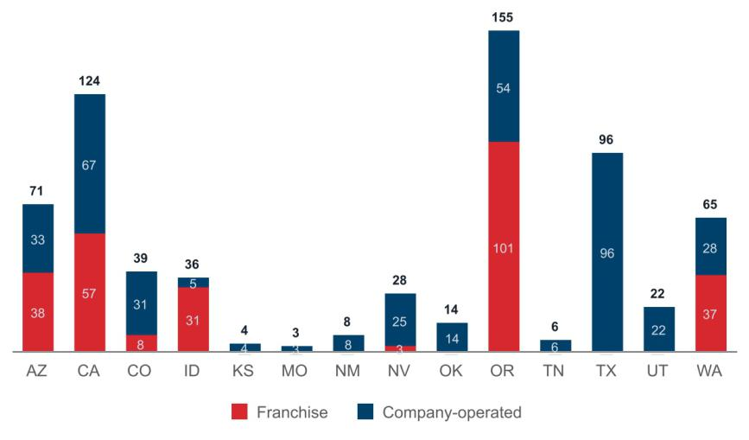

In addition to our company-operated shops, we own and lease the following facilities:

Location |  | Primary Function(s) |  | Square Feet |  | Owned or Leased
Grants Pass, Oregon |  | Corporate headquarters |  | 16,000 |  | Owned
Grants Pass, Oregon |  | Headquarters office space |  | 26,000 |  | Leased
Grants Pass, Oregon |  | Roasting and packing facility |  | 36,000 |  | Owned
Grants Pass, Oregon |  | Roasting and warehouse facility |  | 21,000 |  | Leased
Grants Pass, Oregon |  | Aircraft hangar and transportation operations |  | 84,000 |  | Leased

Our principal executive offices are located at 110 SW 4th Street, Grants Pass, Oregon, 97526. We believe our current facilities are suitable for our near-term expansion plans, and expect to continue to add additional capacity on an as-needed basis. We are in the process of constructing another roasting facility in Texas to service our shops in new markets as we expand eastward, in line with our growth strategy.

For additional information regarding leases, see NOTE 2 — Basis of Presentation and Summary of Significant Accounting Policies and NOTE 8 — Leases in our consolidated financial statements, included elsewhere in this Form 10-K.

Dutch Bros Inc.| Form 10-K | 59

Table of Contents

ITEM 3. LEGAL PROCEEDINGS

We may, from time to time, be party to litigation and subject to claims incident to the ordinary course of business. As our company matures, we may become party to an increasing number of litigation matters and claims. The outcome of litigation and claims cannot be predicted with certainty, and the resolution of these matters could materially adversely affect our business, financial condition, results of operations and growth prospects.

We are not currently involved in any material legal proceedings.

ITEM 4. MINE SAFETY DISCLOSURES

Not applicable.

Dutch Bros Inc.| Form 10-K | 60

Table of Contents

PART II

ITEM 5. MARKET FOR REGISTRANT’S COMMON EQUITY, RELATED STOCKHOLDER MATTERS AND ISSUER PURCHASES OF EQUITY SECURITIES

Market Information for Common Stock

Our Class A common stock is traded on the New York Stock Exchange under the symbol “BROS”. There is no established public trading market for our Class B common stock, Class C common stock, or Class D common stock.

Stockholders

As of December 31, 2022, our Class A common stock was held by 82 holders of record. The actual number of stockholders of Class A common stock is greater than this number of record holders and includes stockholders who are beneficial owners, but whose shares are held in street name by brokers and other nominees. This number of holders of record also does not include stockholders whose shares may be held in trust by other entities. As of December 31, 2022, we also had three holders of record of our Class B common stock, two holders of record of our Class C common stock, and two holders of record of our Class D common stock.

Dividend Policy

We have not paid dividends on our common stock, and we do not anticipate paying dividends in the foreseeable future.

Stock Performance Graph

The graph below compares the cumulative total stockholder return on our Class A common stock (BROS) with the cumulative total return on the S&P 500 Index (SPX) and the S&P 500 Consumer Discretionary Index (SP500.25), assuming an initial investment of $100 at the market close on September 15, 2021, the date our stock commenced trading on the New York Stock Exchange. Data for the S&P 500 Index and the S&P 500 Consumer Discretionary Index assume reinvestment of dividends. As noted above, no dividends have been declared on our Class A common stock to date.

The comparisons in the graph below are based upon historical data and are not indicative of, nor intend to forecast, future performance of our Class A common stock.

Dutch Bros Inc.| Form 10-K | 61

Table of Contents
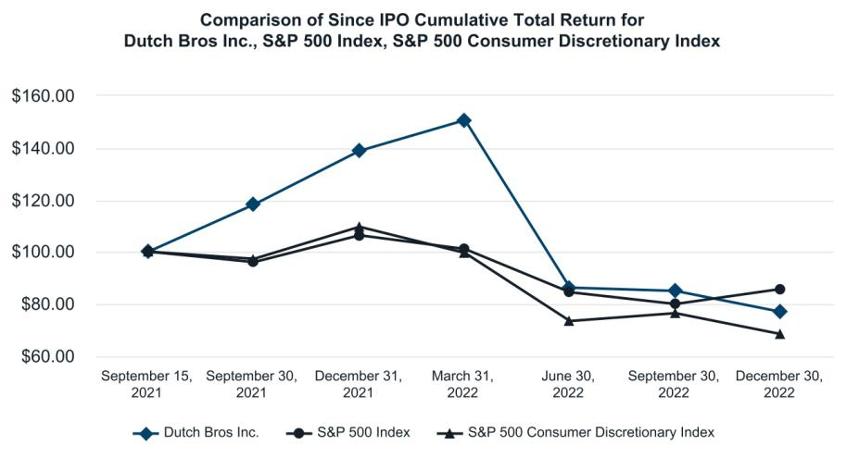

 |  | September 15, |  |  | September 30, |  |  | December 31, |  |  | March 31, |  |  | June 30, |  |  | September 30, |  |  | December 30,
 |  | 2021 |  |  | 2021 |  |  | 2021 |  |  | 2022 |  |  | 2022 |  |  | 2022 |  |  | 2022
Dutch Bros Inc. | $ | 100.00 |  | $ | 118.10 |  | $ | 138.79 |  | $ | 150.68 |  | $ | 86.29 |  | $ | 84.92 |  | $ | 76.85
S&P 500 Index | $ | 100.00 |  | $ | 96.14 |  | $ | 106.37 |  | $ | 101.11 |  | $ | 84.48 |  | $ | 80.02 |  | $ | 85.69
S&P 500 Consumer
Discretionary Index | $ | 100.00 |  | $ | 97.34 |  | $ | 109.67 |  | $ | 99.59 |  | $ | 73.38 |  | $ | 76.41 |  | $ | 68.46

The above Stock Performance Graph and related information shall not be deemed “soliciting material” or to be “filed” with the SEC nor shall such information be incorporated by reference into any future filing under the Securities Act or the Exchange Act, each as amended, except to the extent that we specifically incorporate it by reference into such filing.

ITEM 6. [RESERVED]

ITEM 7. MANAGEMENT’S DISCUSSION AND ANALYSIS OF FINANCIAL CONDITION AND RESULTS OF OPERATIONS

You should read the following discussion and analysis of our financial condition and results of operations together with our audited consolidated financial statements and the related notes included elsewhere in this Form 10-K. Some of the information contained in this discussion and analysis or set forth elsewhere in this document, includes forward looking statements that involve risks, uncertainties, and assumptions. You should carefully read the “Forward-Looking Statements” and “Risk Factors” sections of this Form 10-K for a discussion of important factors that could cause actual results to differ materially from the results described in or implied by the forward-looking statements contained in the following discussion and analysis.

In addition, statements that “we believe” and similar statements reflect our beliefs and opinions on the relevant subject. These statements are based on information available to us as of the date of this Form 10-K. While we believe that information provides a reasonable basis for these statements, that information may be limited or incomplete. Our statements should not be read to indicate that we have conducted an exhaustive inquiry into, or review of, all relevant information. These statements are inherently uncertain, and investors are cautioned not to unduly rely on these statements. In addition, the section of this “Management’s Discussion and Analysis of Financial Condition and

Dutch Bros Inc.| Form 10-K | 62

Table of Contents

Results of Operations” generally discusses 2022 and 2021 items and year-to-year comparisons between 2022 and 2021. Discussions of 2020 items and year-to-year comparisons between 2021 and 2020 are not included in this Annual Report on Form 10-K and can be found in “Management’s Discussion and Analysis of Financial Condition and Results of Operations” in Part II, Item 7 of our Annual Report on Form 10-K for the fiscal year ended December 31, 2021, filed with the SEC on March 11, 2022.

Overview and Highlights

Dutch Bros is a high growth operator and franchisor of drive-thru shops that focus on serving high QUALITY, hand-crafted beverages with unparalleled SPEED and superior SERVICE. Founded in 1992 by brothers Dane and Travis Boersma, Dutch Bros began with a double-head espresso machine and a pushcart in Grants Pass, Oregon. Today, we believe that Dutch Bros is one of the fastest-growing brands in the food service and restaurant industry in the United States by location count.

As of December 31, 2022, we had 671 company-operated and franchised shops in 14 states, an increase of approximately 24.7% from the same period in the prior year. For the year ended December 31, 2022, we generated $739.0 million of revenue, $(19.3) million net loss, and $(0.09) loss per diluted share. We have two reportable operating segments: Company-operated shops and Franchising and other.
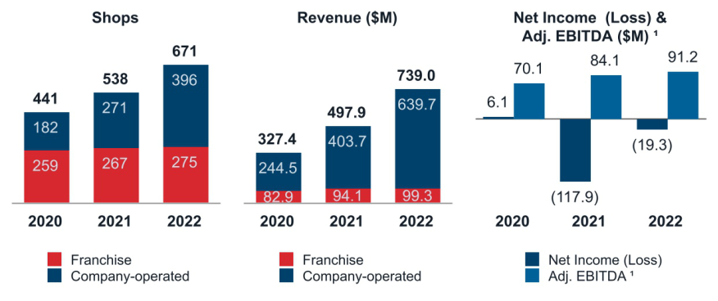

_________________

- Reconciliation of GAAP to non-GAAP results is provided in the section “Non-GAAP Financial Measures” in Part II, Item 7 “Management’s Discussion and Analysis of Financial Condition and Results of Operations”.

Key Highlights

- Opened 120 company-operated shops across multiple new operating areas in the year ended December 31, 2022, bringing total company-operated shops to 59.0% of our total shops, an increase of 46.1% over 2021.

- Celebrated 30 years of serving high QUALITY, hand-crafted beverages with unparalleled SPEED and superior SERVICE to our customers in 2022.

- Surpassed 5.2 million registered users on our Dutch Rewards mobile app, and enhanced the customer experience by providing the opportunity for customers to share their rewards with friends and family.

Dutch Bros Inc.| Form 10-K | 63

Table of Contents

Impact of Global Events

Inflation and Minimum Wage Increases

Similar to many of our peers in our industry, we encountered current commodities inflation, including dairy, coffee, fuel, and packaging, and experienced continuing legislated minimum wage increases that took effect this year in certain states. We expect these inflationary pressures to continue to affect our operating results in the foreseeable future. While these cost increases have impacted our operating results, we have taken measures to gradually increase our menu prices to help offset these pressures. Such price increases may lead to decreases in consumer demand. We will continue to evaluate further pricing actions to protect our operating results.

COVID-19

The effects from the COVID-19 pandemic continue to evolve, and we cannot easily predict the future potential impacts of the pandemic on our business and operations, or on the United States and global economy in general. This also may include any recurrence of the disease, actions taken by governmental authorities in response to the evolving pandemic, any ongoing effects on consumer demand and spending patterns or other direct and indirect impacts of the pandemic, such as supply chain disruptions. Whether these or other currently unanticipated consequences of the pandemic are reasonably likely to materially affect the continued and future impacts on our results of operations, cash flows or financial condition is yet to be determined.

Due to our drive-thru shops model, we have not experienced materially negative impacts to the same degree as others in our industry. Nevertheless, we have been affected by global shipping delays that have impacted deliveries of supplies to our shops.

Russia and Ukraine War

To date, the war between Russia and Ukraine has not had a material direct impact on our business, financial condition, or results of operations. Indirectly, this conflict and resulting sanctions may have caused or contributed to increases in oil and gas prices. Because of our drive-thru shops model, we are monitoring closely the impact of recent volatility in oil and gas prices on our customers’ behavior and believe such increases may contribute to decreased demand, which we believe is likely to continue. We are also monitoring any broader economic impact of the current war, including its effect on commodities (including oil and gas), transportation costs, liquidity and credit availability, declines in consumer confidence, declines in global economic growth, inflation, uncertainty about economic stability, and increases in unemployment rates.

Dutch Bros Inc.| Form 10-K | 64

Table of Contents

Results of Operations

Our historical results have been retroactively revised to reflect an immaterial error correction related to the accrual of employee sick leave. These revisions ensure comparability across all periods reflected herein. For additional information, refer to NOTE 2 — Basis of Presentation and Summary of Significant Accounting Policies and NOTE 20 — Segment Reporting in our consolidated financial statements, included elsewhere in this Form 10-K.

The following tables provide our operating results and explanation of changes for the periods presented.

Consolidated Statements of Operations

 |  |  | Year Ended December 31,
(in thousands) |  |  | 2022 |  |  | 2021 |  |  | 2020
REVENUES
Company-operated shops |  | $ | 639,710 |  | $ | 403,746 |  | $ | 244,514
Franchising and other |  |  | 99,302 |  |  | 94,130 |  |  | 82,899
Total revenues |  |  | 739,012 |  |  | 497,876 |  |  | 327,413
COSTS AND EXPENSES
Cost of sales |  |  | 558,096 |  |  | 344,573 |  |  | 211,478
Selling, general and administrative |  |  | 183,528 |  |  | 264,529 |  |  | 104,935
Total costs and expenses |  |  | 741,624 |  |  | 609,102 |  |  | 316,413
INCOME (LOSS) FROM OPERATIONS |  |  | (2,612) |  |  | (111,226) |  |  | 11,000
OTHER EXPENSE
Interest expense, net |  |  | (18,018) |  |  | (7,093) |  |  | (3,736)
Other income (expense) |  |  | 3,976 |  |  | (1,240) |  |  | (363)
Total other expense |  |  | (14,042) |  |  | (8,333) |  |  | (4,099)
INCOME (LOSS) BEFORE INCOME TAXES |  |  | (16,654) |  |  | (119,559) |  |  | 6,901
Income tax expense (benefit) |  |  | 2,599 |  |  | (1,628) |  |  | 843
NET INCOME (LOSS) |  |  | (19,253) |  |  | (117,931) |  |  | 6,058
Less: Net income (loss) attributable to Dutch Bros OpCo prior to the Reorganization Transactions |  |  | — |  |  | (67,374) |  |  | 6,058
Less: Net loss attributable to non-controlling interests |  |  | (14,500) |  |  | (37,878) |  |  | —
NET LOSS ATTRIBUTABLE TO DUTCH BROS INC. |  | $ | (4,753) |  | $ | (12,679) |  | $ | —

Dutch Bros Inc.| Form 10-K | 65

Table of Contents

Segment Financials

 |  |  | Year Ended December 31,
(in thousands) |  |  | 2022 |  |  | 2021 |  |  | 2020
Revenues:
Company-operated shops |  | $ | 639,710 |  | $ | 403,746 |  | $ | 244,514
Franchising and other |  |  | 99,302 |  |  | 94,130 |  |  | 82,899
Total revenues |  |  | 739,012 |  |  | 497,876 |  |  | 327,413
Cost of sales:
Company-operated shops |  |  | 518,383 |  |  | 317,045 |  |  | 183,968
Franchising and other |  |  | 39,713 |  |  | 27,528 |  |  | 27,510
Total cost of sales |  |  | 558,096 |  |  | 344,573 |  |  | 211,478
Segment gross profit:
Company-operated shops |  |  | 121,327 |  |  | 86,701 |  |  | 60,546
Franchising and other |  |  | 59,589 |  |  | 66,602 |  |  | 55,389
Total gross profit |  |  | 180,916 |  |  | 153,303 |  |  | 115,935
Depreciation and amortization:
Company-operated shops |  | $ | 36,306 |  | $ | 16,291 |  | $ | 9,737
Franchising and other |  |  | 5,706 |  |  | 6,263 |  |  | 4,349
All other |  |  | 2,716 |  |  | 2,663 |  |  | 1,451
Total depreciation and amortization |  | $ | 44,728 |  | $ | 25,217 |  | $ | 15,537
Segment contribution:
Company-operated shops |  |  | 157,633 |  |  | 102,992 |  |  | 70,283
Franchising and other |  |  | 65,295 |  |  | 72,865 |  |  | 59,738
Total segment contribution |  | $ | 222,928 |  | $ | 175,857 |  | $ | 130,021
Selling, general and administrative |  |  | (183,528) |  |  | (264,529) |  |  | (104,935)
Interest expense, net |  |  | (18,018) |  |  | (7,093) |  |  | (3,736)
Other income (expense) |  |  | 3,976 |  |  | (1,240) |  |  | (363)
INCOME (LOSS) BEFORE INCOME TAXES |  | $ | (16,654) |  | $ | (119,559) |  | $ | 6,901

Dutch Bros Inc.| Form 10-K | 66

Table of Contents

Key Performance Indicators

The key performance indicators (KPIs) that we use to effectively manage and evaluate our business are as follows:

 |  |  |  |  |  |  |  |  | Year Ended December 31,
(in thousands, except shop count data; unaudited) |  |  |  |  |  |  | 2022 |  |  |  |  |  | 2021 |  |  |  | 2020
Shop count, beginning of period
Company-operated |  |  |  |  |  |  | 271 |  |  |  |  |  | 182 |  |  |  |  |  | 118
Franchised |  |  |  |  |  |  | 267 |  |  |  |  |  | 259 |  |  |  |  |  | 252
Total shop count |  |  |  |  |  |  | 538 |  |  |  |  |  | 441 |  |  |  |  |  | 370
Company-operated new openings |  |  |  |  |  |  | 120 |  |  |  |  |  | 82 |  |  |  |  |  | 59
Franchised new openings |  |  |  |  |  |  | 13 |  |  |  |  |  | 16 |  |  |  |  |  | 13
Acquisition of franchise shops |  |  |  |  |  |  | 5 |  |  |  |  |  | 7 |  |  |  |  |  | 5
Closures ¹ |  |  |  |  |  |  |  | — |  |  |  |  | (1) |  |  |  |  |  | (1)
Shop count, end of period
Company-operated |  |  |  |  |  |  | 396 |  |  |  |  |  | 271 |  |  |  |  |  | 182
Franchised |  |  |  |  |  |  | 275 |  |  |  |  |  | 267 |  |  |  |  |  | 259
Total shop count |  |  |  |  |  |  | 671 |  |  |  |  |  | 538 |  |  |  |  |  | 441
Systemwide AUV ² |  |  |  |  |  | $ | 1,924 |  | $ |  |  |  | 1,850 |  |  |  | $ |  | 1,679
Company-operated shops AUV ² |  |  |  |  |  | $ | 1,895 |  | $ |  |  |  | 1,752 |  |  |  | $ |  | 1,524
Systemwide same shop sales ^{3, 4} |  |  |  |  |  |  | 1.0 % |  |  |  |  |  | 8.4 % |  |  |  |  |  | 2.0 %
Company-operated same shop sales ³ |  |  |  |  |  |  | 0.6 % |  |  |  |  |  | 9.0 % |  |  |  |  |  | 0.8 %
Systemwide sales ⁴ |  |  |  |  |  | $ | 1,163,182 |  | $ |  |  |  | 913,822 |  |  |  | $ |  | 687,238
Company-operated operating weeks ⁵ |  |  |  |  |  |  | 17,489 |  |  |  |  |  | 11,526 |  |  |  |  |  | 8,316
Franchising and other operating weeks ⁵ |  |  |  |  |  |  | 13,828 |  |  |  |  |  | 13,175 |  |  |  |  |  | 12,358
Dutch Rewards member registrations ⁶ |  |  |  |  |  |  | 2,004 |  |  |  |  |  | 3,202 |  |  |  |  |  | 8
 |  |  |  |  |  |  |  | Year Ended December 31,
 |  | 2022 |  |  |  |  |  |  | 2021 ⁷ |  |  |  |  |  |  |  | 2020 ⁷
(in thousands; unaudited) |  | $ |  |  |  | % |  | $ |  |  |  |  | % |  |  |  | $ |  | %
Company-operated shop revenues |  | 639,710 |  |  |  | 100.0 | 403,746 |  |  |  |  |  | 100.0 |  |  |  | 244,514 |  | 100.0
Company-operated shop gross profit |  | 121,327 |  |  |  | 19.0 | 86,701 |  |  |  |  |  | 21.5 |  |  |  | 60,546 |  | 24.8
Company-operated shop contribution ⁸ |  | 157,633 |  |  |  | 24.6 | 102,992 |  |  |  |  |  | 25.5 |  |  |  | 70,283 |  | 28.7
Selling, general, and administrative expenses |  | 183,528 |  |  |  | 24.8 | 264,529 |  |  |  |  |  | 53.1 |  |  |  | 104,935 |  | 32.0
Adjusted selling, general, and administrative expenses ⁹ |  | 136,441 |  |  |  | 18.5 | 96,498 |  |  |  |  |  | 19.4 |  |  |  | 69,848 |  | 21.3
NET INCOME (LOSS) |  | (19,253) |  |  |  | (2.6) | (117,931) |  |  |  |  |  | (23.7) |  |  |  | 6,058 |  | 1.9
Adjusted EBITDA ⁸ |  | 91,181 |  |  |  | 12.3 | 84,132 |  |  |  |  |  | 16.9 |  |  |  | 70,097 |  | 21.4

Dutch Bros Inc.| Form 10-K | 67

Table of Contents

_________________

- Represents a temporary shop closure in 2021 that remained closed in 2022, and a permanent shop closure in 2020.

- AUVs are determined based on the net sales for any trailing twelve-month period for systemwide and company-operated shops that have been open a minimum of 15 months. AUVs are calculated by dividing the systemwide and company-operated shop net sales by the total number of systemwide and company-operated shops, respectively. Management uses this metric as an indicator of shop growth and future expectations of mature locations.

- Same shop sales reflects the change in year-over-year sales, for the comparable shop base, which we define as shops open for 15 complete months or longer. Management uses this metric as an indicator of shop growth and future expansion strategy. The number of shops included in the systemwide and company-operated comparable bases for the respective periods are presented in the following table.

 |  |  | Year Ended December 31,
(unaudited) |  | 2022 |  | 2021 |  | 2020
Systemwide shop base |  | 414 | 354 |  |  | 316
Company-operated shop base |  | 173 | 120 |  |  | 89

- Systemwide sales and systemwide same shop sales are operating measures that include sales at company-operated shops and sales at franchised shops during the comparable periods presented. Franchise sales represent sales at all franchise shops and are revenues to our franchise partners. We do not record franchise sales as revenues; however, our royalty revenues and advertising fund contributions are calculated based on a percentage of franchise sales. As these metrics include sales reported to us by our non-consolidated franchise partners, these metrics should be considered as a supplement to, not a substitute for, our results as reported under GAAP. Management uses these metrics as indicators of our system’s overall financial health, growth and future expansion prospects.

- Company-operated and franchise shops operating weeks are calculated based on the number operating days for the shop base and dividing by 7. Our shop base is defined as shops opened as of the period end date. The operating weeks calculations, reflect re-acquired franchises through 2022. Management uses these metrics as indicators of our system’s overall financial health, growth and future expansion prospects.

- Dutch Rewards, a digitally-based rewards program available exclusively through the Dutch Rewards mobile app, was launched February 2021. Management uses this metric as an indicator of customer loyalty adoption of our Dutch Rewards mobile app and future promotional plans.

- Our historical results have been revised to reflect immaterial corrections related to the accrual of employee sick leave. For additional information, refer to NOTE 2 — Basis of Presentation and Summary of Significant Accounting Policies and NOTE 20 — Segment Reporting, included elsewhere in this Form 10-K. The impacts of the immaterial error corrections on our non-GAAP measures, not included elsewhere in this Form 10-K, are presented below for the years ended December 31, 2021 and 2020, respectively.

 |  | Year Ended December 31,
(in thousands; unaudited) |  | 2021 |  | 2020
Decrease in adjusted selling, general, and administrative expenses |  | (506) |  | (152)
Increase in EBITDA |  | 2,046 |  | 333
Increase in adjusted EBITDA |  | 2,046 |  | 333

- Reconciliation of GAAP to non-GAAP results is provided in the section “Non-GAAP Financial Measures” in Part II, Item 7 “Management’s Discussion and Analysis of Financial Condition and Results of Operations”.

Dutch Bros Inc.| Form 10-K | 68

Table of Contents

Company-operated Shop Results

The results for our company-operated shops segment were as follows:
 |  |  |  |  |  | Year Ended December 31,
 |  | 2022 |  |  |  | 2021 |  |  |  | 2020
(in thousands; unaudited) |  | $ |  | % |  | $ |  | % |  | $ |  | %
Company-operated shop revenues |  | 639,710 |  | 100.0 |  | 403,746 |  | 100.0 |  | 244,514 |  | 100.0
Beverage, food, and packaging costs |  | 171,864 |  | 26.9 |  | 102,222 |  | 25.3 |  | 54,820 |  | 22.4
Labor costs |  | 182,861 |  | 28.6 |  | 122,161 |  | 30.3 |  | 71,473 |  | 29.2
Occupancy and other costs |  | 109,366 |  | 17.1 |  | 63,570 |  | 15.7 |  | 38,611 |  | 15.8
Pre-opening costs |  | 17,986 |  | 2.8 |  | 12,801 |  | 3.2 |  | 9,327 |  | 3.8
Depreciation and amortization |  | 36,306 |  | 5.6 |  | 16,291 |  | 4.0 |  | 9,737 |  | 4.0
Company-operated shop costs and expenses |  | 518,383 |  | 81.0 |  | 317,045 |  | 78.5 |  | 183,968 |  | 75.2
Company-operated shop gross profit |  | 121,327 |  | 19.0 |  | 86,701 |  | 21.5 |  | 60,546 |  | 24.8
Company-operated shop contribution ¹ |  | 157,633 |  | 24.6 |  | 102,992 |  | 25.5 |  | 70,283 |  | 28.7
_________________

- Reconciliation of GAAP to non-GAAP results is provided in the section “Non-GAAP Financial Measures” in Part II, Item 7 “Management’s Discussion and Analysis of Financial Condition and Results of Operations”.

Company-operated Shops Segment Performance

Company-operated Shop Revenues
 |  |  |  |  |  |  |  |  | Year Ended December 31,
(in thousands; unaudited) |  |  | 2022 |  |  | 2021 |  |  | 2020 |  |  | 2022 v. 2021 |  |  |  | 2021 v. 2020
Company-operated shop revenues |  | $ | 639,710 |  | $ | 403,746 |  | $ | 244,514 |  | $ | 235,964 | 58.4% |  | $ | 159,232 | 65.1%

Year Ended December 31, 2022 v 2021

The Company-operated shop revenue increase was primarily driven by the following:

- $224.4 million from company-operated shops opened in the last 15 months.

- $4.9 million from revenue recognized as a result of loyalty points collected prior to January 1, 2022 that expired on December 31, 2022.

- $2.5 million from revenue recognized as a result of estimated unredeemed loyalty points and rewards from purchases made in 2022.

Dutch Rewards Loyalty Program

In February 2021, Dutch Rewards was established. Accessible through a mobile app, Dutch Rewards provides the following key opportunities for customers:

- Collect points based on purchases

- Convert points to rewards

- Rewards can be redeemed for free drinks

- Receive birthday awards

Dutch Bros Inc.| Form 10-K | 69

Table of Contents

Points collected prior to January 1, 2022, if not redeemed for rewards, expired on December 31, 2022. Points collected on or after January 1, 2022, if not redeemed for rewards within 180 days, will automatically expire and be removed from the customers’ accounts.

Rewards are earned by redeeming points. Rewards that are not used within six months of issuance will automatically expire and be removed from the customers’ accounts.

Birthday awards automatically expire and are removed from the customers’ accounts after 8 to 30 days, depending on the specific award.

Impact of Dutch Rewards Loyalty Breakage

For the three months ended December 31, 2022, we recorded the first estimates of the impact of future expiration patterns on unredeemed points, rewards, and awards.

Based on the terms and conditions of the Dutch Rewards program, we experienced the first actual instance of points expirations in July 2022. No breakage estimates were made for the three months ended September 30, 2022, as the information was considered insufficient to make reasonable estimates.

The following information was collected and used in developing our estimates for the three months ended December 31, 2022 (points converted to redemption value):

- Based on two quarters of activity, we observed that expired points represented approximately 8% of points collected from purchases in 2022

- Approximately 16% of the points collected in 2021 expired and were unredeemed

For the three months ended December 31, 2022, we recognized revenue of $7.4 million, including $4.9 million for points collected from purchases prior to January 1, 2022 that expired on December 31, 2022.

Birthday awards have been a key part of the program since its inception. Although no breakage accounting entries were booked for birthday awards until December 31, 2022, based on the short duration of the birthday awards, any estimated breakage prior to December 31, 2022 would have been immaterial.

Customers typically use rewards converted from points very promptly. Although no breakage accounting entries were booked for rewards converted from points until December 31, 2022, based on the short duration of the rewards converted from points, any estimated breakage prior to December 31, 2022 would have been immaterial.
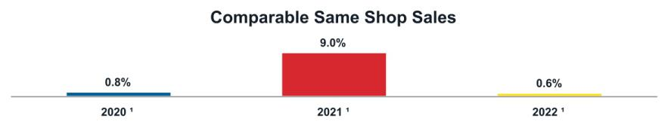

_________________

- The comparable shop bases were 89, 120, and 173 for the years ended December 31, 2020, 2021, and 2022, respectively. The comparable shop base includes mature shops, which we define as open longer than 15 months.

Dutch Bros Inc.| Form 10-K | 70

Table of Contents

Beverage, Food, and Packaging Costs
 |  |  |  |  |  |  |  |  |  |  |  |  |  |  |  | Year Ended December 31,
(in thousands; unaudited) |  |  |  |  |  | 2022 |  |  |  |  | 2021 |  |  |  |  | 2020 |  |  |  |  | 2022 v. 2021 |  |  |  |  |  |  |  |  | 2021 v. 2020
Beverage, food and packaging costs |  |  | $ |  |  | 171,864 |  | $ |  |  | 102,222 |  | $ |  |  | 54,820 |  | $ |  |  | 69,642 | 68.1% |  |  |  | $ |  |  | 47,402 |  |  |  |  | 86.5%
As a percentage of company-operated shop |  |  |  |  |  | 26.9% |  |  |  |  | 25.3% |  |  |  |  | 22.4% |  |  |  |  | N/A | 160 bps |  |  |  |  |  |  | N/A |  |  |  |  | 290 bps
revenues |  |  |  |  |  | 26.9% |  |  |  |  | 25.3% |  |  |  |  | 22.4% |  |  |  |  | N/A |  |  |  |  |  |  |  |  |  |  |  |  | 290 bps
Year Ended December 31, 2022 v 2021
The beverage, food, and packaging costs impacts for the year-over-year comparison were driven by the following (in dollars and basis points):
(in thousands; unaudited) |  |  |  |  |  |  |  |  |  |  |  |  |  |  |  |  |  |  |  |  |  |  |  |  |  |  |  |  | $ |  |  |  |  | BPS
Shop weeks |  |  |  |  |  |  |  |  |  |  |  |  |  |  |  |  |  |  |  |  |  |  |  |  |  | $ |  |  | 52,907 |  |  |  |  | N/A
Higher ingredient costs |  |  |  |  |  |  |  |  |  |  |  |  |  |  |  |  |  |  |  |  |  |  |  |  |  |  |  |  | 22,040 |  |  |  |  | 350
Volume |  |  |  |  |  |  |  |  |  |  |  |  |  |  |  |  |  |  |  |  |  |  |  |  |  |  |  |  | (3,690) |  |  |  |  | N/A
New shop impact |  |  |  |  |  |  |  |  |  |  |  |  |  |  |  |  |  |  |  |  |  |  |  |  |  |  |  |  | (424) |  |  |  |  | (10)
Pricing impacts |  |  |  |  |  |  |  |  |  |  |  |  |  |  |  |  |  |  |  |  |  |  |  |  |  |  |  |  |  | N/A |  |  |  | (150)
Promotional discounts |  |  |  |  |  |  |  |  |  |  |  |  |  |  |  |  |  |  |  |  |  |  |  |  |  |  |  |  |  | N/A |  |  |  | (20)
Other |  |  |  |  |  |  |  |  |  |  |  |  |  |  |  |  |  |  |  |  |  |  |  |  |  |  |  |  | (1,191) |  |  |  |  | (10)
Total change |  |  |  |  |  |  |  |  |  |  |  |  |  |  |  |  |  |  |  |  |  |  |  |  |  | $ |  |  | 69,642 |  |  |  |  | 160
Labor Costs
 |  |  |  |  |  |  |  |  |  |  |  |  |  |  |  | Year Ended December 31,
(in thousands; unaudited) |  |  |  |  |  | 2022 |  |  |  |  | 2021 |  |  |  |  | 2020 |  |  |  |  | 2022 v. 2021 |  |  |  |  |  |  |  |  | 2021 v. 2020
Labor costs |  |  | $ |  |  | 182,861 |  | $ |  |  | 122,161 |  | $ |  |  | 71,473 |  | $ |  |  | 60,700 | 49.7% |  |  |  | $ |  |  | 50,688 |  |  |  |  | 70.9%
As a percentage of company-operated shop |  |  |  |  |  | 28.6% |  |  |  |  | 30.3% |  |  |  |  | 29.2% |  |  |  |  | N/A | (170) bps |  |  |  |  |  |  | N/A |  |  |  |  | 110 bps
revenues |  |  |  |  |  | 28.6% |  |  |  |  | 30.3% |  |  |  |  | 29.2% |  |  |  |  | N/A |  |  |  |  |  |  |  |  |  |  |  |  | 110 bps
Year Ended December 31, 2022 v 2021
The labor costs impacts for the year-over-year comparison were driven by the following (in dollars and basis points):
(in thousands; unaudited) |  |  |  |  |  |  |  |  |  |  |  |  |  |  |  |  |  |  |  |  |  |  |  |  |  | $ |  |  |  |  |  |  |  | BPS
Shop weeks |  |  |  |  |  |  |  |  |  |  |  |  |  |  |  |  |  |  |  |  |  | $ |  |  |  |  |  |  | 60,973 |  |  |  |  | N/A
Legislated minimum wage increases and higher minimum staffing standards |  |  |  |  |  |  |  |  |  |  |  |  |  |  |  |  |  |  |  |  |  |  |  |  |  |  |  |  | 6,115 |  |  |  |  | 100
Volume |  |  |  |  |  |  |  |  |  |  |  |  |  |  |  |  |  |  |  |  |  |  |  |  |  |  |  |  | (1,502) |  |  |  |  | N/A
Lower COVID-19 leave expenses |  |  |  |  |  |  |  |  |  |  |  |  |  |  |  |  |  |  |  |  |  |  |  |  |  |  |  |  | (2,024) |  |  |  |  | (30)
New shop impact |  |  |  |  |  |  |  |  |  |  |  |  |  |  |  |  |  |  |  |  |  |  |  |  |  |  |  |  | 21 |  |  |  |  | —
Pricing impacts |  |  |  |  |  |  |  |  |  |  |  |  |  |  |  |  |  |  |  |  |  |  |  |  |  |  |  |  | N/A |  |  |  |  | (180)
Promotional discounts |  |  |  |  |  |  |  |  |  |  |  |  |  |  |  |  |  |  |  |  |  |  |  |  |  |  |  |  | N/A |  |  |  |  | (10)
Other |  |  |  |  |  |  |  |  |  |  |  |  |  |  |  |  |  |  |  |  |  |  |  |  |  |  |  |  | (2,883) |  |  |  |  | (50)
Total change |  |  |  |  |  |  |  |  |  |  |  |  |  |  |  |  |  |  |  |  |  |  |  | $ |  |  |  |  | 60,700 |  |  |  |  | (170)

Dutch Bros Inc.| Form 10-K | 71

Table of Contents

Occupancy and Other Costs
 |  |  |  |  |  |  |  |  |  |  |  |  |  |  |  | Year Ended December 31,
(in thousands; unaudited) |  |  | 2022 |  |  |  |  |  |  |  | 2021 |  |  |  |  | 2020 |  |  |  |  | 2022 v. 2021 |  |  |  |  |  |  |  |  |  |  | 2021 v. 2020
Occupancy and other costs |  |  | $ |  |  | 109,366 |  | $ |  |  | 63,570 |  | $ |  |  | 38,611 |  | $ |  |  | 45,796 | 72.0% |  |  | $ |  |  |  |  | 24,959 |  |  | 64.6%
As a percentage of company-operated shop revenues |  |  | 17.1% |  |  |  |  |  |  |  | 15.7% |  |  |  |  | 15.8% |  |  |  |  | N/A | 140 bps |  |  |  |  |  |  |  | N/A |  |  | (10) bps
Year Ended December 31, 2022 v 2021
The occupancy and other costs impacts for the year-over-year comparison were driven by the following (in dollars and basis points):
(in thousands; unaudited) |  |  |  |  |  |  |  |  |  |  |  |  |  |  |  |  |  |  |  |  |  |  |  |  | $ |  |  |  |  |  |  |  | BPS
Shop weeks |  |  |  |  |  |  |  |  |  |  |  |  |  |  |  |  |  |  |  |  |  | $ |  |  |  |  |  |  |  | 35,654 |  |  | N/A
Occupancy cost escalation |  |  |  |  |  |  |  |  |  |  |  |  |  |  |  |  |  |  |  |  |  |  |  |  |  |  |  |  |  | 8,733 |  |  | 140
Higher preventative maintenance programs |  |  |  |  |  |  |  |  |  |  |  |  |  |  |  |  |  |  |  |  |  |  |  |  |  |  |  |  |  | 2,816 |  |  | 40
Rent/CAMS |  |  |  |  |  |  |  |  |  |  |  |  |  |  |  |  |  |  |  |  |  |  |  |  |  |  |  |  |  | 2,232 |  |  | 30
New shop impact |  |  |  |  |  |  |  |  |  |  |  |  |  |  |  |  |  |  |  |  |  |  |  |  |  |  |  |  |  | 1,086 |  |  | 20
Volume |  |  |  |  |  |  |  |  |  |  |  |  |  |  |  |  |  |  |  |  |  |  |  |  |  |  |  |  |  | 36 |  |  | N/A
Reinstitution of accepting cash at shops |  |  |  |  |  |  |  |  |  |  |  |  |  |  |  |  |  |  |  |  |  |  |  |  |  |  |  |  |  | (3,080) |  |  | (50)
Leverage/deleverage |  |  |  |  |  |  |  |  |  |  |  |  |  |  |  |  |  |  |  |  |  |  |  |  |  |  |  |  |  | N/A |  |  | 90
Pricing impacts |  |  |  |  |  |  |  |  |  |  |  |  |  |  |  |  |  |  |  |  |  |  |  |  |  |  |  |  |  | N/A |  |  | (100)
Promotional discounts |  |  |  |  |  |  |  |  |  |  |  |  |  |  |  |  |  |  |  |  |  |  |  |  |  |  |  |  |  | N/A |  |  | (10)
Other |  |  |  |  |  |  |  |  |  |  |  |  |  |  |  |  |  |  |  |  |  |  |  |  |  |  |  |  |  | (1,681) |  |  | (20)
Total change |  |  |  |  |  |  |  |  |  |  |  |  |  |  |  |  |  |  |  |  |  | $ |  |  |  |  |  |  |  | 45,796 |  |  | 140
Pre-opening Costs
 |  |  |  |  |  |  |  |  |  |  |  |  |  |  |  | Year Ended December 31,
(in thousands, except shop data; unaudited) |  |  |  |  |  | 2022 |  |  |  |  | 2021 |  |  |  |  | 2020 |  |  |  |  | 2022 v. 2021 |  |  |  |  |  |  |  |  |  |  | 2021 v. 2020
Pre-opening costs |  |  | $ |  |  | 17,986 |  |  |  | $ | 12,801 |  | $ |  |  | 9,327 |  | $ |  |  | 5,185 | 40.5% |  |  | $ |  |  |  |  | 3,474 |  |  | 37.2%
As a percentage of company-operated shop revenues |  |  |  |  |  | 2.8% |  |  |  |  | 3.2% |  |  |  |  | 3.8% |  |  |  |  | N/A |  | (40) bps |  |  |  |  |  |  | N/A |  |  | (60) bps
New company-operated shops opened |  |  |  |  |  | 120 |  |  |  |  | 82 |  |  |  |  | 59 |  |  |  |  | 38 | 46.3% |  |  |  |  |  |  |  | 23 |  |  | 39.0%
Pre-opening costs per new company-operated shop |  |  |  |  |  | $150 |  |  |  |  | $156 |  |  |  |  | $158 |  |  |  |  | $(6) | (3.8)% |  |  |  |  |  |  |  | $(2) |  |  | (1.3)%

Year Ended December 31, 2022 v 2021

The increase in pre-opening costs was primarily driven by opening 38 more company-operated shops in the year ended December 31, 2022 as compared to 2021, while also realizing cost and operational efficiencies.

Depreciation and Amortization
 |  |  |  |  |  |  |  |  | Year Ended December 31,
(in thousands; unaudited) |  |  | 2022 |  |  | 2021 |  |  | 2020 |  |  | 2022 v. 2021 |  |  |  | 2021 v. 2020
Depreciation and amortization |  | $ | 36,306 |  | $ | 16,291 |  | $ | 9,737 |  | $ | 20,015 | 122.9% |  | $ | 6,554 | 67.3%
As a percentage of company-operated shop revenues |  |  | 5.6% |  |  | 4.0% |  |  | 4.0% |  |  | N/A | 160 bps |  |  | N/A | — bps

Dutch Bros Inc.| Form 10-K | 72

Table of Contents

Year Ended December 31, 2022 v 2021

The increase in depreciation and amortization were primarily driven by the opening of 120 new company-operated shops during 2022.

Company-operated Shop Gross Profit and Contribution¹ ²

 |  |  |  |  |  |  |  | Year Ended December 31,
(in thousands; unaudited) |  |  | 2022 |  | 2021 |  |  | 2020 |  |  | 2022 v. 2021 |  |  |  |  |  | 2021 v. 2020
Company-operated shop gross profit |  |  | 121,327 |  | 86,701 |  | $ | 60,546 |  | $ | 34,626 | 39.9% |  | $ | 26,155 |  |  | 43.2%
As a percentage of company-operated shop revenues |  |  | 19.0% |  | 21.5% |  |  | 24.8% |  |  | N/A | (250) bps |  |  | N/A |  |  | (330) bps
Company-operated shop contribution ¹ |  |  | 157,633 |  | 102,992 |  | $ | 70,283 |  | $ | 54,641 | 53.1% |  | $ | 32,709 |  |  | 46.5%
As a percentage of company-operated shop revenues |  |  | 24.6% |  | 25.5% |  |  | 28.7% |  |  | N/A | (90) bps |  |  | N/A |  |  | (320) bps
Year Ended December 31, 2022 v 2021
The Company-operated gross profit and contribution impacts for the year-over-year comparison were driven by the following (in basis points):
(in thousands; unaudited) |  |  |  |  |  |  |  |  |  |  |  |  |  |  |  |  |  | BPS
Higher ingredient costs |  |  |  |  |  |  |  |  |  |  |  |  |  |  |  |  |  | (380)
Higher shop operating expenses |  |  |  |  |  |  |  |  |  |  |  |  |  |  |  |  |  | (90)
Legislated minimum wage increases and higher minimum staffing standards |  |  |  |  |  |  |  |  |  |  |  |  |  |  |  |  |  | (70)
Costs increases |  |  |  |  |  |  |  |  |  |  |  |  |  |  |  |  |  | (540)
Menu price increases |  |  |  |  |  |  |  |  |  |  |  |  |  |  |  |  |  | 430
Higher promotional discounts |  |  |  |  |  |  |  |  |  |  |  |  |  |  |  |  |  | 40
Pricing and discounts |  |  |  |  |  |  |  |  |  |  |  |  |  |  |  |  |  | 470
Higher preventative maintenance programs |  |  |  |  |  |  |  |  |  |  |  |  |  |  |  |  |  | (40)
Higher pre-opening expenses |  |  |  |  |  |  |  |  |  |  |  |  |  |  |  |  |  | 40
New shop impact |  |  |  |  |  |  |  |  |  |  |  |  |  |  |  |  |  | (80)
New shop related items |  |  |  |  |  |  |  |  |  |  |  |  |  |  |  |  |  | (40)
Lower COVID-19 leave expenses |  |  |  |  |  |  |  |  |  |  |  |  |  |  |  |  |  | 30
Leverage (deleverage) |  |  |  |  |  |  |  |  |  |  |  |  |  |  |  |  |  | (80)
Loyalty points breakage 2021 ² |  |  |  |  |  |  |  |  |  |  |  |  |  |  |  |  |  | 50
Loyalty points and rewards breakage 2022 ³ |  |  |  |  |  |  |  |  |  |  |  |  |  |  |  |  |  | 20
Other |  |  |  |  |  |  |  |  |  |  |  |  |  |  |  |  |  | (120)
Total change in Company-operated shop gross profit |  |  |  |  |  |  |  |  |  |  |  |  |  |  |  |  |  | (250)
Depreciation and amortization |  |  |  |  |  |  |  |  |  |  |  |  |  |  |  |  |  | 160
Total change in Company-operated shop contribution ¹ |  |  |  |  |  |  |  |  |  |  |  |  |  |  |  |  |  | (90)

_________________

- Reconciliation of GAAP to non-GAAP results is provided in the section “Non-GAAP Financial Measures” in Part I, Item 2 “Management’s Discussion and Analysis of Financial Condition and Results of Operations”.

- Recognition of $4.9 million of revenue from the loyalty points collected prior to January 1, 2022 that expired on December 31, 2022, which is included in company-operated shop gross margin and contribution. For additional details, see NOTE 2 — Basis of Presentation and Summary of Significant Accounting Policies and NOTE 3 — Revenue Recognition.

- Recognition of $2.5 million of revenue from the estimated unredeemed loyalty points and rewards from purchases made in 2022.

Dutch Bros Inc.| Form 10-K | 73

Table of Contents

Franchising and Other Segment Performance

 |  |  |  |  |  |  |  |  |  |  | Year Ended December 31,
(in thousands; unaudited) |  |  |  | 2022 |  |  | 2021 |  |  | 2020 |  |  | 2022 v. 2021 |  |  |  |  |  |  | 2021 v. 2020
Franchising and other revenue |  |  | $ | 99,302 |  | $ | 94,130 |  | $ | 82,899 | $ |  | 5,172 | 5.5% |  |  |  | $ | 11,231 |  |  | 13.5%
Franchising and other gross profit |  |  | $ | 59,589 |  | $ | 66,602 |  | $ | 55,389 | $ |  | (7,013) | (10.5)% |  |  |  | $ | 11,213 |  |  | 20.2%
As a percentage of franchising and other revenue |  |  |  | 60.0% |  |  | 70.8% |  |  | 66.8% |  | N/A |  | (1,080) bps |  |  |  |  | N/A |  |  | 400 bps
Year Ended December 31, 2022 v 2021
The Franchising and other gross profit impacts for the year-over-year comparison, were driven by the following (in dollars and basis points):
(in thousands; unaudited) |  |  |  |  |  |  |  |  |  |  |  |  |  |  |  |  |  | $ |  |  |  | BPS
Higher net costs of products sold to franchisees |  |  |  |  |  |  |  |  |  |  |  |  |  |  |  |  |  |  | (10,674) |  |  | (1,080)
Shop weeks |  |  |  |  |  |  |  |  |  |  |  |  |  |  |  |  |  |  | 1,580 |  |  | N/A
Same shop sales |  |  |  |  |  |  |  |  |  |  |  |  |  |  |  |  |  |  | 866 |  |  | N/A
Other |  |  |  |  |  |  |  |  |  |  |  |  |  |  |  |  |  |  | 1,215 |  |  | N/A
Total change |  |  |  |  |  |  |  |  |  |  |  |  |  |  |  |  |  |  | (7,013) |  |  | (1,080)

Selling, General, and Administrative

 |  |  |  |  |  |  |  | Year Ended December 31,
(in thousands; unaudited) |  | 2022 |  |  | 2021 |  |  | 2020 |  |  | 2022 v. 2021 |  |  |  | 2021 v. 2020
Selling, General and Administrative |  | $183,528 |  | $ | 264,529 |  | $ | 104,935 |  | $ | (81,001) | (30.6)% |  | $ | 159,594 | 152.1%
As a percentage of total revenues |  | 24.8% |  |  | 53.1% |  |  | 32.0% |  |  | N/A | N/M |  |  | N/A | N/M

Year Ended December 31, 2022 v 2021

The selling, general, and administrative impacts for the year-over-year comparison were driven by the following (in dollars and basis points):

- $116.1 million or 1,570 bps from lower equity-based compensation charges related to one-time awards vested as of the IPO.

- $10.3 million or 140 bps from non-recurring costs and donations associated with our IPO in the prior year.

- $31.6 million from investments in human capital, processes, and systems to support our revenue growth.

- $8.3 million or 110 bps from higher costs incurred as a result of being a public company.

- $2.4 million or 30 bps from company-wide event costs celebrating 30 years serving high QUALITY, hand-crafted beverages with unparalleled SPEED and superior SERVICE to our customers.

Dutch Bros Inc.| Form 10-K | 74

Table of Contents

- $2.3 million or 30 bps from the write-off of prepaid expenses for COVID-19 impacted projects and events. Our 2023 annual kick-off meeting and our virtual corporate engagement platform built in response to COVID-19 as a substitute for in-person engagement practices pre-pandemic were both cancelled due to COVID-19.

The summation of the impact of the specific items above would have decreased selling, general and administrative expenses from prior year by 1,540 bps to be 37.7% of revenue.

However, leverage from revenue growth reduces that percentage by 1,290 bps to be 24.8% of revenue.

Other Expense

 |  |  |  |  |  |  |  |  | Year Ended December 31,
(in thousands; unaudited) |  |  | 2022 |  |  | 2021 |  |  | 2020 |  |  | 2022 v. 2021 |  |  |  |  |  | 2021 v. 2020
Interest expense on finance leases |  | $ | (9,296) |  | $ | (4,145) |  | $ | (2,115) |  | $ | (5,151) |  |  | 124.3% |  | $ | (2,030) |  | 96.0%
Other interest expense, net ¹ |  |  | (8,722) |  |  | (2,948) |  |  | (1,621) |  |  | (5,774) |  |  | 195.9% |  |  | (1,327) |  | 81.9%
Interest expense, net ¹ |  | $ | (18,018) |  | $ | (7,093) |  | $ | (3,736) |  | $ | (10,925) |  |  | 154.0% |  | $ | (3,357) |  | 89.9%
Other income (expense) |  |  | 3,976 |  |  | (1,240) |  |  | (363) |  |  | 5,216 |  |  | N/M |  |  | (877) |  | 241.6%
Total other expense |  | $ | (14,042) |  | $ | (8,333) |  | $ | (4,099) |  | $ | (5,709) |  |  | 68.5% |  | $ | (4,234) |  | 103.3%
_________________

- Effective as of the second half of 2022 and on a prospective basis, we recorded commitment fees for the unused portion of the revolving credit facility as interest expense. These amounts were previously recorded as selling, general, and administrative expense.

Year Ended December 31, 2022 v 2021

The increase in interest expense, net was primarily driven by additional finance leases for new shop builds, increased borrowings associated with our credit facility, and activity related to our interest rate swap.

The increase in other income (expense) was primarily driven by the recognition of a remeasurement gain related to the TRAs liability and sales of previously written off Dutchwear inventory.

Income Tax Expense (Benefit)

 |  |  |  |  |  |  |  |  | Year Ended December 31,
(in thousands; unaudited) |  |  | 2022 |  |  | 2021 |  | 2020 |  |  |  | 2022 v. 2021 |  |  |  | 2021 v. 2020
Income tax expense (benefit) |  | $ | 2,599 |  | $ | (1,628) |  | $ | 843 |  | $ | 4,227 | (259.6)% |  | $ | (2,471) | (293.1)%
Effective tax rate |  |  | (15.6)% |  |  | 1.4% |  | 12.2% |  |  |  | N/A | N/M |  |  | N/A | N/M

Year Ended December 31, 2022 v 2021

The increase in tax expense was primarily driven by mix of income earned by state tax jurisdiction and lower loss attributable to non-controlling interests, partially offset by adjustments to the outside basis differences as a result of the 2021 tax filings and higher tax credits.

Liquidity and Capital Resources

Cash Overview

We had cash and cash equivalents of $20.2 million and $18.5 million as of December 31, 2022 and December 31, 2021, respectively.

Dutch Bros Inc.| Form 10-K | 75

Table of Contents

For the year ended December 31, 2022, our principal sources of liquidity were cash flows from our term loan and revolving credit facilities, and operations. Our principal uses of liquidity for the year ended December 31, 2022 were to pay off our prior revolving credit facility and fund our new shop builds and working capital needs.

Cash Flows

The following table summarizes our cash flows for the periods presented:

 |  |  |  |  |  |  |  |  | Year Ended December 31,
(in thousands; unaudited) |  |  | 2022 |  |  | 2021 |  |  | 2020 |  |  | 2022 v. 2021 |  |  |  |  |  | 2021 v. 2020
Net cash flows provided by operating activities |  | $ | 59,883 |  | $ | 80,375 |  | $ | 53,549 |  | $ | (20,492) |  |  | (25.5)% |  | $ | 26,826 |  | 50.1%
Net cash flows used in investing activities |  |  | (192,572) |  |  | (121,089) |  |  | (45,570) |  |  | (71,483) |  |  | 59.0 |  |  | (75,519) |  | 165.7
Net cash provided by financing activities |  |  | 134,361 |  |  | 27,580 |  |  | 8,077 |  |  | 106,781 |  |  | N/M |  |  | 19,503 |  | N/M
Net increase (decrease) in cash |  | $ | 1,672 |  | $ | (13,134) |  | $ | 16,056 |  | $ | 14,806 |  |  | (112.7)% |  | $ | (29,190) |  | (181.8)%
Cash and cash equivalents at beginning of
period |  |  | 18,506 |  |  | 31,640 |  |  | 15,584 |  |  | (13,134) |  |  | (41.5) |  |  | 16,056 |  | 103.0
Cash and cash equivalents at end of period |  | $ | 20,178 |  | $ | 18,506 |  | $ | 31,640 |  | $ | 1,672 |  |  | 9.0% |  | $ | (13,134) |  | (41.5)%

Operating Activities

The decrease in operating activities cash flows was primarily driven by:

- Higher cost of sales and inventory due to increases in the number of shops and raw material costs

- Higher lease costs as a result of a increase in the number of company-operated shops

Investing Activities

The increase in investing activities cash outflows was primarily driven by:

- Investment in capital expenditures as a result of new company-operated shop openings

Financing Activities

The increase in financing activities cash flows was primarily driven by:

- Higher net proceeds from our credit facilities

- Non-recurring net IPO related activities in the prior year

Cash Requirements

We believe that cash provided by operating activities, cash and cash equivalents, and proceeds from our 2022 Credit Facility are adequate to fund our debt service requirements, lease obligations, and working capital obligations for at least the next 12 months.

Our future capital requirements may vary materially from period to period and will depend on many factors, primarily our expansion and growth by opening additional company-operated shops and/or reacquiring existing franchised shops. We currently expect to fund our material capital requirements in the long term with additional proceeds from our 2022 Credit Facility, but we may also seek additional debt or equity financing.

Dutch Bros Inc.| Form 10-K | 76

Table of Contents

From time to time, we may explore additional financing sources which could include equity, equity‑linked, and debt financing arrangements. Further, the payments that we may be required to make under the TRAs may be significant, and we are currently unable to estimate the timing of the payments that may be due thereunder.

Other than operating expenses, our cash requirements for 2023 are expected to consist primarily of capital expenditures for investments in our new and existing shops, our supply chain, and our corporate facilities, including new roasting facility that is estimated to be approximately $15 million to $20 million. The total capital expenditures for 2023 are estimated to be approximately $225 million to $250 million.

We expect to fund our current and long-term material cash requirements primarily with operating cash flows, and, as needed, proceeds from our 2022 Credit Facility. Our current and long-term material cash requirements as of December 31, 2022, primarily include the following:

- Debt Obligations: Refer to NOTE 9 — Debt, of the notes to the consolidated financial statements, included elsewhere in this Form 10-K, for further information of our obligations and the timing of expected payments. In addition, we have approximately $113 million revolving loans outstanding, which are expected to be paid within 1 year.

- Operating and Finance Leases: Refer to NOTE 8 — Leases, of the notes to the consolidated financial statements, included elsewhere in this Form 10-K, for further information of our obligations and the timing of expected payments.

- Purchase Obligations: include all legally binding contracts, including firm minimum commitments for inventory purchases, commitments for the purchase, construction or remodeling of real estate facilities, equipment purchases, marketing-related contracts, software acquisition/license commitments and service contracts. As of December 31, 2022, purchase obligations were approximately $160 million, of which substantially all are expected to be paid within one year.

- TRAs Obligations: Refer to NOTE 12 — Tax Receivable Agreements and NOTE 18 — Commitments and Contingencies, of the notes to the consolidated financial statements, included elsewhere in this Form 10-K, for further information of our obligations and the timing of expected payments.

Credit Facility

JP Morgan Credit Facility

On February 28, 2022 (the Effective Date) we amended our Senior Secured Credit Facility with JPMorgan Chase, N.A. The 2022 Credit Facility has a total capacity of $500 million, consisting of a $250 million revolving credit facility, a term loan facility of up to $ 100 million, and a delayed draw term loan facility of up to $150 million. The revolving credit facility includes sub-limits for issuance of letters of credit and swing line loans of up to $50 million and $15 million, respectively. It also contains an option allowing Dutch Bros PubCo to increase the size of the 2022 Credit Facility by up to an additional $150 million, with the agreement of the committing lenders. The 2022 Credit Facility expires five years after the Effective Date.

Upon entering into the 2022 Credit Facility, we drew a $100 million term loan and approximately $28 million in revolving loans, and the existing credit facility was repaid and terminated.

Interest on borrowings under the 2022 Credit Facility is based on (a) the Alternate Base Rate plus an applicable margin, or (b) the Adjusted Term SOFR Rate plus an applicable margin, and is payable in accordance with the selected interest rate period (at least quarterly) and upon maturity. Principal payments for the term loans are required on a quarterly basis in accordance with an amortization schedule and upon certain disposition of assets.

Dutch Bros Inc.| Form 10-K | 77

Table of Contents

Obligations under the 2022 Credit Facility are guaranteed by Dutch Bros OpCo and its subsidiaries, and secured by a first priority perfected security interest in substantially all of the assets of the guarantors.

Interest Rate Swap Contract

On April 1, 2022, Dutch Bros PubCo entered into an interest rate swap transaction with JPMorgan Chase Bank, N.A. with respect to $70 million of the term loan under the 2022 Credit Facility. The purpose of the floating-to-fixed interest rate swap was to fix the interest base rate charged on the term loan at 2.67% for the $70 million notional amount. The interest rate swap matures on February 28, 2027.

Critical Accounting Estimates

The methods, assumptions, and estimates that we use in applying our accounting policies may require us to apply judgments regarding matters that are inherently uncertain. We consider an accounting policy to be a critical estimate if: (1) we must make assumptions that were uncertain when the judgment was made, and (2) changes in the estimate assumptions, or selection of a different estimate methodology, could have a significant impact on our financial position and the results that we report in our consolidated financial statements. While we believe that our estimates, assumptions, and judgments are reasonable, they are based on information available when the estimate was made.

Refer to NOTE 2 — Basis of Presentation and Summary of Significant Accounting Policies within the consolidated financial statements, included elsewhere in this Form 10-K, for further information on our critical accounting estimates and policies, which are as follows:

Dutch Rewards Loyalty Program

In February 2021, Dutch Rewards was established. Eligible customers who register for the Dutch Rewards loyalty program collect points for every dollar spent. After accumulating a certain number of points, the customer can convert the points into a reward that can be redeemed for a free drink. Points collected, if not redeemed for rewards expire within 180 days, and rewards that are not used expire six months after issuance.

The estimation of the standalone selling price of points and rewards issued to customers involves several assumptions, primarily the valuation of points, estimated value of product for which a reward is expected to be redeemed, and estimated probability of future expirations of points and rewards. Our estimate of points and other rewards that we expect to be redeemed is based on current and historical company-specific data including redemption rates. These inputs are subject to change over time due to factors such as menu price increases, changes in points redemption options, and changes in customer behavior. Changes in our estimates and inputs could result in material changes to our Dutch Rewards program liability and loyalty program revenue.

Based on the terms and conditions of the Dutch Rewards program, we experienced the first actual instance of points expirations starting in the second half of 2022. Our historical data was considered insufficient to make reasonable estimates of the probability of future expirations of points and rewards through the end of the third quarter. We began estimating breakage in the fourth quarter. See NOTE 3 — Revenue Recognition for further details.

Leases

At the commencement of each lease, we evaluate the lease agreement to determine whether it is an operating or finance lease. The evaluation requires significant judgments in determining the fair value of the lease right-of-use asset and the lease liability and appropriate lease terms.

Our lease agreements generally do not provide an implicit interest rate; as such, the discount rate used to measure the initial lease liability is equal to the rate the Company would pay on a collateralized basis to borrow an amount equal to the lease payments under similar terms. The discount rate is subject to fluctuation based on market interest rates and our credit risk profile.

Dutch Bros Inc.| Form 10-K | 78

Table of Contents

We also estimate the lease term at commencement. The lease term commences on the date when we take possession of the leased property, irrespective of the contractual lease payments schedule. To determine the length of the lease term at inception, we consider both termination and renewal option periods available. Reasonably certain renewal periods are included in the lease term at commencement, and are generally based on historical leasing activity.

Variations in judgment applied to these estimates could result in material differences such as the following:

- Lease expenses, including rent, depreciation and amortization

- Fair value of lease right-of-use asset and lease liability

- Reasonably certain lease term

See NOTE 8 — Leases for further details.

Income Taxes

In determining the provision for income taxes, we make estimates and judgments which affect our evaluation of the carrying value of our deferred tax assets as well as our calculation of certain tax liabilities. We evaluate the carrying value of our deferred tax assets on a quarterly basis. In completing this evaluation, we consider all available positive and negative evidence. Such evidence includes historical operating results, the existence of cumulative earnings and losses in the most recent fiscal years, taxable income in prior carryback year(s) if permitted under the tax law, expectations for future pre-tax operating income, the time period over which our temporary differences will reverse, and the implementation of feasible and prudent tax planning strategies. Estimating future taxable income is inherently uncertain and requires judgment.

Our expense/(benefit) for income taxes, deferred tax assets and liabilities including valuation allowance requires the use of estimates based on our management’s interpretation and application of complex tax laws and accounting guidance.

Deferred taxes are recorded using the asset and liability method, whereby tax assets and liabilities are determined based on the differences between the financial statement and tax basis of assets and liabilities using enacted tax rates in effect for the year in which the differences are expected to reverse. We regularly evaluate the valuation allowances established for deferred tax assets for which future realization is uncertain. In assessing the realizability of deferred tax assets, we consider both positive and negative evidence, including scheduled reversals of deferred tax assets and liabilities, projected future taxable income, tax planning strategies and results of recent operations. If, based on the weight of available evidence, it is more likely than not that the deferred tax assets will not be realized, a valuation allowance is recorded. See NOTE 13 — Income Taxes for further details.

Tax Receivable Agreements

In connection with our IPO, we entered into two TRAs with certain non-controlling interest owners (the Continuing Members). The TRAs generally provide for us to pay the Continuing Members 85% of the net cash savings, if any, in U.S. federal, state and local income tax or franchise tax that we actually realize or are deemed to realize in certain circumstances. We will retain the benefit of the remaining 15% of these net cash savings. As of December 31, 2022, we recognized $220.9 million of liabilities relating to our obligations under the TRAs.

Dutch Bros Inc.| Form 10-K | 79

Table of Contents

Changes in the projected TRAs liability resulting from these tax benefit arrangements may occur based on changes in anticipated future taxable income, changes in applicable tax rates or other changes in tax attributes that may occur and impact the expected future tax benefits to be received by the Company. Estimating future taxable income is a key input in calculating the TRAs liability, and is inherently uncertain and requires judgment. In projecting future taxable income, we consider our historical results and incorporate certain assumptions. See NOTE 12 — Tax Receivable Agreements for further details.

Non-GAAP Financial Measures

In addition to disclosing financial results in accordance with GAAP, this document contains references to the non-GAAP financial measures below. We believe these non-GAAP financial measures provide investors with useful supplemental information about our operating performance, enable comparison of financial trends and results between periods where certain items may vary independent of business performance, and allow for greater transparency with respect to key metrics used by management in operating our business and measuring our performance.

Our non-GAAP financial measures reflect adjustments based on one or more of the following items. These non-GAAP financial measures should not be considered a substitute for, or superior to, financial measures calculated in accordance with GAAP, and the financial results calculated in accordance with GAAP and reconciliations from these results should be carefully evaluated.

Company-operated shop contribution (in dollars and as a percentage of revenue)

Definition and/or calculation

Company-operated segment gross profit, before company-operated shop depreciation and amortization. Company-operated shop contribution in dollars (as defined), taken as a percentage of company-operated shop revenue.

Usefulness to management and investors

This non-GAAP measure is used by our management in making performance decisions without the impact of non-cash depreciation and amortization charges. This is a standard metric used across our industry by investors.

EBITDA, Adjusted EBITDA (in dollars and as a percentage of revenue)

EBITDA — definition and/or calculation

Net income (loss) before interest expense (net of interest income), income taxes expense (benefit), and depreciation and amortization expense.

Adjusted EBITDA — definition and/or calculation

Defined as EBITDA (as defined above), excluding equity-based compensation, expenses and donations associated with equity offerings, COVID-19: “Thank You” pay and catastrophic leave expenses, COVID-19: prepaid costs not utilized, costs incurred for company-wide milestone events, executives transitions costs, and (gain) loss on the remeasurement of the liability related to the TRAs. Adjusted EBITDA in dollars (as defined), taken as a percentage of total revenue.

Usefulness to management and investors

These non-GAAP measures are supplemental operating performance measures we believe facilitate comparisons to historical performance and competitors’ operating results. We believe the non-GAAP measures presented provide investors with a supplemental view of our operating performance that facilitates analysis and comparisons of our ongoing business operations because they exclude items that may not be indicative of our ongoing operating performance.

Dutch Bros Inc.| Form 10-K | 80

Table of Contents

Adjusted selling, general, and administrative (in dollars and as a percentage of revenue)

Definition and/or calculation

Selling, general, and administrative expenses, excluding equity-based compensation expense, expenses and donations associated with equity offering, COVID-19: prepaid costs not utilized, costs incurred for company-wide milestone events, and executive transitions costs.

Usefulness to management and investors

This non-GAAP measure is used as a supplemental measure of operating performance that we believe is useful to evaluate our performance period over period and relative to our competitors. We believe the non-GAAP measures presented provide investors with a supplemental view of our operating performance that facilitates analysis and comparisons of our ongoing business operations because they exclude items that may not be indicative of our ongoing operating performance.

Non-GAAP adjustments

Below are the definitions of the non-GAAP adjustments that are used in the calculation of our non-GAAP measures, as described above.

Equity-based compensation

Non-cash expenses related to the grant and vesting of stock awards, restricted stock awards and restricted stock units in Dutch Bros PubCo and/or Profit Interest Units in Dutch Bros OpCo to certain eligible employees. These awards are accounted for in accordance with guidance prescribed for in accounting for share-based compensation.

Expenses associated with equity offerings

Costs incurred as a result of our equity offerings. These costs include legal fees, consulting fees, tax and accounting fees, and payroll taxes related to the grant and vesting of equity awards for certain employees.

Donations associated with equity offerings

In connection with our IPO, we made a donation to the Dutch Bros Foundation. This donation is separate from other donations to the Dutch Bros Foundation that we may periodically make.

COVID-19: “Thank You” pay and catastrophic leave

Costs related to two separate programs established to support employees during the COVID-19 pandemic. We implemented an hourly wage supplement program for shop employees who continued to work while their state or county was under a stay at home order or similar lockdown requirement. This program lasted in various markets until April 2021. We also established a catastrophic leave policy that provided paid leave to employees who were required to quarantine due to in-shop exposures and could not work their regular hours. All COVID-19-related protocols, including catastrophic leave, will remain in effect until the end of the COVID-19 pandemic as determined by the appropriate government agency.

COVID-19: Prepaid costs not utilized

Costs related to the write-off of previously prepaid expenses for the cancellation of our 2023 annual kick-off meeting as a result of COVID-19 concerns and the development of a virtual corporate engagement platform built in response to the health restrictions of the COVID-19 pandemic. The platform was developed as a substitute for in person engagement practices used pre-pandemic. The platform has been determined ineffective, particularly as we shift back to in-person events with the easing of restrictions related to the COVID-19 pandemic.

Milestone events

Costs incurred for company-wide events to celebrate 30 years of serving high QUALITY, hand-crafted beverages with unparalleled SPEED and superior SERVICE to our customers.

Dutch Bros Inc.| Form 10-K | 81

Table of Contents

Executives transition costs

Employee severance and related benefit costs, as well as sign-on bonus(es) for several executive-level transitions occurring in 2022 and 2023.

TRAs remeasurements

(Gain) loss impacts on consolidated statements of operations related to adjustments of our TRAs liabilities.

Following are the reconciliations of the most comparable GAAP metric to non-GAAP metrics presented:

 |  |  |  |  |  | Year Ended December 31,
 |  | 2022 |  |  |  | 2021 ¹ |  |  |  |  | 2020 ¹
(in thousands; unaudited) |  | $ |  | % |  | $ |  |  | % |  | $ |  |  | %
Company-operated shop gross profit ² |  | 121,327 |  | 19.0 |  | 86,701 |  |  | 21.5 |  | 60,546 |  |  | 24.8
Depreciation and amortization |  | 36,306 |  | 5.6 |  | 16,291 |  |  | 4.0 |  | 9,737 |  |  | 4.0
Company-operated shop contribution ² |  | 157,633 |  | 24.6 |  | 102,992 |  |  | 25.5 |  | 70,283 |  |  | 28.7

 |  |  |  |  |  | Year Ended December 31,
 |  | 2022 |  |  |  | 2021 ¹ |  |  |  | 2020 ¹
(in thousands; unaudited) |  | $ |  | % |  | $ |  | % |  | $ |  |  | %
Net income (loss) ² |  | (19,253) |  | (2.6) |  | (117,931) |  | (23.7) |  | 6,058 |  |  | 1.9
Depreciation and amortization |  | 44,728 |  | 6.0 |  | 25,217 |  | 5.1 |  | 15,537 |  |  | 4.7
Interest expense, net ³ |  | 18,018 |  | 2.4 |  | 7,093 |  | 1.4 |  | 3,736 |  |  | 1.1
Income tax expense (benefit) |  | 2,599 |  | 0.4 |  | (1,628) |  | (0.3) |  | 843 |  |  | 0.3
EBITDA ² |  | 46,092 |  | 6.2 |  | (87,249) |  | (17.5) |  | 26,174 |  |  | 8.0
Equity-based compensation |  | 41,657 |  | 5.6 |  | 157,716 |  | 31.7 |  | 35,087 |  |  | 10.7
Expenses associated with equity offerings |  | — |  | — |  | 6,523 |  | 1.3 |  | — |  |  | —
Donations associated with equity offerings |  | — |  | — |  | 3,792 |  | 0.7 |  | — |  |  | —
COVID-19: Thank You pay and catastrophic leave |  | 1,468 |  | 0.2 |  | 3,350 |  | 0.7 |  | 4,942 |  |  | 1.5
COVID-19: royalty abatement |  | — |  | — |  | — |  | — |  | 1,400 |  |  | 0.4
COVID-19: first responder donation |  | — |  | — |  | — |  | — |  | 2,000 |  |  | 0.6
COVID-19: prepaid costs not utilized |  | 2,305 |  | 0.3 |  | — |  | — |  | — |  |  | —
Dutch Rewards transition |  | — |  | — |  | — |  | — |  | (3,669) |  |  | (1.1)
Dutchwear merchandising adjustment |  | — |  | — |  | — |  | — |  | 4,163 |  |  | 1.3
Milestone events |  | 2,434 |  | 0.3 |  | — |  | — |  | — |  |  | —
Executives transition costs |  | 691 |  | 0.1 |  | — |  | — |  | — |  |  | —
TRAs remeasurement |  | (3,466) |  | (0.4) |  | — |  | — |  | — |  |  | —
Adjusted EBITDA ² |  | 91,181 |  | 12.3 |  | 84,132 |  | 16.9 |  | 70,097 |  |  | 21.4

Dutch Bros Inc.| Form 10-K | 82

Table of Contents

 |  |  |  |  |  | Year Ended December 31,
 |  | 2022 |  |  |  | 2021 ¹ |  |  |  | 2020
(in thousands; unaudited) |  | $ |  | % |  | $ |  | % |  | $ |  | %
Selling, general, and administrative ⁴ |  | 183,528 |  | 24.8 |  | 264,529 |  | 53.1 |  | 104,935 |  | 32.0
Equity-based compensation |  | (41,657) |  | (5.6) |  | (157,716) |  | (31.7) |  | (35,087) |  | (10.7)
Expenses associated with equity offerings |  | — |  | — |  | (6,523) |  | (1.3) |  | — |  | —
Donations associated with equity offerings |  | — |  | — |  | (3,792) |  | (0.7) |  | — |  | —
COVID-19: prepaid costs not utilized |  | (2,305) |  | (0.3) |  | — |  | — |  | — |  | —
Milestone events |  | (2,434) |  | (0.3) |  | — |  | — |  | — |  | —
Executives transition costs |  | (691) |  | (0.1) |  | — |  | — |  | — |  | —
Adjusted selling, general, and administrative |  | 136,441 |  | 18.5 |  | 96,498 |  | 19.4 |  | 69,848 |  | 21.3

_________________

- Our historical results have been revised to reflect immaterial corrections related to the accrual of employee sick leave. For additional information, refer to NOTE 2 — Basis of Presentation and Summary of Significant Accounting Policies and NOTE 20 — Segment Reporting, included elsewhere in this Form 10-K. The impacts of the immaterial corrections on our non-GAAP measures, not included elsewhere in this Form 10-K, are presented below for the year ended December 31, 2021 and 2020, respectively.

 |  | Year Ended December 31,
(in thousands; unaudited) |  | 2021 |  | 2020
Decrease in adjusted selling, general, and administrative expenses |  | (506) |  | (152)
Increase in EBITDA |  | 2,046 |  | 333
Increase in adjusted EBITDA |  | 2,046 |  | 333

- Includes the recognition of $4.9 million of revenue from the loyalty points earned prior to January 1, 2022 that expired on December 31, 2022. For additional details, see NOTE 2 — Basis of Presentation and Summary of Significant Accounting Policies and NOTE 3 — Revenue Recognition.

- Effective as of the second half of 2022, we recorded commitment fees for the unused portion of the revolving credit facility as interest expense. These amounts were previously recorded as selling, general, and administrative expense.

- Selling, general, and administrative expenses include depreciation and amortization.

ITEM 7A. QUANTITATIVE AND QUALITATIVE DISCLOSURES ABOUT MARKET RISK

Commodity Risks

Our profitability is dependent on, among other things, our ability to anticipate and react to changes in the costs of key operating resources, including beverage commodities, energy, and other commodities. We have been able to partially offset cost increases resulting from several factors, including market conditions, shortages or interruptions in supply due to weather or other conditions beyond our control, governmental regulations and inflation by increasing our menu prices as well as making other operational adjustments that increase productivity. However, substantial increases in costs and expenses, including dairy, coffee, fuel, and packaging commodities pricing during the year ended December 31, 2022, could impact our operating results to the extent that such increases continue and cannot be offset by menu price increases. Additionally, if there is a time lag between increasing commodity prices and our ability to increase menu prices or if we choose not to pass on the cost increases, our operating results could be negatively affected.

Dutch Bros Inc.| Form 10-K | 83

Table of Contents

Labor and Benefits Costs

We have experienced minimum wage increases in several states. In the future, we may or may not be able to offset these cost increases with operational efficiencies or menu price increases. As of December 31, 2022, we employed approximately 13,000 hourly workers in our company-operated shops.

Interest Rate Risk

We have historically been exposed to interest rate risk through fluctuations in interest rates on our debt obligations. Our 2022 Credit Facility carries interest at a floating rate. We seek to manage exposure to adverse interest rate changes through our normal operating and financing activities. As of December 31, 2022, $ 98.1 million and $112.7 million were outstanding on our term loan and revolving loans, respectively. A hypothetical increase of interest rates up to 1% on our outstanding term and revolving loans as of December 31, 2022 would result in an increase in our annual interest expense of approximately $2.1 million. From time to time we may use interest rate swaps to mitigate the potential impacts of changes in benchmark interest rates on interest expense and cash flows.

Impact of Inflation

The primary inflation factors affecting our operations are commodity and supplies, energy costs, and construction labor costs of company-operated shops. Increases in the minimum wage requirements directly affect our labor costs. Our leases require us to pay taxes, maintenance, repairs, insurance, and utilities, all of which are generally subject to inflationary increases. Finally, the total cost to build our shops is impacted by inflation. Specifically, increases in sitework and permitting, construction materials, labor, and equipment may increase our overall development costs and capital expenditures, and potentially result in higher rent expenses of new shops. We continue to encounter current commodity inflation, known or pending legislation that will increase minimum wages in certain states, and labor market forces that at times may cause us to increase wages in order to adequately staff our shops. We expect these to affect our operating results in the foreseeable future. While these cost increases have impacted our operating results, we have taken measures to gradually increase our menu prices to help offset these pressures. Price increases and other inflationary pressures may lead to decreases in consumer demand.

Dutch Bros Inc.| Form 10-K | 84

Table of Contents

ITEM 8. FINANCIAL STATEMENTS AND SUPPLEMENTARY DATA

Index to Consolidated Financial Statements

Audited Consolidated Financial Statements of Dutch Bros Inc. and Subsidiaries |  | Page
Report of Independent Registered Public Accounting Firm |  | 86
Consolidated Balance Sheets |  | 88
Consolidated Statements of Operations |  | 90
Consolidated Statements of Comprehensive Income (Loss) |  | 91
Consolidated Statements of Stockholders’/Members’ Equity |  | 92
Consolidated Statements of Cash Flows |  | 95
Notes to Consolidated Financial Statements |  | 97

Dutch Bros Inc.| Form 10-K | 85

Table of Contents

Report of Independent Registered Public Accounting Firm

To the Stockholders and Board of Directors

Dutch Bros Inc.:

Opinion on the Consolidated Financial Statements

We have audited the accompanying consolidated balance sheets of Dutch Bros Inc. and subsidiaries (the Company) as of December 31, 2022 and 2021, the related consolidated statements of operations, comprehensive income (loss), stockholders’/members’ equity, and cash flows for each of the years in the three-year period ended December 31, 2022, and the related notes (collectively, the consolidated financial statements). In our opinion, the consolidated financial statements present fairly, in all material respects, the financial position of the Company as of December 31, 2022 and 2021, and the results of its operations and its cash flows for each of the years in the three-year period ended December 31, 2022, in conformity with U.S. generally accepted accounting principles.

We also have audited, in accordance with the standards of the Public Company Accounting Oversight Board (United States) (PCAOB), the Company’s internal control over financial reporting as of December 31, 2022, based on criteria established in Internal Control – Integrated Framework (2013) issued by the Committee of Sponsoring Organizations of the Treadway Commission, and our report dated February 27, 2023 expressed an adverse opinion on the effectiveness of the Company’s internal control over financial reporting.

Change in Accounting Principle

As discussed in Note 2 to the consolidated financial statements, the Company has changed its method of accounting for leases as of January 1, 2022 due to the adoption of ASC Topic 842, Leases, as amended.

Basis for Opinion

These consolidated financial statements are the responsibility of the Company’s management. Our responsibility is to express an opinion on these consolidated financial statements based on our audits. We are a public accounting firm registered with the PCAOB and are required to be independent with respect to the Company in accordance with the U.S. federal securities laws and the applicable rules and regulations of the Securities and Exchange Commission and the PCAOB.

We conducted our audits in accordance with the standards of the PCAOB. Those standards require that we plan and perform the audit to obtain reasonable assurance about whether the consolidated financial statements are free of material misstatement, whether due to error or fraud. Our audits included performing procedures to assess the risks of material misstatement of the consolidated financial statements, whether due to error or fraud, and performing procedures that respond to those risks. Such procedures included examining, on a test basis, evidence regarding the amounts and disclosures in the consolidated financial statements. Our audits also included evaluating the accounting principles used and significant estimates made by management, as well as evaluating the overall presentation of the consolidated financial statements. We believe that our audits provide a reasonable basis for our opinion.

Critical Audit Matter

The critical audit matter communicated below is a matter arising from the current period audit of the consolidated financial statements that was communicated or required to be communicated to the audit committee and that: (1) relates to accounts or disclosures that are material to the consolidated financial statements and (2) involved our especially challenging, subjective, or complex judgments. The communication of a critical audit matter does not alter in any way our opinion on the consolidated financial statements, taken as a whole, and we are not, by communicating the critical audit matter below, providing a separate opinion on the critical audit matter or on the accounts or disclosures to which it relates.

Dutch Bros Inc.| Form 10-K | 86

Table of Contents

Measurement of the tax receivable agreement liability

As discussed in Note 12 of the consolidated financial statements, the Company has tax receivable agreements (TRA) with certain Pre-IPO Owners, which are contractual commitments to pay an amount equal to 85% of certain tax attributes and benefits, realized or deemed to be realized in certain circumstances by the Company, to the parties to the TRA. As of December 31, 2022, the Company recorded a liability related to obligations under the TRA (TRA Liability) of $220.9 million.

We identified the measurement of the TRA Liability as a critical audit matter. Subjective auditor judgment, including specialized skills and knowledge, was required in the evaluation of the Company’s interpretation of tax law to determine the tax attributes and benefits subject to the TRA. In addition, evaluation of the model used to determine the TRA liability, including the accuracy of the model, required specialized skills and knowledge.

The following are the primary procedures we performed to address this critical audit matter. We evaluated the design of certain internal controls over the TRA liability. This included the internal controls over the Company’s calculation of the TRA Liability and the application of relevant tax law. We involved tax professionals with specialized skills and knowledge, who assisted in:

- developing an independent interpretation of the tax law to determine the tax attributes and benefits subject to the TRA and comparing to the Company’s interpretation

- evaluating the model used by the Company to develop the TRA liability, including the accuracy of the model, by calculating the TRA liability using the Company’s tax attributes and benefits subject to the TRA and comparing the results to the Company’s liability

/s/ KPMG LLP

We have served as the Company’s auditor since 2020.

Portland, Oregon

February 27, 2023

Dutch Bros Inc.| Form 10-K | 87

Table of Contents

DUTCH BROS INC.

Consolidated Balance Sheets

 |  |  |  |  |  | December 31,
(in thousands, except per share amounts) |  |  | December 31, 2022 |  |  | 2021
ASSETS
Current assets:
Cash and cash equivalents |  | $ | 20,178 |  | $ | 18,506
Accounts receivable, net |  |  | 11,966 |  |  | 10,644
Inventories, net |  |  | 39,229 |  |  | 23,345
Prepaid expenses and other current assets |  |  | 10,949 |  |  | 8,796
Total current assets |  |  | 82,322 |  |  | 61,291
Property and equipment, net |  |  | 365,468 |  |  | 301,998
Finance lease right-of-use assets, net |  |  | 247,943 |  |  | —
Operating lease right-of-use assets, net |  |  | 169,302 |  |  | —
Intangibles, net |  |  | 8,804 |  |  | 11,103
Goodwill |  |  | 21,629 |  |  | 18,715
Deferred income tax assets, net |  |  | 288,765 |  |  | 159,031
Other long-term assets |  |  | 2,127 |  |  | 1,562
Total assets |  | $ | 1,186,360 |  | $ | 553,700
LIABILITIES AND EQUITY
Current liabilities:
Accounts payable |  | $ | 21,270 |  | $ | 20,440
Accrued liabilities |  |  | 27,452 |  |  | 20,970
Other current liabilities |  |  | 7,860 |  |  | 6,471
Deferred revenue |  |  | 25,335 |  |  | 22,807
Line of credit |  |  | 110,865 |  |  | 64,104
Current portion of tax receivable agreements liability |  |  | — |  |  | 450
Current portion of finance lease liabilities |  |  | 7,971 |  |  | 3,389
Current portion of operating lease liabilities |  |  | 9,317 |  |  | —
Current portion of long-term debt |  |  | 2,609 |  |  | 103
Total current liabilities |  |  | 212,679 |  |  | 138,734
Deferred revenue, net of current portion |  |  | 6,119 |  |  | 5,030
Tax receivable agreements liability, net of current portion |  |  | 220,923 |  |  | 109,283
Finance lease liabilities, net of current portion |  |  | 237,130 |  |  | 79,588
Operating lease liabilities, net of current portion |  |  | 161,228 |  |  | —
Long-term debt, net of current portion |  |  | 96,297 |  |  | 3,503
Deferred rent |  |  | — |  |  | 3,153
Other long-term liabilities |  |  | 8 |  |  | 680
Total liabilities |  |  | 934,384 |  |  | 339,971
Commitments and contingencies (Note 18)

Dutch Bros Inc.| Form 10-K | 88

Table of Contents

DUTCH BROS INC.

Consolidated Balance Sheets (continued)

 |  |  |  |  |  | December 31,
(in thousands, except per share amounts) |  |  | December 31, 2022 |  |  | 2021
Preferred stock, $0.00001 par value per share - 20,000 shares authorized; zero shares issued and
outstanding as of December 31, 2022 and December 31, 2021 |  |  | — |  |  | —
Class A common stock, $0.00001 par value per share - 400,000 shares authorized; 45,544 and
34,433 shares issued and outstanding as of December 31, 2022 and December 31, 2021,
respectively |  |  | 1 |  |  | —
Class B common stock, $0.00001 par value per share - 144,000 shares authorized; 64,699 shares
issued and outstanding as of December 31, 2022 and December 31, 2021 |  |  | 1 |  |  | 1
Class C common stock, $0.00001 par value per share - 105,000 shares authorized; 41,056 and
49,006 shares issued and outstanding as of December 31, 2022 and December 31, 2021,
respectively |  |  | — |  |  | 1
Class D common stock, $0.00001 par value per share - 42,000 shares authorized; 12,411 and 15,441
shares issued and outstanding as of December 31, 2022 and December 31, 2021, respectively |  |  | — |  |  | —
Additional paid in capital |  |  | 145,613 |  |  | 107,193
Accumulated other comprehensive income |  |  | 813 |  |  | —
Accumulated deficit |  |  | (17,310) |  |  | (12,679)
Total stockholders' equity attributable to Dutch Bros Inc. |  |  | 129,118 |  |  | 94,516
Non-controlling interests |  |  | 122,858 |  |  | 119,213
Total equity |  |  | 251,976 |  |  | 213,729
Total liabilities and equity |  | $ | 1,186,360 |  | $ | 553,700

See accompanying notes to consolidated financial statements.

Dutch Bros Inc.| Form 10-K | 89

Table of Contents

DUTCH BROS INC.

Consolidated Statements of Operations

 |  |  |  | Year Ended December 31,
 | (in thousands, except per share amounts) |  |  | 2022 |  |  | 2021 |  |  | 2020
 | REVENUES
 | Company-operated shops |  | $ | 639,710 |  | $ | 403,746 |  | $ | 244,514
 | Franchising and other |  |  | 99,302 |  |  | 94,130 |  |  | 82,899
 | Total revenues |  |  | 739,012 |  |  | 497,876 |  |  | 327,413
 | COSTS AND EXPENSES
 | Cost of sales |  |  | 558,096 |  |  | 344,573 |  |  | 211,478
 | Selling, general and administrative |  |  | 183,528 |  |  | 264,529 |  |  | 104,935
 | Total costs and expenses |  |  | 741,624 |  |  | 609,102 |  |  | 316,413
 | INCOME (LOSS) FROM OPERATIONS |  |  | (2,612) |  |  | (111,226) |  |  | 11,000
 | OTHER EXPENSE
 | Interest expense, net |  |  | (18,018) |  |  | (7,093) |  |  | (3,736)
 | Other income (expense) |  |  | 3,976 |  |  | (1,240) |  |  | (363)
 | Total other expense |  |  | (14,042) |  |  | (8,333) |  |  | (4,099)
 | INCOME (LOSS) BEFORE INCOME TAXES |  |  | (16,654) |  |  | (119,559) |  |  | 6,901
 | Income tax expense (benefit) |  |  | 2,599 |  |  | (1,628) |  |  | 843
 | NET INCOME (LOSS) |  | $ | (19,253) |  | $ | (117,931) |  | $ | 6,058
 | Less: Net income (loss) attributable to Dutch Bros OpCo prior to the Reorganization Transactions |  |  | — |  |  | (67,374) |  |  | 6,058
 | Less: Net loss attributable to non-controlling interests |  |  | (14,500) |  |  | (37,878) |  |  | —
 | NET LOSS ATTRIBUTABLE TO DUTCH BROS INC. |  | $ | (4,753) |  | $ | (12,679) |  | $ | —
 | Net loss per share of Class A and Class D common stock:¹
 | Basic |  | $ | (0.09) |  | $ | (0.28) |  |  | N/A
 | Diluted |  | $ | (0.09) |  | $ | (0.28) |  |  | N/A
 | Weighted-average shares of Class A and Class D common stock outstanding:
 | Basic |  |  | 51,871 |  |  | 45,864 |  |  | N/A
 | Diluted |  |  | 51,871 |  |  | 45,864 |  |  | N/A
_________________

- Basic and diluted net loss per share of Class A and Class D common stock are applicable only for periods subsequent to September 14, 2021, the effective date of the Company’s Reorganization Transactions and IPO.

See accompanying notes to consolidated financial statements.

Dutch Bros Inc.| Form 10-K | 90

Table of Contents

DUTCH BROS INC.

Consolidated Statements of Comprehensive Income (Loss)

Year Ended December 31,

(in thousands) |  |  | 2022 |  |  | 2021 |  |  | 2020
Net income (loss) |  | $ | (19,253) |  | $ | (117,931) |  | $ | 6,058
Other comprehensive income:
Unrealized gain on derivative securities, effective portion, net of income tax expense of $273, $—, and $—,
respectively |  |  | 2,908 |  |  | — |  |  | —
Comprehensive income (loss) |  |  | (16,345) |  |  | (117,931) |  |  | 6,058
Less: comprehensive income (loss) attributable to Dutch Bros OpCo prior to the Reorganization Transactions |  |  | — |  |  | (67,374) |  |  | 6,058
Less: comprehensive loss attributable to non-controlling interests |  |  | (12,405) |  |  | (37,878) |  |  | —
Comprehensive loss attributable to Dutch Bros Inc. |  | $ | (3,940) |  | $ | (12,679) |  | $ | —

See accompanying notes to consolidated financial statements.

Dutch Bros Inc.| Form 10-K | 91

Table of Contents

DUTCH BROS INC.

Consolidated Statements of Stockholders’/Members’ Equity

Year Ended December 31, 2022

 |  |  |  |  |  |  |  |  |  |  |  | Dutch Bros Inc. Stockholders’ Equity
 |  | Class A |  |  |  |  | Class B |  |  |  |  | Class C |  |  |  |  | Class D
 |  | Common Stock |  |  |  |  | Common Stock |  |  |  |  | Common Stock |  |  |  |  | Common Stock
 |  |  |  |  |  |  |  |  |  |  |  |  |  |  |  |  |  |  |  |  |  |  |  |  | Accumulated
 |  |  |  |  |  |  |  |  |  |  |  |  |  |  |  |  |  |  |  |  |  | Additional |  |  | Other |  | Accumulated |  |  |  | Non- |  | Total
 |  |  |  |  |  |  |  |  |  |  |  |  |  |  |  |  |  |  |  |  |  | Paid-in- |  | Comprehensive |  |  |  |  |  | Controlling |  |  | Total
(in thousands) |  | Shares |  |  | Amount |  | Shares |  |  | Amount |  | Shares |  |  | Amount |  | Shares |  |  | Amount |  | Capital |  |  | Income |  |  | Deficit |  |  | Interests |  | Equity
Balance, December 31, 2021 |  | 34,433 |  | $ | — |  | 64,699 |  | $ | 1 |  | 49,006 |  | $ | 1 |  | 15,441 |  | $ | — |  | $ 107,193 |  | $ | — |  | $ | (12,679) |  | $ | 119,213 |  | $ 213,729
Adoption of ASU 2016-02, as amended |  | — |  |  | — |  | — |  |  | — |  | — |  |  | — |  | — |  |  | — |  | — |  |  | — |  |  | 122 |  |  | 301 |  | 423
Net loss |  | — |  |  | — |  | — |  |  | — |  | — |  |  | — |  | — |  |  | — |  | — |  |  | — |  |  | (4,753) |  |  | (14,500) |  | (19,253)
Unrealized gain on derivative securities,
effective portion, net of income tax |  | — |  |  | — |  | — |  |  | — |  | — |  |  | — |  | — |  |  | — |  | (17) |  |  | 813 |  |  | — |  |  | 2,095 |  | 2,891
expense of $273 |  |  |  |  |  |  |  |  |  |  |  |  |  |  |  |  |  |  |  |  |  | (17) |  |  | 813 |  |  |  |  |  | 2,095 |  | 2,891
Equity-based compensation |  | — |  |  | — |  | — |  |  | — |  | — |  |  | — |  | — |  |  | — |  | 13,743 |  |  | — |  |  | — |  |  | 27,914 |  | 41,657
Issuance of Class A common stock
pursuant to vesting of equity awards, net of |  | 131 |  |  | — |  | — |  |  | — |  | — |  |  | — |  | — |  |  | — |  | (1,145) |  |  | — |  |  | — |  |  | (2,755) |  | (3,900)
stock withheld for tax |  | 131 |  |  |  |  |  |  |  |  |  |  |  |  |  |  |  |  |  |  |  | (1,145) |  |  |  |  |  |  |  |  | (2,755) |  | (3,900)
Impact of Tax Receivable Agreements |  | — |  |  | — |  | — |  |  | — |  | — |  |  | — |  | — |  |  | — |  | 16,429 |  |  | — |  |  | — |  |  | — |  | 16,429
Effect of exchange of Dutch Bros OpCo
Class A common units |  | — |  |  | — |  | — |  |  | — |  | — |  |  | — |  | — |  |  | — |  | 9,410 |  |  | — |  |  | — |  |  | (9,410) |  | —
Surrender and cancellation of Class C & D
common stock |  | 10,980 |  |  | 1 |  | — |  |  | — |  | (7,950) |  |  | (1) |  | (3,030) |  |  | — |  | — |  |  | — |  |  | — |  |  | — |  | —
Balance, December 31, 2022 |  | 45,544 |  | $ | 1 |  | 64,699 |  | $ | 1 |  | 41,056 |  | $ | — |  | 12,411 |  | $ | — |  | $ 145,613 |  | $ | 813 |  | $ | (17,310) |  | $ | 122,858 |  | $ 251,976

Dutch Bros Inc.| Form 10-K | 92

Table of Contents

DUTCH BROS INC.

Consolidated Statements of Stockholders’/Members’ Equity (continued)

 |  |  |  |  |  |  |  |  |  | Year Ended December 31, 2021
 |  |  | Dutch Mafia
 |  |  | LLC
 |  |  | (Prior to
 |  | Reorganization
 |  |  | Transactions) |  |  |  |  |  |  |  |  |  | Dutch Bros. Inc. Stockholders’ Equity
 |  |  |  |  | Class A |  |  |  |  | Class B |  |  |  |  | Class C |  |  |  |  | Class D
 |  |  |  |  | Common Stock |  |  |  |  | Common Stock |  |  |  |  | Common Stock |  |  |  |  | Common Stock
 |  |  |  |  |  |  |  |  |  |  |  |  |  |  |  |  |  |  |  |  |  |  |  |  | Additional |  |  | Accumulated |  |  |  | Non- |  |  | Total
 |  |  |  |  |  |  |  |  |  |  |  |  |  |  |  |  |  |  |  |  |  |  |  |  |  | Paid-in- |  |  |  |  | Controlling |  |  |  | Total
(in thousands) |  | Members’ Equity |  |  | Shares |  |  | Amount |  | Shares |  |  | Amount |  | Shares |  |  | Amount |  | Shares |  |  | Amount |  |  | Capital |  |  | Deficit |  |  | Interests |  |  | Equity
Balance, December 31, 2020 |  | $ | 77,487 |  | — |  | $ | — |  | — |  | $ | — |  | — |  | $ | — |  | — |  | $ | — |  | $ | — |  | $ | — |  | $ | — |  | $ | 77,487
Net loss prior to the Reorganization
Transactions |  |  | (67,374) |  | — |  |  | — |  | — |  |  | — |  | — |  |  | — |  | — |  |  | — |  |  | — |  |  | — |  |  | — |  |  | (67,374)
Reclass of profits interest liability to equity |  |  | 76,596 |  | — |  |  | — |  | — |  |  | — |  | — |  |  | — |  | — |  |  | — |  |  | — |  |  | — |  |  | — |  |  | 76,596
Member distributions |  |  | (213,308) |  | — |  |  | — |  | — |  |  | — |  | — |  |  | — |  | — |  |  | — |  |  | — |  |  | — |  |  | — |  |  | (213,308)
Equity-based compensation recognized
prior to the Reorganization Transactions |  |  | 78,579 |  | — |  |  | — |  | — |  |  | — |  | — |  |  | — |  | — |  |  | — |  |  | — |  |  | — |  |  | — |  |  | 78,579
Effect of the Reorganization Transactions
and initial public offering on non-controlling |  |  | 48,020 |  | 9,877 |  |  | — |  | 71,408 |  |  | 1 |  | 54,068 |  |  | 1 |  | 17,036 |  |  | — |  |  | (195,936) |  |  | — |  |  | 147,914 |  |  | —
interests |  |  | 48,020 |  | 9,877 |  |  |  |  | 71,408 |  |  | 1 |  | 54,068 |  |  | 1 |  | 17,036 |  |  |  |  |  | (195,936) |  |  |  |  |  | 147,914 |  |  | —
Issuance of Class A common stock sold in
initial public offering, net of offering costs |  |  | — |  | 24,211 |  |  | — |  | — |  |  | — |  | — |  |  | — |  | — |  |  | — |  |  | 520,804 |  |  | — |  |  | — |  |  | 520,804
Purchase of OpCo Units in connection with
the initial public offering |  |  | — |  | — |  |  | — |  | (6,709) |  |  | — |  | (5,062) |  |  | — |  | — |  |  | — |  |  | (239,421) |  |  | — |  |  | (13,849) |  |  | (253,270)
Impact of Tax Receivable Agreements |  |  | — |  | — |  |  | — |  | — |  |  | — |  | — |  |  | — |  | — |  |  | — |  |  | 46,446 |  |  | — |  |  | — |  |  | 46,446
Net loss subsequent to the Reorganization
Transactions |  |  | — |  | — |  |  | — |  | — |  |  | — |  | — |  |  | — |  | — |  |  | — |  |  | — |  |  | (12,679) |  |  | (37,878) |  |  | (50,557)
Equity-based compensation recognized
subsequent to the Reorganization |  |  | — |  | — |  |  | — |  | — |  |  | — |  | — |  |  | — |  | — |  |  | — |  |  | 12,663 |  |  | — |  |  | 31,390 |  |  | 44,053
Transactions |  |  |  |  |  |  |  |  |  |  |  |  |  |  |  |  |  |  |  |  |  |  |  |  |  | 12,663 |  |  |  |  |  | 31,390 |  |  | 44,053
Issuance of Class A common stock
pursuant to vesting of equity awards, net of |  |  | — |  | 345 |  |  | — |  | — |  |  | — |  | — |  |  | — |  | — |  |  | — |  |  | (3,258) |  |  | — |  |  | (8,075) |  |  | (11,333)
stock withheld for tax |  |  |  |  | 345 |  |  |  |  |  |  |  |  |  |  |  |  |  |  |  |  |  |  |  |  | (3,258) |  |  |  |  |  | (8,075) |  |  | (11,333)
Effect of exchange of Dutch Bros OpCo
Class A common units |  |  | — |  | — |  |  | — |  | — |  |  | — |  | — |  |  | — |  | — |  |  | — |  |  | 289 |  |  | — |  |  | (289) |  |  | —
Surrender and cancellation of Class C & D
common stock |  |  | — |  | — |  |  | — |  | — |  |  | — |  | — |  |  | — |  | (1,595) |  |  | — |  |  | (34,394) |  |  | — |  |  | — |  |  | (34,394)
Balance, December 31, 2021 |  | $ | — |  | 34,433 |  | $ | — |  | 64,699 |  | $ | 1 |  | 49,006 |  | $ | 1 |  | 15,441 |  | $ | — |  | $ | 107,193 |  | $ | (12,679) |  | $ | 119,213 |  | $ | 213,729

Dutch Bros Inc.| Form 10-K | 93

Table of Contents

DUTCH BROS INC.

Consolidated Statements of Stockholders’/Members’ Equity (continued)

Year Ended December 31, 2020

 |  | Temporary Equity:
 |  |  | Redeemable |  | Permanent Equity: |  |  |  | Total Members’
(in thousands) |  |  | Common Units |  |  | Members’ Deficit |  |  | Equity
Balance, December 31, 2019 |  |  | 937,721 |  |  | (858,542) |  |  | 79,179
Distributions to members |  |  | — |  |  | (7,750) |  |  | (7,750)
Increase in redemption value of common units |  |  | 598,051 |  |  | (598,051) |  |  | —
Net income |  |  | — |  |  | 6,058 |  |  | 6,058
Balance, December 31, 2020 |  | $ | 1,535,772 |  | $ | (1,458,285) |  | $ | 77,487

See accompanying notes to consolidated financial statements.

Dutch Bros Inc.| Form 10-K | 94

Table of Contents

DUTCH BROS INC.

Consolidated Statements of Cash Flows

 |  |  | Year Ended December 31,
(in thousands) |  |  | 2022 |  |  | 2021 |  |  | 2020
Cash flows from operating activities:
Net income (loss) |  | $ | (19,253) |  | $ | (117,931) |  | $ | 6,058
Adjustments to reconcile net income (loss) to net cash provided by operating activities:
Depreciation and amortization |  |  | 44,728 |  |  | 25,217 |  |  | 15,537
Non-cash interest expense |  |  | 691 |  |  | 280 |  |  | 98
(Gain) loss on disposal of assets |  |  | (340) |  |  | 657 |  |  | 475
Loss on extinguishment of debt |  |  | — |  |  | 1,286 |  |  | —
Equity-based compensation |  |  | 41,657 |  |  | 157,716 |  |  | 35,087
Deferred income taxes |  |  | 1,078 |  |  | (2,663) |  |  | —
Remeasurement gain on TRAs |  |  | (3,466) |  |  | — |  |  | —
Non-cash operating leases |  |  | 9,919 |  |  | — |  |  | —
Changes in operating assets and liabilities, net of acquisitions:
Accounts receivable, net |  |  | (1,322) |  |  | 193 |  |  | (4,218)
Inventories, net |  |  | (15,817) |  |  | (7,668) |  |  | (4,587)
Prepaid expenses and other current assets |  |  | (695) |  |  | (3,761) |  |  | (1,284)
Other long-term assets |  |  | 1,147 |  |  | 13 |  |  | (573)
Accounts payable |  |  | 1,606 |  |  | 2,154 |  |  | (518)
Accrued liabilities |  |  | 5,601 |  |  | 7,927 |  |  | 2,194
Other current liabilities |  |  | 1,376 |  |  | 4,955 |  |  | 584
Deferred revenue |  |  | 3,367 |  |  | 11,706 |  |  | 4,419
Deferred rent |  |  | — |  |  | 412 |  |  | 343
Other long-term liabilities |  |  | (672) |  |  | (118) |  |  | (66)
Operating lease liabilities |  |  | (9,722) |  |  | — |  |  | —
Net cash provided by operating activities |  |  | 59,883 |  |  | 80,375 |  |  | 53,549
Cash flows from investing activities:
Purchases of property and equipment |  |  | (187,880) |  |  | (118,444) |  |  | (40,575)
Proceeds from disposal of fixed assets |  |  | 1,359 |  |  | 2,742 |  |  | 99
Acquisition of shops from franchisees |  |  | (6,051) |  |  | (5,387) |  |  | (5,094)
Net cash used in investing activities |  |  | (192,572) |  |  | (121,089) |  |  | (45,570)
Cash flows from financing activities:
Proceeds from line of credit |  |  | 157,705 |  |  | 65,000 |  |  | 30,000
Payments on line of credit |  |  | (10,000) |  |  | (15,000) |  |  | (15,000)
Payments on finance lease obligations |  |  | (5,838) |  |  | (2,653) |  |  | (1,195)
Proceeds from financing lease obligations |  |  | — |  |  | 1,484 |  |  | —
Proceeds from long-term debt |  |  | 1,375 |  |  | 200,000 |  |  | 5,250
Payments on long-term debt |  |  | (1,982) |  |  | (227,594) |  |  | (3,228)
Payments of debt issuance costs |  |  | (2,749) |  |  | (2,406) |  |  | —
Proceeds from Paycheck Protection Program loan |  |  | — |  |  | — |  |  | 10,000
Payments on Paycheck Protection Program loan |  |  | — |  |  | — |  |  | (10,000)
Proceeds from initial public offering, net of offering costs |  |  | — |  |  | 524,858 |  |  | —
Distributions paid to members |  |  | — |  |  | (213,308) |  |  | (7,750)
Payments to repurchase outstanding equity/member units |  |  | — |  |  | (287,664) |  |  | —
Payments of IPO issuance costs |  |  | (250) |  |  | (3,804) |  |  | —
Tax withholding payments upon vesting of equity awards |  |  | (3,900) |  |  | (11,333) |  |  | —
Net cash provided by financing activities |  |  | 134,361 |  |  | 27,580 |  |  | 8,077
Net increase (decrease) in cash and cash equivalents |  |  | 1,672 |  |  | (13,134) |  |  | 16,056
Cash and cash equivalents, beginning of period |  |  | 18,506 |  |  | 31,640 |  |  | 15,584
Cash and cash equivalents, end of period |  | $ | 20,178 |  | $ | 18,506 |  | $ | 31,640

Dutch Bros Inc.| Form 10-K | 95

Table of Contents

DUTCH BROS INC.

Consolidated Statements of Cash Flows (continued)

Year Ended December 31,

(in thousands) |  |  | 2022 |  |  | 2021 |  |  | 2020
Supplemental disclosure of cash flow information
Cash paid for interest |  | $ | 17,613 |  | $ | 7,350 |  | $ | 3,829
Income taxes paid |  |  | 1,316 |  |  | 886 |  |  | 338
Supplemental disclosure of noncash investing and financing activities
Additions of property with capital leases |  |  | — |  |  | 35,169 |  |  | 31,291
Additions of property and equipment accrued as of end of period |  |  | 6,731 |  |  | 6,452 |  |  | 3,518
Deferred offering costs accrued |  |  | — |  |  | 250 |  |  | —
Transfer between line of credit and term loan facility |  |  | 100,000 |  |  | — |  |  | —

See accompanying notes to consolidated financial statements.

Dutch Bros Inc.| Form 10-K | 96

Table of Contents

DUTCH BROS INC.

Index for Notes to Consolidated Financial Statements
Note |  | Page
NOTE 1 — Organization and Background |  | 98
NOTE 2 — Basis of Presentation and Summary of Significant Accounting Policies |  | 99
NOTE 3 — Revenue Recognition |  | 111
NOTE 4 — Shop Acquisitions |  | 112
NOTE 5 — Inventories |  | 113
NOTE 6 — Property and Equipment |  | 114
NOTE 7 — Intangible Assets and Goodwill |  | 114
NOTE 8 — Leases |  | 115
NOTE 9 — Debt |  | 120
NOTE 10 — Fair Value Measurements |  | 121
NOTE 11 — Derivative Financial Instruments |  | 122
NOTE 12 — Tax Receivable Agreements |  | 122
NOTE 13 — Income Taxes |  | 124
NOTE 14 — Equity and Equity-Based Compensation |  | 126
NOTE 15 — Employee Benefit Plans |  | 127
NOTE 16 — Non-Controlling Interests |  | 128
NOTE 17 — Loss Per Share |  | 129
NOTE 18 — Commitments and Contingencies |  | 131
NOTE 19 — Related Party Transactions |  | 132
NOTE 20 — Segment Reporting |  | 132

Dutch Bros Inc.| Form 10-K | 97

Table of Contents

DUTCH BROS INC.

Notes to Consolidated Financial Statements

NOTE 1 — Organization and Background

Business

Dutch Bros is in the business of operating and franchising drive-thru coffee shops as well as the wholesale and distribution of coffee, coffee-related products and accessories. As of December 31, 2022, there were 671 shops in operation in 14 U.S. states, of which 396 were company-operated and 275 were franchised.

Organization

Dutch Bros Inc. was formed on June 4, 2021 as a Delaware corporation for the purpose of facilitating an IPO and other related transactions in order to carry on the business of Dutch Bros OpCo. The Company is the sole managing member of Dutch Bros OpCo and operates and controls all of the business and affairs of Dutch Bros OpCo. As a result, the Company consolidates the financial results of Dutch Bros OpCo and reports a non-controlling interest representing the economic interest in Dutch Bros OpCo held by the other members of Dutch Bros OpCo. The Company’s fiscal year end is December 31.

As of December 31, 2022, the Company held 100.0% of the voting interest and 35.4% of the economic interest of Dutch Bros OpCo. The Continuing Members held none of the voting interest and the remaining 64.6% of the economic interest of Dutch Bros OpCo.

Initial Public Offering

On September 17, 2021, the Company completed its IPO of approximately 24.2 million shares of Class A common stock at a public offering price of $23.00 per share, which included approximately 3.2 million shares issued pursuant to the exercise in full of the underwriters’ option to purchase additional shares. The Company received proceeds of approximately $520.8 million, net of offering costs. The proceeds were used to purchase approximately 10.9 million newly-issued Dutch Bros OpCo Class A common units from Dutch Bros OpCo for approximately $ 234.4 million. The proceeds were also used to purchase approximately 11.7 million Dutch Bros OpCo Class A common units from the Continuing Members for approximately $253.3 million, and approximately 1.6 million shares of Class D common stock from the Pre-IPO Blocker Holders for approximately $34.4 million.

Reorganization Transactions

In connection with the IPO, the Company completed the following Reorganization Transactions:

- Amended and restated the Second Dutch Bros OpCo Agreement to, among other things, effect a recapitalization in which (i) the outstanding Common Units were converted into Dutch Bros OpCo Class A common units paired with an equal number of either Class B voting units or Class C voting units, and (ii) the outstanding Profits Interest (PI) Units were converted into Dutch Bros OpCo Class A common units.

- Amended and restated the Company’s certificate of incorporation to, among other things, authorize four classes of common stock.

- Acquired Dutch Bros OpCo Class A common units and Class C voting units held by certain pre-IPO Dutch Bros OpCo Unitholders in exchange for shares of Class D common stock.

- Contribution of Dutch Bros OpCo Class A common units, Class B voting units, and Class C voting units to the Company in exchange for Class A common stock, Class B common stock, and Class C common stock, respectively.

Dutch Bros Inc.| Form 10-K | 98

Table of Contents

- The Company’s designation as managing member of the Dutch Bros OpCo.

- Entered into a Reorganization Tax Receivable Agreement with the Pre-IPO Blocker Holders and an Exchange Tax Receivable Agreement with the Continuing Members (collectively, the Tax Receivable Agreements or the TRAs), which provide for payment by Dutch Bros PubCo to the Continuing Members and the Pre-IPO Blocker Holders of 85% of the benefits, if any, that Dutch Bros PubCo would be deemed to realize (calculated using certain assumptions) as a result of certain tax attributes and benefits covered by the TRAs. For additional information, see NOTE 12 — Tax Receivable Agreements to the consolidated financial statements.

NOTE 2 — Basis of Presentation and Summary of Significant Accounting Policies

Financial Statements Presentation

The Company’s consolidated financial statements as of December 31, 2022 and 2021 and for the years ended December 31, 2022, 2021, and 2020 have been prepared in accordance with GAAP and pursuant to the rules and regulations of the SEC.

Immaterial Correction of Previously Issued Consolidated Financial Statements

Subsequent to the issuance of the Company’s 2021 consolidated financial statements, management of the Company identified an error in application of Accounting Standards Codification (ASC) 710, Compensation-General, related to accrued sick leave pay. ASC 710-10-25-7 states that an employer is not required to accrue a liability for nonvesting accumulating rights to receive sick pay benefits. Historically, the Company accrued sick leave pay expense for each employee. As unused sick leave pay does not carry forward and is not paid out upon termination, the accrued liability should not have been recorded.

The Company has evaluated the effects of the corrections detailed in the table below on the previously issued consolidated financial statements, individually and in the aggregate, in accordance with the guidance in ASC 250, Accounting Changes and Error Corrections. The Company has concluded such corrections to be immaterial to its previously issued consolidated financial statements.

While management believes the effect of the error is immaterial to the Company’s previously issued consolidated financial statements as of December 31, 2021, and for the years ended December 31, 2021 and 2020, the financial statement line items impacted by this error have been corrected.

The tables below reflect the sections of the Company’s consolidated financial statements that were impacted by the immaterial error.

Dutch Bros Inc.| Form 10-K | 99

Table of Contents

Consolidated Balance Sheet:

(in thousands)

Current liabilities:

Accrued liabilities

Total current liabilities

Total liabilities

Stockholders’ equity:

Additional paid in capital

Accumulated deficit

Total stockholders’ equity attributable to Dutch Bros Inc. / members’ equity Non-controlling interests

Total equity

Consolidated Statements of Operations:

(in thousands)

Costs and expenses

Cost of sales

Selling, general and administrative

Total costs and expenses

Loss from operations

Loss before income taxes

Net loss

(in thousands)

Costs and expenses

Cost of sales

Selling, general and administrative

Total costs and expenses

Income from operations

Income before income taxes

Net income

December 31, 2021

 | As Reported |  |  | Adjustments |  |  | As Corrected
$ | 24,513 |  | $ | (3,543) |  | $ | 20,970
 | 142,277 |  |  | (3,543) |  |  | 138,734
 | 343,514 |  |  | (3,543) |  |  | 339,971
 | 106,410 |  |  | 783 |  |  | 107,193
 | (12,914) |  |  | 235 |  |  | (12,679)
 | 93,498 |  |  | 1,018 |  |  | 94,516
 | 116,688 |  |  | 2,525 |  |  | 119,213
$ | 210,186 |  | $ | 3,543 |  | $ | 213,729

Year Ended December 31, 2021

 | As Reported |  |  | Adjustments |  |  | As Corrected
$ | 346,113 |  | $ | (1,540) |  | $ | 344,573
 | 265,035 |  |  | (506) |  |  | 264,529
 | 611,148 |  |  | (2,046) |  |  | 609,102
 | (113,272) |  |  | 2,046 |  |  | (111,226)
 | (121,605) |  |  | 2,046 |  |  | (119,559)
$ | (119,977) |  | $ | 2,046 |  | $ | (117,931)

Year Ended December 31, 2020

 | As Reported |  |  | Adjustments |  |  | As Corrected
$ | 211,659 |  | $ | (181) |  | $ | 211,478
 | 105,087 |  |  | (152) |  |  | 104,935
 | 316,746 |  |  | (333) |  |  | 316,413
 | 10,667 |  |  | 333 |  |  | 11,000
 | 6,568 |  |  | 333 |  |  | 6,901
$ | 5,725 |  | $ | 333 |  | $ | 6,058

Dutch Bros Inc.| Form 10-K | 100

Table of Contents

Consolidated Statements of Changes in Stockholders’/Members’ Equity:
 |  |  |  | Year Ended December 31, 2021
(in thousands) |  |  |  | As Reported |  |  | Adjustments |  |  | As Corrected
Members' Equity
Balance, December 31, 2020 |  |  | $ | 75,990 |  | $ | 1,497 |  | $ | 77,487
Net loss prior to the Reorganization Transactions |  |  |  | (68,602) |  |  | 1,228 |  |  | (67,374)
Effect of the Reorganization Transactions and initial public offering on non-controlling
interests |  |  |  | 50,745 |  |  | (2,725) |  |  | 48,020
Additional Paid-in-Capital
Effect of the Reorganization Transactions and initial public offering on non-controlling
interests |  |  |  | (196,515) |  |  | 579 |  |  | (195,936)
Purchase of OpCo Units in connection with the initial public offering |  |  |  | (239,622) |  |  | 201 |  |  | (239,421)
Effect of exchange of Dutch Bros OpCo Class A common units |  |  |  | 285 |  |  | 4 |  |  | 289
Balance, December 31, 2021 |  |  |  | 106,409 |  |  | 784 |  |  | 107,193
Accumulated Deficit
Net loss subsequent to the Reorganization Transactions |  |  |  | (12,914) |  |  | 235 |  |  | (12,679)
Balance, December 31, 2021 |  |  |  | (12,914) |  |  | 235 |  |  | (12,679)
Non-Controlling Interests
Effect of the Reorganization Transactions and initial public offering on non-controlling
interests |  |  |  | 145,768 |  |  | 2,146 |  |  | 147,914
Purchase of OpCo Units in connection with the initial public offering |  |  |  | (13,648) |  |  | (201) |  |  | (13,849)
Net loss subsequent to the Reorganization Transactions |  |  |  | (38,461) |  |  | 583 |  |  | (37,878)
Effect of exchange of Dutch Bros OpCo Class A common units |  |  |  | (285) |  |  | (4) |  |  | (289)
Balance, December 31, 2021 |  |  |  | 116,689 |  |  | 2,524 |  |  | 119,213
Total Equity
Balance, December 31, 2020 |  |  |  | 75,990 |  |  | 1,497 |  |  | 77,487
Net loss prior to the Reorganization Transactions |  |  |  | (68,602) |  |  | 1,228 |  |  | (67,374)
Net loss subsequent to the Reorganization Transactions |  |  |  | (51,375) |  |  | 818 |  |  | (50,557)
Balance, December 31, 2021 |  |  |  | 210,186 |  |  | 3,543 |  |  | 213,729
 |  |  |  | Year Ended December 31, 2020
(in thousands) |  |  |  | As Reported |  |  | Adjustments |  |  | As Corrected
Permanent equity: members’ deficit
Balance, December 31, 2019 |  |  | $ | (859,706) |  | $ | 1,164 |  | $ | (858,542)
Net income |  |  |  | 5,725 |  |  | 333 |  |  | 6,058
Balance, December 31, 2020 |  |  | $ | (1,459,782) |  | $ | 1,497 |  | $ | (1,458,285)

Dutch Bros Inc.| Form 10-K | 101

Table of Contents

Consolidated Statements of Cash Flows:
 |  |  |  | Year Ended December 31, 2021
(in thousands) |  |  |  | As Reported |  |  | Adjustments |  |  | As Corrected
Cash flows from operating activities:
Net loss |  |  | $ | (119,977) |  | $ | 2,046 |  | $ | (117,931)
Changes in operating assets and liabilities, net of acquisitions:
Accrued expenses |  |  |  | 9,973 |  |  | (2,046) |  |  | 7,927

 |  |  |  | Year Ended December 31, 2020
(in thousands) |  |  | As Reported |  |  |  | Adjustments |  |  | As Corrected
Cash flows from operating activities:
Net income |  | $ | 5,725 | $ |  |  | 333 |  | $ | 6,058
Changes in operating assets and liabilities, net of acquisitions:
Accrued expenses |  |  | 2,527 |  |  |  | (333) |  |  | 2,194

Dutch Bros Inc.| Form 10-K | 102

Table of Contents

Significant Accounting Policies

Principles of Consolidation

The consolidated financial statements include the accounts of the Company and its subsidiaries that it controls due to ownership of a majority voting interest or pursuant to accounting guidance for non-controlling interests. All intercompany transactions and balances have been eliminated in consolidation.

Use of Estimates

The presentation of consolidated financial statements in conformity with GAAP requires management to make estimates and assumptions, primarily related to long-lived asset valuation, leases, deferred revenue, tax receivable agreements, income taxes, and equity-based compensation that affect the reported amounts of assets and liabilities and disclosure of contingent assets and liabilities at the date of the consolidated financial statements and the reported amounts of revenues and expenses during the reporting periods. Although management bases its estimates on historical experience and assumptions that are believed to be reasonable under the circumstances, actual results could differ from those estimates.

Reclassifications

The Company has reclassified certain amounts in prior-period consolidated financial statements to conform to the current period's presentation.

- NOTE 5 — Inventories: components of inventory related to our Blue Rebel energy drink have been reclassified from finished goods to raw materials. Cash and Cash Equivalents

Cash and cash equivalents include all short-term highly liquid instruments with original maturities of three months or less at the time of purchase, as well as credit card receivables for sales to customers in company-operated shops that generally settle within two to five business days. The Company’s cash accounts are maintained at various high credit quality financial institutions and may exceed federally insured limits. The Company has not experienced any losses in such accounts.

Fair Value Measurements

The Company applies fair value accounting for all financial assets and liabilities and non-financial assets and liabilities that are recognized or disclosed at fair value in the consolidated financial statements on a recurring basis. The Company categorizes assets and liabilities, based on the priority of the inputs to the valuation technique, into a three-level fair value hierarchy as set forth below. The three levels of the hierarchy are defined as follows:

Level 1 – Unadjusted quoted prices in active markets for identical assets or liabilities.

Level 2 – Observable inputs other than quoted prices in active markets for identical assets or liabilities, quoted prices for identical assets or liabilities in inactive markets, or other inputs that are observable or can be corroborated by observable market data for substantially the full term of the assets or liabilities.

Level 3 – Inputs that are both unobservable and significant to the overall fair value measurements reflecting an entity's estimates of assumptions that market participants would use in pricing the asset or liability.

Dutch Bros Inc.| Form 10-K | 103

Table of Contents

The Company’s consolidated balance sheets include cash and cash equivalents, accounts receivable, prepaid expenses and other current assets, accounts payable, accrued expenses and other current liabilities, for which the carrying amounts approximate fair value due to their short-term maturity. The fair value of the Company’s variable-rate credit facilities approximate their carrying amounts as the Company’s cost of borrowing is variable and approximates current market prices, which is considered Level 2 in the fair value hierarchy.

Derivative Instruments

The Company manages exposure to fluctuations in interest rates within its consolidated financial statements according to a hedging policy. Under this policy, the Company may engage in interest rate swap agreements to hedge interest rate risk. A swap agreement is a contract between two parties to exchange cash flows based on specified underlying notional amounts, assets and/or indices. The Company does not enter into derivative instruments for speculative purposes.

By using swap instruments, the Company is exposed to potential credit risk. Credit risk is the failure of the counterparty to perform under the terms of the derivative contract. The Company minimizes this credit risk by entering into transactions with carefully selected, credit-worthy counterparties.

Cash Flow Hedges

Cash flow hedges related to anticipated transactions are designated and documented at the inception of each hedge. Cash flows from hedging transactions are classified in the same categories as the cash flows from the respective hedged items.

For derivative instruments that are designated and qualify as a cash flow hedge, the derivative's gain or loss is reported as a component of other comprehensive income (OCI) and recorded in accumulated other comprehensive income (AOCI) on the Company’s consolidated balance sheets. The gain or loss is subsequently reclassified into net earnings when the hedged exposure affects net earnings, in the same line item as the underlying hedged item on the Company’s consolidated statements of operations.

The Company discontinues hedge accounting when:

- it determines that the cash flow derivative is no longer effective in offsetting changes in the cash flows of a hedged item;

- the derivative expires or is sold, terminated or exercised;

- it is no longer probable that the forecasted transaction will occur; or

- management determines that designation of the derivatives as a hedge instrument is no longer appropriate.

Refer to NOTE 11 — Derivative Financial Instruments for further discussion of the Company’s derivative instruments.

Accounts Receivable

Accounts receivable, net of allowance for doubtful accounts, consist primarily of royalty revenues, outstanding balances for sales of roasted coffee beans, other retail-related supplies to franchisees, and vendor rebates. The allowance for doubtful accounts is estimated based on the Company’s historical losses, review of specific accounts, existing economic conditions in the industry, and the financial stability of its customers. Accounts receivable are charged off against the allowance for doubtful accounts when they are determined by management to be uncollectible. The Company had no allowance for doubtful accounts at December 31, 2022 and 2021.

Dutch Bros Inc.| Form 10-K | 104

Table of Contents

Inventories

Inventories, net consist primarily of roasted and unroasted coffee beans, Blue Rebel, accessories, and other retail related supplies. Inventories are stated at the lower of cost or net realizable value, with cost being determined by the standard cost method which approximates actual cost on a first-in, first-out basis. The Company records product returns as they are received, and obsolete and slow-moving inventory when identified, as these types of transactions have generally been immaterial to the Company’s historical operations.

Property and Equipment

Property and equipment, net are stated at historical cost less accumulated depreciation. Expenditures for maintenance, repairs, and routine replacements are charged to expense as incurred. Expenditures for major repairs and improvements that extend the useful lives of property and equipment are capitalized. When property or equipment is sold or otherwise disposed of, the asset and related accumulated depreciation are removed from the balance sheet and any gain or loss is included in income (loss) from operations in the accompany consolidated statements of operations. Depreciation is computed on a straight-line basis over the following useful lives:

(in years, except for aircraft) |  | Estimated Useful Life
Software |  |  | 3
Equipment and fixtures |  | 3 | - 7
Leasehold improvements |  | 5 - 15 ¹
Buildings |  | 10 | - 20
_________________

- Lesser of lease term or useful life

The Company capitalizes costs associated with the acquisition or development of major software for internal use and amortizes the assets over the expected life of the software, generally 3 years. The Company only capitalizes subsequent additions, modifications, or upgrades to internal-use software to the extent that such changes allow the software to perform a task it previously did not perform. The Company expenses software maintenance and training costs as incurred.

Leases

The Company adopted ASC Topic 842 (ASC 842), Leases, as amended, with an effective date of January 1, 2022. Details of the adoption and the Company’s accounting policies related to leases are provided in NOTE 8 — Leases to the consolidated financial statements.

Sale and Leaseback Transactions

The Company has sale and leaseback transactions that do not qualify for sale-leaseback accounting because of deemed continuing involvement by the Company, which results in the transaction being recorded under the financing method. For additional information, see NOTE 8 — Leases and NOTE 9 — Debt to the consolidated financial statements.

Business Combinations

The Company accounts for the acquisition of reacquired franchises from franchisees using the acquisition method of accounting for business combinations. The Company allocates the purchase price paid for assets acquired and liabilities assumed in connection with an acquisition based on the Company’s estimated fair value at the time of acquisition. This allocation involves a number of assumptions, estimates, and judgments in determining the fair value of the following:

Dutch Bros Inc.| Form 10-K | 105

Table of Contents

- Intangible assets, including the valuation methodology, estimations of future cash flows, discount rates, market segment growth rates, assumed market share, as well as estimated useful life of intangible assets;

- Deferred tax assets and liabilities, uncertain tax positions, and tax-related valuation allowances, which are initially estimated as of the acquisition date;

- Inventory; property and equipment; pre-existing liabilities or legal claims; deferred revenue; and contingent consideration, each as may be applicable; and

- Goodwill as measured as the excess of consideration transferred over the net of the acquisition date fair values of the assets acquired and the liabilities assumed. All goodwill is allocated to the company-operated shops reportable segment.

Goodwill

The Company reviews the recoverability of goodwill on a reporting unit basis at least annually, as of the end of the Company’s third fiscal quarter, and whenever events or changes in circumstances indicate that the carrying amount may not be recoverable. The annual impairment test includes an option to perform a qualitative assessment of whether it is more likely than not that a reporting unit’s fair value is less than its carrying value; the qualitative test may be performed prior to, or as an alternative to, performing a quantitative goodwill impairment test. If, after assessing the totality of events or circumstances, the Company determines that it is more likely than not that the fair value of a reporting unit is less than its carrying value, then the Company is required to perform the quantitative goodwill impairment test. Otherwise, no further analysis is required. The Company performed annual qualitative impairment assessments for the years ended December 31, 2022, 2021, and 2020, and no impairment charges were recognized.

Impairment of Long-Lived Assets

Long-lived assets are reviewed for impairment whenever events or changes in circumstances indicate that the carrying amount of an asset or asset group may not be recoverable. The Company’s assessment of recoverability of property and equipment and finite-lived intangible assets is performed at the component level, which is generally an individual shop, and requires judgment and an estimate of future undiscounted shop-generated cash flows. Estimates of fair values are based on the best information available and require the use of estimates, judgments, and projections. The Company tests for recoverability by comparing the carrying value of the asset (asset group) to the undiscounted cash flows. If the carrying value is not recoverable, the Company would recognize an impairment loss if the carrying value of the asset (asset group) exceeds the fair value. The Company performed an annual qualitative assessment, which indicates no changes in circumstances or triggering events for impairment.

Revenue Recognition

Consolidated revenues are recognized net of any discounts, returns, allowances and sales incentives in accordance with Accounting Standard Codification (ASC) Topic 606, Revenue from Contracts with Customers.

Company-operated Shops Revenue

Retail sales from company-operated shops and through online channels are recognized at the point in time when the products are sold to the customers. The Company reports revenues net of sales taxes collected from customers and remitted to government taxing authorities.

Dutch Rewards Loyalty Program

In February 2021, the Company transitioned from a stamp-based card loyalty program to a digital loyalty program (Dutch Rewards). Accessible through a mobile app, Dutch Rewards provides the following key opportunities for customers:

Dutch Bros Inc.| Form 10-K | 106

Table of Contents

- Collect points based on purchases

- Convert points to rewards

- Rewards can be redeemed for free drinks

- Receive birthday awards

Points collected prior to January 1, 2022, if not redeemed for rewards, expired on December 31, 2022. Points collected on or after January 1, 2022, if not redeemed for rewards within 180 days, will automatically expire and be removed from the customers’ accounts. Rewards are earned by redeeming points. Rewards that are not used within six months of issuance will automatically expire and be removed from the customer’s accounts. Separately, birthday awards automatically expire and are removed from the customers’ accounts after eight to 30 days, depending on the specific award.

The Company defers revenue based on the estimated value of beverages for which the reward is expected to be redeemed, net of estimated unredeemed points, rewards, and awards.

The Company will evaluate Dutch Rewards points breakage on a quarterly basis. The Company completed its initial breakage assessment as of December 31, 2022, which resulted in revenue recognized of $7.4 million, including $4.9 million for points collected prior to January 1, 2022 that expired on December 31, 2022.

Birthday awards have been a key part of the program since its inception. Although no breakage accounting entries were booked for birthday awards until December 31, 2022, based on the short duration of the birthday awards, any estimated breakage prior to December 31, 2022 would have been immaterial.

Customers typically use rewards converted from points very promptly. Although no breakage accounting entries were recognized until December 31, 2022 for rewards converted from points, based on the short duration of the rewards converted from points, any estimated breakage prior to December 31, 2022 would have been immaterial.

Gift Card Program

The Company also operates a gift card program and maintains a contract liability for gift cards sold, recognizing revenue from gift cards when a gift card is redeemed. Gift cards do not have an expiration date or a service fee causing a decrement to the customer balance. Based on historical redemptions rates, which are determined by historical redemption patterns, a portion of gift cards is not expected to be redeemed and will be recognized as breakage over time in proportion to gift card redemptions. The Company’s breakage income is not material.

Franchising Revenue

Franchise royalties are computed as a percentage of net franchise sales in most cases, and as a flat monthly fee in other cases. The royalty fee is charged for continuing support of franchisees for training, marketing, and operations services provided by the Company. These services are highly interrelated and so are not individually distinct performance obligations. As a result, these are accounted as a single performance obligation. Revenue from franchise royalties is recognized on a monthly basis.

The Company receives marketing fees from franchisees which are used to promote the Dutch Bros brand. Contributions are based on a percentage of monthly shop sales. Marketing fees are billed monthly. Marketing fees are recognized as revenue and included in franchising and other revenues, while expenditures are included in selling, general and administrative expenses, in the consolidated statements of operations. Expenditures of the funds collected as marketing fees include payments to third parties, personnel expenses, and allocated costs. At each reporting date, to the extent receipts exceed related marketing expenditures on a cumulative basis, the excess fees collected are recorded in accrued expenses in the consolidated balance sheets. As of December 31, 2022 and 2021, there were no excess marketing fees recorded in accrued liabilities as cumulative expenditures exceeded contributions.

Dutch Bros Inc.| Form 10-K | 107

Table of Contents

Revenue from initial franchise fees (franchise fees) are recognized ratably over the term of the franchise agreement, which is generally ten years. Consideration received in advance of performing all significant services is included in initial franchise deposits and recorded as a contract liability. Deferred franchise fees for shops expected to open within a year and one year of amortization of the initial franchise fees are recorded as a contract liability and classified as a current liability.

Other franchising revenue, including coffee bean sales, Dutch Bros. Blue Rebel beverage sales, accessories and other sales, are recognized on the date of delivery, net of returns.

Other Revenue

Other revenue includes retail coffee and other food and beverage sales, recognized at the date of sale, net of returns, as well as sales of products through the Company website, recognized at the point in time of shipment to customers, net of returns.

Deferred Revenue

Deferred revenue primarily consists of the unredeemed gift card liability and unredeemed points/rewards from our Dutch Rewards loyalty program, as discussed above. Deferred revenue also includes bean and beverage sales to distributors where the performance obligation has not yet been satisfied as control has not transferred to the customer.

Shop Pre-opening Expenses

Pre-opening expenses incurred with the opening of new company-operated shops are expensed as incurred. These costs include rent expense, wages, benefits, travel and lodging for the training and opening management teams, and beverage and other shop operating expenses incurred prior to a shop opening for business and are included in cost of sales on the consolidated statements of operations.

Vendor Rebates

The Company has entered into food and beverage supply agreements with certain major vendors. Pursuant to the terms of these arrangements, rebates are provided to the Company from the vendors based upon the dollar value of purchases for company-operated shops and franchised shops. These rebates are recognized as earned throughout the year and are recorded as accounts receivable and a reduction to cost of sales in the consolidated financial statements.

Advertising Expense

Advertising costs are expensed as they are incurred. Most franchise shops contribute to an advertising fund that the Company manages on behalf of the shops. Under the Company’s standard franchise agreement, the contributions received must be spent on marketing, creative efforts, media support, or other related purposes specified in the agreement. The expenditures are primarily amounts paid to third parties but may also include personnel expenses and allocated costs. Advertising expense was as follows for the periods presented:

 |  |  | Year Ended December 31,
(in thousands) |  | 2022 |  |  |  | 2021 |  |  | 2020
Advertising expense |  | $ | 32,327 |  | $ | 30,652 |  | $ | 18,047

Equity-based Compensation

The Company has granted time-based restricted stock awards (RSAs) to certain officers and employees in connection with the Reorganization Transactions and the IPO, and restricted stock units (RSUs) to directors and certain employees. The RSAs and RSUs are accounted for as equity-classified awards, and are granted at the fair value of the underlying Class A common stock of Dutch Bros Inc. as of the grant date and vest over the requisite service period.

Dutch Bros Inc.| Form 10-K | 108

Table of Contents

The cost of the RSAs and RSUs is recognized as expense over the grantee’s requisite service period, and forfeitures are accounted for as they occur. The Company has not granted performance-based awards under its current equity incentive plan.

Income Taxes

The Company is a corporation and sole managing member of Dutch Bros OpCo which is treated as a partnership for tax purposes. In addition to the Company and Dutch Bros OpCo, Dutch Bros OpCo is the sole member of other single member Dutch Bros OpCo entities disregarded for Federal tax purposes, and one subsidiary organized as a C-Corporation.

For Dutch Bros OpCo, taxable income and the resulting liabilities are allocated among the owners of the entities and reported on the tax filings for those owners. The Company records income tax provision, deferred tax assets, and deferred tax liabilities only for the items for which the Company is responsible for making payments directly to the relevant tax authority.

Deferred income taxes reflect the net tax effects of temporary differences between the financial reporting and tax basis of assets and liabilities and are measured using the enacted tax rates and laws expected to be in effect when such differences are expected to reverse. Such temporary differences are reflected as deferred income tax assets and deferred tax liabilities on the consolidated balance sheets. A deferred tax asset is recognized if it is more likely than not that a tax benefit will be realized.

In assessing the realizability of deferred tax assets, management considers whether it is more likely than not that some or all of the deferred tax assets will be realized and, when necessary, a valuation allowance is established. The ultimate realization of the deferred tax assets is dependent upon the generation of future taxable income during the periods in which temporary differences become deductible.

The Company is required to identify, evaluate and measure all uncertain tax positions taken or to be taken on tax returns and to record liabilities for the amount of these positions that may not be sustained, or may only partially be sustained, upon examination by the relevant taxing authorities. Although the Company believes that its estimates and judgments were reasonable, actual results may differ from these estimates. Some or all of these judgments are subject to review by the taxing authorities.

The Company recognizes the tax benefit from entity level uncertain tax positions if it is more likely than not that the tax position will be sustained on examination by the tax authorities, based on technical merits of the position. The tax benefit is measured based on the largest benefit that has a greater than 50% likelihood of being realized upon ultimate settlement.

Earnings (Loss) Per Share

Basic earnings (loss) per share of Class A and Class D common stock is computed by dividing net income (loss) attributable to Dutch Bros Inc. by the weighted-average number of shares of Class A and Class D common stock outstanding during the period. Diluted earnings (loss) per share of Class A and Class D common stock is computed by dividing net income (loss) attributable to Dutch Bros Inc., adjusted for the assumed exchange of all potentially dilutive instruments for Class A common stock, by the weighted-average number of shares of Class A and Class D common stock outstanding, adjusted to give effect to potentially dilutive elements. Share counts used in the diluted earnings (loss) per share calculations are adjusted for the deemed repurchases provided for in the treasury stock method for restricted stock awards and restricted stock units, and under the if-converted method for the outstanding convertible Class B and Class C common stock, if dilutive.

The basic and diluted earnings (loss) per share calculations for the year ended December 31, 2021 represent the post-IPO period from September 14, 2021 to December 31, 2021 only.

Prior to the IPO, the Dutch Bros OpCo membership structure included common units, redeemable common units, and PI units. The Company analyzed the calculation of earnings (loss) per unit for periods

Dutch Bros Inc.| Form 10-K | 109

Table of Contents

prior to the IPO and determined that it resulted in values that would not be meaningful to the users of these consolidated financial statements. Therefore, earnings (loss) per unit information has not been presented for the year ended December 31, 2020.

Recently Issued Accounting Standards

In December 2022, the Financial Accounting Standards Board (FASB) issued Accounting Standards Update (ASU) No. 2022-06, Reference Rate Reform (Topic 848): Deferral of the Sunset Date of Topic 848. The amendments in this update extend the transition relief period for reference rate reform from December 31, 2022 to December 31, 2024. The amendments in ASU 2022-06 apply to all entities, subject to meeting certain criteria, that have contracts, hedging relationships, and other transactions that reference LIBOR or another reference rate expected to be discontinued because of reference rate reform. ASU 2022-06 was effective upon issuance. The new standard has had no material impact on the Company's consolidated financial statements.

In October 2021, the FASB issued ASU No. 2021-08, Business Combinations (Topic 805): Accounting for Contract Assets and Contract Liabilities from Contracts with Customers. The amendments in this update provide specific guidance to address diversity in practice related to (1) recognition of an acquired contract liability, and (2) payment terms and their effect on subsequent revenue recognized by the acquirer. The amendments in ASU 2021-08 are applied on a prospective basis, and are effective for fiscal years beginning after December 15, 2022, including interim periods within those fiscal years. Early adoption is permitted. The Company does not expect this standard to have a material impact on its consolidated financial statements.

Recently Adopted Accounting Standards

In June 2016, the FASB issued ASU No. 2016-13, Financial Instruments—Credit Losses (Topic 326): Measurement of Credit Losses on Financial Instruments. ASU 2016-13, as amended, replaces the incurred loss impairment methodology in current GAAP with a methodology that reflects expected credit losses and requires consideration of a broader range of reasonable and supportable information to inform credit loss estimates. For accounts receivable and other financial instruments, the Company will be required to use a forward-looking expected loss model rather than the incurred loss model for recognizing credit losses which reflects losses that are probable. Application of the amendments is through a cumulative-effect adjustment to retained earnings as of the effective date. ASU 2016-13, as amended, is effective for fiscal years beginning after December 15, 2022. The Company has completed its evaluation and adoption of ASU 2016-13, as amended, and as of January 1, 2022 had no material impact on its consolidated financial statements.

In February 2016, the FASB issued ASU No. 2016-02, Leases (Topic 842). The pronouncement requires lessees to recognize a liability for lease obligations, which represent the discounted obligation to make future lease payments, and a corresponding right-of-use asset on the balance sheet, as well as new disclosure requirements. The Company adopted Topic 842 effective January 1, 2022 using the modified transition approach. For additional information, refer to NOTE 8 — Leases.

Dutch Bros Inc.| Form 10-K | 110

Table of Contents

NOTE 3 — Revenue Recognition

Revenue

The following table disaggregates revenue by major component:

 |  |  | Year Ended December 31,
(in thousands) |  |  | 2022 |  |  | 2021 |  |  | 2020
Company-operated shops |  | $ | 639,710 |  | $ | 403,746 |  | $ | 244,514
Franchising |  |  | 93,756 |  |  | 87,465 |  |  | 77,625
Other |  |  | 5,546 |  |  | 6,665 |  |  | 5,274
Total revenues |  | $ | 739,012 |  | $ | 497,876 |  | $ | 327,413

Deferred Revenue

Deferred revenue activity related to the Company’s loyalty and gift card programs was as follows:

Year Ended December 31,

(in thousands) |  |  | 2022 |  |  | 2021
Balance, December 31 |  | $ | 22,765 |  | $ | 10,576
Revenue deferred - gift card activations, loyalty app loads, and loyalty points and rewards earned |  |  | 261,909 |  |  | 161,134
Revenue recognized - gift card, loyalty app, and loyalty rewards redemptions, and breakage |  |  | (257,770) |  |  | (148,945)
Balance, December 31 |  |  | 26,904 |  |  | 22,765
Less: current portion |  |  | (22,748) |  |  | (19,843)
Deferred revenue, net of current portion, gift card and loyalty programs |  | $ | 4,156 |  | $ | 2,922

Revenue recognized related to loyalty points collected that was included in deferred revenue as of the end of the previous year was $9.2 million for the year ended December 31, 2022. See NOTE 2 — Basis of Presentation and Summary of Significant Accounting Policies for further details.

Revenue recognized related to gift card redemptions that was included in deferred revenue as of the end of the previous years was $4.0 million and $3.8 million for the year ended December 31, 2022 and 2021, respectively. These amounts exclude cash loads and transactions for the Company’s loyalty rewards program.

Deferred revenue also includes sales to distributors where the performance obligation has not been satisfied and control has not been transferred to the customer as of the reporting date, as well as initial unearned franchise fees from franchise partners. These deferred revenues reported in the Company’s consolidated balance sheets were as follows:

(in thousands) |  |  | December 31, 2022 |  |  | December 31, 2021
Outstanding performance obligations |  | $ | 2,152 |  | $ | 2,512
Initial unearned franchise fees from franchise partners |  |  | 2,398 |  |  | 2,560
Total deferred revenue, excluding gift card and loyalty programs |  |  | 4,550 |  |  | 5,072
Less: current portion |  |  | (2,587) |  |  | (2,964)
Deferred revenue, net of current portion, excluding gift card and loyalty programs |  | $ | 1,963 |  | $ | 2,108

Dutch Bros Inc.| Form 10-K | 111

Table of Contents

Revenue recognized from initial unearned franchise fees was as follows for the periods presented:

 |  |  | Year Ended December 31,
(in thousands) |  | 2022 |  |  |  | 2021 |  |  | 2020
Earned franchise fees |  | $ | 507 |  | $ | 630 |  | $ | 496

Revenue recognized from earned franchise fees that was included in unearned revenue at the beginning of the year was $0.5 million and $0.6 million for the years ended December 31, 2022 and 2021, respectively.

Future amortization of initial unearned franchise fees as of December 31, 2022 is as follows:

(in thousands)
2023 |  | $ | 434
2024 |  |  | 376
2025 |  |  | 322
2026 |  |  | 280
2027 |  |  | 235
Thereafter |  |  | 751
Total |  | $ | 2,398

NOTE 4 — Shop Acquisitions

During the year ended December 31, 2022, the Company repurchased the franchise rights and assets of five shops from one franchise partner in California. For the year ended December 31, 2021, the Company repurchased the franchise rights and assets of seven shops from two separate franchise partners in Washington. The following table summarizes the allocations of the purchase prices to the estimated fair values of assets acquired and liabilities assumed. The fair values for the 2022 and 2021 acquisitions are final.

(in thousands) |  |  | December 31, 2022 |  |  | December 31, 2021
Acquisition consideration:
Purchase price consideration |  | $ | 6,051 |  | $ | 5,387
Equipment and fixtures |  |  | 197 |  |  | 178
Building and leasehold improvements |  |  | 1,470 |  |  | 1,425
Inventories |  |  | 67 |  |  | 97
Other assets |  |  | 6 |  |  | 23
Operating lease right-of-use assets |  |  | 2,327 |  |  | —
Reacquired franchise rights |  |  | 1,735 |  |  | 3,312
Other liabilities |  |  | (88) |  |  | (95)
Gift card liability |  |  | (250) |  |  | (193)
Operating lease obligations |  |  | (2,327) |  |  | —
Net assets acquired |  |  | 3,137 |  |  | 4,747
Goodwill |  | $ | 2,914 |  | $ | 640

Dutch Bros Inc.| Form 10-K | 112

Table of Contents

Reacquired franchise rights have weighted-average useful lives of 4.2 and 5.8 years at the time of purchase for the acquisitions made during the years ended December 31, 2022 and 2021, respectively. The excess of the purchase price over the aggregate fair value of net assets acquired was allocated to goodwill and is attributable to the benefits expected as a result of the acquisitions, including sales and growth opportunities, and is expected to be fully deductible for tax purposes. Goodwill is allocated entirely to the Company-operated shops segment.

The fair value measurement of tangible and intangible assets and liabilities as of the acquisition dates is based on significant inputs not observed in the market and thus represents a Level 3 fair value measurement. Fair value measurements for reacquired franchise rights were determined using the income approach. Fair value measurements for property and equipment were determined using the cost approach.

The results of operations for the 2022 acquisitions are included in the Company’s consolidated statements of operations beginning on the dates of acquisition. Revenues of approximately $9.3 million and net income of approximately $1.6 million are included in the Company’s consolidated statements of operations for the year ended December 31, 2022.

The following table reflects the unaudited pro forma results of the Company and the five shops purchased in 2022 as if the acquisitions had taken place as of January 1, 2021:

Year Ended December 31,

(in thousands; unaudited) |  | 2022 |  |  |  | 2021
Revenue |  | $ | 740,964 |  | $ | 509,566
Net loss |  | $ | (18,875) |  | $ | (115,923)

NOTE 5 — Inventories

Inventories, net consist of the following:
(in thousands) |  |  | December 31, 2022 |  |  | December 31, 2021
Raw materials |  | $ | 21,335 |  | $ | 8,453
Finished goods |  |  | 17,894 |  |  | 14,892
Total inventories |  | $ | 39,229 |  | $ | 23,345

As of December 31, 2022 and 2021, reserves for inventories were $0.1 million and $2.1 million, respectively.

Dutch Bros Inc.| Form 10-K | 113

Table of Contents

NOTE 6 — Property and Equipment

Property and equipment, net consists of the following:

(in thousands) |  | Useful Life (Years) |  |  |  |  | December 31, 2022 |  |  | December 31, 2021
Software |  |  | 3 | $ |  |  | 7,430 |  | $ | 7,132
Equipment and fixtures |  | 3 | — | 7 |  |  | 93,908 |  |  | 57,952
Leasehold improvements |  | 5 | — | 15 |  |  | 29,985 |  |  | 20,744
Buildings |  | 10 | — | 20 |  |  | 158,250 |  |  | 168,395
Land |  |  | N/A |  |  |  | 7,956 |  |  | 5,242
Aircraft ¹ |  |  | N/A |  |  |  | 9,195 |  |  | 9,531
Construction-in-progress ² |  |  | N/A |  |  |  | 131,240 |  |  | 88,050
Property and equipment, gross |  |  |  |  |  |  | 437,964 |  |  | 357,046
Less: accumulated depreciation |  |  |  |  |  |  | (72,496) |  |  | (55,048)
Property and equipment, net |  |  |  |  |  | $ | 365,468 |  | $ | 301,998
_______________

1 | Aircraft is depreciated under the consumption method.

- Construction-in-progress primarily consists of construction and equipment costs for new and existing shops, as well as our new roasting facility in Texas.

Depreciation expense included in the Company’s consolidated statements of operations was as follows:

 |  |  | Year Ended December 31,
(in thousands) |  |  | 2022 |  |  | 2021 ¹ |  |  | 2020 ¹
Cost of sales |  | $ | 26,261 |  | $ | 19,023 |  | $ | 11,426
Selling, general and administrative expenses |  |  | 2,705 |  |  | 2,663 |  |  | 1,451
Total depreciation expense |  | $ | 28,966 |  | $ | 21,686 |  | $ | 12,877
_______________

- 2021 and 2020 include depreciation for capital leases under ASC 840, however see NOTE 8 — Leases for 2022 amortization related to financing leases under ASC 842.

No impairment charges were recognized for the years ended December 31, 2022, 2021, and 2020.

NOTE 7 — Intangible Assets and Goodwill

Intangible Assets

The details of the intangible assets are as follows:

(in thousands)

Reacquired franchise rights

Less: accumulated amortization

Intangibles, net

Weighted-average amortization
period (in years) |  |  | December 31, 2022 |  |  | December 31, 2021
3.5 |  | $ | 27,049 |  | $ | 25,314
 |  |  | (18,245) |  |  | (14,211)
 |  | $ | 8,804 |  | $ | 11,103

Dutch Bros Inc.| Form 10-K | 114

Table of Contents

Amortization expense included in the Company’s consolidated statements of operations was as follows:

 |  |  | Year Ended December 31,
(in thousands) |  |  | 2022 |  |  | 2021 |  |  |  |  | 2020
Cost of sales |  | $ | 4,034 |  | $ | 3,531 |  |  |  | $ | 2,660
The estimated future amortization expense of the reacquired franchise rights as of December 31, 2022 is as follows:
(in thousands)
2023 |  |  |  |  |  | $ |  |  |  |  | 3,389
2024 |  |  |  |  |  |  |  |  |  |  | 2,469
2025 |  |  |  |  |  |  |  |  |  |  | 1,435
2026 |  |  |  |  |  |  |  |  |  |  | 681
2027 |  |  |  |  |  |  |  |  |  |  | 383
Thereafter |  |  |  |  |  |  |  |  |  |  | 447
Total |  |  |  |  |  | $ |  |  |  |  | 8,804
Goodwill
Goodwill is allocated entirely to the Company-operated shops segment. The carrying amount and activity of goodwill was as follows:
(in thousands)
Balance, December 31, 2020 |  |  |  |  |  | $ |  |  |  |  | 18,075
Business combinations |  |  |  |  |  |  |  |  |  |  | 640
Balance, December 31, 2021 |  |  |  |  |  | $ |  |  |  |  | 18,715
Business combinations |  |  |  |  |  |  |  |  |  |  | 2,914
Balance, December 31, 2022 |  |  |  |  |  | $ |  |  |  |  | 21,629

No impairment charges were recognized for the years ended December 31, 2022, 2021, and 2020.

NOTE 8 — Leases

Adoption of ASC 842

The Company adopted ASC 842, as amended, using the modified retrospective transition method with an effective date of January 1, 2022. The modified retrospective approach permits a company to use its effective date as the date of initial application to apply the standard to its leases, and, therefore, not restate comparative prior period financial information. As such, results for reporting periods beginning on or after January 1, 2022 are presented under ASC 842. Prior period amounts were not revised and continue to be reported in accordance with ASC Topic 840 (ASC 840). Further, disclosures required under the new standard will not be provided for dates and periods prior to January 1, 2022. The adoption of the lease standard resulted in a cumulative adjustment to opening equity of $0.4 million, as provided in the table below.

Subsequent to the Company’s January 1, 2022 adoption of the lease standard, the Company continued to review relevant lease contract elements and improve business processes, which resulted in adjustments to the Company’s adoption entries and presentation. The impacts of the adjustments were recorded during 2022, and are presented in the table below and in the consolidated financial statements.

Dutch Bros Inc.| Form 10-K | 115

Table of Contents

Upon adoption, the Company recognized operating lease liabilities of $152.8 million based on the present value of the remaining lease payments for existing operating leases, and operating right-of-use assets of $150.7 million, net of reductions for the impacts of deferred rents. As part of the transition, the Company derecognized all landlord funded lease incentives and deemed landlord financing liabilities, including capital assets related to previous sale and leaseback transactions which were remeasured under ASC 842 adoption requirements.

The standard provides several optional practical expedients in transition. The Company elected the package of practical expedients, which permits it to not reassess, under the new standard, the Company's prior conclusions about lease identification, lease classification and initial direct costs. As such, the Company applied the modified retrospective transition method as of the adoption date to those lease contracts for which it had taken possession of the property as of January 1, 2022.

The Company also elected the practical expedient pertaining to land easements and did not elect the practical expedient related to use-of-hindsight. The new standard also provides practical expedients for an entity’s ongoing accounting. The Company elected the short-term lease recognition exemption and also the practical expedient to not separate lease and non-lease components for all its leases.

Upon transition, the Company recorded the following increases (decreases) to the respective line items on its consolidated balance sheet:

 |  |  | Adjustments as of January 1, |  |  |  |  |  | Cumulative Adjustments as of
 |  |  | 2022 |  |  | Subsequent |  |  | December 31, 2022
(in thousands) |  |  | (As Reported) |  |  | Adjustments |  |  | (As Corrected)
Property and equipment, net |  | $ | (79,821) |  | $ | (6,171) |  | $ | (85,992)
Finance lease right-of-use assets, net |  |  | 111,826 |  |  | 3,745 |  |  | 115,571
Operating lease right-of-use assets, net |  |  | 150,689 |  |  | — |  |  | 150,689
Deferred rent |  |  | (3,153) |  |  | — |  |  | (3,153)
Current portion of finance lease liabilities |  |  | 607 |  |  | — |  |  | 607
Current portion of operating lease liabilities |  |  | 8,430 |  |  | — |  |  | 8,430
Current portion of long-term debt |  |  | (46) |  |  | — |  |  | (46)
Finance lease liabilities, net of current portion |  |  | 32,534 |  |  | — |  |  | 32,534
Operating lease liabilities, net of
current portion |  |  | 144,405 |  |  | — |  |  | 144,405
Long-term debt, net of current portion |  |  | (1,426) |  |  | (1,506) |  |  | (2,932)
Accumulated deficit |  |  | 386 |  |  | (264) |  |  | 122
Non-controlling interests |  |  | 957 |  |  | (656) |  |  | 301

Dutch Bros Inc.| Form 10-K | 116

Table of Contents

Nature of Leases

The Company leases all of its domestic company-operated shops, warehouse facilities, most headquarters buildings, and certain equipment under various non-cancelable lease agreements that expire on various dates through 2042. The Company evaluates contracts entered into to determine whether the contract involves the use of property or equipment, which is either explicitly or implicitly identified in the contract. The Company evaluates whether it controls the use of the asset, which is determined by assessing whether it obtains substantially all economic benefits from the use of the asset, and whether the Company has the right to direct the use of the asset. If these criteria are met, a lease has been identified and if it has a term greater than one year, the Company accounts for the contract under the requirements of ASC 842.

Lease commencement is determined when the Company takes possession of a leased asset, at which time the Company also determines the lease classification as an operating or finance lease. The Company’s real estate leases consist of commercial ground leases (land only) and build-to-suit leases (land and building).

The real estate leases are a combination of both operating and finance leases, depending on evaluation of the lease terms. Generally, the Company’s real estate leases have an initial term of 15 years and typically include two to three renewal options of five-years each. These renewal options are included in the lease term when it is reasonably certain that the option will be exercised. For commercial ground leases, one five-year renewal is included in the Company’s initial lease term calculations. The Company’s real estate leases typically provide for fixed minimum rent payments. For operating leases, the Company recognizes lease expense on a straight-line basis over the lease term from the date the Company takes possession of the leased property. Lease expense incurred prior to lease commencement is included in the calculation of the right-of-use asset. Once a lease commences, the Company records lease expense in cost of sales on the Company’s consolidated statements of operations. Variable lease costs generally include payments for additional rent such as real estate taxes, insurance, and common area maintenance, and are excluded from the measurement of the lease liability. Variable lease costs are included in cost of sales on the consolidated statements of operations.

The Company calculates right-of-use assets and lease liabilities based on the present value of the fixed lease payments, including any estimated lease incentives, at lease commencement using its incremental borrowing rate, which is established by a third party, and applied on a portfolio basis. As the interest rate implicit in the Company’s leases cannot be readily determined, the discount rate used to measure the lease liability is equal to the rate the Company would pay on a collateralized basis to borrow an amount equal to the lease payments under similar terms.

The Company expends cash for leasehold improvements to build out and equip its leased premises. For certain leases, a portion of the leasehold improvements and building costs are reimbursed by landlords as landlord incentives pursuant to agreed-upon terms in the Company’s lease agreements. Landlord incentives, if obtained, are received in cash after the Company takes possession of the property, and as the Company meets required milestones during the construction of the property. The Company includes these amounts in the measurement of the initial right-of-use asset and lease liability.

Dutch Bros Inc.| Form 10-K | 117

Table of Contents

A summary of finance and operating lease right-of-use assets and lease liabilities as of December 31, 2022 is as follows:
(in thousands) |  | Balance Sheet Classification |  |  |  |  | December 31, 2022
Right-of-use assets
Finance leases |  | Finance lease right-of-use assets, net |  |  |  | $ | 247,943
Operating leases |  | Operating lease right-of-use assets, net |  |  |  |  | 169,302
Total right-of-use assets |  |  |  |  |  | $ | 417,245
Lease liabilities
Finance leases |  | Current portion of finance lease liabilities |  |  |  | $ | 7,971
 |  | Finance lease liabilities, net of current portion |  |  |  |  | 237,130
Operating leases |  | Current portion of operating lease liabilities |  |  |  |  | 9,317
 |  | Operating lease liabilities, net of current portion |  |  |  |  | 161,228
Total lease liabilities |  |  |  |  |  | $ | 415,646
The components of lease cost were as follows for the period presented:
 |  |  |  |  |  |  | Year Ended December 31,
(in thousands) |  |  |  | Statement of Operations Classification |  |  | 2022
Finance lease cost
Amortization of right-of-use assets |  |  |  | Cost of sales |  | $ | 11,728
Interest on lease liabilities |  |  |  | Interest expense |  |  | 9,263
Total finance lease cost |  |  |  |  |  |  | 20,991
Operating lease cost |  |  |  | Cost of sales |  |  | 16,465
Variable lease cost |  |  |  | Cost of sales |  |  | 3,979
Total lease cost |  |  |  |  |  | $ | 41,435

Dutch Bros Inc.| Form 10-K | 118

Table of Contents

Future minimum lease payments for finance and operating lease liabilities as of December 31, 2022 were as follows:

(in thousands) |  |  | Finance |  |  | Operating
2023 |  | $ | 20,654 |  | $ | 16,258
2024 |  |  | 20,965 |  |  | 15,926
2025 |  |  | 21,188 |  |  | 15,692
2026 |  |  | 21,508 |  |  | 15,538
2027 |  |  | 22,220 |  |  | 15,211
Thereafter |  |  | 263,381 |  |  | 154,510
Total |  | $ | 369,916 |  | $ | 233,135
Less: imputed interest |  |  | (124,815) |  |  | (62,590)
Present value of minimum lease payments |  |  | 245,101 |  |  | 170,545
Less: current portion |  |  | (7,971) |  |  | (9,317)
Lease liabilities, net of current portion |  | $ | 237,130 |  | $ | 161,228

Future minimum lease payments under noncancellable operating leases and capital lease liabilities as of December 31, 2021 were as follows:

(in thousands) |  |  | Capital |  |  |  |  | Operating
2022 |  | $ | 8,824 | $ |  |  |  | 12,398
2023 |  |  | 8,672 |  |  |  |  | 12,002
2024 |  |  | 8,743 |  |  |  |  | 11,699
2025 |  |  | 8,926 |  |  |  |  | 11,420
2026 |  |  | 9,229 |  |  |  |  | 11,297
Thereafter |  |  | 85,985 |  |  |  |  | 125,774
Total |  | $ | 130,379 | $ |  |  |  | 184,590
Less: imputed interest |  |  | (47,402)
Present value of minimum lease payments |  |  | 82,977
Less: current portion |  |  | (3,389)
Lease liabilities, net of current portion |  | $ | 79,588
A summary of lease terms and discount rates for finance and operating leases as of December 31, 2022 is as follows:
 |  |  |  |  |  |  |  | December 31, 2022
Weighted-average remaining lease term (years)
Finance leases |  |  |  |  |  |  |  | 16.1
Operating leases |  |  |  |  |  |  |  | 14.9
Weighted-average discount rate (percentages)
Finance leases |  |  |  |  |  |  |  | 5.3%
Operating leases |  |  |  |  |  |  |  | 4.2%

Dutch Bros Inc.| Form 10-K | 119

Table of Contents

Supplemental cash flow information related to leases as of December 31, 2022 is as follows for the period presented:
(in thousands) |  |  | Year Ended December 31, 2022
Cash paid for amounts included in the measurement of lease liabilities:
Operating cash flows from finance leases |  | $ | 9,264
Operating cash flows from operating leases |  |  | 16,269
Financing cash flows from finance leases |  |  | 5,838
Right-of-use assets obtained in exchange for lease obligations ¹:
Finance leases |  |  | 167,687
Operating leases |  |  | 178,138
_________________

¹ Amounts include the transition adjustment for the adoption of ASU 2016-02, as amended.

NOTE 9 — Debt

Credit Facility

On February 28, 2022 (the Effective Date) the Company amended its credit facility entered into on May 12, 2021 with JPMorgan Chase, N.A. (the Senior Secured Credit Facility). The amended facility (the 2022 Credit Facility) has a total capacity of $500 million, consisting of a $ 250 million revolving credit facility, a delayed draw term loan facility of up to $150 million, and a term loan facility of up to $100 million. The revolving credit facility includes sub-limits for issuance of letters of credit and swing line loans of up to $50 million and $15 million, respectively. The 2022 Credit Facility also contains an option allowing the Company to increase the size of the 2022 Credit Facility by up to an additional $150 million, with the agreement of the committing lenders. The 2022 Credit Facility expires five years after the Effective Date.

Upon entering into the 2022 Credit Facility, in February 2022, the Company drew the full $100 million term loan facility and approximately $28 million in revolving loans, and the existing credit facility was repaid and terminated.

Interest on borrowings under the 2022 Credit Facility is based on (a) the Alternate Base Rate plus an applicable margin, or (b) the Adjusted Term SOFR Rate plus an applicable margin, and is payable in accordance with the selected interest rate period (at least quarterly) and upon maturity. Principal payments for the term loans are required on a quarterly basis in accordance with an amortization schedule and upon certain disposition of assets.

The Company is required to pay a commitment fee on a quarterly basis, at a per annum rate of between 0.20% and 0.45% (depending on the Company’s maximum net lease-adjusted total leverage ratio) based on the (i) average daily unused portion of the revolving credit facility, and (ii) the daily undrawn amount of the delayed draw term loan facility. These fees are recorded as interest expense on the Company’s consolidated statements of operations.

The 2022 Credit Facility contains financial covenants that require the Company to not exceed a maximum net lease-adjusted total leverage ratio and maintain a minimum fixed charge coverage ratio. The 2022 Credit Facility also contains certain negative covenants that, among other things, limit the Company’s ability to incur additional debt, grant liens on assets, merge with or acquire other companies, make other investments, dispose of assets, and enter into sale and leaseback transactions and swap agreements. Obligations under the 2022 Credit Facility are guaranteed by Dutch Bros OpCo and its subsidiaries, and secured by a first priority perfected security interest in substantially all of the assets of the guarantors.

Dutch Bros Inc.| Form 10-K | 120

Table of Contents

As of December 31, 2022, approximately $98.1 million and $112.7 million were outstanding on the term loan and revolving loans, respectively, and $137.3 million was available for borrowing on the revolving loans. The term loan bears interest at 6.92% and revolving loans bear interest at approximately 6.87% as of December 31, 2022. The Company was in compliance with its financial covenants as of that date.

Long-Term Debt
The Company’s long-term debt consisted of the following for the periods presented:
(in thousands) |  |  | December 31, 2022 |  |  | December 31, 2021
Terms loan under credit facility |  | $ | 98,125 |  | $ | —
Finance obligation¹ |  |  | 1,379 |  |  | 2,978
Unsecured note payable |  |  | 524 |  |  | 628
Total debt |  |  | 100,028 |  |  | 3,606
Less: loan origination fees |  |  | (1,122) |  |  | —
Less: current portion |  |  | (2,609) |  |  | (103)
Total long-term debt, net of current portion |  | $ | 96,297 |  | $ | 3,503
_______________

- Effective January 1, 2022, with our adoption of ASC 842 (Leases), the 2021 failed sale-leaseback transactions were remeasured and included in our lease obligations. Subsequently we entered into a failed sale-leaseback arrangement under ASC 842 during the first half of 2022.

Future annual maturities of long-term debt as of December 31, 2022 are as follows:

(in thousands)
2023 |  | $ | 2,609
2024 |  |  | 4,491
2025 |  |  | 6,998
2026 |  |  | 13,256
2027 |  |  | 71,295
Thereafter |  |  | 1,379
Total |  | $ | 100,028

NOTE 10 — Fair Value Measurements

The Company’s consolidated financial statements include cash and cash equivalents, accounts receivable, accounts payable, accrued expenses and other current liabilities, for which the carrying amounts approximate fair value due to their short-term maturity. The fair value of the Company’s variable-rate term loan and revolving loans approximate their carrying amounts; these debt instruments are designated as Level 2 within the fair value hierarchy, as the Company’s cost of borrowing is variable and approximates current market rates.

The Company has an interest rate swap, which is required to be measured at fair value on a recurring basis. Designated as a Level 2 instrument within the fair value hierarchy, the interest rate swap as of December 31, 2022 had a fair value of $3.2 million, and is recorded as an asset on the Company’s consolidated balance sheet.

The fair value of the Company’s interest rate swap was determined based on the present value of expected future cash flows considering the risks involved, including nonperformance risk, and using discount rates appropriate for the duration based on observable inputs.

Dutch Bros Inc.| Form 10-K | 121

Table of Contents

See NOTE 11 — Derivative Financial Instruments for additional details related to the interest rate swap.

NOTE 11 — Derivative Financial Instruments

From time to time, the Company may enter into interest rate swaps to fix a portion of interest expense. The Company does not enter into derivative instruments for any other purpose other than to manage its risks related to fluctuations in interest rates, and does not engage in interest rate speculation using derivative instruments.

During 2022, the Company entered into a $70 million receive-variable (Receive Leg), pay-fixed (Pay Leg) interest rate swap with JPMorgan Chase Bank, N.A. The interest rate swap matures on February 28, 2027 and has a fixed rate of 2.67% per annum for the Pay Leg. The variable rate on the Receive Leg of the interest rate swap is the one-month adjusted term SOFR rate plus an applicable margin. As of December 31, 2022, the one-month adjusted term SOFR rate was 4.32%. The Company had no derivatives prior to 2022, and as such, no comparable prior years’ information is presented.

The Company typically designates all interest rate swaps as cash flow hedges, and accordingly, records the change in fair value for the effective portion of the interest rate swap in AOCI rather than in current period earnings until the underlying hedged transaction affects earnings. As of December 31, 2022, the Company expects to reclassify a gain of approximately $1.5 million from AOCI to earnings within the next twelve months.

The fair value and effect of the derivative instrument included in the Company’s consolidated financial statements was as follows:

(in thousands) |  | Balance Sheet Classification |  |  | December 31, 2022
Derivative instrument designated as cash flow hedge:
Interest rate swap contract |  | Prepaid expenses and other current assets |  | $ | 1,457
 |  | Other long-term assets |  |  | 1,706
Total derivative instrument designated as cash flow hedge |  |  |  | $ | 3,163

(in thousands) |  | Financial Statements Classification |  |  | Year Ended December 31, 2022
Derivative instrument designated as cash flow hedge:
Income recognized in other comprehensive income before reclassifications |  | Statement of Comprehensive Income |  | $ | 2,966
Reclassification from accumulated other comprehensive income to earnings for
the effective portion |  | Statement of Operations - Interest expense, net |  | $ | 215
Income tax expense |  | Statement of Operations - Income tax expense |  | $ | (273)

For additional information related to the Company’s derivative, see NOTE 2 — Basis of Presentation and Summary of Significant Accounting Policies and NOTE 10 — Fair Value Measurements.

NOTE 12 — Tax Receivable Agreements

In connection with the Reorganization Transactions and the IPO, the Company entered into (i) the Exchange Tax Receivable Agreement with the holders of Class B common stock and Class C common stock (the Exchange Reorganization Agreement), and (ii) the Reorganization Tax Receivable Agreement

Dutch Bros Inc.| Form 10-K | 122

Table of Contents

with the holders of Class D common stock (the Reorganization Tax Receivable Agreement and together with the Exchange Tax Receivable Agreement, the Tax Receivable Agreements or TRAs). These TRAs provide for the payment by Dutch Bros Inc. or any member of its affiliated, consolidated, combined, or unitary tax group (collectively, the Dutch Bros Tax Group) to such Pre-IPO Owners (pre-IPO Dutch Bros OpCo unitholders and Pre-IPO Blocker Holders) of 85.0% of the benefits, if any, the Dutch Bros Tax Group actually realizes, or is deemed to realize in certain circumstances, as a result of certain tax attributes and benefits covered by the Tax Receivable Agreements. The Exchange Tax Receivable Agreement provides for the payment by members of the Dutch Bros Tax Group to certain Pre-IPO Dutch Bros OpCo Unitholders of 85% of the benefits, if any, that the Dutch Bros Tax Group realizes as a result of (i) the Dutch Bros Tax Group’s allocable share of existing tax basis acquired in the IPO and (ii) increases in the Dutch Bros Tax Group’s allocable share of existing tax basis and tax basis adjustments that will increase the tax basis of the tangible and intangible assets of the Dutch Bros Tax Group as a result of sales or exchanges of OpCo Units for shares of Class A common stock after the IPO, (iii) disproportionate allocations (if any) of tax benefits to Dutch Bros Inc. under section 704(c) of the code as a result of Dutch Bros Inc.’s earlier acquisition of Dutch Bros OpCo Class A common units in connection with the IPO and (iv) certain other tax benefits, including tax benefits attributable to payments under the Exchange Tax Receivable Agreement. The Reorganization Tax Receivable Agreement provides for the payment by Dutch Bros Inc. to the Pre-IPO Blocker Holders of 85% of the benefits, if any, that the Dutch Bros Tax Group realizes as a result of the Dutch Bros Tax Group’s utilization of certain tax attributes of the Blocker Companies (including the Dutch Bros Tax Group’s allocable share of existing tax basis acquired in the Reorganization Transactions), and certain other tax benefits, including tax benefits attributable to payments under the Reorganization Tax Receivable Agreement. The Company expects to benefit from the remaining 15% of any cash savings that it realizes.

The Company expects to obtain an increase in its share of the tax basis in the net assets of Dutch Bros OpCo when OpCo Units are exchanged by Pre-IPO Dutch Bros OpCo Unitholders. The Company intends to treat any redemptions and exchanges of OpCo Units as direct purchases for U.S. federal income tax purposes. These increases in tax basis may reduce the amounts that it would otherwise pay in the future to various tax authorities. They may also decrease gains (or increase losses) on future dispositions of certain capital assets to the extent tax basis is allocated to those capital assets.

The changes related to the Company’s TRAs were as follows:
(in thousands) |  |  | December 31, 2022 |  |  | December 31, 2021
TRAs liability, beginning balance |  | $ | 109,733 |  | $ | —
Additions (reductions) to TRAs:
Exchange of Dutch Bros OpCo Class A common units for Class A common stock |  |  | 114,656 |  |  | 109,733
TRAs remeasurements ¹ |  |  | (3,466) |  |  | —
 |  | $ | 220,923 |  | $ | 109,733
Less: current portion under TRAs liability |  |  | — |  |  | (450)
TRAs liability, net of current portion, ending balance |  | $ | 220,923 |  | $ | 109,283
_________________

- Impact primarily related to state tax rates and adjustments from previous estimates upon finalization of the tax attributes subject to the TRA.

TRA-related liabilities are classified on the Company’s consolidated balance sheets as current or non-current assets based on the expected date of payment under the captions “Current portion of tax receivable agreements liability” and “Tax receivable agreements liability, net of current portion,” respectively.

Dutch Bros Inc.| Form 10-K | 123

Table of Contents

NOTE 13 — Income Taxes

The Company’s income tax expense (benefit) consisted of the following:

 |  |  |  |  |  | Year Ended December 31,
(in thousands) |  |  |  |  | 2022 |  |  |  |  | 2021 |  |  |  |  | 2020
Current tax provision
Federal |  |  |  | $ | 181 |  |  |  | $ | 170 |  |  |  | $ | 265
State |  |  |  |  | 1,340 |  |  |  |  | 865 |  |  |  |  | 706
Total current tax provision |  |  |  |  | 1,521 |  |  |  |  | 1,035 |  |  |  |  | 971
Deferred tax expense (benefit)
Federal |  |  |  |  | (6,081) |  |  |  |  | (2,265) |  |  |  |  | (107)
State |  |  |  |  | 7,159 |  |  |  |  | (398) |  |  |  |  | (21)
Total deferred tax provision |  |  |  |  | 1,078 |  |  |  |  | (2,663) |  |  |  |  | (128)
Income tax expense (benefit) |  |  |  | $ | 2,599 |  |  |  | $ | (1,628) |  |  |  | $ | 843
The Company’s effective income tax rate differs from the U.S. federal statutory income tax rate as itemized below:
 |  |  |  |  | Year Ended December 31,
(in thousands) |  |  |  |  | 2022 |  |  |  |  | 2021 |  |  |  |  | 2020
U.S. federal statutory income tax rate |  |  |  |  | 21.0 % |  |  |  |  | 21.0 % |  |  |  |  | 21.0 %
Income allocable to non-controlling interests not subject to tax |  |  |  |  | (32.9)% |  |  |  |  | (18.4)% |  |  |  |  | (18.7)%
State and local income taxes, net of federal benefit |  |  |  |  | (9.5)% |  |  |  |  | (0.8)% |  |  |  |  | 10.2 %
State rate adjustment |  |  |  |  | (39.1)% |  |  |  |  | — % |  |  |  |  | — %
Net impact of GAAP basis shifts |  |  |  |  | — % |  |  |  |  | (0.2)% |  |  |  |  | — %
Non-deductible compensation |  |  |  |  | (2.0)% |  |  |  |  | (0.2)% |  |  |  |  | — %
Tax credits |  |  |  |  | 10.1 % |  |  |  |  | 0.3 % |  |  |  |  | — %
TRA adjustments |  |  |  |  | 4.4 % |  |  |  |  | — % |  |  |  |  | — %
Return-to-provision adjustments |  |  |  |  | 32.4 % |  |  |  |  | — % |  |  |  |  | — %
Other |  |  |  |  | — % |  |  |  |  | — % |  |  |  |  | (0.3)%
Valuation allowance |  |  |  |  | — % |  |  |  |  | (0.3)% |  |  |  |  | — %
Effective income tax rate |  |  |  |  | (15.6)% |  |  |  |  | 1.4 % |  |  |  |  | 12.2 %

Dutch Bros Inc.| Form 10-K | 124

Table of Contents

The components of the Company’s deferred tax assets are as follows:
(in thousands) |  |  | December 31, 2022 |  |  | December 31, 2021
Deferred tax assets
Investment in Dutch Bros OpCo |  | $ | 255,763 |  | $ | 148,699
Net operating loss carryforwards |  |  | 19,356 |  |  | 6,163
Interest expense |  |  | 7,781 |  |  | 3,007
Credit carryforwards |  |  | 2,813 |  |  | 1,142
Charitable contribution carryforward |  |  | 1,498 |  |  | —
Other |  |  | 2,661 |  |  | 1,315
Total deferred tax assets |  |  | 289,872 |  |  | 160,326
Less: valuation allowance |  |  | (1,107) |  |  | (1,295)
Net deferred tax assets |  | $ | 288,765 |  | $ | 159,031

The Company recognizes deferred tax assets to the extent, based on available evidence, that it is more likely than not that they will be realized. In making such a determination, the Company considers all available positive and negative evidence, including future reversals of existing taxable temporary differences, projected future taxable income, tax planning strategies, and recent results of operations. For the year ended December 31, 2022, the Company recorded a valuation allowance on its deferred tax assets, primarily related to the Company’s charitable contributions, of which it does not expect to recognize the benefit from in the foreseeable future. The Company has no deferred tax liabilities.

As of December 31, 2022, the Company had U.S. federal net operating losses of $74.8 million and tax credit carryforwards of approximately $2.8 million. The Company’s federal net operating losses do not expire and tax credits will begin to expire in 2038 if not utilized. As of December 31, 2022, the Company had $64.7 million of state tax net operating losses and no state tax credits. Of the state tax net operating losses, $59.5 million will begin to expire in 2033 if not utilized and the remaining $5.1 million do not expire.

Utilization of net operating losses, credit carryforwards, and certain deductions may be subject to a substantial annual limitation due to ownership change limitations provided by the Internal Revenue Code of 1986, as amended, and similar state provisions. The tax benefits related to future utilization of federal and state net operating losses, tax credit carryforwards, and other deferred tax assets may be limited or lost if cumulative changes in ownership exceeds 50% within any three-year period. Additional limitations on the use of these tax attributes could occur in the event of possible disputes arising in examinations from various taxing authorities.

There were no interest and penalties accrued for the years ended December 31, 2022, 2021 and 2020. The Company has assessed its tax positions taken and concluded there are no significant uncertain tax positions. The Company has no unrecognized tax benefits as of December 31, 2022 or 2021, that, if recognized, would affect the amount of income tax expense reported.

The Company files returns with the Internal Revenue Service and multiple state jurisdictions, which are subject to examination by the taxing authorities for years 2018 and later. The earlier tax years are subject to examination due to the utilization of net operating losses in recent tax years. None of our federal or state income tax returns are currently under examination by federal or state taxing authorities.

Dutch Bros Inc.| Form 10-K | 125

Table of Contents

NOTE 14 — Equity and Equity-Based Compensation

Equity Awards

As of December 31, 2022, the Company had equity-based compensation awards outstanding consisting of RSAs and RSUs.

Unless indicated otherwise, the equity-based compensation awards described below are subject to time-based service requirements. The service vesting condition is currently a period of three years. For awards granted prior to 2022, vesting occurs in approximately one-third installments on each anniversary of the vesting commencement date. Beginning with awards granted in 2022, vesting occurs at 50% of the total award on each of the second and third anniversaries of the vesting commencement date. During 2022, a special grant was awarded to certain management employees with a 100% cliff vesting of the total award on the third anniversary of the vesting commencement date. Vesting of all awards granted are subject to the grantee’s continued service to the Company through the applicable vesting date.

Restricted Stock Awards

Activity for the Company’s RSAs was as follows:

 |  |  |  |  | Weighted-average grant date fair
(in thousands, except per share amounts) |  | Restricted Stock Awards |  |  | value per share
Balance, December 31, 2020 |  | — |  | $ | —
Effect of Reorganization Transactions and IPO |  | 9,834 |  |  | 23.00
Vested |  | (5,834) |  |  | 23.00
Balance, December 31, 2021 |  | 4,000 |  | $ | 23.00
Vested |  | (1,333) |  |  | 23.00
Balance, December 31, 2022 |  | 2,667 |  | $ | 23.00
Restricted Stock Units
Activity for the Company’s RSUs was as follows:
 |  |  |  |  | Weighted-average grant date fair
(in thousands, except per share amounts) |  | Restricted Stock Units |  |  | value per share
Balance, December 31, 2020 |  | — |  | $ | —
Effect of Reorganization Transactions and IPO |  | 1,189 |  |  | 43.55
Vested |  | (593) |  |  | 43.55
Balance, December 31, 2021 |  | 596 |  | $ | 43.55
New grants |  | 196 |  |  | 45.85
Vested |  | (206) |  |  | 51.69
Forfeitures |  | (3) |  |  | 47.57
Balance, December 31, 2022 |  | 583 |  | $ | 44.34

Total release date fair value of vested restricted stock awards and units for the years ended December 31, 2022 and 2021 are presented below. The Company had no restricted stock equity awards prior to the Reorganization Transactions in September 2021, and as such, no comparable information for 2020 is presented.

Dutch Bros Inc.| Form 10-K | 126

Table of Contents

 |  |  |  |  | Weighted-average vest |  |  |  | Weighted-average vest
 |  |  | Year Ended December 31, |  |  | date fair value per |  | Year Ended December 31, |  | date fair value per
(in thousands, except per share amounts) |  |  | 2022 |  |  | share |  | 2021 |  | share
Restricted stock awards |  | $ | 69,604 |  | $ | 52.22 | $ | 134,182 | $ | 23.00
Restricted stock units |  |  | 10,627 |  |  | 51.59 |  | 26,431 |  | 44.57

Equity-Based Compensation

Equity-based compensation expense is recognized on a straight-line basis and is included in the Company’s consolidated statements of operations as follows:

 |  |  | Year Ended December 31,
(in thousands) |  | 2022 |  |  |  | 2021 |  |  | 2020
Selling, general, and administrative expenses |  | $ | 41,657 |  | $ | 157,716 |  | $ | 35,087

As of December 31, 2022, total unrecognized stock-based compensation related to unvested stock awards was $39.9 million, which will be recognized as follows:

(in thousands)
2023 |  | $ | 35,695
2024 |  |  | 3,437
2025 |  |  | 737
Total unrecognized stock-based compensation |  | $ | 39,869

NOTE 15 — Employee Benefit Plans

The Company’s 401(k) plan (the 401(k) Plan) covers substantially all employees of the Company who meet certain requirements. Contributions to the 401(k) Plan are determined by each participant by means of an elective compensation deferral, subject to annual limits. The Company matches 100% of employee contributions, up to 4% of eligible compensation. The total employer matching contributions to the 401(k) Plan recognized in the Company’s consolidated statements of operations were as follows:

 |  |  |  | Year Ended December 31,
(in thousands) |  | 2022 |  |  |  | 2021 |  |  | 2020
Selling, general, and administrative expenses |  | $ | 1,680 | $ |  | 1,185 |  | $ | 714

Dutch Bros Inc.| Form 10-K | 127

Table of Contents

NOTE 16 — Non-Controlling Interests

The Company is the sole managing member of Dutch Bros OpCo, and, as a result, consolidates the financial results of Dutch Bros OpCo. The Company reports a non-controlling interest representing the economic interest in the Dutch Bros OpCo held by the other members of Dutch Bros OpCo. The Dutch Bros OpCo Agreement provides that holders of Dutch Bros OpCo Class A common units may, from time to time, require Dutch Bros OpCo to redeem all or a portion of its Dutch Bros OpCo Class A common units for newly-issued shares of Class A common stock on a one-for-one basis. In connection with any redemption or exchange, the Company will receive a corresponding number of Dutch Bros OpCo Class A common units, increasing the Company’s total ownership in Dutch Bros OpCo. Changes in the Company’s ownership in Dutch Bros OpCo, while the Company retains its controlling interest in Dutch Bros OpCo, will be accounted for as equity transactions. As such, future redemptions or direct exchanges of Dutch Bros OpCo Class A common units in Dutch Bros OpCo by the other members of Dutch Bros OpCo will result in a change in ownership and reduce the amount recorded as non-controlling interest and increase additional paid-in-capital.

The following table summarizes the ownership interest in Dutch Bros OpCo:

December 31, 2022

(in thousands)

Dutch Bros OpCo Class A common units held by Dutch Bros Inc.¹

Dutch Bros OpCo Class A common units held by non-controlling interest holders

Total Dutch Bros OpCo Class A common units outstanding

_________________

OpCo Units

57,955

105,756

163,711

Ownership %

35.4 %

64.6 %

100.0 %

- Includes approximately 2.7 million Dutch Bros OpCo Class A common units related to unvested restricted stock awards held by former Profits Interest Units holders. These Dutch Bros OpCo Class A common units are excluded from non-controlling interest calculations.

Dutch Bros Inc.| Form 10-K | 128

Table of Contents

The following table summarizes the effect of changes in ownership of Dutch Bros OpCo on the Company’s equity for the periods presented:

(in thousands) |  |  | Year Ended December 31,
 |  |  | 2022 |  |  | 2021
Net loss attributable to Dutch Bros Inc. |  | $ | (4,753) |  | $ | (12,679)
Other comprehensive income:
Unrealized gain on derivative securities, effective portion, net of income tax expense |  |  | 813 |  |  | —
Transfers from (to) non-controlling interests:
Decrease in additional paid-in capital as a result of the Reorganization Transactions |  |  | — |  |  | (195,936)
Decrease in accumulated deficit as a result of the adoption of ASC 842 |  |  | 122 |  |  | —
Increase in additional paid-in capital as a result of equity-based compensation |  |  | 13,743 |  |  | 12,663
Decrease in additional paid-in capital as a result of common stock issuances pursuant to vesting of equity awards, net of
stock withheld for tax |  |  | (1,145) |  |  | (3,258)
Increase (decrease) in additional paid-in capital as a result of the acquisition of Dutch Bros OpCo Class A common units |  |  | 9,410 |  |  | (239,132)
Total effect of changes in ownership interest on equity attributable to Dutch Bros Inc. |  | $ | 18,190 |  | $ | (438,342)

The weighted-average ownership percentage for the applicable reporting period is used to attribute net income (loss) to Dutch Bros Inc. and the non-controlling interest holders. The non-controlling interest holders’ weighted-average ownership percentage were as follows for the periods presented:

Year Ended December 31,

2022 2021

Weighted-average ownership percentage 67.8 % *

* The non-controlling interest holders’ weighted-average ownership percentage for the period from the September 14, 2021 Reorganization date to December 31, 2021 was 71.3%.

The Company had no non-controlling interest holders prior to its Reorganization Transactions in September 2021, and as such, no comparable prior year information for 2020 is presented.

NOTE 17 — Loss Per Share

Basic net loss per share of Class A and Class D common stock is computed by dividing net loss attributable to Dutch Bros Inc. by the weighted-average number of shares of Class A and Class D common stock outstanding during the period.

Diluted net loss per share of Class A and Class D common stock is computed by dividing loss attributable to the Company, adjusted for the assumed exchange of all potentially dilutive instruments for Class A common stock, by the weighted-average number of shares of Class A and Class D common stock outstanding, adjusted to give effect to potentially dilutive elements. Share counts used in the diluted net loss per share calculations are adjusted for the deemed repurchases provided for in the treasury stock method for restricted stock awards and restricted stock units, and under the if-converted method for the outstanding convertible Class B and Class C common stock.

Dutch Bros Inc.| Form 10-K | 129

Table of Contents

The following tables set forth the numerators and denominators used to compute basic and diluted net loss per share of Class A and Class D common stock for the periods presented. The basic and diluted net loss per share for the year ended December 31, 2021 reflects only the period from September 14, 2021 to December 31, 2021, which represents the period from the date of the Reorganization Transactions during which the Company had outstanding Class A and Class D common stock. The Company had no outstanding common stock prior to the Reorganization Transactions in September 2021, and as such, no comparable loss per share information for 2020 is presented.

 |  |  |  | Year Ended December 31,
(in thousands) |  |  | 2022 |  |  | 2021 |  |  | 2020
Numerator:
Net income (loss) |  | $ | (19,253) | $ |  | (117,931) |  | $ | 6,058
Less: net income (loss) attributable to Dutch Bros OpCo before Reorganization Transactions |  |  | — |  |  | (67,374) |  |  | 6,058
Less: net loss attributable to non-controlling interests |  |  | (14,500) |  |  | (37,878) |  |  | —
Net loss attributable to Dutch Bros Inc. |  | $ | (4,753) | $ |  | (12,679) |  | $ | —

Year Ended December 31,

(in thousands, except per share amounts) |  |  | 2022 |  |  | 2021
Basic and diluted net loss per share attributable to common stockholders
Numerator:
Net loss attributable to Dutch Bros Inc. |  | $ | (4,753) |  | $ | (12,679)
Denominator:
Weighted-average number of shares of Class A and Class D common stock outstanding - basic |  |  | 51,871 |  |  | 45,864
Dilutive effect of restricted stock awards |  |  | — |  |  | —
Dilutive effect of restricted stock units |  |  | — |  |  | —
Weighted-average number of shares of Class A and Class D common stock outstanding - diluted |  |  | 51,871 |  |  | 45,864
Basic net loss per share attributable to common stockholders |  | $ | (0.09) |  | $ | (0.28)
Diluted net loss per share attributable to common stockholders |  | $ | (0.09) |  | $ | (0.28)

Shares of the Company’s Class B and Class C common stock do not participate in the earnings or losses of the Company and are therefore not participating securities. As such, separate presentation of basic and diluted loss per share of Class B and Class C common stock under the two-class method has not been presented.

The following common stock equivalents were excluded from diluted loss per share in the periods presented because they were anti-dilutive:

Year Ended December 31,

(in thousands) |  | 2022 |  | 2021
Restricted stock awards |  | 2,667 |  | 4,000
Restricted stock units |  | 583 |  | 595
Total anti-dilutive securities |  | 3,250 |  | 4,595

Dutch Bros Inc.| Form 10-K | 130

Table of Contents

NOTE 18 — Commitments and Contingencies

Purchase Obligations

The Company enters into fixed-price and price-to-be fixed green coffee purchase commitments. For both fixed-price and price-to-be fixed purchase commitments, the Company expects to take delivery of green coffee and to utilize the coffee in a reasonable period of time in the ordinary course of business. Such contracts are used in the normal purchases of green coffee and not for speculative purposes. The Company does not enter into futures contracts or other derivative instruments related to its green coffee purchase commitments.

Guarantees

The Company periodically provides guarantees to franchise partners for lease payments. Annually, the Company determines if a liability needs to be recorded related to these guarantees. As of December 31, 2022 and December 31, 2021, the Company had guaranteed approximately $1.6 million and $1.7 million, respectively, in franchise partners’ lease payments and has not established a liability for these guarantees as any liability arising from the guarantees is not material to the consolidated financial statements.

Legal Proceedings

The Company is a party to routine legal actions arising in the ordinary course of and incidental to its business. These claims, legal proceedings and litigation principally arise from alleged casualty, employment, and other disputes.

In determining loss contingencies, the Company considers the likelihood of loss as well as the ability to reasonably estimate the amount of such loss or liability. An estimated loss is recognized when it is considered probable that a liability has been incurred and when the amount of loss can be reasonably estimated.

Because litigation is inherently unpredictable, assessing contingencies is highly subjective and requires judgments about future events. When evaluating litigation contingencies, we may be unable to provide a meaningful estimate due to a number of factors, including the procedural status of the matter in question, developments in legislation or regulations that affect the validity of certain claims and defenses, the availability of appellate remedies, insurance coverage related to the claim or claims in question, the presence of complex or novel legal theories, and/or the ongoing discovery and development of information important to the matter.

Dutch Bros Inc.| Form 10-K | 131

Table of Contents

While any claim, proceeding or litigation has an element of uncertainty, the Company believes the outcome of any of these that are pending or threatened will not have a material adverse effect on its financial condition, results of operations, or cash flows.

Liabilities Under Tax Receivable Agreements

As described in NOTE 12 — Tax Receivable Agreements, the Company is a party to the TRAs under which the Company is contractually committed to pay the non-controlling interest holders 85% of the amount of any tax benefits that the Company actually realizes, or in some cases is deemed to realize, as a result of certain transactions. The Company is not obligated to make any payments under the TRAs until the tax benefits associated with the transactions that gave rise to the payments are realized. Amounts payable under the TRAs are contingent upon, among other things, (i) generation of future taxable income over the term of the TRAs, and (ii) future changes in tax laws. If the Company does not generate sufficient taxable income in the aggregate over the term of the TRAs to utilize the tax benefits, then the Company would not be required to make the related TRA payments. As of December 31, 2022, the Company recognized $ 220.9 million of liabilities related to its obligations under the TRAs, after concluding that it was probable that the Company would have sufficient future taxable income to utilize the related tax benefits. There were no transactions subject to the TRAs for which the Company did not recognize the related liability, as the Company concluded that it would have sufficient future taxable income to utilize all of the related tax benefits generated by all transactions that occurred during the year ended December 31, 2022.

NOTE 19 — Related Party Transactions

The Company’s donations to the Foundation, a not-for-profit founded by the Company that provides philanthropy to coffee farmers and local communities and for which the

Company’s Chief Executive Officer (CEO) serves on the board of directors, were as follows:

 |  |  | Year Ended December 31,
(in thousands) |  | 2022 |  |  |  | 2021 |  |  | 2020
Donations to Dutch Bros Foundation |  | $ | 5,149 |  | $ | 10,546 |  | $ | 5,848

NOTE 20 — Segment Reporting

Segment information is prepared on the same basis that the Company’s CEO, who is the chief operating decision maker (CODM), manages the segments, evaluates financial results and makes key operating decisions. The Company’s CEO evaluates the financial performance of the Company based on two operating segments: Company-operated shops and Franchising and other. The Company-operated shops segment includes coffee shop sales to customers. The Franchising and other segment includes bean and product sales to franchise partners and includes the initial franchise fees, royalties, and marketing fees.

The CODM reviews segment performance and allocates resources based upon segment contribution, which is defined as segment gross profit before depreciation and amortization.

All segment revenue is earned in the United States, and there are no intersegment revenues. As the CODM is not provided with asset information by segment, assets are reported only on a consolidated basis.

Selling, general and administrative expenses primarily consist of the Company’s unallocated corporate expenses. Unallocated corporate expenses include corporate administrative functions that support the segments but are not directly attributable to or managed by any segment and are not included in the reported financial results of the segments.

Dutch Bros Inc.| Form 10-K | 132

Table of Contents

No changes have been made to the Company’s segments during the year ended December 31, 2022. In addition, one customer represented 10% or more of total revenue for the year ended December 31, 2022, while no customer represented 10% or more of total revenues for the years ended December 31, 2021, and 2020.

Financial information for the Company’s reportable segments was as follows for the periods presented:
 |  |  | Year Ended December 31,
(in thousands) |  |  | 2022 |  |  | 2021 ¹ |  |  | 2020 ¹
Revenues:
Company-operated shops |  | $ | 639,710 |  | $ | 403,746 |  | $ | 244,514
Franchising and other |  |  | 99,302 |  |  | 94,130 |  |  | 82,899
Total revenues |  |  | 739,012 |  |  | 497,876 |  |  | 327,413
Cost of sales:
Company-operated shops |  |  | 518,383 |  |  | 317,045 |  |  | 183,968
Franchising and other |  |  | 39,713 |  |  | 27,528 |  |  | 27,510
Total cost of sales |  |  | 558,096 |  |  | 344,573 |  |  | 211,478
Segment contribution:
Company-operated shops |  |  | 157,633 |  |  | 102,992 |  |  | 70,283
Franchising and other |  |  | 65,295 |  |  | 72,865 |  |  | 59,738
Total segment contribution |  | $ | 222,928 |  | $ | 175,857 |  | $ | 130,021
Depreciation and amortization:
Company-operated shops |  |  | 36,306 |  |  | 16,291 |  |  | 9,737
Franchising and other |  |  | 5,706 |  |  | 6,263 |  |  | 4,349
Total depreciation and amortization |  |  | 42,012 |  |  | 22,554 |  |  | 14,086
Selling, general and administrative |  |  | (183,528) |  |  | (264,529) |  |  | (104,935)
Interest expense, net |  |  | (18,018) |  |  | (7,093) |  |  | (3,736)
Other income (expense), net |  |  | 3,976 |  |  | (1,240) |  |  | (363)
Income (loss) before income taxes |  | $ | (16,654) |  | $ | (119,559) |  | $ | 6,901
_________________

- The Company identified immaterial corrections related to the accrual of employee sick leave and the application of ASC 710, Compensation - General, which resulted in revisions to prior period reported amounts with impacted line items presented below for the years ended December 31, 2021 and 2020, respectively.

 |  |  | Year Ended December 31,
(in thousands) |  |  | 2021 |  |  | 2020
Decrease in company-operated shops cost of sales (labor costs) |  | $ | (1,518) |  | $ | (178)
Decrease in total cost of sales |  |  | (1,540) |  |  | (181)
Increase in company-operated shops gross profit |  |  | 1,518 |  |  | 178
Increase in company-operated shops segment contribution |  |  | 1,518 |  |  | 178
Increase in total gross profit |  |  | 1,540 |  |  | 181
Increase in total segment contribution |  |  | 1,540 |  |  | 181
Decrease in selling, general and administrative expenses |  |  | (506) |  |  | (152)
Increase in income before income taxes |  |  | 2,046 |  |  | 333

ITEM 9. CHANGES IN AND DISAGREEMENTS WITH ACCOUNTANTS ON ACCOUNTING AND FINANCIAL DISCLOSURE

None.

Dutch Bros Inc.| Form 10-K | 133

Table of Contents

ITEM 9A. CONTROLS AND PROCEDURES

Evaluation of Disclosure Controls and Procedures

Our management has evaluated, under the supervision and with the participation of our Chief Executive Officer (principal executive officer) and Chief Financial Officer (principal financial officer), the effectiveness of our disclosure controls and procedures as of the end of the period covered by this report pursuant to Rule 13a-15(b) under the Securities Exchange Act of 1934 (the Exchange Act). Disclosure controls and procedures can provide only reasonable assurance regarding the control objectives. The design of any system of disclosure controls and procedures is based in part upon various assumptions about the likelihood of future events, and there is no assurance that any design will succeed in achieving its stated goals under all potential future conditions, regardless of how remote. Based on that evaluation our Chief Executive Officer and Chief Financial Officer concluded that as of December 31, 2022, due to the material weaknesses in internal control over financial reporting described below, our disclosure controls and procedures were not effective at the reasonable assurance level in ensuring that information required to be disclosed by us in the reports that we file or submit under the Exchange Act is (1) recorded, processed, summarized, and reported within the time periods specified in the rules and forms of the SEC, and (2) accumulated and communicated to our management, including our principal executive officer and principal financial officer, or persons performing similar functions, as appropriate, to allow timely decisions regarding required disclosure.

In light of the material weaknesses described below, management performed additional analysis and other procedures to ensure that our consolidated financial statements were prepared in accordance with accounting principles generally accepted in the United States of America (U.S. GAAP). Accordingly, management believes that the consolidated financial statements included in this Annual Report on Form 10-K fairly present, in all material respects, our financial position, results of operations, and cash flows as of and for the periods presented, in accordance with U.S. GAAP.

Management’s Report on Internal Control over Financial Reporting

Management is responsible for establishing and maintaining adequate internal control over financial reporting and for the assessment of the effectiveness of internal control over financial reporting as defined in Rule 13a-15(f) and 15d-15(f) under the Exchange Act. Our internal control over financial reporting is a process designed under the supervision and with the participation of our management, including our Chief Executive Officer and our Chief Financial Officer, to provide reasonable assurance regarding the reliability of financial reporting and the preparation of our financial statements for external reporting purposes in accordance with U.S. GAAP and those policies and procedures that (1) pertain to the maintenance of records that, in reasonable detail, accurately and fairly reflect the transactions and dispositions of our company’s assets, (2) provide reasonable assurance that transactions are recorded as necessary to permit preparation of financial statements in accordance with generally accepted accounting principles, and that our company’s receipts and expenditures are being made only in accordance with authorizations of our company’s management and directors, and (3) provide reasonable assurance regarding prevention or timely detection of unauthorized acquisition, use or disposition of our company’s assets that could have a material effect on the consolidated financial statements.

Under the supervision and with the participation of our Chief Executive Officer and our Chief Financial Officer and oversight of the board of directors, our management conducted an assessment of the effectiveness of our internal control over financial reporting as of December 31, 2022, based on the framework established in Internal Control — Integrated Framework (2013) issued by the Committee of Sponsoring Organizations of the Treadway Commission. Based on this assessment, management has determined that our internal control over financial reporting was not effective as of December 31, 2022 because of material weaknesses in our internal control over financial reporting. A material weakness is a deficiency, or combination of deficiencies, in internal control over financial reporting such that there is a

Dutch Bros Inc.| Form 10-K | 134

Table of Contents

reasonable possibility that a material misstatement of our annual or interim consolidated financial statements will not be prevented or detected on a timely basis.

We did not have effective controls over change management of system configurations in two IT environments. As a result, process level automated controls that are dependent on the affected IT environments were ineffective because they could have been adversely impacted. Additionally, we did not have effectively designed controls over the accounting for breakage estimates related to our Dutch Rewards loyalty program.

These control deficiencies were the result of our risk assessment not identifying controls to address system changes, as well as changes in the timing of the expiration of points collected through our Dutch Rewards loyalty program.

While we did not identify any material misstatements to the consolidated financial statements, and there were no changes to previously released financial results arising from these material weaknesses, the control deficiencies created a reasonable possibility that a material misstatement to the consolidated financial statements would not be prevented or detected on a timely basis.

Our independent registered public accounting firm, KPMG LLP, who audited the consolidated financial statements included in this report, has issued an adverse opinion on the effectiveness of the Company’s internal control over financial reporting, which is included at the end of Part II, Item 9A of this Form 10-K.

Remediation Plans

Related to IT system change management issues, we plan to design and implement controls to ensure that all system changes to configurations within the IT environments are logged and approved.

Related to our Dutch Rewards breakage estimates, we have designed and implemented reconciliation and review controls to ensure that the accounting for breakage is complete and accurate.

Once controls are designed and implemented, the controls must be operating for a sufficient period of time and be tested by management to determine they are operating effectively in order to consider them remediated and conclude that the design is effective to address the control deficiencies.

In addition, we previously identified and disclosed in our Annual Report on Form 10-K for the year ended December 31, 2021, a material weakness in our internal control over financial reporting due to limited accounting department personnel capable of appropriately accounting for complex transactions undertaken by the Company. In response, our management has implemented the following remediation steps to address the previously disclosed material weakness:

- Hired additional full-time accounting subject matter experts with appropriate levels of experience, and augmented skills gaps with external experts;

- Reallocated responsibilities across the accounting organization to ensure level of knowledge and experience are applied based on risk and complexity of transactions and tasks under review, as well as to establish appropriate segregation of duties;

- Engaged a professional accounting services firm for technical support in critical areas regarding pronouncements and standards;

- Established procedures to document review of manual journal entries and implemented application controls within the accounting system to ensure proper segregation of duties;

- Established detailed accounting policies review to confirm alignment with GAAP. This review process identified the immaterial error related to historic sick leave pay accruals that should not have been recorded; and

Dutch Bros Inc.| Form 10-K | 135

Table of Contents

- Established an entity-wide risk assessment process which included documenting internal ownership of risk monitoring and mitigation efforts, risk monitoring activities, and regular reporting by internal audit to executive management and our Audit and Risk Committee of the board of directors on an appropriate frequency.

Based on the steps implemented, management concluded that we have remediated the previously disclosed material weakness during the year ended December 31, 2022.

Changes in Internal Control over Financial Reporting

As defined in Rules 13a-15(f) and 15d-15(f) under the Exchange Act, our management, including our Chief Executive Officer and Chief Financial Officer, have evaluated our internal control over financial reporting to determine whether any changes to our internal control over financial reporting occurred during the fourth quarter of the year ended December 31, 2022 that have materially affected, or are reasonably likely to materially affect, our internal control over financial reporting. Based on that evaluation, other than the identification of the material weaknesses noted above, no such changes to our internal control over financial reporting occurred during the fourth quarter of the year ended December 31, 2022.

Inherent Limitations on the Effectiveness of Internal Control

Control systems, including ours, no matter how well designed and operated, can provide only reasonable, not absolute, assurance that the control systems’ objectives are being met. Further, the design of any control systems must reflect the fact that there are resource constraints, and the benefits of all controls must be considered relative to their costs. Because of the inherent limitations in all control systems, no evaluation of controls can provide absolute assurance that all control issues and instances of fraud, if any, within our Company have been detected. These inherent limitations include the realities that judgments in decision making can be faulty and that breakdowns can occur because of simple error or mistake. Control systems can also be circumvented by the individual acts of some persons, by collusion of two or more people, or by management override of the controls. The design of any system of controls is based, in part, on certain assumptions about the likelihood of future events, and there can be no assurance that any design will succeed in achieving its stated goals under all potential future conditions. Over time, controls may become inadequate because of changes in conditions or deterioration in the degree of compliance with policies or procedures. We intend to continue to monitor and upgrade our internal controls as necessary or appropriate for our business but cannot assure you that such improvements will be sufficient to provide us with effective internal control over financial reporting.

Dutch Bros Inc.| Form 10-K | 136

Table of Contents

Report of Independent Registered Public Accounting Firm

To the Stockholders and Board of Directors

Dutch Bros Inc.:

Opinion on Internal Control Over Financial Reporting

We have audited Dutch Bros Inc. and subsidiaries' (the Company) internal control over financial reporting as of December 31, 2022, based on criteria established in Internal Control

– Integrated Framework (2013) issued by the Committee of Sponsoring Organizations of the Treadway Commission. In our opinion, because of the effect of the material weaknesses, described below, on the achievement of the objectives of the control criteria, the Company has not maintained effective internal control over financial reporting as of December 31, 2022, based on criteria established in Internal Control – Integrated Framework (2013) issued by the Committee of Sponsoring Organizations of the Treadway Commission.

We also have audited, in accordance with the standards of the Public Company Accounting Oversight Board (United States) (PCAOB), the consolidated balance sheets of the Company as of December 31, 2022 and 2021, the related consolidated statements of operations, comprehensive income (loss), stockholders’/members’ equity, and cash flows for each of the years in the three-year period ended December 31, 2022, and the related notes (collectively, the consolidated financial statements), and our report dated February 27, 2023 expressed an unqualified opinion on those consolidated financial statements.

A material weakness is a deficiency, or a combination of deficiencies, in internal control over financial reporting, such that there is a reasonable possibility that a material misstatement of the company’s annual or interim financial statements will not be prevented or detected on a timely basis. The material weaknesses related to ineffective controls over change management of system configurations in two information technology environments, resulting in ineffective process level automated controls dependent on the affected information technology environments, and ineffective controls over the accounting for breakage estimates related to the Dutch Rewards loyalty program have been identified and included in management’s assessment. The material weaknesses were considered in determining the nature, timing, and extent of audit tests applied in our audit of the 2022 consolidated financial statements, and this report does not affect our report on those consolidated financial statements.

Basis for Opinion

The Company’s management is responsible for maintaining effective internal control over financial reporting and for its assessment of the effectiveness of internal control over financial reporting, included in the accompanying Management's Report on Internal Control over Financial Reporting. Our responsibility is to express an opinion on the Company’s internal control over financial reporting based on our audit. We are a public accounting firm registered with the PCAOB and are required to be independent with respect to the Company in accordance with the U.S. federal securities laws and the applicable rules and regulations of the Securities and Exchange Commission and the PCAOB.

We conducted our audit in accordance with the standards of the PCAOB. Those standards require that we plan and perform the audit to obtain reasonable assurance about whether effective internal control over financial reporting was maintained in all material respects. Our audit of internal control over financial reporting included obtaining an understanding of internal control over financial reporting, assessing the risk that a material weakness exists, and testing and evaluating the design and operating effectiveness of internal control based on the assessed risk. Our audit also included performing such other procedures as we considered necessary in the circumstances. We believe that our audit provides a reasonable basis for our opinion.

Dutch Bros Inc.| Form 10-K | 137

Table of Contents

Definition and Limitations of Internal Control Over Financial Reporting

A company’s internal control over financial reporting is a process designed to provide reasonable assurance regarding the reliability of financial reporting and the preparation of financial statements for external purposes in accordance with generally accepted accounting principles. A company’s internal control over financial reporting includes those policies and procedures that (1) pertain to the maintenance of records that, in reasonable detail, accurately and fairly reflect the transactions and dispositions of the assets of the company;
- provide reasonable assurance that transactions are recorded as necessary to permit preparation of financial statements in accordance with generally accepted accounting principles, and that receipts and expenditures of the company are being made only in accordance with authorizations of management and directors of the company; and (3) provide reasonable assurance regarding prevention or timely detection of unauthorized acquisition, use, or disposition of the company’s assets that could have a material effect on the financial statements.

Because of its inherent limitations, internal control over financial reporting may not prevent or detect misstatements. Also, projections of any evaluation of effectiveness to future periods are subject to the risk that controls may become inadequate because of changes in conditions, or that the degree of compliance with the policies or procedures may deteriorate.

/s/ KPMG LLP

Portland, Oregon

February 27, 2023

ITEM 9B. OTHER INFORMATION

None.

ITEM 9C. DISCLOSURE REGARDING FOREIGN JURISDICTIONS THAT PREVENT INSPECTIONS

Not applicable.

Dutch Bros Inc.| Form 10-K | 138

Table of Contents

PART III

ITEM 10. DIRECTORS, EXECUTIVE OFFICERS AND CORPORATE GOVERNANCE

Information regarding our executive officers is included in “Information about our Executive Officers” section in Part I, Item I of this Form 10-K.

We have adopted a Code of Business Conduct and Ethics that applies to all of our officers, directors, and employees, including our principal executive officer, principal financial officer, principal accounting officer and controller, or persons performing similar functions, which is posted on our website at https://investors.dutchbros.com/governance. Our Code of Business Conduct and Ethics is a “code of ethics,” as defined in Item 406(b) of Regulation S-K. We will make any legally required disclosures regarding amendments to, or waivers of, provisions for our Code of Business Conduct and Ethics on our website. The information contained on, or accessible from, our website is not part of this Form 10-K by reference or otherwise.

The remaining information required by this item will be included in our definitive Proxy Statement relating to our 2023 Annual Meeting of Stockholders, which will be filed with the SEC within 120 days of the end of our fiscal year ended December 31, 2022 (the 2023 Proxy Statement) and is incorporated herein by reference.

ITEM 11. EXECUTIVE COMPENSATION

The information required by this item will be included in the “Executive Compensation” section of the 2023 Proxy Statement and is incorporated herein by reference.

ITEM 12. SECURITY OWNERSHIP OF CERTAIN BENEFICIAL OWNERS AND MANAGEMENT AND RELATED STOCKHOLDER MATTERS

The information required by this item will be included in the “Security Ownership of Certain Beneficial Owners and Management” section of the 2023 Proxy Statement and is incorporated herein by reference.

ITEM 13. CERTAIN RELATIONSHIPS AND RELATED TRANSACTIONS, AND DIRECTOR INDEPENDENCE

The information required by this item will be included in the “Transactions with Related Persons” section of the 2023 Proxy Statement and is incorporated herein by reference.

ITEM 14. PRINCIPAL ACCOUNTANT FEES AND SERVICES

Our independent registered public accounting firm is:

- Firm name: KPMG LLP

- Firm location: Portland, Oregon

- Auditor Firm ID: 185

The information required by this item will be included in the “Audit and Related Fees” section of the 2023 Proxy Statement and is incorporated herein by reference.

Dutch Bros Inc.| Form 10-K | 139

Table of Contents

PART IV

ITEM 15. EXHIBITS AND FINANCIAL STATEMENT SCHEDULES

(a) Exhibits.

The following exhibits are included herein or incorporated herein by reference:

 |  |  |  |  |  |  |  |  |  |  |  |  |  |  |  |  |  |  |  |  |  |  |  |  |  |  |  | Incorporated by Reference
Exhibit Number |  |  | Description |  |  |  |  |  |  |  |  |  |  |  |  |  |  |  |  |  |  |  |  |  |  |  | Form | File No. | Exhibit |  | Filing Date |  | Filed Herewith
3.1 |  |  | Amended and Restated Certificate of Incorporation of Registrant. |  |  |  |  |  |  |  |  |  |  |  |  |  |  |  |  |  |  |  |  |  |  |  | 8-K | 001-40798 | 3.1 |  | September 17, 2021
3.2 |  |  | Amended and Restated Bylaws of Registrant. |  |  |  |  |  |  |  |  |  |  |  |  |  |  |  |  |  |  |  |  |  |  |  | 8-K | 001-40798 | 3.2 |  | September 17, 2021
4.1 |  |  | Form of Common Stock Certificate. |  |  |  |  |  |  |  |  |  |  |  |  |  |  |  |  |  |  |  |  |  |  |  | S-1/A | 333-258988 | 4.1 |  | September 7, 2021
4.2 |  |  | Description of Capital Stock |  |  |  |  |  |  |  |  |  |  |  |  |  |  |  |  |  |  |  |  |  |  |  |  |  |  |  |  |  | X
 |  |  | Third Amended and Restated Limited Liability Company Agreement of
10.1 |  |  | Dutch Mafia, LLC, dated September 14, 2021. |  |  |  |  |  |  |  |  |  |  |  |  |  |  |  |  |  |  |  |  |  |  |  | 8-K | 001-40798 | 10.1 |  | September 17, 2021
10.2 |  |  | Tax Receivable Agreement (Reorganization), dated September 14, 2021. |  |  |  |  |  |  |  |  |  |  |  |  |  |  |  |  |  |  |  |  |  |  |  | 8-K | 001-40798 | 10.2 |  | September 17, 2021
10.3 |  |  | Tax Receivable Agreement (Exchanges), dated September 14, 2021. |  |  |  |  |  |  |  |  |  |  |  |  |  |  |  |  |  |  |  |  |  |  |  | 8-K | 001-40798 | 10.3 |  | September 17, 2021
 |  |  | Registration Rights Agreement, by and between the Registrant and the
10.4 |  |  | Sponsor, dated September 17, 2021. |  |  |  |  |  |  |  |  |  |  |  |  |  |  |  |  |  |  |  |  |  |  |  | 8-K | 001-40798 | 10.4 |  | September 17, 2021
 |  |  | Stockholders Agreement, by and between the Registrant and the Sponsor,
10.5 |  |  | dated September 17, 2021. |  |  |  |  |  |  |  |  |  |  |  |  |  |  |  |  |  |  |  |  |  |  |  | 8-K | 001-40798 | 10.5 |  | September 17, 2021
10.6 |  |  | Form of Director and Officer Indemnification Agreement. |  |  |  |  |  |  |  |  |  |  |  |  |  |  |  |  |  |  |  |  |  |  |  | S-1 | 333-258988 | 10.2 |  | August 20, 2021
10.7† |  |  | 2021 Equity Incentive Plan. |  |  |  |  |  |  |  |  |  |  |  |  |  |  |  |  |  |  |  |  |  |  |  | S-8 | 333-259618 | 99.1 |  | September 17, 2021
 |  |  | Form of Stock Option Grant Notice, Stock Option Agreement and Notice of
10.8† |  |  | Exercise under the 2021 Equity Incentive Plan. |  |  |  |  |  |  |  |  |  |  |  |  |  |  |  |  |  |  |  |  |  |  |  | S-1/A | 333-258988 | 10.8 |  | September 7, 2021
 |  |  | Form of RSU Award Grant Notice and Award Agreement under the 2021
10.9† |  |  | Equity Incentive Plan. |  |  |  |  |  |  |  |  |  |  |  |  |  |  |  |  |  |  |  |  |  |  |  | S-1/A | 333-258988 | 10.9 |  | September 7, 2021
 |  |  | Form of Restricted Stock Grant Notice and Restricted Stock Agreement
10.10† |  |  | under the 2021 Equity Incentive Plan. |  |  |  |  |  |  |  |  |  |  |  |  |  |  |  |  |  |  |  |  |  |  |  | S-1/A | 333-258988 | 10.1 |  | September 7, 2021
 |  |  | Offer Letter by and between Jonathan Ricci and the Company dated
10.11† |  |  | November 23, 2021. |  |  |  |  |  |  |  |  |  |  |  |  |  |  |  |  |  |  |  |  |  |  |  | 8-K | 001-40798 | 10.1 |  | December 1, 2021
 |  |  | Offer Letter by and between Charles Jemley and the Company dated
10.12† |  |  | November 23, 2021. |  |  |  |  |  |  |  |  |  |  |  |  |  |  |  |  |  |  |  |  |  |  |  | 8-K | 001-40798 | 10.2 |  | December 1, 2021

Dutch Bros Inc.| Form 10-K | 140

Table of Contents

Exhibit Number |  |  | Description
 |  |  | Offer Letter by and between Stephen Gillett and the Company dated
10.13† |  |  | November 5, 2021.
 |  |  | Offer Letter by and between Brian Maxwell and the Company dated
10.14† |  |  | November 23, 2021.
 |  |  | Amended and Restated Credit Agreement by and between JPMorgan
 |  |  | Chase Bank, N.A., the Company, and the other parties listed therein, dated
10.15 |  |  | February 28, 2022.
 |  |  | Offer Letter by and between Ann M. Miller and the Company, dated August
10.16† |  | 12, 2022.
 |  |  | Offer Letter by and between Christine Barone and the Company, dated
10.17† |  |  | November 7, 2022.
 |  |  | Participation Agreement by and between Christine Barone and the
10.18† |  |  | Company, dated November 9, 2022.
 |  |  | Separation Letter Agreement, by and between John Graham and the
10.19† |  |  | Company, dated November 11, 2022.
21.1 |  |  | Subsidiaries of Dutch Bros Inc.
23.1 |  |  | Consent of KPMG LLP, Independent Registered Public Accounting Firm.
24.1 |  |  | Power of Attorney (included on signature page of this Form 10-K).
 |  |  | Certification of Chief Executive Officer Pursuant to Rules 13a-14(a) and
 |  |  | 15d-14(a) of the Securities Exchange Act of 1934, as Adopted Pursuant to
31.1 |  |  | Section 302 of the Sarbanes-Oxley Act of 2002.
 |  |  | Certification of Chief Financial Officer Pursuant to Rules 13a-14(a) and 15d-
 |  |  | 14(a) of the Securities Exchange Act of 1934, as Adopted Pursuant to
31.2 |  |  | Section 302 of the Sarbanes-Oxley Act of 2002.
 |  |  | Certifications of Chief Executive Officer and Chief Financial Officer
 |  |  | Pursuant to 18 U.S.C. Section 1350, as Adopted Pursuant to Section 906 of
32.1* |  |  | the Sarbanes-Oxley Act of 2002.
101.INS |  |  | XBRL Instance Document.
101.SCH |  |  | XBRL Taxonomy Extension Schema Document.
101.CAL |  |  | XBRL Taxonomy Extension Calculation Linkbase Document.
101.DEF |  |  | XBRL Taxonomy Extension Definition Linkbase Document.
101.LAB |  |  | XBRL Taxonomy Extension Label Linkbase Document.

 |  | Incorporated by Reference
 | Form | File No. | Exhibit |  | Filing Date |  | Filed Herewith
 | 8-K | 001-40798 | 10.1 |  | December 15, 2021
 | 10-K | 001-40798 | 10.15 |  | March 11, 2022
 | 10-K | 001-40798 | 10.16 |  | March 11, 2022
 | 8-K | 001-40798 | 10.1 |  | August 22, 2022
 | 8-K | 001-40798 | 10.1 |  | November 28, 2022
 | 8-K | 001-40798 | 10.2 |  | November 28, 2022

X

X

X

X

X

X

X

X

X

X

X

X

Dutch Bros Inc.| Form 10-K | 141

Table of Contents

 |  |  |  |  | Incorporated by Reference
Exhibit Number |  | Description |  | Form | File No. | Exhibit |  | Filing Date |  | Filed Herewith
101.PRE |  | XBRL Taxonomy Extension Presentation Linkbase Document. |  |  |  |  |  |  |  | X
 |  | Cover Page with Interactive Data File (formatted as Inline XBRL with
104 |  | applicable taxonomy extension information contained in Exhibits 101). |  |  |  |  |  |  |  | X

_______________________

- Management contract or compensatory plan or arrangement.

- The certifications furnished in Exhibit 32.1 hereto are deemed to accompany this Annual Report on Form 10-K and will not be deemed "filed" for purposes of Section 18 of the Securities Exchange Act of 1934, as amended, except to the extent that the registrant specifically incorporates it by reference.

ITEM 16. FORM 10-K SUMMARY

None.

Dutch Bros Inc.| Form 10-K | 142

SIGNATURES

Pursuant to the requirements of Section 13 or 15(d) of the Securities Exchange Act of 1934, the Registrant has duly caused this report to be signed on its behalf by the undersigned, thereunto duly authorized.

 | DUTCH BROS INC.
February 27, 2023 | By: |  | /s/ JONATHAN RICCI
Date |  |  | Jonathan Ricci
 |  |  | Chief Executive Officer

POWER OF ATTORNEY

KNOW ALL PERSONS BY THESE PRESENTS, that each person whose signature appears below constitutes and appoints Jonathan Ricci and Charles L. Jemley, and each one of them, as his or her true and lawful attorneys-in-fact and agents, with full power of substitution and resubstitution, for him or her in his or her name, place and stead, in any and all capacities, to sign any and all amendments to this report, and to file the same, with all exhibits thereto and other documents in connection therewith, with the Securities and Exchange Commission, granting unto said attorneys-in-fact and agents, and each of them, full power and authority to do and perform each and every act and thing requisite and necessary to be done in connection therewith, as fully to all intents and purposes as he or she might or could do in person, hereby ratifying and confirming all that said attorneys-in-fact and agents, or any of them, or his, her or their substitute or substitutes, may lawfully do or cause to be done by virtue hereof.

Pursuant to the requirements of the Securities Exchange Act of 1934, this report has been signed by the following persons on behalf of the registrant and in the capacities and on the dates indicated.

Signature |  | Title |  | Date
/s/ JONATHAN RICCI |  | Chief Executive Officer and Director
Jonathan Ricci |  | (Principal Executive Officer) |  | February 27, 2023
/s/ TRAVIS BOERSMA
Travis Boersma |  | Executive Chairman |  | February 27, 2023
/s/ CHARLES L. JEMLEY |  | Chief Financial Officer
Charles L. Jemley |  | (Principal Financial and Accounting Officer) |  | February 27, 2023
/s/ SHELLEY BROADER
Shelley Broader |  | Director |  | February 27, 2023
/s/ THOMAS DAVIS
Thomas Davis |  | Director |  | February 27, 2023
/s/ CHARLES ESSERMAN
Charles Esserman |  | Director |  | February 27, 2023
/s/ KATHRYN GEORGE
Kathryn George |  | Director |  | February 27, 2023
/s/ STEPHEN GILLETT
Stephen Gillett |  | Director |  | February 27, 2023
/s/ BLYTHE JACK
Blythe Jack |  | Director |  | February 27, 2023
/s/ ANN MILLER
Ann Miller |  | Director |  | February 27, 2023

Dutch Bros Inc.| Form 10-K | 143

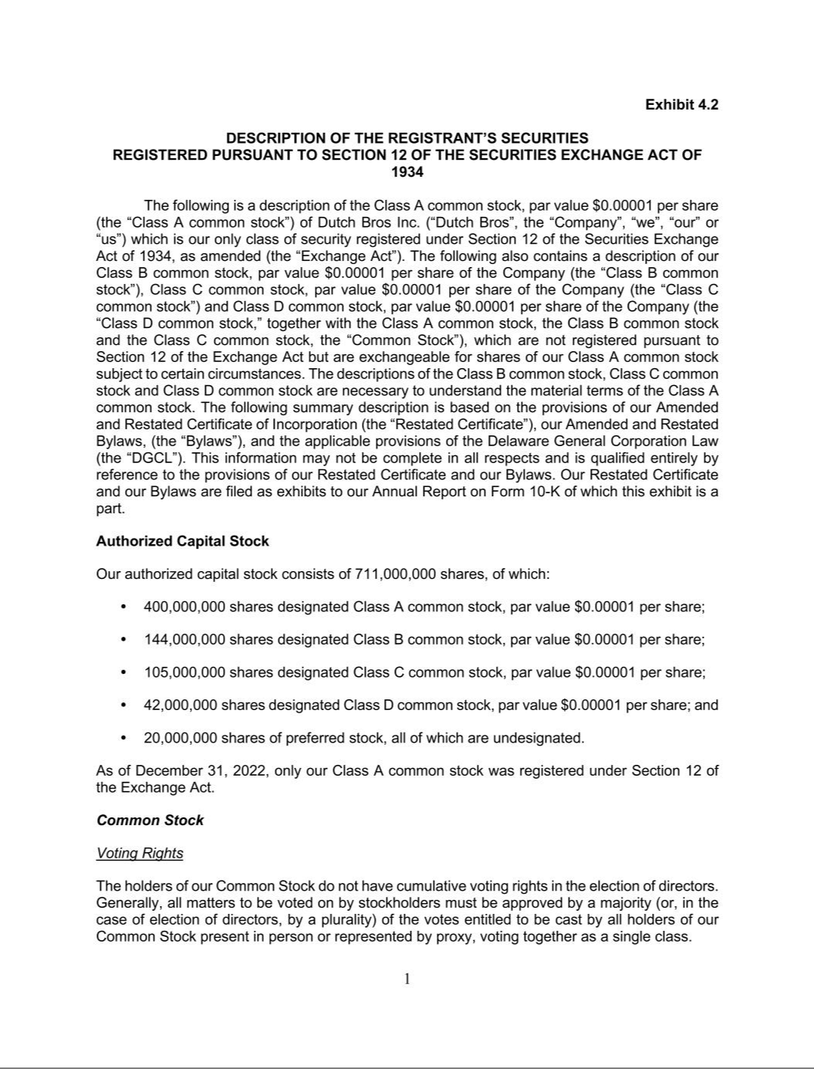

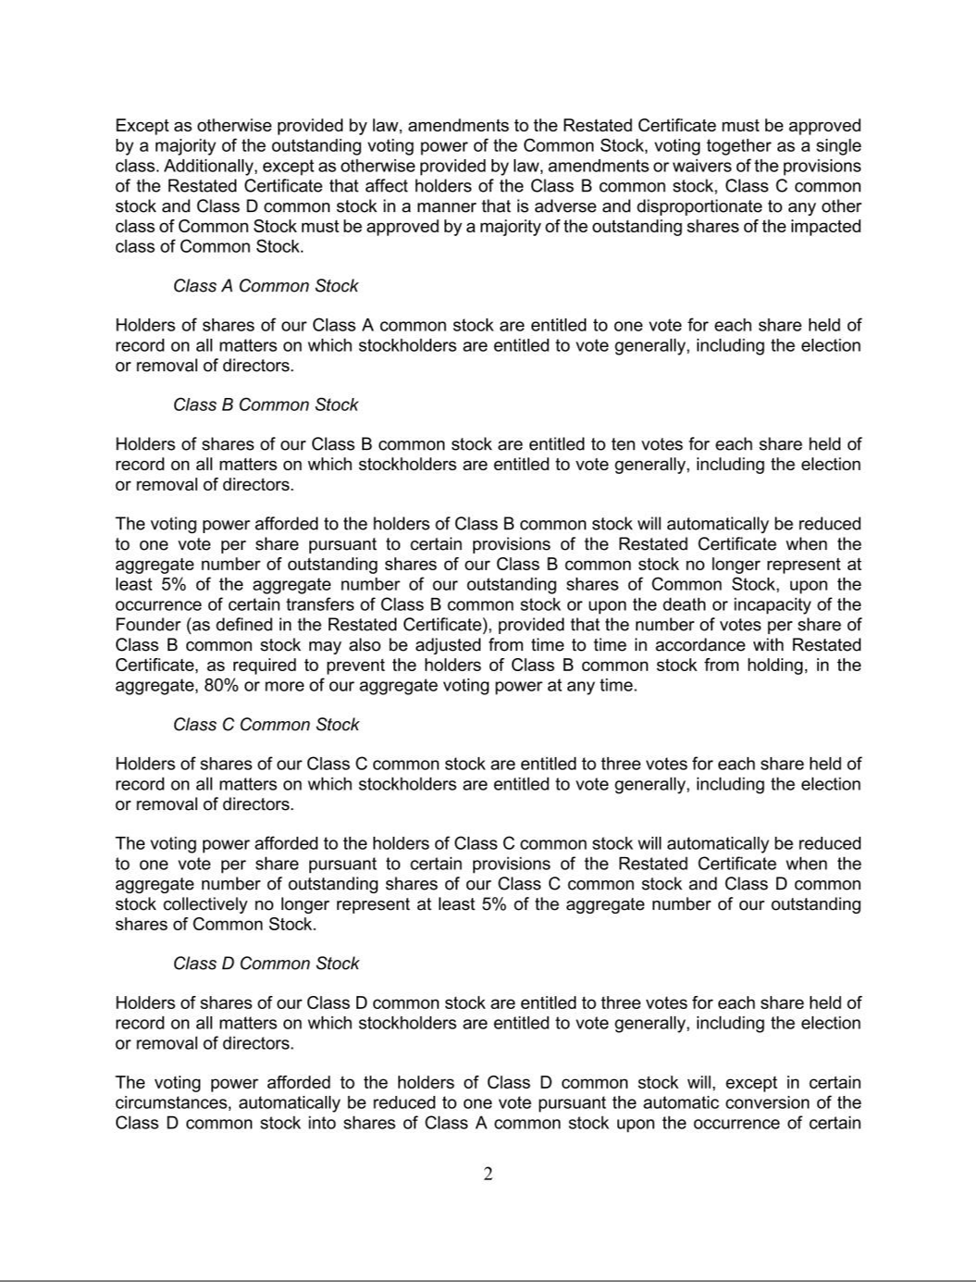

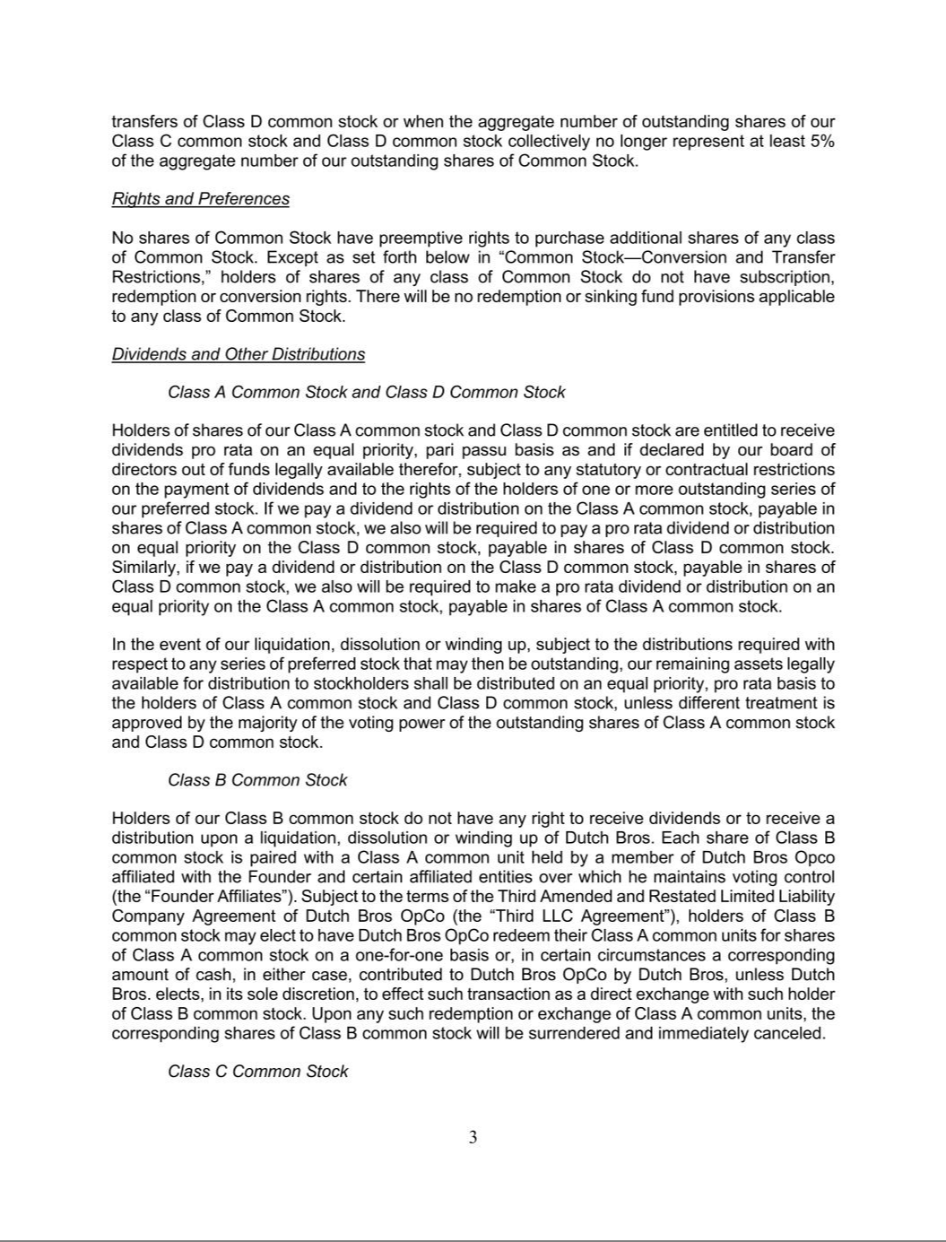

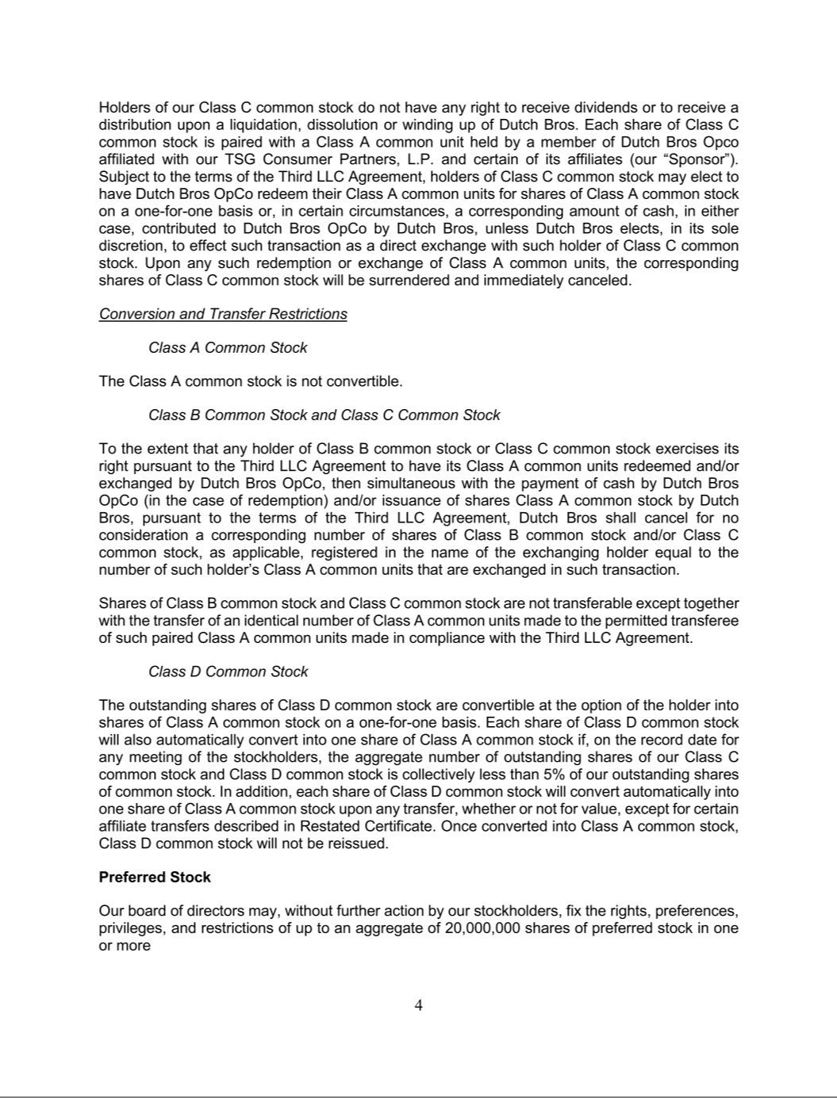

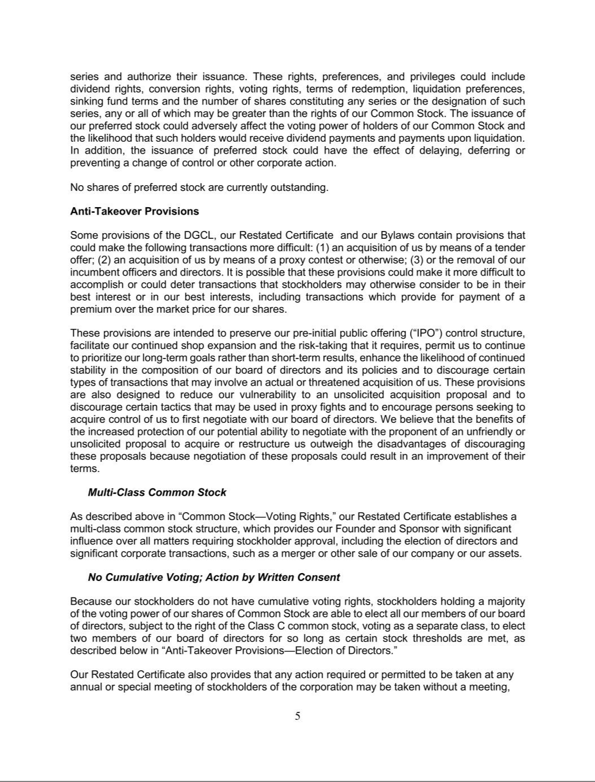

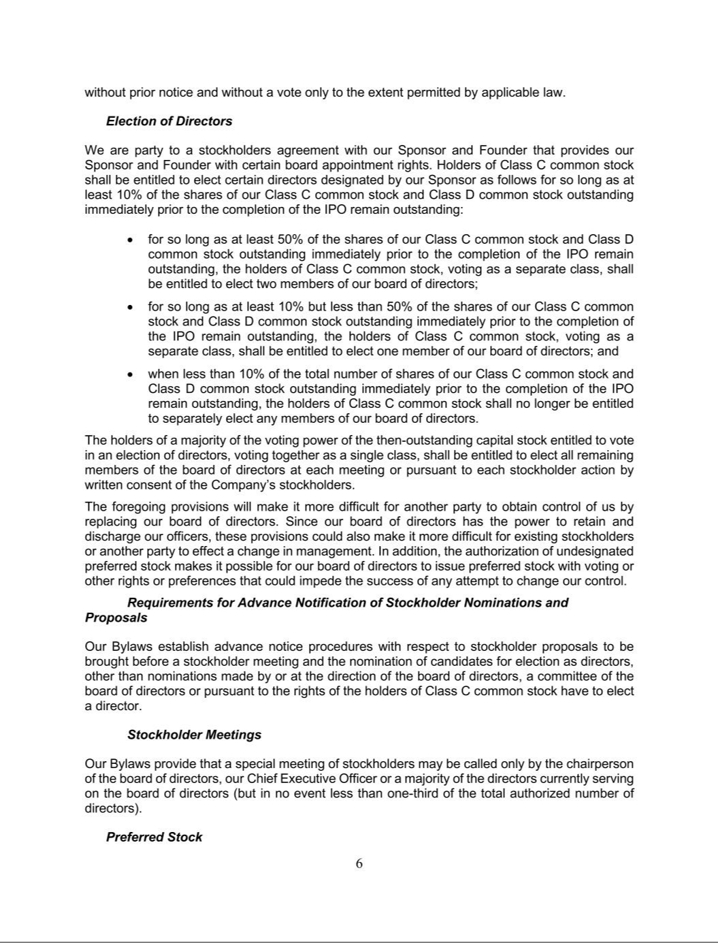

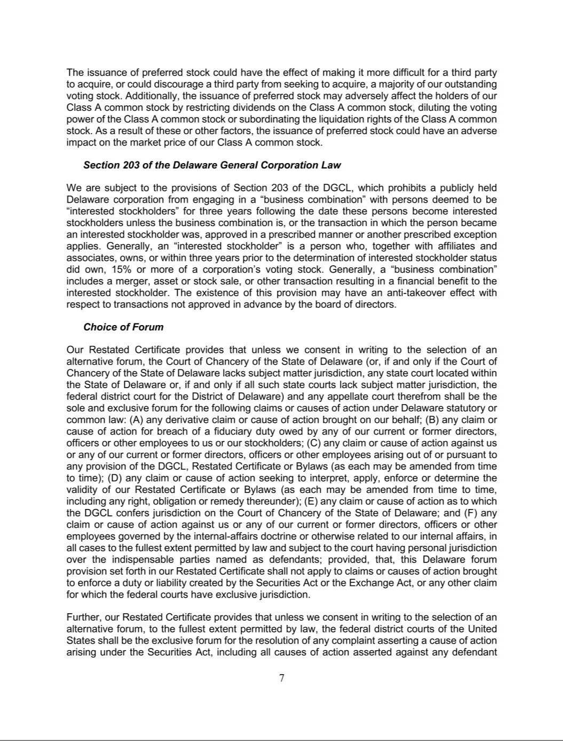

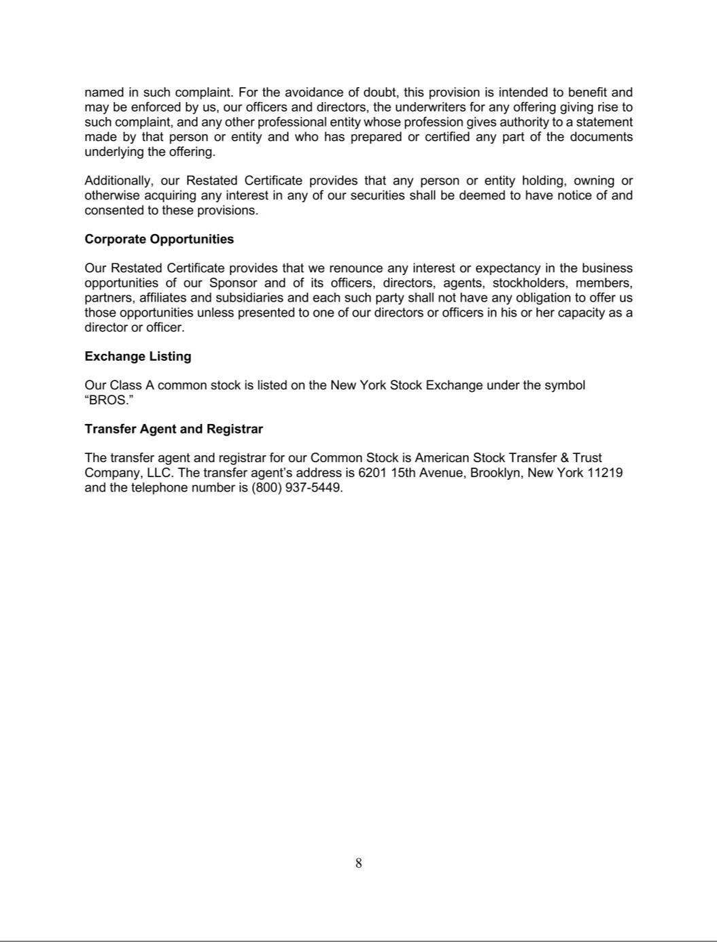

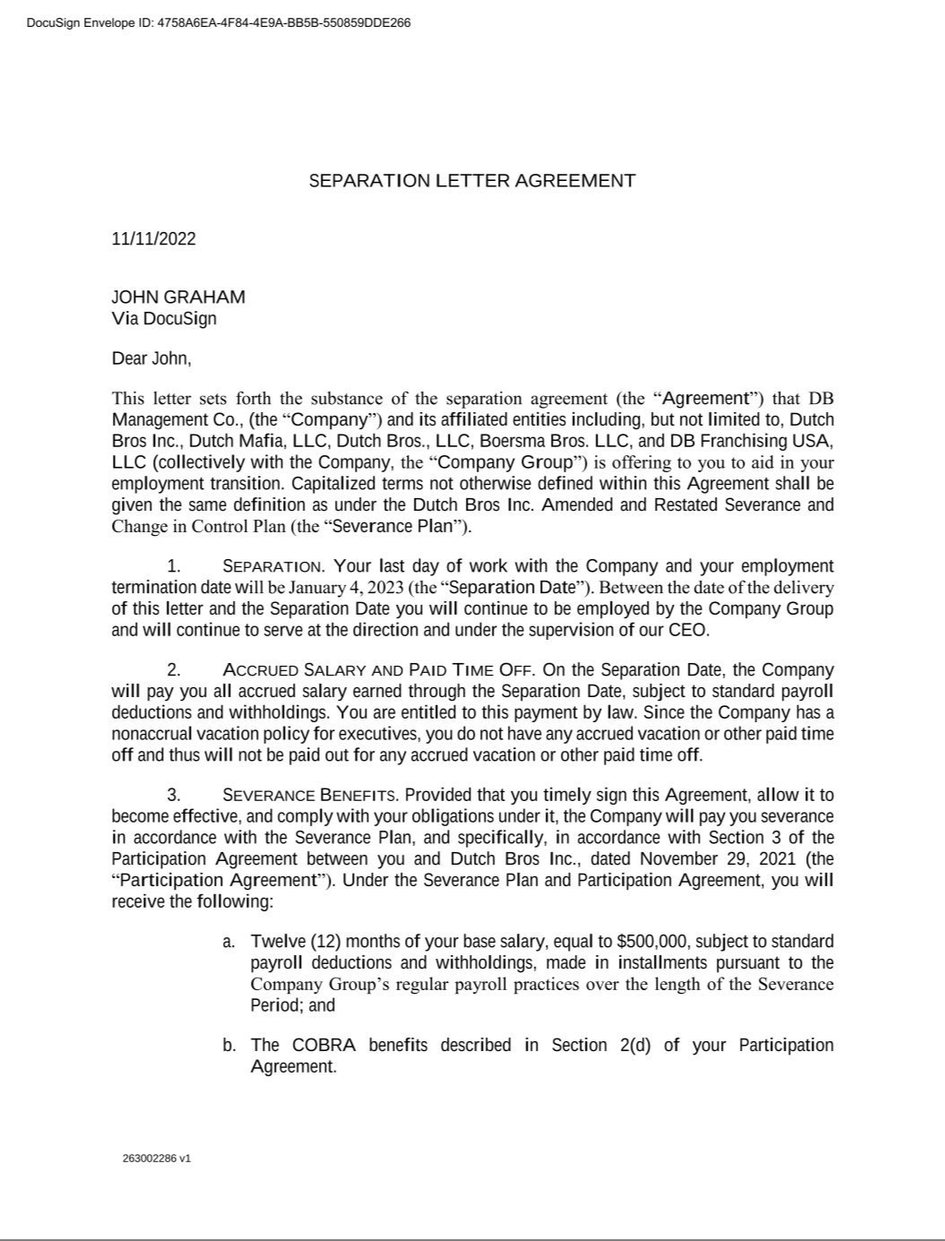

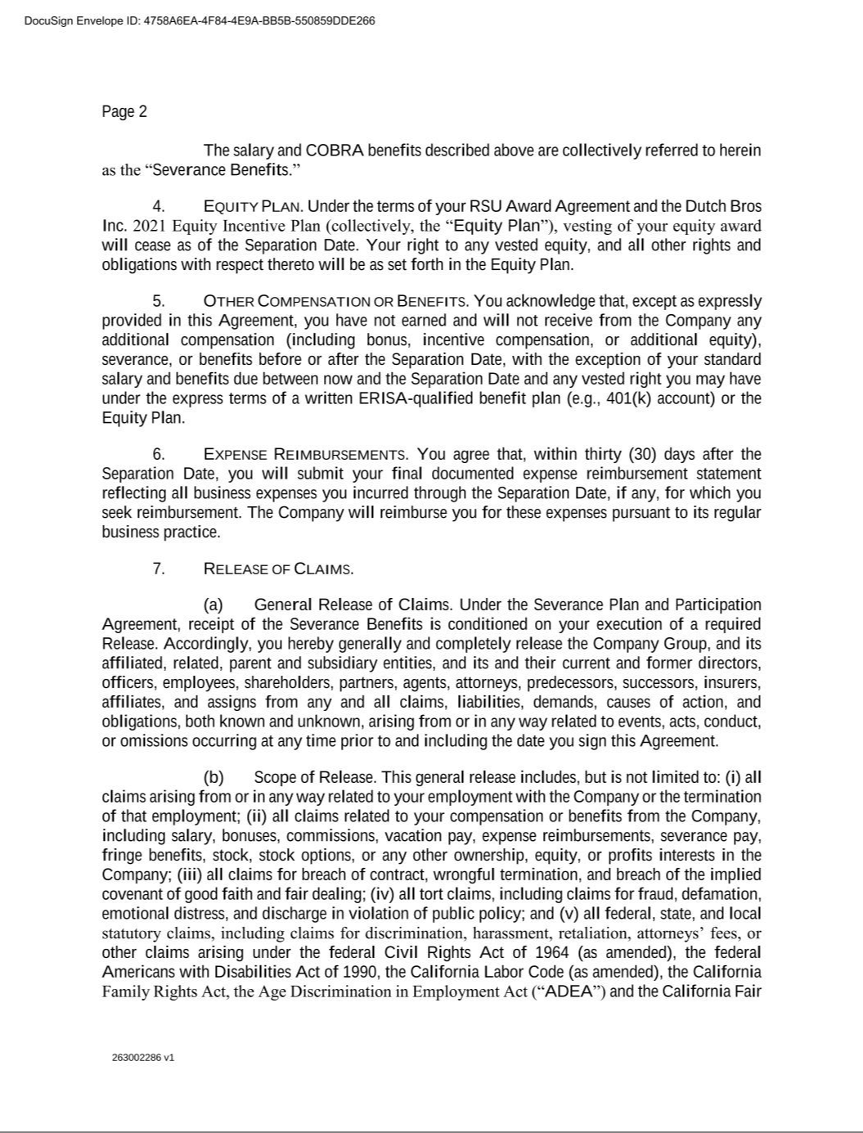

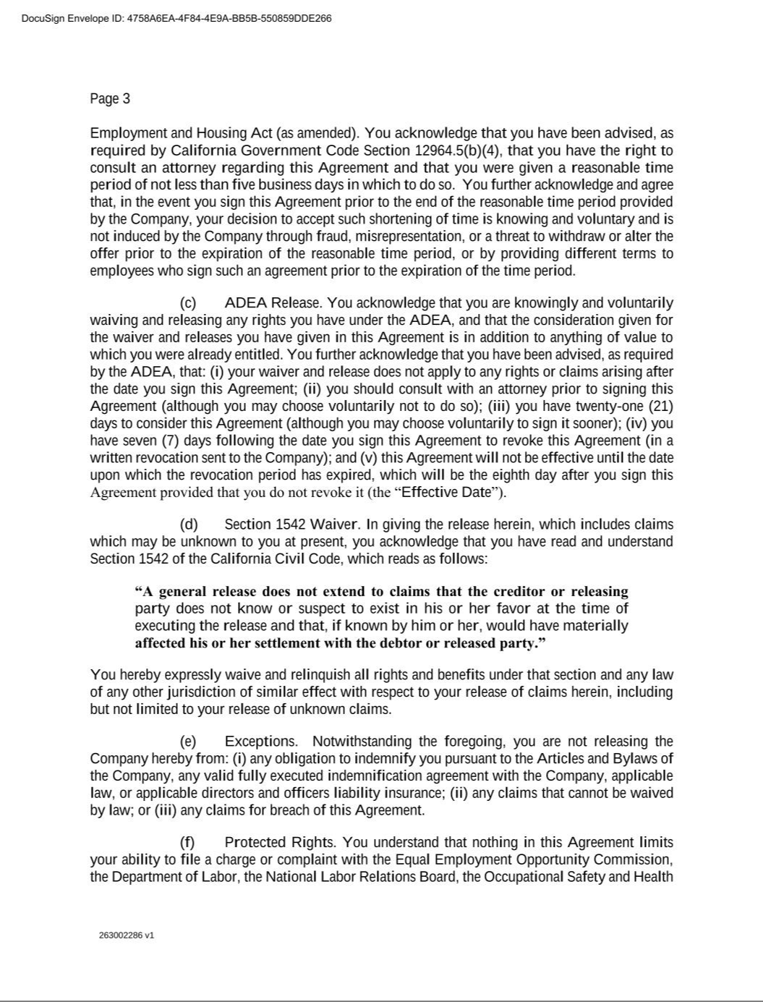

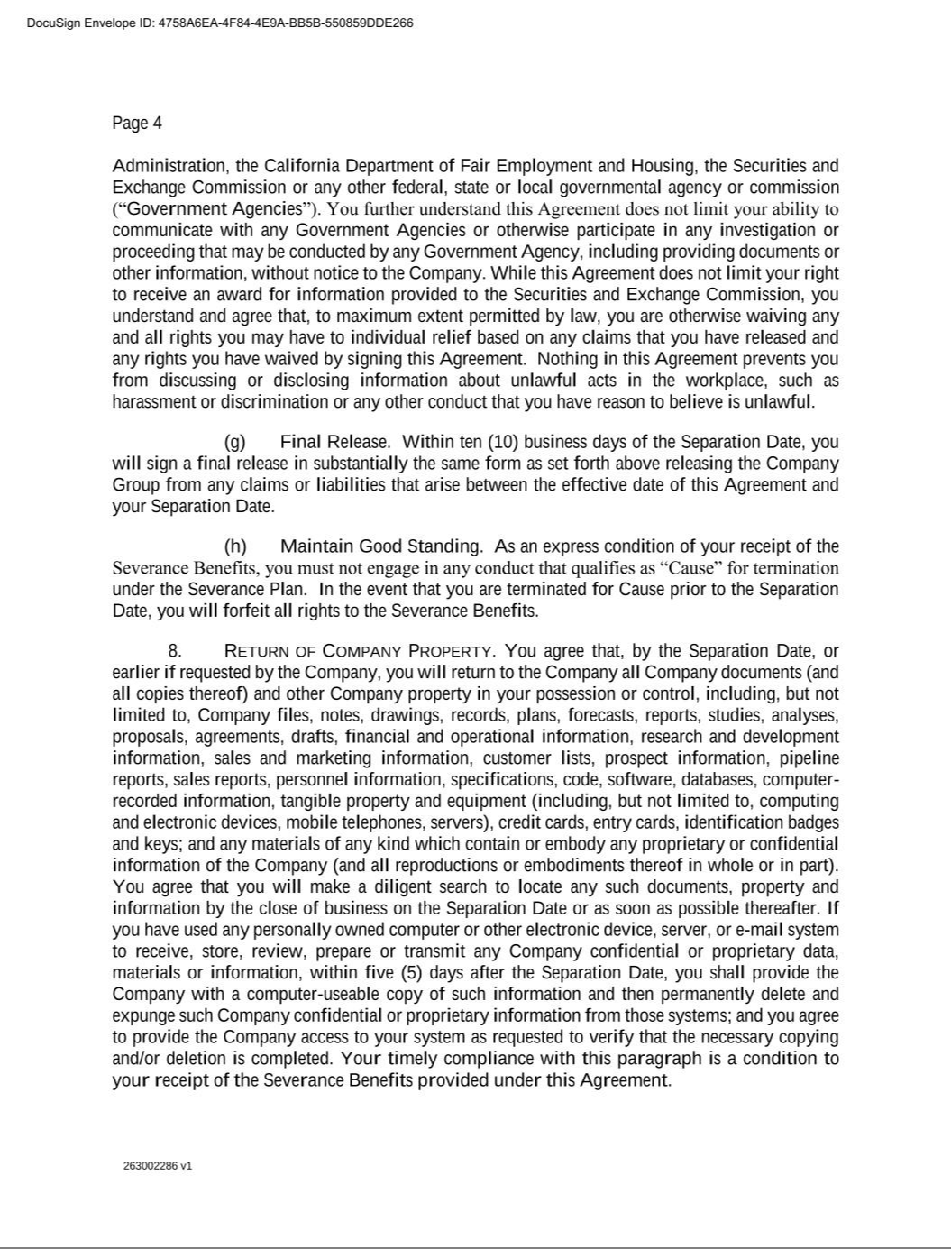

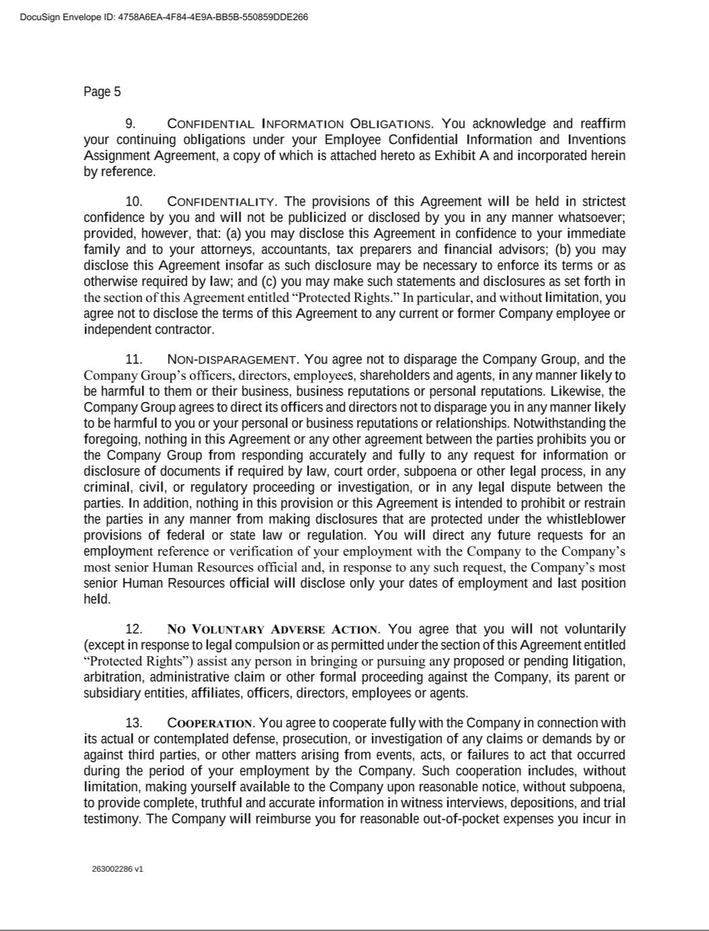

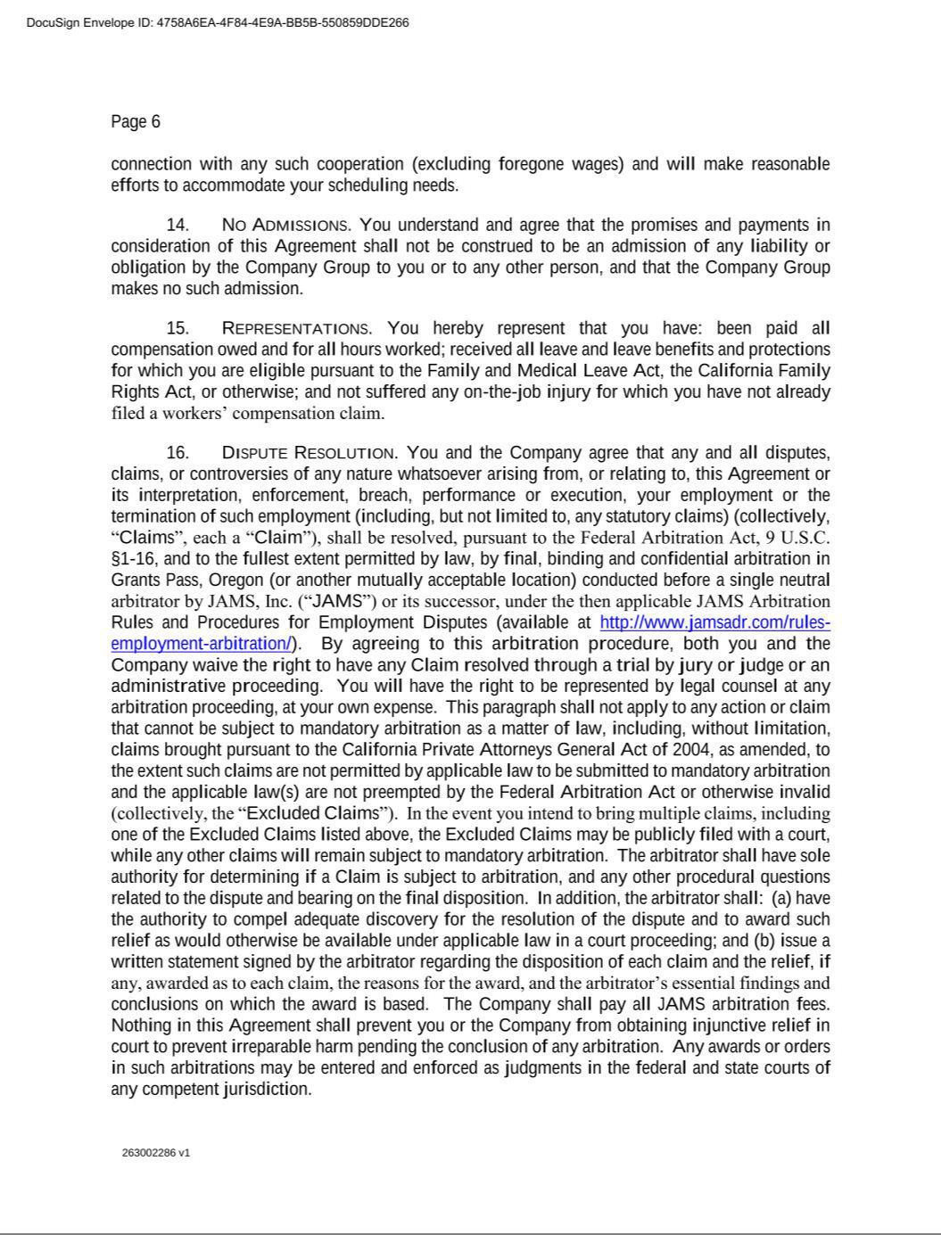

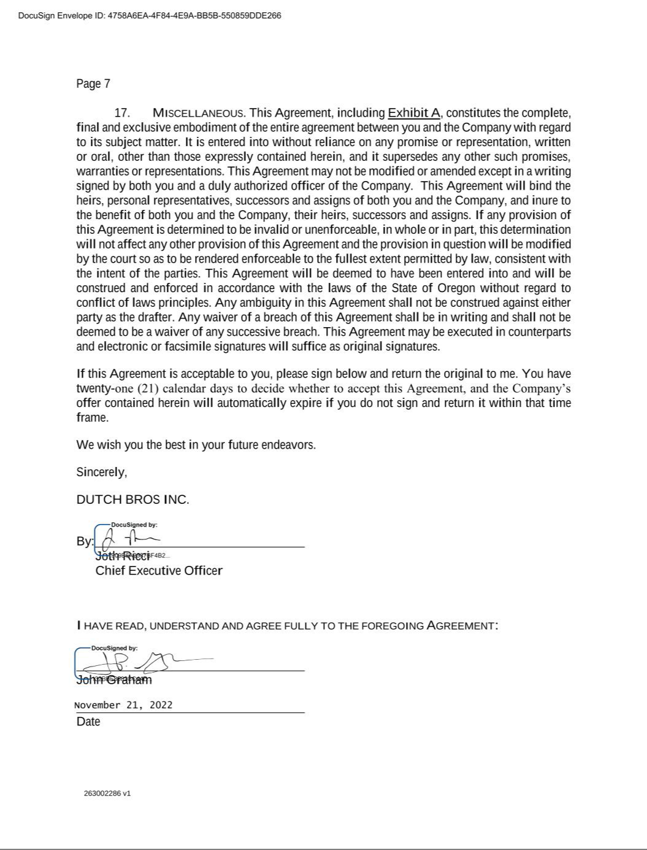



Exhibit 21.1

 | Subsidiaries of Dutch Bros Inc.
 | As of December 31, 2022
Name of Subsidiary |  |  | Jurisdiction of Incorporation or Organization
Dutch Mafia, LLC |  |  | Delaware
Boersma Bros. LLC |  |  | Oregon
DB Franchising USA, LLC |  |  | Oregon
DB Management Co. |  |  | Delaware
Dutch Bros., LLC |  |  | Oregon
Dutchwear, LLC |  |  | Oregon
BB Holdings AL, LLC |  |  | Oregon
BB Holdings AR, LLC |  |  | Oregon
BB Holdings AZ, LLC |  |  | Oregon
BB Holdings CA, LLC |  |  | Oregon
BB Holdings Colorado, LLC |  |  | Oregon
BB Holdings FL, LLC |  |  | Oregon
BB Holdings ID, LLC |  |  | Oregon
BB Holdings KS, LLC |  |  | Oregon
BB Holdings KY, LLC |  |  | Oregon
BB Holdings MO, LLC |  |  | Oregon
BB Holdings NM, LLC |  |  | Oregon
BB Holdings NV, LLC |  |  | Oregon
BB Holdings OK Group, LLC |  |  | Oregon
BB Holdings OR, LLC |  |  | Oregon
BB Holdings TN, LLC |  |  | Oregon
BB Holdings TX, LLC |  |  | Oregon
BB Holdings UT, LLC |  |  | Oregon
BB Holdings WA, LLC |  |  | Oregon

Dutch Bros Inc.| Exhibit 21.1

Exhibit 23.1

Consent of Independent Registered Public Accounting Firm

We consent to the incorporation by reference in the registration statements (Nos. 333-263493 and 333-259618) on Form S-8 of our reports dated February 27, 2023, with respect to the consolidated financial statements of Dutch Bros Inc. and subsidiaries and the effectiveness of internal control over financial reporting.

/s/ KPMG LLP

Portland, Oregon

February 27, 2023

Dutch Bros Inc.| Exhibit 23.1

Exhibit 31.1

DUTCH BROS INC.

CERTIFICATION OF CHIEF EXECUTIVE OFFICER

PURSUANT TO RULE 13a-14(a) AND RULE 15d-14(a) OF

THE SECURITIES EXCHANGE ACT OF 1934

AS ADOPTED PURSUANT TO SECTION 302 OF

THE SARBANES-OXLEY ACT OF 2002

I, Jonathan Ricci, certify that:

- I have reviewed this Annual Report on Form 10-K for the period ended December 31, 2022 of Dutch Bros Inc.;

- Based on my knowledge, this report does not contain any untrue statement of a material fact or omit to state a material fact necessary to make the statements made, in light of the circumstances under which such statements were made, not misleading with respect to the period covered by this report;

- Based on my knowledge, the financial statements, and other financial information included in this report, fairly present in all material respects the financial condition, results of operations and cash flows of the registrant as of, and for, the periods presented in this report;

- The registrant’s other certifying officer and I are responsible for establishing and maintaining disclosure controls and procedures (as defined in Exchange Act Rules 13a-15(e) and 15d-15(e)) and internal control over financial reporting (as defined in Exchange Act Rules 13a-15(f) and 15d-15(f)) for the registrant and have:

  - Designed such disclosure controls and procedures, or caused such disclosure controls and procedures to be designed under our supervision, to ensure that material information relating to the registrant, including its consolidated subsidiaries, is made known to us by others within those entities, particularly during the period in which this report is being prepared;

  - Designed such internal control over financial reporting, or caused such internal control over financial reporting to be designed under our supervision, to provide reasonable assurance regarding the reliability of financial reporting and the preparation of financial statements for external purposes in accordance with generally accepted accounting principles;

  - Evaluated the effectiveness of the registrant’s disclosure controls and procedures and presented in this report our conclusions about the effectiveness of the disclosure controls and procedures, as of the end of the period covered by this report based on such evaluation; and

  - Disclosed in this report any change in the registrant’s internal control over financial reporting that occurred during the registrant’s most recent fiscal quarter (the registrant's fourth fiscal quarter in the case of an annual report) that has materially affected, or is reasonably likely to materially affect, the registrant’s internal control over financial reporting; and

- The registrant’s other certifying officer and I have disclosed, based on our most recent evaluation of internal control over financial reporting, to the registrant’s auditors and the audit committee of the registrant’s board of directors (or persons performing the equivalent functions):

  - All significant deficiencies and material weaknesses in the design or operation of internal control over financial reporting which are reasonably likely to adversely affect the registrant’s ability to record, process, summarize and report financial information; and

  - Any fraud, whether or not material, that involves management or other employees who have a significant role in the registrant’s internal control over financial reporting.

February 27, 2023 |  | /s/ Jonathan Ricci
Date |  | Jonathan Ricci
 |  | Chief Executive Officer
 |  | (Principal Executive Officer)
 |  | Dutch Bros Inc.| Exhibit 31.1

Exhibit 31.2

DUTCH BROS INC.

CERTIFICATION OF CHIEF FINANCIAL OFFICER

PURSUANT TO RULE 13a-14(a) AND RULE 15d-14(a) OF

THE SECURITIES EXCHANGE ACT OF 1934

AS ADOPTED PURSUANT TO SECTION 302 OF

THE SARBANES-OXLEY ACT OF 2002

I, Charles L. Jemley, certify that:

- I have reviewed this Annual Report on Form 10-K for the period ended December 31, 2022 of Dutch Bros Inc.;

- Based on my knowledge, this report does not contain any untrue statement of a material fact or omit to state a material fact necessary to make the statements made, in light of the circumstances under which such statements were made, not misleading with respect to the period covered by this report;

- Based on my knowledge, the financial statements, and other financial information included in this report, fairly present in all material respects the financial condition, results of operations and cash flows of the registrant as of, and for, the periods presented in this report;

- The registrant’s other certifying officer and I are responsible for establishing and maintaining disclosure controls and procedures (as defined in Exchange Act Rules 13a-15(e) and 15d-15(e)) and internal control over financial reporting (as defined in Exchange Act Rules 13a-15(f) and 15d-15(f)) for the registrant and have:

  - Designed such disclosure controls and procedures, or caused such disclosure controls and procedures to be designed under our supervision, to ensure that material information relating to the registrant, including its consolidated subsidiaries, is made known to us by others within those entities, particularly during the period in which this report is being prepared;

  - Designed such internal control over financial reporting, or caused such internal control over financial reporting to be designed under our supervision, to provide reasonable assurance regarding the reliability of financial reporting and the preparation of financial statements for external purposes in accordance with generally accepted accounting principles;

  - Evaluated the effectiveness of the registrant’s disclosure controls and procedures and presented in this report our conclusions about the effectiveness of the disclosure controls and procedures, as of the end of the period covered by this report based on such evaluation; and

  - Disclosed in this report any change in the registrant’s internal control over financial reporting that occurred during the registrant’s most recent fiscal quarter (the registrant's fourth fiscal quarter in the case of an annual report) that has materially affected, or is reasonably likely to materially affect, the registrant’s internal control over financial reporting; and

- The registrant’s other certifying officer and I have disclosed, based on our most recent evaluation of internal control over financial reporting, to the registrant’s auditors and the audit committee of the registrant’s board of directors (or persons performing the equivalent functions):

  - All significant deficiencies and material weaknesses in the design or operation of internal control over financial reporting which are reasonably likely to adversely affect the registrant’s ability to record, process, summarize and report financial information; and

  - Any fraud, whether or not material, that involves management or other employees who have a significant role in the registrant’s internal control over financial reporting.

February 27, 2023 |  | /s/ Charles L. Jemley
Date |  | Charles L. Jemley
 |  | Chief Financial Officer
 |  | (Principal Financial and Accounting Officer)
 |  | Dutch Bros Inc.| Exhibit 31.2

Exhibit 32.1

DUTCH BROS INC.

CERTIFICATIONS OF

CHIEF EXECUTIVE OFFICER AND CHIEF FINANCIAL OFFICER

PURSUANT TO 18 U.S.C. SECTION 1350

AS ADOPTED PURSUANT TO SECTION 906 OF

THE SARBANES-OXLEY ACT OF 2002

In connection with the Annual Report of Dutch Bros Inc. (the Company) on Form 10-K for the period ended December 31, 2022, as filed with the Securities and Exchange Commission on the date of the signatures below (the Report), Jonathan Ricci, Chief Executive Officer of the Company, and Charles L. Jemley, Chief Financial Officer of the Company, each hereby certifies, pursuant to 18 U.S.C. Section 1350, as adopted pursuant to Section 906 of the Sarbanes-Oxley Act of 2002, that, to the best of their respective knowledge:

- the Report fully complies with the requirements of Section 13(a) or Section 15(d) of the Securities Exchange Act of 1934; and

- the information contained in the Report fairly presents, in all material respects, the financial condition and results of operations of the Company.

February 27, 2023 |  | /s/ Jonathan Ricci
Date |  | Jonathan Ricci
 |  | Chief Executive Officer
 |  | (Principal Executive Officer)

February 27, 2023 |  | /s/ Charles L. Jemley
Date |  | Charles L. Jemley
 |  | Chief Financial Officer
 |  | (Principal Financial and Accounting Officer)

This certification accompanies the Report to which it relates, is not deemed filed with the Securities and Exchange Commission and is not to be incorporated by reference into any filing of Dutch Bros Inc. under the Securities Act of 1933, as amended, or the Securities Exchange Act of 1934, as amended (whether made before or after the date of the Report), irrespective of any general incorporation language contained in such filing.

Dutch Bros Inc.| Exhibit 32.1

