UNITED STATES
SECURITIES AND EXCHANGE COMMISSION
Washington, D.C. 20549
______________________________
FORM 10-Q
______________________________
(Mark One)
☒ |  |  | QUARTERLY REPORT PURSUANT TO SECTION 13 OR 15(d) OF THE SECURITIES EXCHANGE ACT OF 1934
For the Quarterly Period ended September 30, 2025
OR
☐ |  |  | TRANSITION REPORT PURSUANT TO SECTION 13 OR 15(d) OF THE SECURITIES EXCHANGE ACT OF 1934
For the transition period from ________ to ________
Commission file number 001-40798
______________________________
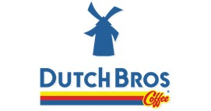
DUTCH BROS INC.
(Exact name of Registrant as specified in its charter)
______________________________
Delaware |  |  |  |  |  |  |  |  |  |  |  | 87-1041305
(State or other jurisdiction of  incorporation or organization) |  |  |  |  |  |  |  |  |  |  |  | (I.R.S. Employer Identification No.)
1930 W. Rio Salado Pkwy
 |  |  | Tempe, |  |  | Arizona |  |  |  |  |  | 85281
(Address of Principal Executive Offices) |  |  |  |  |  |  |  |  |  |  |  | (Zip Code)
(877) 899-2767
(Registrant's telephone number, including area code)
______________________________

Securities registered pursuant to Section 12(b) of the Act:
Title of Each Class |  |  | Trading Symbol |  |  | Name of Exchange on which Registered
Class A Common Stock,  par value $0.00001 per share |  |  | BROS |  |  | The New York Stock Exchange

Indicate by check mark whether the registrant: (1) has filed all reports required to be filed by Section 13 or 15(d) of the Securities Exchange Act of 1934 during the preceding 12 months (or for such shorter period that the registrant was required to file such reports); and (2) has been subject to such filing requirements for the past 90 days. Yes x No o
Indicate by check mark whether the registrant has submitted electronically every Interactive Data File required to be submitted pursuant to Rule 405 of Regulation S-T (§232.405 of this chapter) during the preceding 12 months (or for such shorter period that the registrant was required to submit such files). Yes x No o
Indicate by check mark whether the registrant is a large accelerated filer, an accelerated filer, a non-accelerated filer, a smaller reporting company, or an emerging growth company. See the definitions of “large accelerated filer,” “accelerated filer,” “smaller reporting company,” and “emerging growth company” in Rule 12b-2 of the Exchange Act.
Large accelerated filer |  |  | x |  |  |  |  |  | Accelerated filer |  |  | o
Non-accelerated filer |  |  | o |  |  |  |  |  | Smaller reporting company |  |  | o
 |  |  |  |  |  |  |  |  | Emerging growth company |  |  | o
If an emerging growth company, indicate by check mark if the registrant has elected not to use the extended transition period for complying with any new or revised financial accounting standards provided pursuant to Section 13(a) of the Exchange Act. o
Indicate by check mark whether the registrant is a shell company (as defined in Rule 12b-2 of the Act). Yes o No x
As of October 31, 2025, the registrant’s outstanding shares of common stock were as follows:

Class A common stock |  |  | 127,031,344
Class B common stock |  |  | 35,210,946
Class C common stock |  |  | 2,279,846

DUTCH BROS INC.
QUARTERLY REPORT ON FORM 10-Q
TABLE OF CONTENTS
 |  |  |  |  |  | Page
Glossary |  |  |  |  |  | 1
Forward-Looking Statements |  |  |  |  |  | 2
PART I |  |  | FINANCIAL INFORMATION |  |  | 3
ITEM 1. |  |  | Financial Statements (Unaudited) |  |  | 3
 |  |  | Condensed Consolidated Balance Sheets |  |  | 3
 |  |  | Condensed Consolidated Statements of Operations |  |  | 5
 |  |  | Condensed Consolidated Statements of Comprehensive Income |  |  | 6
 |  |  | Condensed Consolidated Statements of Stockholders’ Equity |  |  | 7
 |  |  | Condensed Consolidated Statements of Cash Flows |  |  | 11
 |  |  | Notes to Condensed Consolidated Financial Statements |  |  | 13
ITEM 2. |  |  | Management’s Discussion and Analysis of Financial Condition and  Results of Operations |  |  | 33
ITEM 3. |  |  | Quantitative and Qualitative Disclosures About Market Risk |  |  | 49
ITEM 4. |  |  | Controls and Procedures |  |  | 50
PART II |  |  | OTHER INFORMATION |  |  | 51
ITEM 1. |  |  | Legal Proceedings |  |  | 51
ITEM 1A. |  |  | Risk Factors |  |  | 51
ITEM 2. |  |  | Unregistered Sales of Equity Securities and Use of Proceeds |  |  | 53
ITEM 3. |  |  | Defaults Upon Senior Securities |  |  | 54
ITEM 4. |  |  | Mine Safety Disclosure |  |  | 54
ITEM 5. |  |  | Other Information |  |  | 54
ITEM 6. |  |  | Exhibits |  |  | 55
SIGNATURES |  |  |  |  |  | 56

GLOSSARY
As used in this Quarterly Report on Form 10-Q (this Form 10-Q), the terms identified below have the meanings specified below unless otherwise noted or the context requires otherwise. References in this Form 10-Q to “Dutch Bros,” the “Company,” “we,” “us” and “our” refer to Dutch Bros Inc. and its consolidated subsidiaries unless the context indicates otherwise.
Term |  |  |  |  |  | Definition
2022 Credit Facility |  |  |  |  |  | Has the meaning set forth in NOTE 9 — Debt to the condensed consolidated financial statements, included elsewhere in this Form 10-Q
2025 Credit Facility |  |  |  |  |  | Has the meaning set forth in NOTE 9 — Debt to the condensed consolidated financial statements, included elsewhere in this Form 10-Q
AOCI |  |  |  |  |  | Accumulated Other Comprehensive Income
ASU |  |  |  |  |  | Accounting Standards Update
AUV |  |  |  |  |  | Average Unit Volume
BPS or bps |  |  |  |  |  | Basis points, which is used to express differences in rates. One basis point is the equivalent of 1/100 of one percent
CEO |  |  |  |  |  | Chief Executive Officer
CODM |  |  |  |  |  | Chief Operating Decision Maker
Co-Founder |  |  |  |  |  | Travis Boersma, our Executive Chairman and Co-Founder, and affiliated entities over which he maintains voting control
Continuing Members |  |  |  |  |  | The Co-Founder and the Sponsor
Dutch Bros OpCo |  |  |  |  |  | Dutch Mafia, LLC, a Delaware limited liability company and direct subsidiary of Dutch Bros Inc.
Dutch Bros Inc. |  |  |  |  |  | A Delaware corporation, the Class A common stock of which is publicly traded on the New York Stock Exchange under the symbol “BROS”
EBITDAR |  |  |  |  |  | Earnings before interest, taxes, depreciation, amortization, and rent costs
FASB |  |  |  |  |  | Financial Accounting Standards Board
GAAP |  |  |  |  |  | U.S. Generally Accepted Accounting Principles
IPO |  |  |  |  |  | Initial Public Offering
N/A |  |  |  |  |  | Not applicable
N/M |  |  |  |  |  | Not meaningful
OpCo LLC Agreement |  |  |  |  |  | The Fifth Amended and Restated Limited Liability Company Agreement of Dutch Bros OpCo
OpCo Units |  |  |  |  |  | Class A common units, Class B voting units and Class C voting units of Dutch Bros OpCo, each as further defined in the OpCo LLC Agreement, collectively
PSU |  |  |  |  |  | Performance-Based Stock Units
RSA |  |  |  |  |  | Restricted Stock Awards
RSU |  |  |  |  |  | Restricted Stock Units
Same Shop Sales |  |  |  |  |  | The estimated percentage change in year-over-year sales, for the comparable shop base, which we define as shops open for 15 complete months or longer as of the first day of the reporting period
SEC |  |  |  |  |  | Securities and Exchange Commission
SOFR |  |  |  |  |  | Secured Overnight Financing Rate
Sponsor |  |  |  |  |  | TSG Consumer Partners, L.P. and certain of its affiliates
Tax Receivable Agreements (TRAs) |  |  |  |  |  | The Tax Receivable Agreement (Exchanges) that Dutch Bros Inc. entered into with the Continuing Members and the Tax Receivable Agreement (Reorganization) that Dutch Bros Inc. entered into with TSG7 A AIV VI Holdings-A, L.P. and DG Coinvestor Blocker Aggregator, L.P. or their assignees or successors, in connection with the IPO
Dutch Bros, our Windmill logo (), Dutch Bros Blue Rebel, and our other registered and common law trade names, trademarks and service marks are the property of Dutch Bros Inc. All other trademarks, trade names, and service marks appearing in this Form 10-Q are the property of their respective owners. Solely for convenience, the trademarks and trade names in this Form 10-Q may be referred to without the ® and ™ symbols, but such references should not be construed as any indicator that their respective owners will not assert their rights thereto.

Dutch Bros Inc.| Form 10-Q | 1
Table of Contents
Forward-Looking Statements
Certain statements in this Form 10-Q, including those in the section titled “Management’s Discussion and Analysis,” that are not historical facts, including those regarding the impact of inflation, increased minimum wages, interest rate risk, and general macroeconomic conditions on our results of operations, supply chain, or liquidity, the potential impact of actions we have taken to mitigate the impact of unforeseen circumstances, taxes and tax rates, our expectations regarding the number of new shops we may open, anticipated future revenues and earnings, consumer demand, and our expectations to generate positive cash flow in the foreseeable future are forward-looking statements as defined in the Private Securities Litigation Reform Act of 1995. We use words such as “anticipate,” “believe,” “could,” “estimate,” “expect,” “intend,” “may,” “predict,” “project,” “should,” “target,” and similar terms and phrases, including references to assumptions, to identify forward-looking statements. In addition, statements that “we believe” and similar statements reflect our beliefs and opinions on the relevant subject. While we believe that information provides a reasonable basis for these statements, that information may be limited or incomplete, and our statements should not be read to indicate that we have conducted an exhaustive inquiry into, or review of, all relevant information. These forward-looking statements are based on information available to us as of the date of this Form 10-Q, and we assume no obligation to update these forward-looking statements. These statements are subject to risks and uncertainties that could cause actual results to differ materially from those described in the statements. You should not place undue reliance on forward-looking statements, which speak only as of the date of this Form 10-Q.
You should read the following unaudited condensed consolidated financial statements and the related notes in this Form 10-Q together with our analysis and discussion of our financial condition and results of operations and other financial information included elsewhere in this Form 10-Q. You should also read our Annual Report on Form 10-K for the year ended December 31, 2024, filed with the SEC on February 13, 2025 (2024 Form 10-K).
While we believe that our assumptions are reasonable, we caution that it is very difficult to predict the impact of known factors, and it is impossible for us to anticipate all factors that could affect actual results. You should evaluate all forward-looking statements made in this report in the context of the factors that could cause outcomes to differ materially from expectations. These factors include, but are not limited to, those listed under the “Risk Factors” section of this Form 10-Q, and in our 2024 Form 10-K, as such risk factors may be amended, supplemented or superseded from time to time by other reports we file with the SEC.
Website Disclosure
We use our website as a distribution channel of material company information. Financial and other important information regarding our company is routinely posted on and accessible through our website at https://investors.dutchbros.com. In addition, you may automatically receive email alerts and other information about our company when you subscribe your email address by visiting the “Investor Email Alerts” section of our investor relations page at https://investors.dutchbros.com/resources. The information on our website is not incorporated herein or otherwise a part of this Form 10-Q.

Dutch Bros Inc.| Form 10-Q | 2

Table of Contents
PART I. FINANCIAL INFORMATION

ITEM 1. FINANCIAL STATEMENTS

DUTCH BROS INC.
Condensed Consolidated Balance Sheets
(in thousands, except per share amounts; unaudited) |  |  |  |  |  | September 30,  2025 |  |  |  |  |  | December 31,  2024
Assets
Current assets:
Cash and cash equivalents |  |  |  |  |  | $ | 267,195 |  |  |  |  | $ | 293,354
Accounts receivable, net |  |  |  |  |  | 14,303 |  |  |  |  |  | 10,598
Inventories, net |  |  |  |  |  | 45,295 |  |  |  |  |  | 36,488
Prepaid expenses and other current assets |  |  |  |  |  | 14,345 |  |  |  |  |  | 17,501
Total current assets |  |  |  |  |  | 341,138 |  |  |  |  |  | 357,941
Property and equipment, net |  |  |  |  |  | 789,333 |  |  |  |  |  | 683,971
Finance lease right-of-use assets, net |  |  |  |  |  | 393,406 |  |  |  |  |  | 374,623
Operating lease right-of-use assets, net |  |  |  |  |  | 415,021 |  |  |  |  |  | 315,256
Intangibles, net |  |  |  |  |  | 1,762 |  |  |  |  |  | 2,947
Goodwill |  |  |  |  |  | 21,629 |  |  |  |  |  | 21,629
Deferred income tax assets, net |  |  |  |  |  | 949,663 |  |  |  |  |  | 742,126
Other long-term assets |  |  |  |  |  | 10,045 |  |  |  |  |  | 2,592
Total assets |  |  |  |  |  | $ | 2,921,997 |  |  |  |  | $ | 2,501,085
Liabilities and Equity
Current liabilities:
Accounts payable |  |  |  |  |  | $ | 38,242 |  |  |  |  | $ | 32,225
Accrued compensation and benefits |  |  |  |  |  | 49,256 |  |  |  |  |  | 49,778
Other accrued liabilities |  |  |  |  |  | 39,946 |  |  |  |  |  | 26,516
Other current liabilities |  |  |  |  |  | 14,421 |  |  |  |  |  | 7,067
Deferred revenue |  |  |  |  |  | 45,606 |  |  |  |  |  | 42,868
Current portion of tax receivable agreements liability |  |  |  |  |  | 514 |  |  |  |  |  | 71
Current portion of finance lease liabilities |  |  |  |  |  | 15,364 |  |  |  |  |  | 13,256
Current portion of operating lease liabilities |  |  |  |  |  | 17,228 |  |  |  |  |  | 13,979
Current portion of long-term debt |  |  |  |  |  | 3,879 |  |  |  |  |  | 17,311
Total current liabilities |  |  |  |  |  | 224,456 |  |  |  |  |  | 203,071
Deferred revenue, net of current portion |  |  |  |  |  | 7,104 |  |  |  |  |  | 8,015
Finance lease liabilities, net of current portion |  |  |  |  |  | 390,707 |  |  |  |  |  | 369,297
Operating lease liabilities, net of current portion |  |  |  |  |  | 413,402 |  |  |  |  |  | 309,311
Long-term debt, net of current portion |  |  |  |  |  | 195,997 |  |  |  |  |  | 219,755
Tax receivable agreements liability, net of current portion |  |  |  |  |  | 825,302 |  |  |  |  |  | 627,763
Other long-term liabilities |  |  |  |  |  | — |  |  |  |  |  | 8
Total liabilities |  |  |  |  |  | 2,056,968 |  |  |  |  |  | 1,737,220
Commitments and contingencies (Note 15)

Dutch Bros Inc.| Form 10-Q | 3

Table of Contents
DUTCH BROS INC.
Condensed Consolidated Balance Sheets (continued)
(in thousands, except per share amounts; unaudited) |  |  |  |  |  | September 30,  2025 |  |  |  |  |  | December 31,  2024
Preferred stock, $0.00001 par value per share - 20,000 shares authorized; zero shares issued and outstanding as of September 30, 2025 and December 31, 2024, respectively |  |  |  |  |  | — |  |  |  |  |  | —
Class A common stock, $0.00001 par value per share - 400,000 shares authorized; 127,031 and 115,432 shares issued and outstanding as of September 30, 2025 and December 31, 2024, respectively |  |  |  |  |  | 1 |  |  |  |  |  | 1
Class B common stock, $0.00001 par value per share - 144,000 shares authorized; 35,211 and 35,227 shares issued and outstanding as of September 30, 2025 and December 31, 2024, respectively |  |  |  |  |  | — |  |  |  |  |  | —
Class C common stock, $0.00001 par value per share - 105,000 shares authorized; 2,280 and 3,545 shares issued and outstanding as of September 30, 2025 and December 31, 2024, respectively |  |  |  |  |  | — |  |  |  |  |  | —
Additional paid-in capital |  |  |  |  |  | 578,256 |  |  |  |  |  | 517,074
Accumulated other comprehensive income |  |  |  |  |  | 162 |  |  |  |  |  | 628
Retained earnings |  |  |  |  |  | 78,138 |  |  |  |  |  | 19,666
Total stockholders' equity attributable to Dutch Bros Inc. |  |  |  |  |  | 656,557 |  |  |  |  |  | 537,369
Non-controlling interests |  |  |  |  |  | 208,472 |  |  |  |  |  | 226,496
Total equity |  |  |  |  |  | 865,029 |  |  |  |  |  | 763,865
Total liabilities and equity |  |  |  |  |  | $ | 2,921,997 |  |  |  |  | $ | 2,501,085
See accompanying notes to condensed consolidated financial statements.

Dutch Bros Inc.| Form 10-Q | 4
Table of Contents

DUTCH BROS INC.
Condensed Consolidated Statements of Operations
 |  |  |  |  |  | Three Months Ended September 30, |  |  |  |  |  |  |  |  |  |  |  | Nine Months Ended September 30,
(in thousands, except per share amounts; unaudited) |  |  |  |  |  | 2025 |  |  |  |  |  | 2024 |  |  |  |  |  | 2025 |  |  |  |  |  | 2024
Revenues
Company-operated shops |  |  |  |  |  | $ | 392,833 |  |  |  |  | $ | 308,295 |  |  |  |  | $ | 1,099,754 |  |  |  |  | $ | 851,648
Franchising and other |  |  |  |  |  | 30,751 |  |  |  |  |  | 29,917 |  |  |  |  |  | 94,795 |  |  |  |  |  | 86,581
Total revenues |  |  |  |  |  | 423,584 |  |  |  |  |  | 338,212 |  |  |  |  |  | 1,194,549 |  |  |  |  |  | 938,229
Costs and Expenses
Cost of sales |  |  |  |  |  | 316,805 |  |  |  |  |  | 248,161 |  |  |  |  |  | 877,733 |  |  |  |  |  | 686,048
Selling, general and administrative |  |  |  |  |  | 65,289 |  |  |  |  |  | 57,536 |  |  |  |  |  | 189,595 |  |  |  |  |  | 161,866
Total costs and expenses |  |  |  |  |  | 382,094 |  |  |  |  |  | 305,697 |  |  |  |  |  | 1,067,328 |  |  |  |  |  | 847,914
Income from operations |  |  |  |  |  | 41,490 |  |  |  |  |  | 32,515 |  |  |  |  |  | 127,221 |  |  |  |  |  | 90,315
Other expense
Interest expense, net |  |  |  |  |  | (6,695) |  |  |  |  |  | (6,869) |  |  |  |  |  | (20,886) |  |  |  |  |  | (20,259)
Other income (expense), net |  |  |  |  |  | 149 |  |  |  |  |  | 764 |  |  |  |  |  | (1,852) |  |  |  |  |  | 7,357
Total other expense |  |  |  |  |  | (6,546) |  |  |  |  |  | (6,105) |  |  |  |  |  | (22,738) |  |  |  |  |  | (12,902)
Income before income taxes |  |  |  |  |  | 34,944 |  |  |  |  |  | 26,410 |  |  |  |  |  | 104,483 |  |  |  |  |  | 77,413
Income tax expense |  |  |  |  |  | 7,661 |  |  |  |  |  | 4,698 |  |  |  |  |  | 16,363 |  |  |  |  |  | 17,330
Net income |  |  |  |  |  | $ | 27,283 |  |  |  |  | $ | 21,712 |  |  |  |  | $ | 88,120 |  |  |  |  | $ | 60,083
Less: Net income attributable to non-controlling interests |  |  |  |  |  | 9,788 |  |  |  |  |  | 9,068 |  |  |  |  |  | 29,648 |  |  |  |  |  | 28,437
Net income attributable to Dutch Bros Inc. |  |  |  |  |  | $ | 17,495 |  |  |  |  | $ | 12,644 |  |  |  |  | $ | 58,472 |  |  |  |  | $ | 31,646
Net income per share of Class A and Class D common stock:
Basic |  |  |  |  |  | $ | 0.14 |  |  |  |  | $ | 0.11 |  |  |  |  | $ | 0.47 |  |  |  |  | $ | 0.32
Diluted |  |  |  |  |  | $ | 0.14 |  |  |  |  | $ | 0.11 |  |  |  |  | $ | 0.47 |  |  |  |  | $ | 0.32
Weighted-average shares of Class A and Class D common stock outstanding:
Basic |  |  |  |  |  | 126,986 |  |  |  |  |  | 113,819 |  |  |  |  |  | 124,751 |  |  |  |  |  | 99,756
Diluted |  |  |  |  |  | 127,379 |  |  |  |  |  | 114,252 |  |  |  |  |  | 125,204 |  |  |  |  |  | 100,070
See accompanying notes to condensed consolidated financial statements.

Dutch Bros Inc.| Form 10-Q | 5
Table of Contents

DUTCH BROS INC.
Condensed Consolidated Statements of Comprehensive Income
 |  |  |  |  |  | Three Months Ended September 30, |  |  |  |  |  |  |  |  |  |  |  | Nine Months Ended September 30,
(in thousands; unaudited) |  |  |  |  |  | 2025 |  |  |  |  |  | 2024 |  |  |  |  |  | 2025 |  |  |  |  |  | 2024
Net income |  |  |  |  |  | $ | 27,283 |  |  |  |  | $ | 21,712 |  |  |  |  | $ | 88,120 |  |  |  |  | $ | 60,083
Other comprehensive loss:
Unrealized loss on derivative securities, effective portion, net of income tax benefit of $(40), $(247), $(187) and $(183), respectively |  |  |  |  |  | (187) |  |  |  |  |  | (1,324) |  |  |  |  |  | (777) |  |  |  |  |  | (537)
Comprehensive income |  |  |  |  |  | 27,096 |  |  |  |  |  | 20,388 |  |  |  |  |  | 87,343 |  |  |  |  |  | 59,546
Less: comprehensive income attributable to non-controlling interests |  |  |  |  |  | 9,723 |  |  |  |  |  | 8,506 |  |  |  |  |  | 29,337 |  |  |  |  |  | 28,134
Comprehensive income attributable to Dutch Bros Inc. |  |  |  |  |  | $ | 17,373 |  |  |  |  | $ | 11,882 |  |  |  |  | $ | 58,006 |  |  |  |  | $ | 31,412
See accompanying notes to condensed consolidated financial statements.

Dutch Bros Inc.| Form 10-Q | 6
Table of Contents
DUTCH BROS INC.
Condensed Consolidated Statements of Stockholders’ Equity
Three Months Ended September 30, 2025
 |  |  |  |  |  |  |  | Dutch Bros Inc. Stockholders’ Equity
 |  |  |  |  |  |  |  | Class A  Common Stock |  |  |  |  |  |  |  |  |  |  |  | Class B  Common Stock |  |  |  |  |  |  |  |  |  |  |  | Class C  Common Stock
(in thousands; unaudited) |  |  |  |  |  |  |  | Shares |  |  |  |  |  | Amount |  |  |  |  |  | Shares |  |  |  |  |  | Amount |  |  |  |  |  | Shares |  |  |  |  |  | Amount |  |  |  |  |  |  |  |  |  | Additional Paid-in-Capital |  |  |  |  |  | Accumulated Other Comprehensive Income |  |  |  |  |  | Retained Earnings |  |  |  |  |  | Non-Controlling Interests |  |  |  |  |  | Total Equity
Balance, June 30, 2025 |  |  |  |  |  |  |  | 126,932 |  |  |  |  |  | $ | 1 |  |  |  |  | 35,211 |  |  |  |  |  | $ | — |  |  |  |  | 2,347 |  |  |  |  |  | $ | — |  |  |  |  |  |  |  |  | $ | 575,240 |  |  |  |  | $ | 284 |  |  |  |  | $ | 60,643 |  |  |  |  | $ | 197,761 |  |  |  |  | $ | 833,929
Net income |  |  |  |  |  |  |  | — |  |  |  |  |  | — |  |  |  |  |  | — |  |  |  |  |  | — |  |  |  |  |  | — |  |  |  |  |  | — |  |  |  |  |  |  |  |  |  | — |  |  |  |  |  | — |  |  |  |  |  | 17,495 |  |  |  |  |  | 9,788 |  |  |  |  |  | 27,283
Unrealized loss on derivative securities, effective portion, net of income tax benefit of $40 |  |  |  |  |  |  |  | — |  |  |  |  |  | — |  |  |  |  |  | — |  |  |  |  |  | — |  |  |  |  |  | — |  |  |  |  |  | — |  |  |  |  |  |  |  |  |  | — |  |  |  |  |  | (122) |  |  |  |  |  | — |  |  |  |  |  | (65) |  |  |  |  |  | (187)
Equity-based compensation expense |  |  |  |  |  |  |  | — |  |  |  |  |  | — |  |  |  |  |  | — |  |  |  |  |  | — |  |  |  |  |  | — |  |  |  |  |  | — |  |  |  |  |  |  |  |  |  | 3,326 |  |  |  |  |  | — |  |  |  |  |  | — |  |  |  |  |  | 1,322 |  |  |  |  |  | 4,648
Issuance of Class A common stock pursuant to vesting of equity awards |  |  |  |  |  |  |  | 32 |  |  |  |  |  | — |  |  |  |  |  | — |  |  |  |  |  | — |  |  |  |  |  | — |  |  |  |  |  | — |  |  |  |  |  |  |  |  |  | (728) |  |  |  |  |  | — |  |  |  |  |  | — |  |  |  |  |  | (289) |  |  |  |  |  | (1,017)
Issuance of Class A common stock for conversion of Dutch Bros OpCo Class A common units, and for surrender and cancellation of Class C common stock, pursuant to exchange transactions |  |  |  |  |  |  |  | 67 |  |  |  |  |  | — |  |  |  |  |  | — |  |  |  |  |  | — |  |  |  |  |  | (67) |  |  |  |  |  | — |  |  |  |  |  |  |  |  |  | — |  |  |  |  |  | — |  |  |  |  |  | — |  |  |  |  |  | — |  |  |  |  |  | —
Effect of equity transactions of Dutch Bros OpCo Class A common units |  |  |  |  |  |  |  | — |  |  |  |  |  | — |  |  |  |  |  | — |  |  |  |  |  | — |  |  |  |  |  | — |  |  |  |  |  | — |  |  |  |  |  |  |  |  |  | 45 |  |  |  |  |  | — |  |  |  |  |  | — |  |  |  |  |  | (45) |  |  |  |  |  | —
Impacts of Tax Receivable Agreements |  |  |  |  |  |  |  | — |  |  |  |  |  | — |  |  |  |  |  | — |  |  |  |  |  | — |  |  |  |  |  | — |  |  |  |  |  | — |  |  |  |  |  |  |  |  |  | 373 |  |  |  |  |  | — |  |  |  |  |  | — |  |  |  |  |  | — |  |  |  |  |  | 373
Balance, September 30, 2025 |  |  |  |  |  |  |  | 127,031 |  |  |  |  |  | $ | 1 |  |  |  |  | 35,211 |  |  |  |  |  | $ | — |  |  |  |  | 2,280 |  |  |  |  |  | $ | — |  |  |  |  |  |  |  |  | $ | 578,256 |  |  |  |  | $ | 162 |  |  |  |  | $ | 78,138 |  |  |  |  | $ | 208,472 |  |  |  |  | $ | 865,029

Dutch Bros Inc.| Form 10-Q | 7
Table of Contents
DUTCH BROS INC.
Condensed Consolidated Statements of Stockholders’ Equity (continued)

Nine Months Ended September 30, 2025
 |  |  |  |  |  |  |  | Dutch Bros Inc. Stockholders’ Equity
 |  |  |  |  |  |  |  | Class A  Common Stock |  |  |  |  |  |  |  |  |  |  |  | Class B  Common Stock |  |  |  |  |  |  |  |  |  |  |  | Class C  Common Stock
(in thousands; unaudited) |  |  |  |  |  |  |  | Shares |  |  |  |  |  | Amount |  |  |  |  |  | Shares |  |  |  |  |  | Amount |  |  |  |  |  | Shares |  |  |  |  |  | Amount |  |  |  |  |  |  |  |  |  | Additional Paid-in-Capital |  |  |  |  |  | Accumulated Other Comprehensive Income |  |  |  |  |  | Retained Earnings |  |  |  |  |  | Non-Controlling Interests |  |  |  |  |  | Total Equity
Balance, December 31, 2024 |  |  |  |  |  |  |  | 115,432 |  |  |  |  |  | $ | 1 |  |  |  |  | 35,227 |  |  |  |  |  | $ | — |  |  |  |  | 3,545 |  |  |  |  |  | $ | — |  |  |  |  |  |  |  |  | $ | 517,074 |  |  |  |  | $ | 628 |  |  |  |  | $ | 19,666 |  |  |  |  | $ | 226,496 |  |  |  |  | $ | 763,865
Net income |  |  |  |  |  |  |  | — |  |  |  |  |  | — |  |  |  |  |  | — |  |  |  |  |  | — |  |  |  |  |  | — |  |  |  |  |  | — |  |  |  |  |  |  |  |  |  | — |  |  |  |  |  | — |  |  |  |  |  | 58,472 |  |  |  |  |  | 29,648 |  |  |  |  |  | 88,120
Unrealized loss on derivative securities, effective portion, net of income tax benefit of $187 |  |  |  |  |  |  |  | — |  |  |  |  |  | — |  |  |  |  |  | — |  |  |  |  |  | — |  |  |  |  |  | — |  |  |  |  |  | — |  |  |  |  |  |  |  |  |  | (108) |  |  |  |  |  | (466) |  |  |  |  |  | — |  |  |  |  |  | (311) |  |  |  |  |  | (885)
Equity-based compensation expense |  |  |  |  |  |  |  | — |  |  |  |  |  | — |  |  |  |  |  | — |  |  |  |  |  | — |  |  |  |  |  | — |  |  |  |  |  | — |  |  |  |  |  |  |  |  |  | 9,567 |  |  |  |  |  | — |  |  |  |  |  | — |  |  |  |  |  | 3,946 |  |  |  |  |  | 13,513
Issuance of Class A common stock pursuant to vesting of equity awards, net of stock withheld for tax withholding obligations |  |  |  |  |  |  |  | 335 |  |  |  |  |  | — |  |  |  |  |  | — |  |  |  |  |  | — |  |  |  |  |  | — |  |  |  |  |  | — |  |  |  |  |  |  |  |  |  | (8,499) |  |  |  |  |  | — |  |  |  |  |  | — |  |  |  |  |  | (3,536) |  |  |  |  |  | (12,035)
Issuance of Class A common stock for conversion of Dutch Bros OpCo Class A common units, and for surrender and cancellation of Class C common stock, pursuant to exchange transactions |  |  |  |  |  |  |  | 11,264 |  |  |  |  |  | — |  |  |  |  |  | — |  |  |  |  |  | — |  |  |  |  |  | (1,264) |  |  |  |  |  | — |  |  |  |  |  |  |  |  |  | — |  |  |  |  |  | — |  |  |  |  |  | — |  |  |  |  |  | — |  |  |  |  |  | —
Effect of equity transactions of Dutch Bros OpCo Class A common units |  |  |  |  |  |  |  | — |  |  |  |  |  | — |  |  |  |  |  | — |  |  |  |  |  | — |  |  |  |  |  | — |  |  |  |  |  | — |  |  |  |  |  |  |  |  |  | 40,904 |  |  |  |  |  | — |  |  |  |  |  | — |  |  |  |  |  | (40,904) |  |  |  |  |  | —
Impacts of Tax Receivable Agreements |  |  |  |  |  |  |  | — |  |  |  |  |  | — |  |  |  |  |  | — |  |  |  |  |  | — |  |  |  |  |  | — |  |  |  |  |  | — |  |  |  |  |  |  |  |  |  | 19,318 |  |  |  |  |  | — |  |  |  |  |  | — |  |  |  |  |  | — |  |  |  |  |  | 19,318
Reverse Split transaction pursuant to OpCo Recapitalization |  |  |  |  |  |  |  | — |  |  |  |  |  | — |  |  |  |  |  | (16) |  |  |  |  |  | — |  |  |  |  |  | (1) |  |  |  |  |  | — |  |  |  |  |  |  |  |  |  | — |  |  |  |  |  | — |  |  |  |  |  | — |  |  |  |  |  | — |  |  |  |  |  | —
Distributions paid to non-controlling interest holders |  |  |  |  |  |  |  | — |  |  |  |  |  | — |  |  |  |  |  | — |  |  |  |  |  | — |  |  |  |  |  | — |  |  |  |  |  | — |  |  |  |  |  |  |  |  |  | — |  |  |  |  |  | — |  |  |  |  |  | — |  |  |  |  |  | (6,867) |  |  |  |  |  | (6,867)
Balance, September 30, 2025 |  |  |  |  |  |  |  | 127,031 |  |  |  |  |  | $ | 1 |  |  |  |  | 35,211 |  |  |  |  |  | $ | — |  |  |  |  | 2,280 |  |  |  |  |  | $ | — |  |  |  |  |  |  |  |  | $ | 578,256 |  |  |  |  | $ | 162 |  |  |  |  | $ | 78,138 |  |  |  |  | $ | 208,472 |  |  |  |  | $ | 865,029

Dutch Bros Inc.| Form 10-Q | 8
Table of Contents
DUTCH BROS INC.
Condensed Consolidated Statements of Stockholders’ Equity (continued)

Three Months Ended September 30, 2024
 |  |  |  |  |  | Dutch Bros Inc. Stockholders’ Equity
 |  |  |  |  |  | Class A  Common Stock |  |  |  |  |  |  |  |  |  |  |  | Class B  Common Stock |  |  |  |  |  |  |  |  |  |  |  | Class C  Common Stock
(in thousands; unaudited) |  |  |  |  |  | Shares |  |  |  |  |  | Amount |  |  |  |  |  | Shares |  |  |  |  |  | Amount |  |  |  |  |  | Shares |  |  |  |  |  | Amount |  |  |  |  |  |  |  |  |  | Additional Paid-in-Capital |  |  |  |  |  | Accumulated Other Comprehensive Income |  |  |  |  |  | Retained Earnings (Accumulated Deficit) |  |  |  |  |  | Non-Controlling Interests |  |  |  |  |  | Total Equity
Balance, June 30, 2024 |  |  |  |  |  | 113,817 |  |  |  |  |  | $ | 1 |  |  |  |  | 35,227 |  |  |  |  |  | $ | — |  |  |  |  | 5,142 |  |  |  |  |  | $ | — |  |  |  |  |  |  |  |  | $ | 504,657 |  |  |  |  | $ | 1,072 |  |  |  |  | $ | 3,410 |  |  |  |  | $ | 220,672 |  |  |  |  | $ | 729,812
Net income |  |  |  |  |  | — |  |  |  |  |  | — |  |  |  |  |  | — |  |  |  |  |  | — |  |  |  |  |  | — |  |  |  |  |  | — |  |  |  |  |  |  |  |  |  | — |  |  |  |  |  | — |  |  |  |  |  | 12,644 |  |  |  |  |  | 9,068 |  |  |  |  |  | 21,712
Unrealized loss on derivative securities, effective portion, net of income tax benefit of $247 |  |  |  |  |  | — |  |  |  |  |  | — |  |  |  |  |  | — |  |  |  |  |  | — |  |  |  |  |  | — |  |  |  |  |  | — |  |  |  |  |  |  |  |  |  | — |  |  |  |  |  | (762) |  |  |  |  |  | — |  |  |  |  |  | (562) |  |  |  |  |  | (1,324)
Equity-based compensation expense |  |  |  |  |  | — |  |  |  |  |  | — |  |  |  |  |  | — |  |  |  |  |  | — |  |  |  |  |  | — |  |  |  |  |  | — |  |  |  |  |  |  |  |  |  | 1,902 |  |  |  |  |  | — |  |  |  |  |  | — |  |  |  |  |  | 1,059 |  |  |  |  |  | 2,961
Issuance of Class A common stock pursuant to vesting of equity awards, net of stock withheld for tax withholding obligations |  |  |  |  |  | 6 |  |  |  |  |  | — |  |  |  |  |  | — |  |  |  |  |  | — |  |  |  |  |  | — |  |  |  |  |  | — |  |  |  |  |  |  |  |  |  | (36) |  |  |  |  |  | — |  |  |  |  |  | — |  |  |  |  |  | (21) |  |  |  |  |  | (57)
Effect of equity transactions of Dutch Bros OpCo Class A common units |  |  |  |  |  | — |  |  |  |  |  | — |  |  |  |  |  | — |  |  |  |  |  | — |  |  |  |  |  | — |  |  |  |  |  | — |  |  |  |  |  |  |  |  |  | 8 |  |  |  |  |  | — |  |  |  |  |  | — |  |  |  |  |  | (8) |  |  |  |  |  | —
Tax impacts of other equity-related transactions |  |  |  |  |  | — |  |  |  |  |  | — |  |  |  |  |  | — |  |  |  |  |  | — |  |  |  |  |  | — |  |  |  |  |  | — |  |  |  |  |  |  |  |  |  | 254 |  |  |  |  |  | — |  |  |  |  |  | — |  |  |  |  |  | — |  |  |  |  |  | 254
Distributions paid to non-controlling interest holders |  |  |  |  |  | — |  |  |  |  |  | — |  |  |  |  |  | — |  |  |  |  |  | — |  |  |  |  |  | — |  |  |  |  |  | — |  |  |  |  |  |  |  |  |  | — |  |  |  |  |  | — |  |  |  |  |  | — |  |  |  |  |  | (687) |  |  |  |  |  | (687)
Balance, September 30, 2024 |  |  |  |  |  | 113,823 |  |  |  |  |  | $ | 1 |  |  |  |  | 35,227 |  |  |  |  |  | $ | — |  |  |  |  | 5,142 |  |  |  |  |  | $ | — |  |  |  |  |  |  |  |  | $ | 506,785 |  |  |  |  | $ | 310 |  |  |  |  | $ | 16,054 |  |  |  |  | $ | 229,521 |  |  |  |  | $ | 752,671

Dutch Bros Inc.| Form 10-Q | 9
Table of Contents
DUTCH BROS INC.
Condensed Consolidated Statements of Stockholders’ Equity (continued)

Nine Months Ended September 30, 2024
 |  |  |  |  |  | Dutch Bros Inc. Stockholders’ Equity
 |  |  |  |  |  | Class A  Common Stock |  |  |  |  |  |  |  |  |  |  |  | Class B  Common Stock |  |  |  |  |  |  |  |  |  |  |  | Class C  Common Stock |  |  |  |  |  |  |  |  |  |  |  | Class D  Common Stock
(in thousands; unaudited) |  |  |  |  |  | Shares |  |  |  |  |  | Amount |  |  |  |  |  | Shares |  |  |  |  |  | Amount |  |  |  |  |  | Shares |  |  |  |  |  | Amount |  |  |  |  |  | Shares |  |  |  |  |  | Amount |  |  |  |  |  | Additional Paid-in-Capital |  |  |  |  |  | Accumulated Other Comprehensive Income |  |  |  |  |  | Retained Earnings (Accumulated Deficit) |  |  |  |  |  | Non-Controlling Interests |  |  |  |  |  | Total Equity
Balance, December 31, 2023 |  |  |  |  |  | 69,958 |  |  |  |  |  | $ | 1 |  |  |  |  | 60,629 |  |  |  |  |  | $ | 1 |  |  |  |  | 35,864 |  |  |  |  |  | $ | — |  |  |  |  | 10,669 |  |  |  |  |  | $ | — |  |  |  |  | $ | 379,391 |  |  |  |  | $ | 544 |  |  |  |  | $ | (15,592) |  |  |  |  | $ | 311,576 |  |  |  |  | $ | 675,921
Net income |  |  |  |  |  | — |  |  |  |  |  | — |  |  |  |  |  | — |  |  |  |  |  | — |  |  |  |  |  | — |  |  |  |  |  | — |  |  |  |  |  | — |  |  |  |  |  | — |  |  |  |  |  | — |  |  |  |  |  | — |  |  |  |  |  | 31,646 |  |  |  |  |  | 28,437 |  |  |  |  |  | 60,083
Unrealized loss on derivative securities, effective portion, net of income tax benefit of $183 |  |  |  |  |  | — |  |  |  |  |  | — |  |  |  |  |  | — |  |  |  |  |  | — |  |  |  |  |  | — |  |  |  |  |  | — |  |  |  |  |  | — |  |  |  |  |  | — |  |  |  |  |  | (328) |  |  |  |  |  | (234) |  |  |  |  |  | — |  |  |  |  |  | (303) |  |  |  |  |  | (865)
Equity-based compensation expense |  |  |  |  |  | — |  |  |  |  |  | — |  |  |  |  |  | — |  |  |  |  |  | — |  |  |  |  |  | — |  |  |  |  |  | — |  |  |  |  |  | — |  |  |  |  |  | — |  |  |  |  |  | 4,866 |  |  |  |  |  | — |  |  |  |  |  | — |  |  |  |  |  | 3,354 |  |  |  |  |  | 8,220
Issuance of Class A common stock pursuant to vesting of equity awards, net of stock withheld for tax withholding obligations |  |  |  |  |  | 71 |  |  |  |  |  | — |  |  |  |  |  | — |  |  |  |  |  | — |  |  |  |  |  | — |  |  |  |  |  | — |  |  |  |  |  | — |  |  |  |  |  | — |  |  |  |  |  | 1,831 |  |  |  |  |  | — |  |  |  |  |  | — |  |  |  |  |  | (2,763) |  |  |  |  |  | (932)
Issuance of Class A common stock in exchange for surrender and cancellation of Class D common stock, and conversion of Dutch Bros OpCo Class A common units for surrender and cancellation of Class B and C common stock, pursuant to exchange transactions |  |  |  |  |  | 43,794 |  |  |  |  |  | — |  |  |  |  |  | (2,402) |  |  |  |  |  | — |  |  |  |  |  | (30,722) |  |  |  |  |  | — |  |  |  |  |  | (10,669) |  |  |  |  |  | — |  |  |  |  |  | — |  |  |  |  |  | — |  |  |  |  |  | — |  |  |  |  |  | — |  |  |  |  |  | —
Effect of exchange transactions of Dutch Bros OpCo Class A common units |  |  |  |  |  | — |  |  |  |  |  | — |  |  |  |  |  | — |  |  |  |  |  | — |  |  |  |  |  | — |  |  |  |  |  | — |  |  |  |  |  | — |  |  |  |  |  | — |  |  |  |  |  | 110,093 |  |  |  |  |  | — |  |  |  |  |  | — |  |  |  |  |  | (110,093) |  |  |  |  |  | —
Tax impacts of other equity-related transactions |  |  |  |  |  | — |  |  |  |  |  | — |  |  |  |  |  | — |  |  |  |  |  | — |  |  |  |  |  | — |  |  |  |  |  | — |  |  |  |  |  | — |  |  |  |  |  | — |  |  |  |  |  | 254 |  |  |  |  |  | — |  |  |  |  |  | — |  |  |  |  |  | — |  |  |  |  |  | 254
Impacts of Tax Receivable Agreements |  |  |  |  |  | — |  |  |  |  |  | — |  |  |  |  |  | — |  |  |  |  |  | — |  |  |  |  |  | — |  |  |  |  |  | — |  |  |  |  |  | — |  |  |  |  |  | — |  |  |  |  |  | 10,678 |  |  |  |  |  | — |  |  |  |  |  | — |  |  |  |  |  | — |  |  |  |  |  | 10,678
Class B common stock decoupled from Dutch Bros OpCo Class A common units, surrendered and cancelled |  |  |  |  |  | — |  |  |  |  |  | — |  |  |  |  |  | (23,000) |  |  |  |  |  | (1) |  |  |  |  |  | — |  |  |  |  |  | — |  |  |  |  |  | — |  |  |  |  |  | — |  |  |  |  |  | — |  |  |  |  |  | — |  |  |  |  |  | — |  |  |  |  |  | — |  |  |  |  |  | (1)
Distributions paid to non-controlling interest holders |  |  |  |  |  | — |  |  |  |  |  | — |  |  |  |  |  | — |  |  |  |  |  | — |  |  |  |  |  | — |  |  |  |  |  | — |  |  |  |  |  | — |  |  |  |  |  | — |  |  |  |  |  | — |  |  |  |  |  | — |  |  |  |  |  | — |  |  |  |  |  | (687) |  |  |  |  |  | (687)
Balance, September 30, 2024 |  |  |  |  |  | 113,823 |  |  |  |  |  | $ | 1 |  |  |  |  | 35,227 |  |  |  |  |  | $ | — |  |  |  |  | 5,142 |  |  |  |  |  | $ | — |  |  |  |  | — |  |  |  |  |  | $ | — |  |  |  |  | $ | 506,785 |  |  |  |  | $ | 310 |  |  |  |  | $ | 16,054 |  |  |  |  | $ | 229,521 |  |  |  |  | $ | 752,671
See accompanying notes to condensed consolidated financial statements.

Dutch Bros Inc.| Form 10-Q | 10
Table of Contents
DUTCH BROS INC.
Condensed Consolidated Statements of Cash Flows
 |  |  |  |  |  | Nine Months Ended September 30,
(in thousands; unaudited) |  |  |  |  |  | 2025 |  |  |  |  |  | 2024
Cash flows from operating activities:
Net income |  |  |  |  |  | $ | 88,120 |  |  |  |  | $ | 60,083
Adjustments to reconcile net income to net cash provided by operating activities:
Depreciation and amortization |  |  |  |  |  | 83,389 |  |  |  |  |  | 67,484
Non-cash interest expense |  |  |  |  |  | 635 |  |  |  |  |  | 834
(Gain) loss on disposal of assets |  |  |  |  |  | 115 |  |  |  |  |  | (1,373)
Loss on extinguishment of debt |  |  |  |  |  | 809 |  |  |  |  |  | —
Equity-based compensation |  |  |  |  |  | 13,513 |  |  |  |  |  | 8,220
Deferred income taxes |  |  |  |  |  | 14,649 |  |  |  |  |  | 15,335
Remeasurement gain on TRAs |  |  |  |  |  | — |  |  |  |  |  | (5,687)
Non-cash operating lease cost |  |  |  |  |  | 14,959 |  |  |  |  |  | 11,334
Changes in operating assets and liabilities:
Accounts receivable, net |  |  |  |  |  | (3,705) |  |  |  |  |  | (1,238)
Inventories, net |  |  |  |  |  | (8,807) |  |  |  |  |  | 8,572
Prepaid expenses and other current assets |  |  |  |  |  | 2,800 |  |  |  |  |  | 2,894
Other long-term assets |  |  |  |  |  | (9,541) |  |  |  |  |  | (729)
Accounts payable |  |  |  |  |  | 1,131 |  |  |  |  |  | 3,236
Accrued compensation and benefits |  |  |  |  |  | (522) |  |  |  |  |  | 7,701
Other accrued liabilities |  |  |  |  |  | 11,771 |  |  |  |  |  | 9,804
Other current liabilities |  |  |  |  |  | 7,354 |  |  |  |  |  | (461)
Deferred revenue |  |  |  |  |  | 1,827 |  |  |  |  |  | 5,080
Other long-term liabilities |  |  |  |  |  | (8) |  |  |  |  |  | —
Operating lease liabilities |  |  |  |  |  | (2,583) |  |  |  |  |  | (6,894)
Net cash provided by operating activities |  |  |  |  |  | 215,906 |  |  |  |  |  | 184,195
Cash flows from investing activities:
Purchases of property and equipment |  |  |  |  |  | (169,967) |  |  |  |  |  | (178,969)
Proceeds from disposal of fixed assets |  |  |  |  |  | 31 |  |  |  |  |  | 9,606
Net cash used in investing activities |  |  |  |  |  | (169,936) |  |  |  |  |  | (169,363)
Cash flows from financing activities:
Payments on finance lease liabilities |  |  |  |  |  | (11,266) |  |  |  |  |  | (7,726)
Proceeds from long-term debt |  |  |  |  |  | 250,000 |  |  |  |  |  | 150,000
Payments on long-term debt |  |  |  |  |  | (285,716) |  |  |  |  |  | (7,898)
Payments of debt issuance costs |  |  |  |  |  | (1,547) |  |  |  |  |  | —
Tax withholding payments upon vesting of equity awards |  |  |  |  |  | (12,035) |  |  |  |  |  | (932)
Distributions to non-controlling interest holders |  |  |  |  |  | (6,867) |  |  |  |  |  | (687)
Payments under tax receivable agreements |  |  |  |  |  | (4,698) |  |  |  |  |  | —
Net cash provided by (used in) financing activities |  |  |  |  |  | (72,129) |  |  |  |  |  | 132,757
Net increase (decrease) in cash and cash equivalents |  |  |  |  |  | (26,159) |  |  |  |  |  | 147,589
Cash and cash equivalents, beginning of period |  |  |  |  |  | 293,354 |  |  |  |  |  | 133,545
Cash and cash equivalents, end of period |  |  |  |  |  | $ | 267,195 |  |  |  |  | $ | 281,134

Dutch Bros Inc.| Form 10-Q | 11
Table of Contents
DUTCH BROS INC.
Condensed Consolidated Statements of Cash Flows (continued)

 |  |  |  |  |  | Nine Months Ended September 30,
(in thousands; unaudited) |  |  |  |  |  | 2025 |  |  |  |  |  | 2024
Supplemental disclosure of cash flow information
Interest paid |  |  |  |  |  | $ | 29,196 |  |  |  |  | $ | 29,125
Income taxes paid |  |  |  |  |  | 900 |  |  |  |  |  | 1,824
Supplemental disclosure of noncash investing and financing activities
Additions of property and equipment accrued as of end of period |  |  |  |  |  | 19,180 |  |  |  |  |  | 13,155
See accompanying notes to condensed consolidated financial statements.

Dutch Bros Inc.| Form 10-Q | 12
Table of Contents
DUTCH BROS INC.
Index for Notes to Condensed Consolidated Financial Statements
Note |  |  |  |  |  | Page
NOTE 1 — Organization and Background |  |  |  |  |  | 14
NOTE 2 — Basis of Presentation and Summary of Significant Accounting Policies |  |  |  |  |  | 14
NOTE 3 — Revenue Recognition |  |  |  |  |  | 16
NOTE 4 — Organization Realignment and Restructurings |  |  |  |  |  | 17
NOTE 5 — Inventories |  |  |  |  |  | 18
NOTE 6 — Property and Equipment |  |  |  |  |  | 18
NOTE 7 — Intangible Assets |  |  |  |  |  | 19
NOTE 8 — Leases |  |  |  |  |  | 20
NOTE 9 — Debt |  |  |  |  |  | 21
NOTE 10 — Derivative Financial Instruments |  |  |  |  |  | 22
NOTE 11 — Income Taxes |  |  |  |  |  | 23
NOTE 12 — Equity-Based Compensation |  |  |  |  |  | 25
NOTE 13 — Non-Controlling Interests |  |  |  |  |  | 26
NOTE 14 — Income Per Share |  |  |  |  |  | 28
NOTE 15 — Commitments and Contingencies |  |  |  |  |  | 29
NOTE 16 — Related Party Transactions |  |  |  |  |  | 31
NOTE 17 — Segment Reporting |  |  |  |  |  | 31

Dutch Bros Inc.| Form 10-Q | 13
Table of Contents
DUTCH BROS INC.
Notes to Condensed Consolidated Financial Statements (Unaudited)
NOTE 1 — Organization and Background
Business
Dutch Bros Inc., a Delaware corporation, together with its subsidiaries (the Company, we, us, or our, collectively) is in the business of operating and franchising drive-thru coffee shops as well as the wholesale and distribution of coffee, coffee-related products, and accessories. As of September 30, 2025, there were 1,081 shops in operation in 24 U.S. states, of which 759 were company-operated and 322 were franchised.
Organization
Dutch Bros Inc. is the sole managing member of Dutch Bros OpCo and operates and controls all of the business and affairs of Dutch Bros OpCo. As a result, Dutch Bros Inc. consolidates the financial results of Dutch Bros OpCo and reports a non-controlling interest representing the economic interest in Dutch Bros OpCo held by the other members of Dutch Bros OpCo. The Company’s fiscal year end is December 31. As of September 30, 2025, Dutch Bros Inc. held 100.0% of the voting interest and 71.6% of the economic interest of Dutch Bros OpCo. The Continuing Members held no voting interest and the remaining 28.4% of the economic interest of Dutch Bros OpCo.

Dutch Bros OpCo Recapitalization
From time to time, Dutch Bros Inc. receives cash distributions from Dutch Bros OpCo pursuant to the OpCo LLC Agreement. Dutch Bros Inc. may then loan any cash in excess of its liabilities back to Dutch Bros OpCo for operations, under the open-ended balance Subordinated Intercompany Note, between Dutch Bros OpCo and Dutch Bros Inc., dated February 28, 2022 (the Intercompany Note).
On February 7, 2025, Dutch Bros Inc. entered into a subscription agreement with Dutch Bros OpCo, pursuant to which Dutch Bros OpCo issued 51,942 newly authorized Dutch Bros OpCo Class A common units to Dutch Bros Inc. in exchange for satisfaction of the outstanding balance of the Intercompany Note, which at that time was approximately $3.5 million.
In accordance with the OpCo LLC Agreement, all outstanding Dutch Bros OpCo Class A common units were then recapitalized through a reverse unit split (the Reverse Split) in order to maintain a one-to-one ratio between the number of Dutch Bros OpCo Class A common units owned by Dutch Bros Inc. and the number of outstanding shares of Class A common stock. Consequently, 15,734 outstanding shares of Class B common stock, and 1,220 outstanding shares of Class C common stock, that were paired with Dutch Bros OpCo Class A common units eliminated as a result of the Reverse Split, were cancelled.

NOTE 2 — Basis of Presentation and Summary of Significant Accounting Policies
Financial Statements Presentation

Our condensed consolidated financial statements as of September 30, 2025 and for the three and nine months ended September 30, 2025 and 2024 have been prepared in accordance with GAAP and pursuant to the rules and regulations of the SEC, consistent in all material respects with those applied in the 2024 Form 10-K and as updated by this Form 10-Q.

We have made estimates and judgments affecting the amounts reported in its condensed consolidated financial statements and the accompanying notes. Although management bases its estimates on historical experience and assumptions that are believed to be reasonable under the circumstances, actual results could differ from those estimates. This report should be read in conjunction with the consolidated financial statements in the 2024 Form 10-K that includes additional information on accounting estimates, policies, and the methods and assumptions used in its estimates.
Dutch Bros Inc.| Form 10-Q | 14
Table of Contents
In the opinion of management, the accompanying condensed consolidated financial statements reflect all adjustments, consisting of normal recurring adjustments, necessary to present fairly our consolidated financial statements for the periods presented. Operating results for the three and nine months ended September 30, 2025 are not necessarily indicative of the results that may be expected for the fiscal year ending December 31, 2025.

Significant Accounting Policies Updates
There have been no material updates to our significant accounting policies during the nine months ended September 30, 2025 from those previously reported in the 2024 Form 10-K.

Recently Issued Accounting Standards
In September 2025, the FASB issued ASU 2025-06, Intangibles - Goodwill and Other - Internal-Use Software (Subtopic 350-40): Targeted Improvements to the Accounting for Internal-Use Software. The intent of this ASU is to address businesses’ shift from using prescriptive and sequential software development methods to using incremental and iterative development methods. The amendments in this ASU remove all references to prescriptive and sequential software development stages, and also provides criteria for when an entity is required to start capitalizing software costs. ASU 2025-06 is effective for all entities' annual reporting periods beginning after December 15, 2027, and interim periods within those annual reporting periods using a prospective transition, modified transition or retrospective transition approach. Early adoption is permitted as of the beginning of an annual reporting period. We will assess potential impacts of this standard on our disclosures in future periods.
In November 2024, the FASB issued ASU No. 2024-03, Income Statement - Reporting Comprehensive Income - Expense Disaggregation Disclosures (Subtopic 220-40). The intent of this ASU is to improve public entity financial footnote disclosures around types of expenses in commonly presented expense categories (i.e., cost of sales; selling, general, and administrative expense; and research and development expense). The amendments in this ASU do not change or remove current expense disclosure requirements, but rather 1) impact where this information appears in the notes to the consolidated financial statements and 2) add additional disclosure requirements for certain expense line items appearing on the face of our consolidated statements of operations. ASU 2024-03, as amended, is effective for annual reporting periods beginning after December 15, 2026 and interim reporting periods beginning after December 15, 2027. Early adoption is permitted. We are currently assessing potential impacts of this standard on our business processes and future disclosures.
In December 2023, the FASB issued ASU No. 2023-09, Income Taxes (Topic 740): Improvements to Income Tax Disclosures. The amendments in this update are intended to enhance the transparency and decision usefulness of income tax disclosures, primarily through improvements to the rate reconciliation and income taxes paid information, specifically requiring (1) consistent categories and greater disaggregation of information in the rate reconciliation, and (2) income taxes paid disaggregation by jurisdiction. These amendments are effective for public business entities' annual periods beginning after December 15, 2024 and interim periods within fiscal years beginning after December 15, 2025, and should be applied on a prospective basis. Early adoption is permitted for annual financial statements that have not yet been issued. We expect to provide additional detail and disclosures under the new guidance in our Form 10-K to be filed for the year ending December 31, 2025.

Dutch Bros Inc.| Form 10-Q | 15
Table of Contents
NOTE 3 — Revenue Recognition
Revenue
The following table disaggregates revenue by major component:
 |  |  |  |  |  | Three Months Ended September 30, |  |  |  |  |  |  |  |  |  |  |  | Nine Months Ended September 30,
(in thousands) |  |  |  |  |  | 2025 |  |  |  |  |  | 2024 |  |  |  |  |  | 2025 |  |  |  |  |  | 2024
Company-operated shops |  |  |  |  |  | $ | 392,833 |  |  |  |  | $ | 308,295 |  |  |  |  | $ | 1,099,754 |  |  |  |  | $ | 851,648
Franchising |  |  |  |  |  | 29,122 |  |  |  |  |  | 28,694 |  |  |  |  |  | 89,787 |  |  |  |  |  | 82,545
Other |  |  |  |  |  | 1,629 |  |  |  |  |  | 1,223 |  |  |  |  |  | 5,008 |  |  |  |  |  | 4,036
Total revenues |  |  |  |  |  | $ | 423,584 |  |  |  |  | $ | 338,212 |  |  |  |  | $ | 1,194,549 |  |  |  |  | $ | 938,229

Deferred Revenue
Components of our deferred revenue liability are as follows:
(in thousands) |  |  |  |  |  | September 30, 2025 |  |  |  |  |  | December 31, 2024
Gift card and loyalty programs |  |  |  |  |  | $ | 50,226 |  |  |  |  | $ | 48,265
Other deferred revenue, net 1 |  |  |  |  |  | 2,484 |  |  |  |  |  | 2,618
Total deferred revenue |  |  |  |  |  | $ | 52,710 |  |  |  |  | $ | 50,883
_______________
1 Other deferred revenue, net, are primarily unearned franchise fees.
Deferred revenue activity was as follows:
 |  |  |  |  |  | Nine Months Ended September 30,
(in thousands) |  |  |  |  |  | 2025 |  |  |  |  |  | 2024
Beginning balance |  |  |  |  |  | $ | 50,883 |  |  |  |  | $ | 37,025
Revenue deferred 1 |  |  |  |  |  | 405,087 |  |  |  |  |  | 312,963
Revenue recognized 2 |  |  |  |  |  | (403,126) |  |  |  |  |  | (308,012)
Other deferred revenue, net |  |  |  |  |  | (134) |  |  |  |  |  | 129
Ending balance |  |  |  |  |  | 52,710 |  |  |  |  |  | 42,105
Less: current portion |  |  |  |  |  | (45,606) |  |  |  |  |  | (35,738)
Deferred revenue, net of current portion |  |  |  |  |  | $ | 7,104 |  |  |  |  | $ | 6,367
_______________
1 Revenue deferred includes gift card activations, loyalty app cash loads and loyalty points and rewards earned.
2 Revenue recognized includes redemptions of gift cards, loyalty app and loyalty rewards, and breakage.

Revenue recognized during the three and nine months ended September 30, 2025 and 2024, respectively, that was included in the respective deferred revenue liability balances at the beginning of the period are shown below.
 |  |  |  |  |  | Three Months Ended September 30, |  |  |  |  |  |  |  |  |  |  |  | Nine Months Ended September 30,
(in thousands) |  |  |  |  |  | 2025 |  |  |  |  |  | 2024 |  |  |  |  |  | 2025 |  |  |  |  |  | 2024
Gift card redemptions 1 |  |  |  |  |  | $ | 756 |  |  |  |  | $ | 637 |  |  |  |  | $ | 7,163 |  |  |  |  | $ | 5,737
Earned franchise fees |  |  |  |  |  | 110 |  |  |  |  |  | 112 |  |  |  |  |  | 337 |  |  |  |  |  | 336
_____________________
1 Amounts exclude cash loads and transactions related to our loyalty rewards program.

Dutch Bros Inc.| Form 10-Q | 16
Table of Contents
Future recognition of initial unearned franchise fees as of September 30, 2025 is as follows:
(in thousands)
Remainder of 2025 |  |  |  |  |  | $ | 111
2026 |  |  |  |  |  | 418
2027 |  |  |  |  |  | 373
2028 |  |  |  |  |  | 324
2029 |  |  |  |  |  | 279
Thereafter |  |  |  |  |  | 979
Total |  |  |  |  |  | $ | 2,484

NOTE 4 — Organization Realignment and Restructurings
On January 29, 2024, our Board of Directors approved an organizational realignment and restructuring plan to expand support operations at our Phoenix, Arizona office. As part of this large-scale initiative, we relocated certain support center staff from our Grants Pass, Oregon headquarters to the Phoenix office. As of March 31, 2025, this initiative was substantially complete, including the build-out and move into our new Phoenix office location. We incurred total aggregate charges of approximately $19.1 million related to this initiative, consisting of (i) approximately $16.6 million in employee-related costs, including relocation, retention and transition costs, termination benefits, and duplicate transition wages and benefits; and (ii) approximately $2.5 million in other costs, including the donation of a building, consulting fees, and duplicate rent. Substantially all of the charges have resulted in current or expected future cash expenditures.
On May 13, 2025, our Board of Directors approved the plan for an additional restructuring program, primarily related to the relocation and streamlining of our remaining back-office operations from our former Grants Pass, Oregon headquarters to our newly-designated Phoenix office corporate headquarters. Affected employees were either offered an opportunity to relocate and continue employment in the Phoenix office or were offered a severance package; these communications were largely completed by May 20, 2025. For this program, we expect to incur total aggregate charges of approximately $8.5 million, consisting of (i) employee-related costs, including relocation, retention and transition costs, termination benefits, and duplicate transition wages and benefits; and (ii) other costs, including consulting fees. Substantially all of the estimated charges are expected to result in current and future cash expenditures. We expect that by December 31, 2025, substantially all of our headquarters employees will be located in our Phoenix office.

During the three and nine months ended September 30, 2025 and 2024, we recorded restructuring charges for employee-related and other costs in selling, general and administrative expenses on the condensed consolidated statements of operations as follows:
 |  |  |  |  |  | Three Months Ended September 30, |  |  |  |  |  |  |  |  |  |  |  | Nine Months Ended September 30,
(in thousands) |  |  |  |  |  | 2025 |  |  |  |  |  | 2024 |  |  |  |  |  | 2025 |  |  |  |  |  | 2024
Relocation and travel costs |  |  |  |  |  | $ | 1,122 |  |  |  |  | $ | 2,217 |  |  |  |  | $ | 1,903 |  |  |  |  | $ | 9,710
Termination benefits |  |  |  |  |  | 1,362 |  |  |  |  |  | 1,781 |  |  |  |  |  | 3,324 |  |  |  |  |  | 3,577
Total employee-related costs |  |  |  |  |  | 2,484 |  |  |  |  |  | 3,998 |  |  |  |  |  | 5,227 |  |  |  |  |  | 13,287
Duplicate rent |  |  |  |  |  | — |  |  |  |  |  | 193 |  |  |  |  |  | 244 |  |  |  |  |  | 223
Consulting |  |  |  |  |  | 166 |  |  |  |  |  | — |  |  |  |  |  | 170 |  |  |  |  |  | —
Total other costs |  |  |  |  |  | 166 |  |  |  |  |  | 193 |  |  |  |  |  | 414 |  |  |  |  |  | 223
Total restructuring costs incurred |  |  |  |  |  | $ | 2,650 |  |  |  |  | $ | 4,191 |  |  |  |  | $ | 5,641 |  |  |  |  | $ | 13,510

Dutch Bros Inc.| Form 10-Q | 17
Table of Contents
As of September 30, 2025 and December 31, 2024, the accruals for corporate restructuring costs are included in accounts payable, accrued compensation and benefits, and accrued expenses on the condensed consolidated balance sheets. The following table summarizes the activity for the restructuring liabilities during the nine months ended September 30, 2025:
(in thousands) |  |  |  |  |  | Liability, December 31, 2024 |  |  |  |  |  | Charges |  |  |  |  |  | Cash Payments |  |  |  |  |  |  |  | Liability, September 30, 2025
Relocation and travel costs |  |  |  |  |  | $ | 698 |  |  |  |  | $ | 1,903 |  |  |  |  | $ | (2,545) |  |  |  |  |  |  | $ | 56
Termination benefits |  |  |  |  |  | 2,028 |  |  |  |  |  | 3,324 |  |  |  |  |  | (3,447) |  |  |  |  |  |  |  | 1,905
Total employee-related costs |  |  |  |  |  | 2,726 |  |  |  |  |  | 5,227 |  |  |  |  |  | (5,992) |  |  |  |  |  |  |  | 1,961
Duplicate rent |  |  |  |  |  | — |  |  |  |  |  | 244 |  |  |  |  |  | (244) |  |  |  |  |  |  |  | —
Consulting |  |  |  |  |  | 55 |  |  |  |  |  | 170 |  |  |  |  |  | (191) |  |  |  |  |  |  |  | 34
Total other costs |  |  |  |  |  | 55 |  |  |  |  |  | 414 |  |  |  |  |  | (435) |  |  |  |  |  |  |  | 34
Totals |  |  |  |  |  | $ | 2,781 |  |  |  |  | $ | 5,641 |  |  |  |  | $ | (6,427) |  |  |  |  |  |  | $ | 1,995

NOTE 5 — Inventories
Inventories, net consist of the following:
(in thousands) |  |  |  |  |  | September 30, 2025 |  |  |  |  |  | December 31, 2024
Raw materials |  |  |  |  |  | $ | 21,835 |  |  |  |  | $ | 14,594
Finished goods |  |  |  |  |  | 23,460 |  |  |  |  |  | 21,894
Total inventories |  |  |  |  |  | $ | 45,295 |  |  |  |  | $ | 36,488

NOTE 6 — Property and Equipment
Property and equipment, net consists of the following:
(dollars in thousands) |  |  |  |  |  | Useful Life (Years) |  |  |  |  |  |  |  |  |  |  |  | September 30, 2025 |  |  |  |  |  | December 31, 2024
Software |  |  |  |  |  | 3 |  |  |  |  |  |  |  |  |  |  |  | $ | 13,676 |  |  |  |  | $ | 10,666
Equipment and fixtures |  |  |  |  |  | 3 |  |  | — |  |  | 7 |  |  |  |  |  | 254,859 |  |  |  |  |  | 229,307
Leasehold improvements |  |  |  |  |  | 5 |  |  | — |  |  | 15 |  |  |  |  |  | 63,864 |  |  |  |  |  | 54,535
Buildings |  |  |  |  |  | 10 |  |  | — |  |  | 39 |  |  |  |  |  | 574,221 |  |  |  |  |  | 487,060
Land |  |  |  |  |  | N/A |  |  |  |  |  |  |  |  |  |  |  | 7,022 |  |  |  |  |  | 7,022
Construction-in-progress 1 |  |  |  |  |  | N/A |  |  |  |  |  |  |  |  |  |  |  | 113,571 |  |  |  |  |  | 71,951
Property and equipment, gross |  |  |  |  |  |  |  |  |  |  |  |  |  |  |  |  |  | 1,027,213 |  |  |  |  |  | 860,541
Less: accumulated depreciation |  |  |  |  |  |  |  |  |  |  |  |  |  |  |  |  |  | (237,880) |  |  |  |  |  | (176,570)
Property and equipment, net |  |  |  |  |  |  |  |  |  |  |  |  |  |  |  |  |  | $ | 789,333 |  |  |  |  | $ | 683,971
_______________
1 Construction-in-progress primarily consists of construction and equipment costs for new and existing shops.
Dutch Bros Inc.| Form 10-Q | 18
Table of Contents
Depreciation expense included in our condensed consolidated statements of operations was as follows:
 |  |  |  |  |  | Three Months Ended September 30, |  |  |  |  |  |  |  |  |  |  |  | Nine Months Ended September 30,
(in thousands) |  |  |  |  |  | 2025 |  |  |  |  |  | 2024 |  |  |  |  |  | 2025 |  |  |  |  |  | 2024
Cost of sales |  |  |  |  |  | $ | 20,901 |  |  |  |  | $ | 16,556 |  |  |  |  | $ | 59,808 |  |  |  |  | $ | 45,579
Selling, general, and administrative |  |  |  |  |  | 914 |  |  |  |  |  | 373 |  |  |  |  |  | 2,102 |  |  |  |  |  | 841
Total depreciation expense |  |  |  |  |  | $ | 21,815 |  |  |  |  | $ | 16,929 |  |  |  |  | $ | 61,910 |  |  |  |  | $ | 46,420

NOTE 7 — Intangible Assets
The details of the intangible assets are as follows:
(dollars in thousands) |  |  |  |  |  |  |  | Weighted-average amortization period (in years) |  |  |  |  |  | September 30, 2025 |  |  |  |  |  | December 31, 2024
Reacquired franchise rights |  |  |  |  |  |  |  | 3.0 |  |  |  |  |  | $ | 27,049 |  |  |  |  | $ | 27,049
Less: accumulated amortization |  |  |  |  |  |  |  |  |  |  |  |  |  | (25,287) |  |  |  |  |  | (24,102)
Intangibles, net |  |  |  |  |  |  |  |  |  |  |  |  |  | $ | 1,762 |  |  |  |  | $ | 2,947
Amortization expense included in our condensed consolidated statements of operations was as follows:
 |  |  |  |  |  | Three Months Ended September 30, |  |  |  |  |  |  |  |  |  |  |  | Nine Months Ended September 30,
(in thousands) |  |  |  |  |  | 2025 |  |  |  |  |  | 2024 |  |  |  |  |  | 2025 |  |  |  |  |  | 2024
Cost of sales |  |  |  |  |  | $ | 272 |  |  |  |  | $ | 508 |  |  |  |  | $ | 1,185 |  |  |  |  | $ | 1,960

Dutch Bros Inc.| Form 10-Q | 19
Table of Contents
NOTE 8 — Leases

The components of lease costs, excluding short-term lease costs and sublease income (both immaterial for the periods presented), were as follows:
 |  |  |  |  |  | Statements of Operations Classification |  |  |  |  |  | Three Months Ended September 30, |  |  |  |  |  |  |  |  |  |  |  | Nine Months Ended September 30,
(in thousands) |  |  |  |  |  |  |  |  |  |  |  | 2025 |  |  |  |  |  | 2024 |  |  |  |  |  | 2025 |  |  |  |  |  | 2024
Finance lease costs
Amortization of right-of-use assets |  |  |  |  |  | Cost of sales |  |  |  |  |  | $ | 6,969 |  |  |  |  | $ | 6,429 |  |  |  |  | $ | 20,254 |  |  |  |  | $ | 19,059
Amortization of right-of-use assets |  |  |  |  |  | Selling, general, and administrative |  |  |  |  |  | 10 |  |  |  |  |  | 15 |  |  |  |  |  | 40 |  |  |  |  |  | 45
Interest on lease liabilities |  |  |  |  |  | Interest expense |  |  |  |  |  | 5,896 |  |  |  |  |  | 5,541 |  |  |  |  |  | 17,234 |  |  |  |  |  | 16,499
Total finance lease costs |  |  |  |  |  |  |  |  |  |  |  | 12,876 |  |  |  |  |  | 11,985 |  |  |  |  |  | 37,529 |  |  |  |  |  | 35,603
Operating lease costs
Lease expenses |  |  |  |  |  | Cost of sales |  |  |  |  |  | 10,851 |  |  |  |  |  | 7,656 |  |  |  |  |  | 29,170 |  |  |  |  |  | 20,568
Lease expenses |  |  |  |  |  | Selling, general, and administrative |  |  |  |  |  | 709 |  |  |  |  |  | 680 |  |  |  |  |  | 2,108 |  |  |  |  |  | 959
Total operating lease costs |  |  |  |  |  |  |  |  |  |  |  | 11,560 |  |  |  |  |  | 8,336 |  |  |  |  |  | 31,278 |  |  |  |  |  | 21,527
Variable lease costs |  |  |  |  |  | Cost of sales |  |  |  |  |  | 2,552 |  |  |  |  |  | 1,747 |  |  |  |  |  | 6,977 |  |  |  |  |  | 4,871
Total lease costs |  |  |  |  |  |  |  |  |  |  |  | $ | 26,988 |  |  |  |  | $ | 22,068 |  |  |  |  | $ | 75,784 |  |  |  |  | $ | 62,001

Supplemental cash flow information related to leases is as follows for the periods presented:
 |  |  |  |  |  | Nine Months Ended September 30,
(in thousands) |  |  |  |  |  | 2025 |  |  |  |  |  | 2024
Cash paid for amounts included in the measurement of lease liabilities
Operating cash flows from finance leases |  |  |  |  |  | $ | 17,234 |  |  |  |  | $ | 16,499
Operating cash flows from operating leases1 |  |  |  |  |  | 18,904 |  |  |  |  |  | 17,086
Financing cash flows from finance leases |  |  |  |  |  | 11,266 |  |  |  |  |  | 7,726
Right-of-use assets obtained in exchange for lease obligations
Finance leases |  |  |  |  |  | 34,783 |  |  |  |  |  | 12,520
Operating leases |  |  |  |  |  | 110,050 |  |  |  |  |  | 112,579
_______________
1 For the nine months ended September 30, 2025, the amount presented is net of a $5.4 million tenant improvement allowance received from the landlord related to our Arizona headquarters office lease.

Dutch Bros Inc.| Form 10-Q | 20
Table of Contents
NOTE 9 — Debt

Credit Facility
On May 29, 2025 (the Effective Date), we amended and restated our existing $650 million senior secured credit facility, dated February 28, 2022 (as previously amended, the 2022 Credit Facility), with JPMorgan Chase Bank, N.A. as administrative agent (Administrative Agent) and other financial institutions as the lenders party thereto (the 2025 Credit Facility). The 2025 Credit Facility consists of a $500 million revolving credit facility and a term loan facility of up to $150 million. The 2025 Credit Facility also includes sublimits for letters of credit and swingline loans of up to $100 million and $20 million, respectively. The 2025 Credit Facility expires on May 29, 2030 (the Maturity Date). It also contains an option allowing the Loan Parties to increase the size of the 2025 Credit Facility by up to an additional (i) $230 million or (ii) 80% of EBITDAR, whichever is greater, with the agreement of the Administrative Agent and the applicable lenders party thereto.
On the Effective Date, we drew the full $150 million in term loan and $50 million in revolving loans under the 2025 Credit Facility, and all outstanding debt under the 2022 Credit Facility was repaid. As a result of the amendment and restatement, we recognized a loss on debt extinguishment of approximately $2.0 million, comprised of: (i) approximately $1.2 million of fees to intermediaries and other costs related to the 2025 Credit Facility, and (ii) the write-off of approximately $0.8 million unamortized loan costs related to the 2022 Credit Facility. These expenses were recognized in Other income (expense), net on our condensed consolidated statements of operations. In addition, we capitalized approximately $1.5 million of debt issuance costs related to the 2025 Credit Facility in Long-term debt, net of current portion on our condensed consolidated balance sheets.
Interest on borrowings under the 2025 Credit Facility is based on (i) the Alternate Base Rate plus an applicable margin, or (ii) the Term SOFR Rate plus an applicable margin (each as defined in the 2025 Credit Facility), and is payable in accordance with the selected interest rate period and upon maturity. Principal payments for the term loans are required on a quarterly basis in accordance with an amortization schedule up through and including the Maturity Date.
We are required to pay a commitment fee on a quarterly basis, at a per annum rate of between 0.20% and 0.45%, depending on the Net Lease-Adjusted Total Leverage Ratio (as defined in the 2025 Credit Facility), based on the average daily unused portion of the revolving credit facility. These fees are recorded as interest expense on our condensed consolidated statements of operations.
The 2025 Credit Facility contains financial covenants that require us to not exceed a maximum Net Lease-Adjusted Total Leverage Ratio and maintain a minimum Coverage Ratio (as defined in the 2025 Credit Facility). The 2025 Credit Facility also contains certain negative covenants that, among other things, restrict our ability to incur additional debt, grant liens on assets, merge with or acquire other companies, make other investments, dispose of assets, and make restricted payments. Obligations under the 2025 Credit Facility are guaranteed by Dutch Bros OpCo and its subsidiaries, and secured by a first priority perfected security interest in substantially all of the assets of the guarantors.

As of September 30, 2025, $50.0 million was outstanding on our revolving credit facility, and $438.3 million was available for borrowing, net of $11.7 million in letters of credit, and approximately $149.1 million of principal was outstanding on the term loan facility. The revolving loan and term loan both bear interest at approximately 5.83% as of September 30, 2025, excluding any impacts from our interest rate swap. We were in compliance with our financial covenants as of that date.

Dutch Bros Inc.| Form 10-Q | 21
Table of Contents
Long-Term Debt
Our long-term debt consisted of the following for the periods presented:
(in thousands) |  |  |  |  |  | September 30, 2025 |  |  |  |  |  | December 31, 2024
Term loan under credit facility |  |  |  |  |  | $ | 149,063 |  |  |  |  | $ | 234,688
Revolving loan under credit facility |  |  |  |  |  | 50,000 |  |  |  |  |  | —
Finance obligations1 |  |  |  |  |  | 3,022 |  |  |  |  |  | 3,022
Unsecured note payable |  |  |  |  |  | 208 |  |  |  |  |  | 299
Total debt |  |  |  |  |  | 202,293 |  |  |  |  |  | 238,009
Less: loan origination fees |  |  |  |  |  | (2,417) |  |  |  |  |  | (943)
Less: current portion |  |  |  |  |  | (3,879) |  |  |  |  |  | (17,311)
Total long-term debt, net of current portion |  |  |  |  |  | $ | 195,997 |  |  |  |  | $ | 219,755
_______________
1 Represents failed sale-leaseback arrangements.

Future annual maturities of long-term debt as of September 30, 2025 are as follows:
(in thousands)
Remainder of 2025 |  |  |  |  |  | $ | 970
2026 |  |  |  |  |  | 3,881
2027 |  |  |  |  |  | 5,670
2028 |  |  |  |  |  | 7,500
2029 |  |  |  |  |  | 11,250
Thereafter |  |  |  |  |  | 173,022
Total |  |  |  |  |  | $ | 202,293

NOTE 10 — Derivative Financial Instruments
We have a receive-variable (Receive Leg), pay-fixed (Pay Leg) interest rate swap with JPMorgan Chase Bank, N.A. As of September 30, 2025, the interest rate swap had a notional amount of approximately $60.4 million and hedges interest rate risk on the term loan under the 2025 Credit Facility. The interest rate swap matures on February 28, 2027, and has a fixed rate of 2.67% per annum for the Pay Leg. The variable rate on the Receive Leg of the interest rate swap is the one-month adjusted term SOFR plus an applicable margin. As of September 30, 2025, the one-month adjusted term SOFR was 4.16%.
Our interest rate swap has been designated as a cash flow hedge, and as such, we record the change in fair value for the effective portion of the interest rate swap in AOCI rather than in current period earnings until the underlying hedged transaction affects earnings. As of September 30, 2025, we expect to reclassify a gain of approximately $0.6 million from AOCI to earnings within the next twelve months.
Dutch Bros Inc.| Form 10-Q | 22
Table of Contents
Designated as a Level 2 instrument within the fair value hierarchy, the fair value and effect of the derivative instrument included in our condensed consolidated financial statements was as follows:
(in thousands) |  |  |  |  |  | Balance Sheets Classification |  |  |  |  |  | September 30, 2025 |  |  |  |  |  | December 31, 2024
Derivative instrument designated as cash flow hedge
Interest rate swap contract |  |  |  |  |  | Prepaid expenses and other current assets |  |  |  |  |  | $ | 596 |  |  |  |  | $ | 953
Interest rate swap contract |  |  |  |  |  | Other long-term assets |  |  |  |  |  | 115 |  |  |  |  |  | 832
Total derivative instrument designated as cash flow hedge |  |  |  |  |  |  |  |  |  |  |  | $ | 711 |  |  |  |  | $ | 1,785
 |  |  |  |  |  |  |  |  |  |  |  | Three Months Ended September 30, |  |  |  |  |  |  |  |  |  |  |  | Nine Months Ended September 30,
(in thousands) |  |  |  |  |  | Financial Statements Classification |  |  |  |  |  | 2025 |  |  |  |  |  | 2024 |  |  |  |  |  | 2025 |  |  |  |  |  | 2024
Derivative instrument designated as cash flow hedge
Income (loss) recognized in other comprehensive income before reclassifications |  |  |  |  |  | Statements of Comprehensive Income |  |  |  |  |  | $ | 51 |  |  |  |  | $ | (1,111) |  |  |  |  | $ | (124) |  |  |  |  | $ | 673
Reclassification from accumulated other comprehensive income to earnings for the effective portion |  |  |  |  |  | Statements of Operations - Interest expense, net |  |  |  |  |  | (278) |  |  |  |  |  | (460) |  |  |  |  |  | (840) |  |  |  |  |  | (1,393)
Income tax benefit |  |  |  |  |  | Statements of Operations - Income tax expense |  |  |  |  |  | 40 |  |  |  |  |  | 247 |  |  |  |  |  | 187 |  |  |  |  |  | 183

The amendment to our credit facility, as discussed in NOTE 9 — Debt, had no impact on our interest rate swap derivative.

NOTE 11 — Income Taxes
 |  |  |  |  |  | Three Months Ended September 30, |  |  |  |  |  |  |  |  |  |  |  | Nine Months Ended September 30,
(dollars in thousands) |  |  |  |  |  | 2025 |  |  |  |  |  | 2024 |  |  |  |  |  | 2025 |  |  |  |  |  | 2024
Income tax expense |  |  |  |  |  | $ | 7,661 |  |  |  |  | $ | 4,698 |  |  |  |  | $ | 16,363 |  |  |  |  | $ | 17,330
Effective tax rate |  |  |  |  |  | 21.9 |  | % |  |  |  | 17.8 |  | % |  |  |  | 15.7 |  | % |  |  |  | 22.4 |  | %
The effective tax rate for the quarter ended September 30, 2025, was 21.9%, which reflects the US federal statutory rate of 21% on pre-tax income, increased by the impact of state income taxes and offset by the tax benefits of federal tax credits and income attributable to non-controlling interests. The increase in the effective tax rate from 17.8% in the same period in 2024 is primarily due to an increase in valuation allowance related to charitable contributions.
Dutch Bros Inc.| Form 10-Q | 23
Table of Contents
The effective tax rate for the nine months ended September 30, 2025, was 15.7%, which reflects the US federal statutory rate of 21% on pre-tax income, offset by the tax benefits of federal tax credits, income attributable to non-controlling interests, and stock compensation windfall benefits realized during the quarter. The decrease in the effective tax rate from 22.4% in the same period in 2024 is due to tax deductions related to stock-based compensation, as well as the impact of changes in state rates and apportionment on deferred taxes.
In accordance with ASC 740, the effects of changes in tax rates and laws are recognized in the period in which the legislation is enacted. On July 4, 2025, the One Big Beautiful Bill Act (OBBBA) was enacted in the United States. The OBBBA includes significant provisions, including the permanent extension of certain expiring provisions of the Tax Cuts and Jobs Act and the restoration of favorable tax treatment for specific business provisions. The legislation has multiple effective dates, with some provisions taking effect in 2025 and others phased in through 2027. The permanent extension of bonus depreciation provisions in the OBBBA prompted a reassessment of the realizability of our charitable contribution carryforwards during the quarter resulting in the recording of an additional valuation allowance of $1.7 million.

Tax Receivable Agreements
In connection with our IPO, we executed two TRAs which require payment to certain Dutch Bros OpCo owners of 85% of the income tax benefits, if any, that we actually realize or in some cases is deemed to realize (calculated using certain assumptions) as a result of certain tax attributes and benefits covered by the TRAs.
The TRAs-related liabilities are classified on our condensed consolidated balance sheets as current or non-current based on the expected date of payment under the captions “Current portion of tax receivable agreements liability” and “Tax receivable agreements liability, net of current portion,” respectively.
As of September 30, 2025, our total TRAs-related liabilities were $825.8 million. The changes related to these liabilities were as follows:
(in thousands) |  |  |  |  |  | September 30, 2025 |  |  |  |  |  | December 31, 2024
Beginning balance |  |  |  |  |  | $ | 627,834 |  |  |  |  | $ | 290,920
Additions (reductions) to TRAs:
Exchange of Dutch Bros OpCo Class A common units for Class A common stock |  |  |  |  |  | 202,680 |  |  |  |  |  | 341,161
Payments under TRA |  |  |  |  |  | (4,698) |  |  |  |  |  | —
TRAs remeasurements 1 |  |  |  |  |  | — |  |  |  |  |  | (4,247)
Ending balance |  |  |  |  |  | $ | 825,816 |  |  |  |  | $ | 627,834
Less: current portion |  |  |  |  |  | (514) |  |  |  |  |  | (71)
TRAs liability, net of current portion |  |  |  |  |  | $ | 825,302 |  |  |  |  | $ | 627,763
_________________
1 Impact primarily related to state tax rates and adjustments from previous estimates upon finalization of the tax attributes subject to the TRAs.

Dutch Bros Inc.| Form 10-Q | 24
Table of Contents
NOTE 12 — Equity-Based Compensation

Restricted Stock Units
RSU activity was as follows:
(in thousands, except per share amounts) |  |  |  |  |  | Restricted Stock Units |  |  |  |  |  | Weighted-average grant date fair value per share
Balance, December 31, 2024 |  |  |  |  |  | 1,211 |  |  |  |  |  | $ | 32.38
New grants |  |  |  |  |  | 304 |  |  |  |  |  | 78.48
Vested |  |  |  |  |  | (489) |  |  |  |  |  | 34.60
Forfeitures |  |  |  |  |  | (164) |  |  |  |  |  | 39.78
Balance, September 30, 2025 |  |  |  |  |  | 862 |  |  |  |  |  | $ | 45.97
PSU activity was as follows:
(in thousands, except per share amounts) |  |  |  |  |  | Performance - Based Stock Units |  |  |  |  |  | Weighted-average grant date fair value per share
Balance, December 31, 2024 |  |  |  |  |  | — |  |  |  |  |  | $ | —
New grants |  |  |  |  |  | 63 |  |  |  |  |  | 132.96
Forfeitures |  |  |  |  |  | (7) |  |  |  |  |  | 132.96
Balance, September 30, 2025 |  |  |  |  |  | 56 |  |  |  |  |  | $ | 132.96
Total release date fair value of vested equity awards for the nine months ended September 30, 2025 and 2024 are presented below:
 |  |  |  |  |  |  |  |  |  | Nine Months Ended September 30,
(in thousands, except per share amounts) |  |  |  |  |  |  |  |  |  | 2025 |  |  |  |  |  |  |  |  |  |  |  | 2024
 |  |  |  |  |  |  |  |  |  | Awards/units |  |  |  |  |  | W/A vest date fair value |  |  |  |  |  | Awards/units |  |  |  |  |  | W/A vest date fair value
RSAs |  |  |  |  |  |  |  |  |  | — |  |  |  |  |  | $ | — |  |  |  |  | 39,752 |  |  |  |  |  | $ | 30.99
RSUs |  |  |  |  |  |  |  |  |  | 37,988 |  |  |  |  |  | 77.69 |  |  |  |  |  | 3,197 |  |  |  |  |  | 31.34
Equity-Based Compensation
Equity-based compensation expense is recognized on a straight-line basis and is included in our condensed consolidated statements of operations as follows:
 |  |  |  |  |  | Three Months Ended September 30, |  |  |  |  |  |  |  |  |  |  |  | Nine Months Ended September 30,
(in thousands) |  |  |  |  |  | 2025 |  |  |  |  |  | 2024 |  |  |  |  |  | 2025 |  |  |  |  |  | 2024
Cost of sales |  |  |  |  |  | $ | 572 |  |  |  |  | $ | 273 |  |  |  |  | $ | 1,547 |  |  |  |  | $ | 637
Selling, general, and administrative expenses |  |  |  |  |  | 4,076 |  |  |  |  |  | 2,688 |  |  |  |  |  | 11,966 |  |  |  |  |  | 7,583
Total stock-based compensation expense |  |  |  |  |  | $ | 4,648 |  |  |  |  | $ | 2,961 |  |  |  |  | $ | 13,513 |  |  |  |  | $ | 8,220
Dutch Bros Inc.| Form 10-Q | 25
Table of Contents
As of September 30, 2025, total unrecognized stock-based compensation related to unvested RSUs and PSUs was $34.3 million, which will be recognized as follows:
(in thousands)
Remainder of 2025 |  |  |  |  |  | $ | 4,947
2026 |  |  |  |  |  | 16,439
2027 |  |  |  |  |  | 10,655
2028 |  |  |  |  |  | 2,213
Total unrecognized stock-based compensation |  |  |  |  |  | $ | 34,254

NOTE 13 — Non-Controlling Interests
Dutch Bros Inc. is the sole managing member of Dutch Bros OpCo, and, as a result, consolidates the financial results of Dutch Bros OpCo. We report a non-controlling interest representing the economic interest in the Dutch Bros OpCo held by the other members of Dutch Bros OpCo. The OpCo LLC Agreement provides that holders of Dutch Bros OpCo Class A common units may, from time to time, require Dutch Bros OpCo to redeem all or a portion of their Dutch Bros OpCo Class A common units for newly issued shares of Class A common stock on a one-for-one basis. In connection with any redemption or exchange, Dutch Bros Inc. will receive a corresponding number of Dutch Bros OpCo Class A common units, increasing Dutch Bros Inc.’s total ownership in Dutch Bros OpCo. Changes in Dutch Bros Inc.’s ownership in Dutch Bros OpCo, while Dutch Bros Inc. retains its controlling interest in Dutch Bros OpCo, will be accounted for as equity transactions. As such, future redemptions or direct exchanges of Dutch Bros OpCo Class A common units by the other members of Dutch Bros OpCo will result in a change in ownership and reduce the amount recorded as non-controlling interest and increase additional paid-in-capital.
The following table summarizes the ownership interest in Dutch Bros OpCo¹:
 |  |  |  |  |  | September 30, 2025
(units in thousands) |  |  |  |  |  | OpCo Units |  |  |  |  |  | Ownership %
Dutch Bros OpCo Class A common units held by Dutch Bros Inc. |  |  |  |  |  | 127,031 |  |  |  |  |  | 71.6 |  | %
Dutch Bros OpCo Class A common units held by non-controlling interest holders |  |  |  |  |  | 50,481 |  |  |  |  |  | 28.4 |  | %
Total Dutch Bros OpCo Class A common units outstanding |  |  |  |  |  | 177,512 |  |  |  |  |  | 100.0 |  | %
_______________
1 Dutch Bros OpCo effected a recapitalization on February 7, 2025. For additional information, refer to NOTE 1 — Organization and Background.

Dutch Bros Inc.| Form 10-Q | 26
Table of Contents
The following table summarizes the effect of changes in ownership of Dutch Bros OpCo on our equity for the periods presented:
 |  |  |  |  |  | Three Months Ended September 30, |  |  |  |  |  |  |  |  |  |  |  | Nine Months Ended September 30,
(in thousands) |  |  |  |  |  | 2025 |  |  |  |  |  | 2024 |  |  |  |  |  | 2025 |  |  |  |  |  | 2024
Net income attributable to Dutch Bros Inc. |  |  |  |  |  | $ | 17,495 |  |  |  |  | $ | 12,644 |  |  |  |  | $ | 58,472 |  |  |  |  | $ | 31,646
Other comprehensive loss:
Unrealized loss on derivative securities, effective portion, net of income tax impacts |  |  |  |  |  | (122) |  |  |  |  |  | (762) |  |  |  |  |  | (466) |  |  |  |  |  | (234)
Transfers from (to) non-controlling interests:
Increase in additional paid-in capital as a result of equity-based compensation |  |  |  |  |  | 3,326 |  |  |  |  |  | 1,902 |  |  |  |  |  | 9,567 |  |  |  |  |  | 4,866
Increase (decrease) in additional paid-in capital as a result of common stock issuances pursuant to vesting of equity awards, net of stock withheld for tax |  |  |  |  |  | (728) |  |  |  |  |  | (36) |  |  |  |  |  | (8,499) |  |  |  |  |  | 1,831
Increase in additional paid-in capital as a result of the acquisition of Dutch Bros OpCo Class A common units |  |  |  |  |  | 45 |  |  |  |  |  | 8 |  |  |  |  |  | 40,904 |  |  |  |  |  | 110,093
Total effect of changes in ownership interest on equity attributable to Dutch Bros Inc. |  |  |  |  |  | $ | 20,016 |  |  |  |  | $ | 13,756 |  |  |  |  | $ | 99,978 |  |  |  |  | $ | 148,202

The weighted-average ownership percentage for the applicable reporting period is used to attribute net income to Dutch Bros Inc. and the non-controlling interest holders. The non-controlling interest holders’ weighted-average ownership percentage were as follows for the periods presented:
 |  |  |  |  |  | Three Months Ended September 30, |  |  |  |  |  |  |  |  |  |  |  | Nine Months Ended September 30,
 |  |  |  |  |  | 2025 |  |  |  |  |  | 2024 |  |  |  |  |  | 2025 |  |  |  |  |  | 2024
Weighted-average ownership percentage of non-controlling interest holders |  |  |  |  |  | 28.5 |  | % |  |  |  | 35.8 |  | % |  |  |  | 29.7 |  | % |  |  |  | 43.7 |  | %

Under the OpCo LLC Agreement, Dutch Bros OpCo is required to make certain distributions to its members with regard to tax obligations. Such distributions paid to members were as follows for the periods presented, and no amounts were payable as of the periods then ended.
 |  |  |  |  |  | Three Months Ended September 30, |  |  |  |  |  |  |  |  |  |  |  | Nine Months Ended September 30,
(in thousands) |  |  |  |  |  | 2025 |  |  |  |  |  | 2024 |  |  |  |  |  | 2025 |  |  |  |  |  | 2024
Amounts paid to non-controlling interest holders |  |  |  |  |  | $ | — |  |  |  |  | $ | 687 |  |  |  |  | $ | 6,867 |  |  |  |  | $ | 687

Dutch Bros Inc.| Form 10-Q | 27
Table of Contents
NOTE 14 — Income Per Share
The following tables set forth the numerators and denominators used to compute basic and diluted net income per share of Class A and Class D common stock for the periods presented:
 |  |  |  |  |  | Three Months Ended September 30, |  |  |  |  |  |  |  |  |  |  |  | Nine Months Ended September 30,
(in thousands) |  |  |  |  |  | 2025 |  |  |  |  |  | 2024 |  |  |  |  |  | 2025 |  |  |  |  |  | 2024
Numerator:
Net income |  |  |  |  |  | $ | 27,283 |  |  |  |  | $ | 21,712 |  |  |  |  | $ | 88,120 |  |  |  |  | $ | 60,083
Less: Net income attributable to non-controlling interests |  |  |  |  |  | 9,788 |  |  |  |  |  | 9,068 |  |  |  |  |  | 29,648 |  |  |  |  |  | 28,437
Net income attributable to Dutch Bros Inc. |  |  |  |  |  | $ | 17,495 |  |  |  |  | $ | 12,644 |  |  |  |  | $ | 58,472 |  |  |  |  | $ | 31,646
 |  |  |  |  |  | Three Months Ended September 30, |  |  |  |  |  |  |  |  |  |  |  | Nine Months Ended September 30,
(in thousands, except per share amounts) |  |  |  |  |  | 2025 |  |  |  |  |  | 2024 |  |  |  |  |  | 2025 |  |  |  |  |  | 2024
Basic net income per share attributable to common stockholders
Numerator:
Net income attributable to Dutch Bros Inc. |  |  |  |  |  | $ | 17,495 |  |  |  |  | $ | 12,644 |  |  |  |  | $ | 58,472 |  |  |  |  | $ | 31,646
Denominator:
Weighted-average number of shares of Class A and Class D common stock outstanding - basic ¹ |  |  |  |  |  | 126,986 |  |  |  |  |  | 113,819 |  |  |  |  |  | 124,751 |  |  |  |  |  | 99,756
Basic net income per share attributable to common stockholders ¹ |  |  |  |  |  | $ | 0.14 |  |  |  |  | $ | 0.11 |  |  |  |  | $ | 0.47 |  |  |  |  | $ | 0.32
_______________
1 Class D common shares were included in net income per share and weighted-average number of shares calculations in periods prior to June 2024. As of June 2024, all Class D common shares were converted to Class A common shares.

Dutch Bros Inc.| Form 10-Q | 28
Table of Contents
 |  |  |  |  |  | Three Months Ended September 30, |  |  |  |  |  |  |  |  |  |  |  | Nine Months Ended September 30,
(in thousands, except per share amounts) |  |  |  |  |  | 2025 |  |  |  |  |  | 2024 |  |  |  |  |  | 2025 |  |  |  |  |  | 2024
Diluted net income per share attributable to common stockholders
Numerator:
Undistributed net income for basic computation |  |  |  |  |  | $ | 17,495 |  |  |  |  | $ | 12,644 |  |  |  |  | $ | 58,472 |  |  |  |  | $ | 31,646
Increase in net income attributable to common stockholders upon conversion of potentially dilutive instruments |  |  |  |  |  | 22 |  |  |  |  |  | 22 |  |  |  |  |  | 76 |  |  |  |  |  | 50
Allocation of undistributed net income |  |  |  |  |  | $ | 17,517 |  |  |  |  | $ | 12,666 |  |  |  |  | $ | 58,548 |  |  |  |  | $ | 31,696
Denominator:
Number of shares used in basic computation |  |  |  |  |  | 126,986 |  |  |  |  |  | 113,819 |  |  |  |  |  | 124,751 |  |  |  |  |  | 99,756
Add: weighted-average effect of dilutive securities
RSAs |  |  |  |  |  | — |  |  |  |  |  | — |  |  |  |  |  | — |  |  |  |  |  | 12
RSUs |  |  |  |  |  | 393 |  |  |  |  |  | 433 |  |  |  |  |  | 453 |  |  |  |  |  | 302
Weighted-average number of shares of Class A and Class D common stock outstanding used to calculate diluted net income per share ¹ |  |  |  |  |  | 127,379 |  |  |  |  |  | 114,252 |  |  |  |  |  | 125,204 |  |  |  |  |  | 100,070
Diluted net income per share attributable to common stockholders ¹ |  |  |  |  |  | $ | 0.14 |  |  |  |  | $ | 0.11 |  |  |  |  | $ | 0.47 |  |  |  |  | $ | 0.32
_______________
1 Class D common shares were included in net income per share and weighted-average number of shares calculations in periods prior to June 2024. As of June 2024, all Class D common shares were converted to Class A common shares.

The following Class A common stock equivalents were excluded from diluted net income per share in the periods presented because they were anti-dilutive:
 |  |  |  |  |  | Three Months Ended September 30, |  |  |  |  |  |  |  |  |  |  |  | Nine Months Ended September 30,
(in thousands) |  |  |  |  |  | 2025 |  |  |  |  |  | 2024 |  |  |  |  |  | 2025 |  |  |  |  |  | 2024
RSUs |  |  |  |  |  | 264 |  |  |  |  |  | 160 |  |  |  |  |  | 203 |  |  |  |  |  | 481
PSUs |  |  |  |  |  | 71 |  |  |  |  |  | — |  |  |  |  |  | 61 |  |  |  |  |  | —
Total anti-dilutive securities |  |  |  |  |  | 335 |  |  |  |  |  | 160 |  |  |  |  |  | 264 |  |  |  |  |  | 481

NOTE 15 — Commitments and Contingencies
Purchase Obligations
We enter into fixed-price and price-to-be-fixed green coffee purchase commitments. For both fixed-price and price-to-be-fixed purchase commitments, we expect to take delivery of green coffee and to utilize the coffee in a reasonable period of time in the ordinary course of business. Such contracts are used for the normal purchases of green coffee and not for speculative purposes. We do not enter into futures contracts or other derivative instruments related to our green coffee purchase commitments.
Dutch Bros Inc.| Form 10-Q | 29
Table of Contents
Guarantees
We periodically provide guarantees to franchise partners for lease payments. As of September 30, 2025 and December 31, 2024, we had guaranteed approximately $7.9 million and $8.2 million, respectively, in franchise partners’ lease payments and have not established a liability for these guarantees as any liability arising from the guarantees is not material to the condensed consolidated financial statements.
Legal Proceedings
The Company is a party to routine legal actions arising in the ordinary course of and incidental to its business. These claims, legal proceedings, and litigation principally arise from alleged casualty, employment, and other disputes.
In determining loss contingencies, the Company considers the likelihood of loss as well as the ability to reasonably estimate the amount of such loss or liability. An estimated loss is recognized when it is considered probable that a liability has been incurred and when the amount of loss can be reasonably estimated.
Because litigation is inherently unpredictable, assessing contingencies is highly subjective and requires judgments about future events. When evaluating litigation contingencies, we may be unable to provide a meaningful estimate due to a number of factors, including the procedural status of the matter in question, developments in legislation or regulations that affect the validity of certain claims and defenses, the availability of appellate remedies, insurance coverage related to the claim or claims in question, the presence of complex or novel legal theories, and/or the ongoing discovery and development of information important to the matter.
Any claim, proceeding, or litigation has an element of uncertainty, and an unfavorable outcome may have a material adverse effect on the Company’s financial condition, results of operations, or cash flows.

Liabilities Under Tax Receivable Agreements
Under the TRAs, Dutch Bros Inc. is contractually committed to pay the non-controlling interest holders 85% of the amount of any tax benefits that Dutch Bros Inc. actually realizes, or in some cases is deemed to realize, as a result of certain transactions. As of September 30, 2025, Dutch Bros Inc. recognized $825.8 million of liabilities related to its obligations under the TRAs. Refer to NOTE 11 — Income Taxes for additional information.

Dutch Bros Inc.| Form 10-Q | 30
Table of Contents
NOTE 16 — Related Party Transactions

Related party transactions were as follows for the periods presented:
 |  |  |  |  |  | Three Months Ended September 30, |  |  |  |  |  |  |  |  |  |  |  | Nine Months Ended September 30,
(in thousands) |  |  |  |  |  | 2025 |  |  |  |  |  | 2024 |  |  |  |  |  | 2025 |  |  |  |  |  | 2024
Distributions and TRA payments to Co-Founder and Sponsor ¹ |  |  |  |  |  | $ | — |  |  |  |  | $ | 687 |  |  |  |  | $ | 11,565 |  |  |  |  | $ | 687
Sales of Company Aircraft ²:
Sales price |  |  |  |  |  | — |  |  |  |  |  | 869 |  |  |  |  |  | — |  |  |  |  |  | 9,545
Net book value |  |  |  |  |  | — |  |  |  |  |  | 319 |  |  |  |  |  | — |  |  |  |  |  | 8,243
Gain on disposal of Aircraft |  |  |  |  |  | — |  |  |  |  |  | 550 |  |  |  |  |  | — |  |  |  |  |  | 1,302
Donations to Dutch Bros Foundation |  |  |  |  |  | 63 |  |  |  |  |  | 63 |  |  |  |  |  | 2,188 |  |  |  |  |  | 1,688
_______________
1 See NOTE 11 — Income Taxes and NOTE 13 — Non-Controlling Interests for further information.
2 In June 2024 and July 2024, respectively, we sold our airplane, and hangar and related equipment (collectively, the Aircraft), to the Co-Founder.
The Dutch Bros Foundation is a not-for-profit organization founded by our Company that provides philanthropy to local communities. Our Vice Chair, Chief Financial Officer, Chief People Officer, and Chief Legal Officer serve on the board of directors, our Vice Chair serves as the President, and our Chief Legal Officer serves as the Secretary-Treasurer.

NOTE 17 — Segment Reporting
Segment information is prepared on the same basis that our CEO, who is the CODM, manages the segments, evaluates financial results and makes key operating decisions. Our CEO evaluates financial performance based on two operating segments, which offer distinct products and services to different customers: Company-operated shops and Franchising and other. The Company-operated shops segment includes retail coffee shop sales to end consumers. The Franchising and other segment includes bean and product sales to franchise partners, initial franchise fees, royalties, and marketing fees related to the franchise partners, as well as sales of products through our website.
The CODM reviews segment performance and allocates resources based upon segment contribution, which is defined as segment gross profit before depreciation and amortization. Segment contribution is used to monitor and assess segment results compared to prior periods, forecasted results, and our annual operating plan.
All segment revenue is earned in the United States. All intercompany sales amongst the Dutch Bros entities are fully eliminated in consolidation. Further, there are no intersegment revenues. The CODM does not evaluate operating segments using discrete asset information.
Selling, general and administrative expenses primarily consist of unallocated corporate expenses. Unallocated corporate expenses include corporate administrative functions that support the segments but are not directly attributable to or managed by any segment and are not included in the reported financial results of the segments.
No changes have been made to our segments during the three and nine months ended September 30, 2025. In addition, no customer represented 10% or more of total revenue for the three and nine months ended September 30, 2025 and 2024.
Dutch Bros Inc.| Form 10-Q | 31
Table of Contents
Financial information for our reportable segments was as follows for the periods presented:
 |  |  |  |  |  | Three Months Ended September 30, |  |  |  |  |  |  |  |  |  |  |  | Nine Months Ended September 30,
(in thousands) |  |  |  |  |  | 2025 |  |  |  |  |  | 2024 |  |  |  |  |  | 2025 |  |  |  |  |  | 2024
Revenues
Company-operated shops |  |  |  |  |  | $ | 392,833 |  |  |  |  | $ | 308,295 |  |  |  |  | $ | 1,099,754 |  |  |  |  | $ | 851,648
Franchising and other |  |  |  |  |  | 30,751 |  |  |  |  |  | 29,917 |  |  |  |  |  | 94,795 |  |  |  |  |  | 86,581
Total revenues |  |  |  |  |  | 423,584 |  |  |  |  |  | 338,212 |  |  |  |  |  | 1,194,549 |  |  |  |  |  | 938,229
Cost of sales
Company-operated shops
Beverage, food & packaging |  |  |  |  |  | 101,875 |  |  |  |  |  | 78,060 |  |  |  |  |  | 279,722 |  |  |  |  |  | 216,923
Labor costs |  |  |  |  |  | 108,098 |  |  |  |  |  | 85,144 |  |  |  |  |  | 298,807 |  |  |  |  |  | 230,807
Occupancy & other costs |  |  |  |  |  | 66,696 |  |  |  |  |  | 50,693 |  |  |  |  |  | 180,607 |  |  |  |  |  | 136,466
Pre-opening costs |  |  |  |  |  | 6,933 |  |  |  |  |  | 3,551 |  |  |  |  |  | 17,086 |  |  |  |  |  | 11,552
Franchising and other |  |  |  |  |  | 5,061 |  |  |  |  |  | 7,221 |  |  |  |  |  | 20,265 |  |  |  |  |  | 23,704
Segment cost of sales1 |  |  |  |  |  | 288,663 |  |  |  |  |  | 224,669 |  |  |  |  |  | 796,487 |  |  |  |  |  | 619,452
Segment contribution
Company-operated shops |  |  |  |  |  | 109,231 |  |  |  |  |  | 90,847 |  |  |  |  |  | 323,532 |  |  |  |  |  | 255,900
Franchising and other |  |  |  |  |  | 25,690 |  |  |  |  |  | 22,696 |  |  |  |  |  | 74,530 |  |  |  |  |  | 62,877
Total segment contribution |  |  |  |  |  | $ | 134,921 |  |  |  |  | $ | 113,543 |  |  |  |  | $ | 398,062 |  |  |  |  | $ | 318,777
Segment depreciation and amortization |  |  |  |  |  | (28,142) |  |  |  |  |  | (23,492) |  |  |  |  |  | (81,246) |  |  |  |  |  | (66,596)
Selling, general and administrative |  |  |  |  |  | (65,289) |  |  |  |  |  | (57,536) |  |  |  |  |  | (189,595) |  |  |  |  |  | (161,866)
Interest expense, net |  |  |  |  |  | (6,695) |  |  |  |  |  | (6,869) |  |  |  |  |  | (20,886) |  |  |  |  |  | (20,259)
Other income (expense), net |  |  |  |  |  | 149 |  |  |  |  |  | 764 |  |  |  |  |  | (1,852) |  |  |  |  |  | 7,357
Income before income taxes |  |  |  |  |  | $ | 34,944 |  |  |  |  | $ | 26,410 |  |  |  |  | $ | 104,483 |  |  |  |  | $ | 77,413
__________________
1 Segment cost of sales for this presentation excludes the impact of depreciation and amortization.

Dutch Bros Inc.| Form 10-Q | 32
Table of Contents
ITEM 2. MANAGEMENT’S DISCUSSION AND ANALYSIS OF FINANCIAL CONDITION AND RESULTS OF OPERATIONS

Index to Management’s Discussion and Analysis of Financial Condition and Results of Operations
Section |  |  |  |  |  | Page
Overview and Highlights |  |  |  |  |  | 34
Impact of Global Events |  |  |  |  |  | 34
Results of Operations |  |  |  |  |  | 35
Key Performance Indicators |  |  |  |  |  | 36
Company-operated Shops Results |  |  |  |  |  | 38
Franchising and Other Segment Performance |  |  |  |  |  | 41
Selling, General, and Administrative |  |  |  |  |  | 41
Other Expense |  |  |  |  |  | 42
Income Tax Expense |  |  |  |  |  | 42
Liquidity and Capital Resources |  |  |  |  |  | 43
Non-GAAP Financial Measures |  |  |  |  |  | 45

Dutch Bros Inc.| Form 10-Q | 33
Table of Contents
Overview
Dutch Bros is a high growth operator and franchisor of drive-thru shops that focus on serving high QUALITY, hand-crafted beverages with unparalleled SPEED and superior SERVICE. Founded in 1992 by brothers Dane and Travis Boersma, Dutch Bros began with a double-head espresso machine and a pushcart in Grants Pass, Oregon. Today, we believe that Dutch Bros is one of the fastest-growing brands in the quick service beverage industry in the United States.

Impact of Global Events
General Macroeconomic Uncertainties
As a retailer that is dependent upon consumer discretionary spending, our results of operations are sensitive to changes in macroeconomic conditions. Inflation, coupled with a rise in the U.S. unemployment rate, may have a material adverse effect on our business, financial condition or results of operations. Our customers may have or in the future may have less money available for discretionary purchases and may reduce or stop purchasing our products.
On a macro level, conditions, including changes in tariffs, tax laws, interest rates, inflation, geopolitical conflicts, and significant weather events (such as the 2025 wildfires in California), have created significant uncertainty in the global economy. While we are not able to fully predict the potential impacts of these conditions, we do not currently believe any potential impacts of these macroeconomic conditions would be material to our business.
Minimum Wage Increases
We continued to experience the effects of legislated minimum wage increases that took effect in 2024 in certain states. We expect these pressures to continue to affect our operating results in the foreseeable future. For example, California’s minimum wage increased to $20 per hour effective April 2024 for covered employees in our industry. Additionally, several other states that we operate in have increased their minimum wage requirements in 2025. While these pressures have impacted our operating results, we have taken measures to gradually increase our menu prices, adjust our Dutch Rewards loyalty program, and make operating adjustments that increase productivity to help offset them. Menu price increases may lead to decreases in consumer demand. We will continue to evaluate further pricing actions to protect our operating results, however, if there is a time lag between increasing costs and our ability to increase menu prices or take other action in response, or if we choose not to pass on the cost increases by increasing menu prices, our operating results could be negatively affected.

Dutch Bros Inc.| Form 10-Q | 34
Table of Contents
Results of Operations
As of September 30, 2025, we had 1,081 systemwide shops in 24 states, an increase of approximately 13.8% from the same period in the prior year. For the three months ended September 30, 2025, we generated $423.6 million of revenue, $27.3 million of net income, and $0.14 of income per diluted share. We have two reportable operating segments: Company-operated shops and Franchising and other.
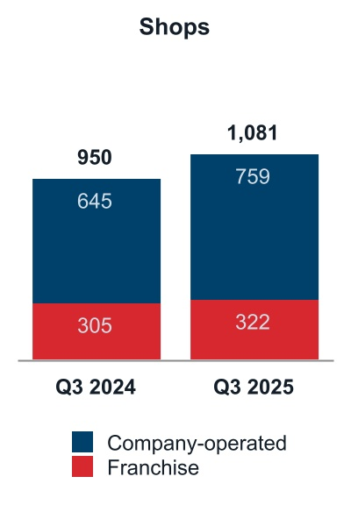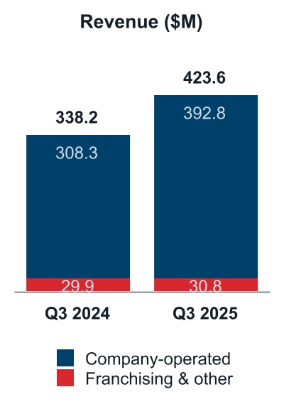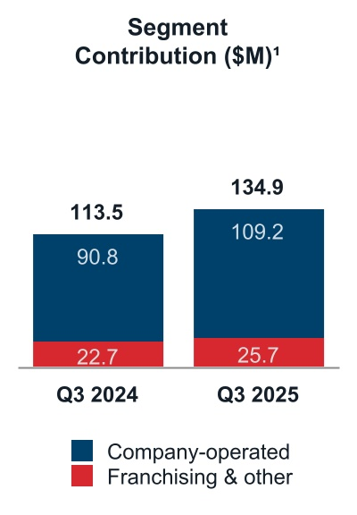
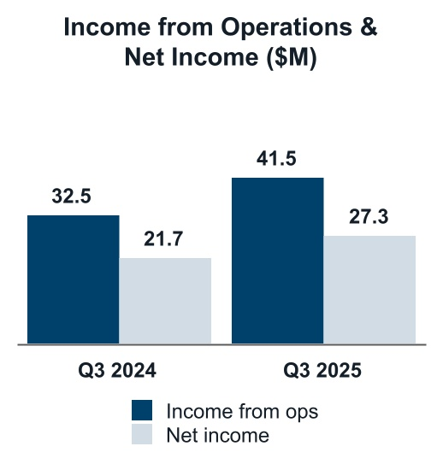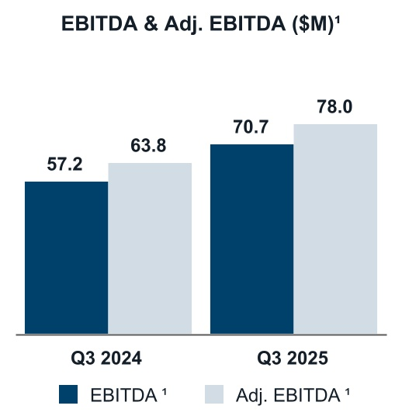
_________________
1 Reconciliation of GAAP to non-GAAP results is provided in the section “Non-GAAP Financial Measures” in Part I, Item 2 “Management’s Discussion and Analysis of Financial Condition and Results of Operations”.
 |  |  |  |  |  | 2025 vs 2024
Increase in total shops |  |  |  |  |  | 13.8 |  | %
Increase in total quarter-to-date revenue |  |  |  |  |  | 25.2 |  | %

Dutch Bros Inc.| Form 10-Q | 35
Table of Contents
Key Performance Indicators
The key performance indicators that we use to effectively manage and evaluate our business are as follows:
 |  |  |  |  |  | Three Months Ended September 30, |  |  |  |  |  |  |  |  |  |  |  | Nine Months Ended September 30,
(dollars in thousands; unaudited) |  |  |  |  |  | 2025 |  |  |  |  |  | 2024 |  |  |  |  |  | 2025 |  |  |  |  |  | 2024
Shop count, beginning of period
Company-operated |  |  |  |  |  | 725 |  |  |  |  |  | 612 |  |  |  |  |  | 670 |  |  |  |  |  | 542
Franchised |  |  |  |  |  | 318 |  |  |  |  |  | 300 |  |  |  |  |  | 312 |  |  |  |  |  | 289
Total shop count |  |  |  |  |  | 1,043 |  |  |  |  |  | 912 |  |  |  |  |  | 982 |  |  |  |  |  | 831
Company-operated new openings |  |  |  |  |  | 34 |  |  |  |  |  | 33 |  |  |  |  |  | 89 |  |  |  |  |  | 103
Franchised new openings |  |  |  |  |  | 4 |  |  |  |  |  | 5 |  |  |  |  |  | 10 |  |  |  |  |  | 16
Shop count, end of period
Company-operated |  |  |  |  |  | 759 |  |  |  |  |  | 645 |  |  |  |  |  | 759 |  |  |  |  |  | 645
Franchised |  |  |  |  |  | 322 |  |  |  |  |  | 305 |  |  |  |  |  | 322 |  |  |  |  |  | 305
Total shop count |  |  |  |  |  | 1,081 |  |  |  |  |  | 950 |  |  |  |  |  | 1,081 |  |  |  |  |  | 950
Systemwide AUV 1 |  |  |  |  |  | N/A |  |  |  |  |  | N/A |  |  |  |  |  | $ | 2,081 |  |  |  |  | $ | 2,004
Company-operated shops AUV 1 |  |  |  |  |  | N/A |  |  |  |  |  | N/A |  |  |  |  |  | $ | 2,023 |  |  |  |  | $ | 1,921
Systemwide same shop sales 2, 3 |  |  |  |  |  | 5.7 |  | % |  |  |  | 2.7 |  | % |  |  |  | 5.2 |  | % |  |  |  | 5.2 |  | %
Ticket |  |  |  |  |  | 1.0 |  | % |  |  |  | 1.9 |  | % |  |  |  | 2.3 |  | % |  |  |  | 5.6 |  | %
Transactions |  |  |  |  |  | 4.7 |  | % |  |  |  | 0.8 |  | % |  |  |  | 2.9 |  | % |  |  |  | (0.4) |  | %
Company-operated same shop sales 2 |  |  |  |  |  | 7.4 |  | % |  |  |  | 4.0 |  | % |  |  |  | 7.0 |  | % |  |  |  | 6.3 |  | %
Ticket |  |  |  |  |  | 0.6 |  | % |  |  |  | 1.6 |  | % |  |  |  | 2.0 |  | % |  |  |  | 5.3 |  | %
Transactions |  |  |  |  |  | 6.8 |  | % |  |  |  | 2.4 |  | % |  |  |  | 5.0 |  | % |  |  |  | 1.0 |  | %
Systemwide sales 3 |  |  |  |  |  | $ | 576,886 |  |  |  |  | $ | 478,765 |  |  |  |  | $ | 1,637,831 |  |  |  |  | $ | 1,342,750
Company-operated shops operating weeks 4 |  |  |  |  |  | 9,645 |  |  |  |  |  | 8,212 |  |  |  |  |  | 27,566 |  |  |  |  |  | 23,195
Franchising shops operating weeks 4 |  |  |  |  |  | 4,192 |  |  |  |  |  | 3,955 |  |  |  |  |  | 12,322 |  |  |  |  |  | 11,576
Dutch Rewards transactions as a percentage of total transactions 5 |  |  |  |  |  | 71.8 |  | % |  |  |  | 67.2 |  | % |  |  |  | 71.7 |  | % |  |  |  | 66.8 |  | %
Dutch Bros Inc.| Form 10-Q | 36
Table of Contents
 |  |  |  |  |  | Three Months Ended September 30, |  |  |  |  |  |  |  |  |  |  |  |  |  |  |  |  |  |  |  |  |  |  |  | Nine Months Ended September 30,
 |  |  |  |  |  | 2025 |  |  |  |  |  |  |  |  |  |  |  | 2024 |  |  |  |  |  |  |  |  |  |  |  | 2025 |  |  |  |  |  |  |  |  |  |  |  | 2024
(dollars in thousands; unaudited) |  |  |  |  |  | $ |  |  |  |  |  | % |  |  |  |  |  | $ |  |  |  |  |  | % |  |  |  |  |  | $ |  |  |  |  |  | % |  |  |  |  |  | $ |  |  |  |  |  | %
Company-operated shops revenues |  |  |  |  |  | 392,833 |  |  |  |  |  | 100.0 |  |  |  |  |  | 308,295 |  |  |  |  |  | 100.0 |  |  |  |  |  | 1,099,754 |  |  |  |  |  | 100.0 |  |  |  |  |  | 851,648 |  |  |  |  |  | 100.0
Company-operated shops gross profit |  |  |  |  |  | 82,435 |  |  |  |  |  | 21.0 |  |  |  |  |  | 68,377 |  |  |  |  |  | 22.2 |  |  |  |  |  | 246,485 |  |  |  |  |  | 22.4 |  |  |  |  |  | 192,698 |  |  |  |  |  | 22.6
Company-operated shops contribution 6 |  |  |  |  |  | 109,231 |  |  |  |  |  | 27.8 |  |  |  |  |  | 90,847 |  |  |  |  |  | 29.5 |  |  |  |  |  | 323,532 |  |  |  |  |  | 29.4 |  |  |  |  |  | 255,900 |  |  |  |  |  | 30.0
Selling, general, and administrative expenses |  |  |  |  |  | 65,289 |  |  |  |  |  | 15.4 |  |  |  |  |  | 57,536 |  |  |  |  |  | 17.0 |  |  |  |  |  | 189,595 |  |  |  |  |  | 15.9 |  |  |  |  |  | 161,866 |  |  |  |  |  | 17.3
Adjusted selling, general, and administrative expenses 6 |  |  |  |  |  | 57,639 |  |  |  |  |  | 13.6 |  |  |  |  |  | 50,268 |  |  |  |  |  | 14.9 |  |  |  |  |  | 169,845 |  |  |  |  |  | 14.2 |  |  |  |  |  | 138,321 |  |  |  |  |  | 14.7
Net income |  |  |  |  |  | 27,283 |  |  |  |  |  | 6.4 |  |  |  |  |  | 21,712 |  |  |  |  |  | 6.4 |  |  |  |  |  | 88,120 |  |  |  |  |  | 7.4 |  |  |  |  |  | 60,083 |  |  |  |  |  | 6.4
Adjusted EBITDA 6 |  |  |  |  |  | 78,003 |  |  |  |  |  | 18.4 |  |  |  |  |  | 63,762 |  |  |  |  |  | 18.9 |  |  |  |  |  | 229,912 |  |  |  |  |  | 19.2 |  |  |  |  |  | 181,461 |  |  |  |  |  | 19.3
_________________
1 AUVs are determined based on the net sales for any trailing twelve-month period for systemwide and company-operated shops that have been open a minimum of 15 months. AUVs are calculated by dividing the systemwide and company-operated shops net sales by the total number of systemwide and company-operated shops, respectively. Management uses these metrics as an indicator of shop growth and future expectations of mature locations.
2 Same shop sales represents the estimated percentage change in year-over-year sales, for the comparable shop base, which we define as shops open for 15 complete months or longer as of the first day of the reporting period. Same shop sales can be impacted by changes in customer transaction counts and by changes in the per-ticket amounts. Management uses these metrics as an indicator of shop growth and future expansion strategy. The number of shops included in the systemwide and company-operated comparable bases for the respective periods are presented in the following table.
 |  |  |  |  |  | Three Months Ended September 30, |  |  |  |  |  |  |  |  |  |  |  | Nine Months Ended September 30,
(unaudited) |  |  |  |  |  | 2025 |  |  |  |  |  | 2024 |  |  |  |  |  | 2025 |  |  |  |  |  | 2024
Systemwide shop base |  |  |  |  |  | 876 |  |  |  |  |  | 716 |  |  |  |  |  | 794 |  |  |  |  |  | 641
Company-operated shops base |  |  |  |  |  | 582 |  |  |  |  |  | 438 |  |  |  |  |  | 510 |  |  |  |  |  | 370
3 Systemwide sales and systemwide same shop sales are operating measures that include sales at company-operated shops and sales at franchised shops during the comparable periods presented. Franchise sales represent sales at all franchise shops and are revenues to our franchise partners. We do not record franchise sales as revenues; however, our royalty revenues and advertising fund contributions are calculated based on a percentage of franchise sales. As these metrics include sales reported to us by our non-consolidated franchise partners, these metrics should be considered as a supplement to, not a substitute for, our results as reported under GAAP. Management uses these metrics as indicators of our system’s overall financial health, growth and future expansion prospects.
4 Company-operated and franchise shops operating weeks are calculated based on the number of operating days for the shop base and dividing by 7. Our shop base is defined as shops opened as of the period end date. Management uses these metrics as indicators of our system’s overall financial health, growth and future expansion prospects.
5 Dutch Rewards is our digitally based rewards program available exclusively through the Dutch Rewards app. Management uses this metric as an indicator of customer loyalty adoption of our Dutch Rewards app and future promotional plans.
6 Reconciliation of GAAP to non-GAAP results is provided in the section “Non-GAAP Financial Measures” in Part I, Item 2 “Management’s Discussion and Analysis of Financial Condition and Results of Operations.”

Dutch Bros Inc.| Form 10-Q | 37
Table of Contents
Company-operated Shops Results
Results for our company-operated shops segment were as follows:
 |  |  |  |  |  | Three Months Ended September 30, |  |  |  |  |  |  |  |  |  |  |  |  |  |  |  |  |  |  |  |  |  |  |  | Nine Months Ended September 30,
 |  |  |  |  |  | 2025 |  |  |  |  |  |  |  |  |  |  |  | 2024 |  |  |  |  |  |  |  |  |  |  |  | 2025 |  |  |  |  |  |  |  |  |  |  |  | 2024
(dollars in thousands; unaudited) |  |  |  |  |  | $ |  |  |  |  |  | % |  |  |  |  |  | $ |  |  |  |  |  | % |  |  |  |  |  | $ |  |  |  |  |  | % |  |  |  |  |  | $ |  |  |  |  |  | %
Company-operated shops revenues |  |  |  |  |  | 392,833 |  |  |  |  |  | 100.0 |  |  |  |  |  | 308,295 |  |  |  |  |  | 100.0 |  |  |  |  |  | 1,099,754 |  |  |  |  |  | 100.0 |  |  |  |  |  | 851,648 |  |  |  |  |  | 100.0
Beverage, food, and packaging costs |  |  |  |  |  | 101,875 |  |  |  |  |  | 25.9 |  |  |  |  |  | 78,060 |  |  |  |  |  | 25.3 |  |  |  |  |  | 279,722 |  |  |  |  |  | 25.4 |  |  |  |  |  | 216,923 |  |  |  |  |  | 25.5
Labor costs |  |  |  |  |  | 108,098 |  |  |  |  |  | 27.5 |  |  |  |  |  | 85,144 |  |  |  |  |  | 27.6 |  |  |  |  |  | 298,807 |  |  |  |  |  | 27.2 |  |  |  |  |  | 230,807 |  |  |  |  |  | 27.1
Occupancy and other costs |  |  |  |  |  | 66,696 |  |  |  |  |  | 17.0 |  |  |  |  |  | 50,693 |  |  |  |  |  | 16.4 |  |  |  |  |  | 180,607 |  |  |  |  |  | 16.4 |  |  |  |  |  | 136,466 |  |  |  |  |  | 16.0
Pre-opening costs |  |  |  |  |  | 6,933 |  |  |  |  |  | 1.8 |  |  |  |  |  | 3,551 |  |  |  |  |  | 1.2 |  |  |  |  |  | 17,086 |  |  |  |  |  | 1.6 |  |  |  |  |  | 11,552 |  |  |  |  |  | 1.4
Depreciation and amortization |  |  |  |  |  | 26,796 |  |  |  |  |  | 6.8 |  |  |  |  |  | 22,470 |  |  |  |  |  | 7.3 |  |  |  |  |  | 77,047 |  |  |  |  |  | 7.0 |  |  |  |  |  | 63,202 |  |  |  |  |  | 7.4
Company-operated shops costs and expenses |  |  |  |  |  | 310,398 |  |  |  |  |  | 79.0 |  |  |  |  |  | 239,918 |  |  |  |  |  | 77.8 |  |  |  |  |  | 853,269 |  |  |  |  |  | 77.6 |  |  |  |  |  | 658,950 |  |  |  |  |  | 77.4
Company-operated shops gross profit |  |  |  |  |  | 82,435 |  |  |  |  |  | 21.0 |  |  |  |  |  | 68,377 |  |  |  |  |  | 22.2 |  |  |  |  |  | 246,485 |  |  |  |  |  | 22.4 |  |  |  |  |  | 192,698 |  |  |  |  |  | 22.6
Company-operated shops contribution1 |  |  |  |  |  | 109,231 |  |  |  |  |  | 27.8 |  |  |  |  |  | 90,847 |  |  |  |  |  | 29.5 |  |  |  |  |  | 323,532 |  |  |  |  |  | 29.4 |  |  |  |  |  | 255,900 |  |  |  |  |  | 30.0
_________________
1 Reconciliation of GAAP to non-GAAP results is provided in the section “Non-GAAP Financial Measures” in Part I, Item 2 “Management’s Discussion and Analysis of Financial Condition and Results of Operations.”

Company-operated Shops Segment Performance
Company-operated Shops Revenue
 |  |  |  |  |  | Three Months Ended September 30, |  |  |  |  |  |  |  |  |  |  |  |  |  |  |  |  |  |  |  |  |  |  |  | Nine Months Ended September 30,
(dollars in thousands; unaudited) |  |  |  |  |  | 2025 |  |  |  |  |  | 2024 |  |  |  |  |  | 2025 v. 2024 |  |  |  |  |  |  |  |  |  |  |  | 2025 |  |  |  |  |  | 2024 |  |  |  |  |  |  |  | 2025 v. 2024
Company-operated shops revenue |  |  |  |  |  | $392,833 |  |  |  |  |  | $308,295 |  |  |  |  |  | $84,538 |  |  |  |  |  | 27.4% |  |  |  |  |  | $1,099,754 |  |  |  |  |  | $851,648 |  |  |  |  |  |  |  | $248,106 |  |  |  |  |  | 29.1%

Three Months Ended September 30, 2025 v. 2024
Company-operated shops revenue increased $62.0 million from newly opened shops not yet in the comparable shop base and $22.5 million from a 7.4% increase in same shop sales.

Nine Months Ended September 30, 2025 v. 2024
Company-operated shops revenue increased $194.5 million from newly opened shops not yet in the comparable shop base and $53.6 million from a 7.0% increase in same shop sales.

Dutch Bros Inc.| Form 10-Q | 38
Table of Contents
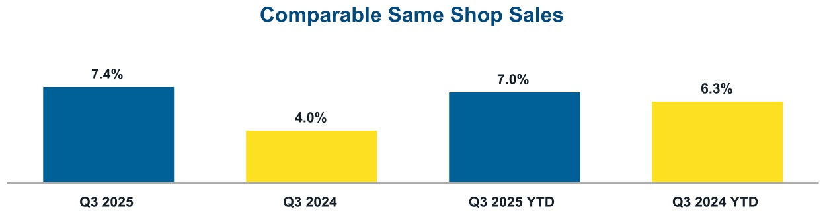

Beverage, Food, and Packaging Costs
 |  |  |  |  |  | Three Months Ended September 30, |  |  |  |  |  |  |  |  |  |  |  |  |  |  |  |  |  |  |  |  |  |  |  | Nine Months Ended September 30,
(dollars in thousands; unaudited) |  |  |  |  |  | 2025 |  |  |  |  |  | 2024 |  |  |  |  |  | 2025 v. 2024 |  |  |  |  |  |  |  |  |  |  |  | 2025 |  |  |  |  |  | 2024 |  |  |  |  |  |  |  | 2025 v. 2024
Beverage, food and packaging costs |  |  |  |  |  | $101,875 |  |  |  |  |  | $78,060 |  |  |  |  |  | $23,815 |  |  |  |  |  | 30.5% |  |  |  |  |  | $279,722 |  |  |  |  |  | $216,923 |  |  |  |  |  |  |  | $62,799 |  |  |  |  |  | 28.9%
As a percentage of company-operated shops revenues |  |  |  |  |  | 25.9% |  |  |  |  |  | 25.3% |  |  |  |  |  | N/A |  |  |  |  |  | 60 bps |  |  |  |  |  | 25.4% |  |  |  |  |  | 25.5% |  |  |  |  |  |  |  | N/A |  |  |  |  |  | (10) bps

Three Months Ended September 30, 2025 v. 2024
As a percentage of company-operated shops revenues, beverage, food and packaging costs increased by 60 basis points. This was primarily due to an increase in coffee costs of 70 basis points, partially offset by the impact of pricing on the comparable shop base.

Nine Months Ended September 30, 2025 v. 2024
As a percentage of company-operated shops revenues, beverage, food and packaging costs decreased by 10 basis points. This was primarily due to a 60 basis point impact of pricing on the comparable shop base, partially offset by an increase in coffee costs.

Labor Costs
 |  |  |  |  |  | Three Months Ended September 30, |  |  |  |  |  |  |  |  |  |  |  |  |  |  |  |  |  |  |  |  |  |  |  | Nine Months Ended September 30,
(dollars in thousands; unaudited) |  |  |  |  |  | 2025 |  |  |  |  |  | 2024 |  |  |  |  |  | 2025 v. 2024 |  |  |  |  |  |  |  |  |  |  |  | 2025 |  |  |  |  |  | 2024 |  |  |  |  |  |  |  | 2025 v. 2024
Labor costs |  |  |  |  |  | $108,098 |  |  |  |  |  | $85,144 |  |  |  |  |  | $22,954 |  |  |  |  |  | 27.0% |  |  |  |  |  | $298,807 |  |  |  |  |  | $230,807 |  |  |  |  |  |  |  | $68,000 |  |  |  |  |  | 29.5%
As a percentage of company-operated shops revenues |  |  |  |  |  | 27.5% |  |  |  |  |  | 27.6% |  |  |  |  |  | N/A |  |  |  |  |  | (10) bps |  |  |  |  |  | 27.2% |  |  |  |  |  | 27.1% |  |  |  |  |  |  |  | N/A |  |  |  |  |  | 10 bps

Three Months Ended September 30, 2025 v. 2024
As a percentage of company-operated shops revenues, labor costs decreased by 10 basis points primarily due to the impact of pricing and sales leverage, partially offset by increased wages.

Nine Months Ended September 30, 2025 v. 2024
As a percentage of company-operated shops revenues, labor costs increased by 10 basis points. This was primarily due to 80 basis points from increased wages partially offset by a decrease of 60 basis points from the impact of pricing.

Dutch Bros Inc.| Form 10-Q | 39
Table of Contents
Occupancy and Other Costs
 |  |  |  |  |  | Three Months Ended September 30, |  |  |  |  |  |  |  |  |  |  |  |  |  |  |  |  |  |  |  |  |  |  |  | Nine Months Ended September 30,
(dollars in thousands; unaudited) |  |  |  |  |  | 2025 |  |  |  |  |  | 2024 |  |  |  |  |  | 2025 v. 2024 |  |  |  |  |  |  |  |  |  |  |  | 2025 |  |  |  |  |  | 2024 |  |  |  |  |  |  |  | 2025 v. 2024
Occupancy and other costs |  |  |  |  |  | $66,696 |  |  |  |  |  | $50,693 |  |  |  |  |  | $16,003 |  |  |  |  |  | 31.6% |  |  |  |  |  | $180,607 |  |  |  |  |  | $136,466 |  |  |  |  |  |  |  | $44,141 |  |  |  |  |  | 32.3%
As a percentage of company-operated shops revenues |  |  |  |  |  | 17.0% |  |  |  |  |  | 16.4% |  |  |  |  |  | N/A |  |  |  |  |  | 60 bps |  |  |  |  |  | 16.4% |  |  |  |  |  | 16.0% |  |  |  |  |  |  |  | N/A |  |  |  |  |  | 40 bps

Three and Nine Months Ended September 30, 2025 v. 2024
As a percentage of company-operated shops revenues, occupancy and other costs increased by 60 basis points and 40 basis points for the three and nine months ended September 30, 2025, respectively. These increases were primarily due to the impact of occupancy rates from new shops as we shift our lease types to a greater proportion of build-to-suit lease agreements.

Pre-opening Costs
 |  |  |  |  |  | Three Months Ended September 30, |  |  |  |  |  |  |  |  |  |  |  |  |  |  |  |  |  |  |  |  |  |  |  | Nine Months Ended September 30,
(dollars in thousands; unaudited) |  |  |  |  |  | 2025 |  |  |  |  |  | 2024 |  |  |  |  |  | 2025 v. 2024 |  |  |  |  |  |  |  |  |  |  |  | 2025 |  |  |  |  |  | 2024 |  |  |  |  |  |  |  | 2025 v. 2024
Pre-opening costs |  |  |  |  |  | $6,933 |  |  |  |  |  | $3,551 |  |  |  |  |  | $3,382 |  |  |  |  |  | 95.2% |  |  |  |  |  | $17,086 |  |  |  |  |  | $11,552 |  |  |  |  |  |  |  | $5,534 |  |  |  |  |  | 47.9%
As a percentage of company-operated shops revenues |  |  |  |  |  | 1.8% |  |  |  |  |  | 1.2% |  |  |  |  |  | N/A |  |  |  |  |  | 60 bps |  |  |  |  |  | 1.6% |  |  |  |  |  | 1.4% |  |  |  |  |  |  |  | N/A |  |  |  |  |  | 20 bps
New company-operated shops opened |  |  |  |  |  | 34 |  |  |  |  |  | 33 |  |  |  |  |  | 1 |  |  |  |  |  | 3.0% |  |  |  |  |  | 89 |  |  |  |  |  | 103 |  |  |  |  |  |  |  | (14) |  |  |  |  |  | (13.6)%
Pre-opening costs per new company-operated shop |  |  |  |  |  | $204 |  |  |  |  |  | $108 |  |  |  |  |  | $95 |  |  |  |  |  | 88.0% |  |  |  |  |  | $192 |  |  |  |  |  | $112 |  |  |  |  |  |  |  | $80 |  |  |  |  |  | 71.4%

Three and Nine Months Ended September 30, 2025 v. 2024
The increase in pre-opening costs was primarily driven by increased travel for setup and training teams, and lease expense related to unopened shops, in the three and nine months ended September 30, 2025 as compared to the same period in 2024.

Depreciation and Amortization
 |  |  |  |  |  | Three Months Ended September 30, |  |  |  |  |  |  |  |  |  |  |  |  |  |  |  |  |  |  |  |  |  |  |  | Nine Months Ended September 30,
(dollars in thousands; unaudited) |  |  |  |  |  | 2025 |  |  |  |  |  | 2024 |  |  |  |  |  | 2025 v. 2024 |  |  |  |  |  |  |  |  |  |  |  | 2025 |  |  |  |  |  | 2024 |  |  |  |  |  |  |  | 2025 v. 2024
Depreciation and amortization |  |  |  |  |  | $26,796 |  |  |  |  |  | $22,470 |  |  |  |  |  | $4,326 |  |  |  |  |  | 19.3% |  |  |  |  |  | $77,047 |  |  |  |  |  | $63,202 |  |  |  |  |  |  |  | $13,845 |  |  |  |  |  | 21.9%
As a percentage of company-operated shops revenues |  |  |  |  |  | 6.8% |  |  |  |  |  | 7.3% |  |  |  |  |  | N/A |  |  |  |  |  | (50) bps |  |  |  |  |  | 7.0% |  |  |  |  |  | 7.4% |  |  |  |  |  |  |  | N/A |  |  |  |  |  | (40) bps

Three and Nine Months Ended September 30, 2025 v. 2024
The increase in depreciation and amortization was primarily driven by the increase in the number of company-operated shops in the current period compared to the prior period.

Dutch Bros Inc.| Form 10-Q | 40
Table of Contents
Company-operated Shops Gross Profit and Contribution1
 |  |  |  |  |  | Three Months Ended September 30, |  |  |  |  |  |  |  |  |  |  |  |  |  |  |  |  |  |  |  |  |  |  |  | Nine Months Ended September 30,
(dollars in thousands; unaudited) |  |  |  |  |  | 2025 |  |  |  |  |  | 2024 |  |  |  |  |  | 2025 v. 2024 |  |  |  |  |  |  |  |  |  |  |  | 2025 |  |  |  |  |  | 2024 |  |  |  |  |  |  |  | 2025 v. 2024
Company-operated shops gross profit |  |  |  |  |  | $82,435 |  |  |  |  |  | $68,377 |  |  |  |  |  | $14,058 |  |  |  |  |  | 20.6% |  |  |  |  |  | $246,485 |  |  |  |  |  | $192,698 |  |  |  |  |  |  |  | $53,787 |  |  |  |  |  | 27.9%
As a percentage of company-operated shops revenues |  |  |  |  |  | 21.0% |  |  |  |  |  | 22.2% |  |  |  |  |  | N/A |  |  |  |  |  | (120) bps |  |  |  |  |  | 22.4% |  |  |  |  |  | 22.6% |  |  |  |  |  |  |  | N/A |  |  |  |  |  | (20) bps
Company-operated shops contribution 1 |  |  |  |  |  | $109,231 |  |  |  |  |  | $90,847 |  |  |  |  |  | $18,384 |  |  |  |  |  | 20.2% |  |  |  |  |  | $323,532 |  |  |  |  |  | $255,900 |  |  |  |  |  |  |  | $67,632 |  |  |  |  |  | 26.4%
As a percentage of company-operated shops revenues |  |  |  |  |  | 27.8% |  |  |  |  |  | 29.5% |  |  |  |  |  | N/A |  |  |  |  |  | (170) bps |  |  |  |  |  | 29.4% |  |  |  |  |  | 30.0% |  |  |  |  |  |  |  | N/A |  |  |  |  |  | (60) bps
_______________________
1 Reconciliation of GAAP to non-GAAP results is provided in the section “Non-GAAP Financial Measures” in Part I, Item 2 “Management’s Discussion and Analysis of Financial Condition and Results of Operations.”

Three and Nine Months Ended September 30, 2025 v. 2024
The company-operated shops gross profit margin decreased by 120 basis points and 20 basis points for the three and nine months ended September 30, 2025, respectively. This was primarily driven by increased coffee costs and labor costs partially offset by leverage from increased sales in the comparable shop base.

Franchising and Other Segment Performance
 |  |  |  |  |  | Three Months Ended September 30, |  |  |  |  |  |  |  |  |  |  |  |  |  |  |  |  |  |  |  |  |  |  |  | Nine Months Ended September 30,
(dollars in thousands; unaudited) |  |  |  |  |  | 2025 |  |  |  |  |  | 2024 |  |  |  |  |  | 2025 v. 2024 |  |  |  |  |  |  |  |  |  |  |  | 2025 |  |  |  |  |  | 2024 |  |  |  |  |  |  |  | 2025 v. 2024
Franchising and other revenue |  |  |  |  |  | $30,751 |  |  |  |  |  | $29,917 |  |  |  |  |  | $834 |  |  |  |  |  | 2.8% |  |  |  |  |  | $94,795 |  |  |  |  |  | $86,581 |  |  |  |  |  |  |  | $8,214 |  |  |  |  |  | 9.5%
Franchising and other gross profit |  |  |  |  |  | $24,344 |  |  |  |  |  | $21,674 |  |  |  |  |  | $2,670 |  |  |  |  |  | 12.3% |  |  |  |  |  | $70,331 |  |  |  |  |  | $59,483 |  |  |  |  |  |  |  | $10,848 |  |  |  |  |  | 18.2%
As a percentage of franchising and other revenue |  |  |  |  |  | 79.2% |  |  |  |  |  | 72.4% |  |  |  |  |  | N/A |  |  |  |  |  | 680 bps |  |  |  |  |  | 74.2% |  |  |  |  |  | 68.7% |  |  |  |  |  |  |  | N/A |  |  |  |  |  | 550 bps

Three and Nine Months Ended September 30, 2025 v. 2024
The franchising and other gross profit increases for the three and nine months ended September 30, 2025 were primarily driven by products sold to franchisees (net of costs and adjustments), royalties and marketing fees generated from higher franchise partner sales.

Selling, General, and Administrative
 |  |  |  |  |  | Three Months Ended September 30, |  |  |  |  |  |  |  |  |  |  |  |  |  |  |  |  |  |  |  |  |  |  |  | Nine Months Ended September 30,
(dollars in thousands; unaudited) |  |  |  |  |  | 2025 |  |  |  |  |  | 2024 |  |  |  |  |  | 2025 v. 2024 |  |  |  |  |  |  |  |  |  |  |  | 2025 |  |  |  |  |  | 2024 |  |  |  |  |  |  |  | 2025 v. 2024
Selling, General, and Administrative |  |  |  |  |  | $65,289 |  |  |  |  |  | $57,536 |  |  |  |  |  | $7,753 |  |  |  |  |  | 13.5% |  |  |  |  |  | $189,595 |  |  |  |  |  | $161,866 |  |  |  |  |  |  |  | $27,729 |  |  |  |  |  | 17.1%
As a percentage of total revenues |  |  |  |  |  | 15.4% |  |  |  |  |  | 17.0% |  |  |  |  |  | N/A |  |  |  |  |  | (160) bps |  |  |  |  |  | 15.9% |  |  |  |  |  | 17.3% |  |  |  |  |  |  |  | N/A |  |  |  |  |  | (140) bps

Dutch Bros Inc.| Form 10-Q | 41
Table of Contents
Three Months Ended September 30, 2025 v. 2024
The selling, general, and administrative increase of approximately $7.8 million was primarily driven by increased expenses of $5.8 million consisting of investments in human capital to support our revenue growth along with higher performance-based compensation and $1.4 million of higher equity-based compensation. These increases were partially offset by lower realignment and restructuring charges of $1.5 million, as the 2024 realignment program was larger in scope.

Nine Months Ended September 30, 2025 v. 2024
The selling, general, and administrative increase of approximately $27.7 million was primarily driven by increased expenses of $21.2 million consisting of investments in human capital to support our revenue growth and higher performance-based compensation; an increase of $9.5 million related to professional fees and technology services to support our growing business; $4.4 million of higher equity-based compensation; and $2.0 million of increased donations to the Dutch Bros Foundation. These increases were partially offset by lower realignment and restructuring charges of $7.9 million and lower nonrecurring equity offering expenses of $1.5 million.

Other Expense
 |  |  |  |  |  | Three Months Ended September 30, |  |  |  |  |  |  |  |  |  |  |  |  |  |  |  |  |  |  |  |  |  |  |  | Nine Months Ended September 30,
(dollars in thousands; unaudited) |  |  |  |  |  | 2025 |  |  |  |  |  | 2024 |  |  |  |  |  | 2025 v. 2024 |  |  |  |  |  |  |  |  |  |  |  | 2025 |  |  |  |  |  | 2024 |  |  |  |  |  |  |  | 2025 v. 2024
Interest expense on finance leases |  |  |  |  |  | $ | (5,896) |  |  |  |  | $ | (5,541) |  |  |  |  | $ | (355) |  |  |  |  | 6.4% |  |  |  |  |  | $ | (17,234) |  |  |  |  | $ | (16,499) |  |  |  |  |  |  | $ | (735) |  |  |  |  | 4.5%
Other interest expense, net |  |  |  |  |  | (799) |  |  |  |  |  | (1,328) |  |  |  |  |  | 529 |  |  |  |  |  | (39.8)% |  |  |  |  |  | (3,652) |  |  |  |  |  | (3,760) |  |  |  |  |  |  |  | 108 |  |  |  |  |  | (2.9)%
Interest expense, net |  |  |  |  |  | $ | (6,695) |  |  |  |  | $ | (6,869) |  |  |  |  | $ | 174 |  |  |  |  | (2.5)% |  |  |  |  |  | $ | (20,886) |  |  |  |  | $ | (20,259) |  |  |  |  |  |  | $ | (627) |  |  |  |  | 3.1%
Other income (expense), net |  |  |  |  |  | 149 |  |  |  |  |  | 764 |  |  |  |  |  | (615) |  |  |  |  |  | (80.5)% |  |  |  |  |  | (1,852) |  |  |  |  |  | 7,357 |  |  |  |  |  |  |  | (9,209) |  |  |  |  |  | N/M
Total other expense |  |  |  |  |  | $ | (6,546) |  |  |  |  | $ | (6,105) |  |  |  |  | $ | (441) |  |  |  |  | 7.2% |  |  |  |  |  | $ | (22,738) |  |  |  |  | $ | (12,902) |  |  |  |  |  |  | $ | (9,836) |  |  |  |  | 76.2%

Three Months Ended September 30, 2025 v. 2024
The decrease in other income (expense), net was primarily driven by a non-recurring prior year gain on sale of the Company hangar and related equipment to our Co-Founder.

Nine Months Ended September 30, 2025 v. 2024
The decrease in other income (expense), net was primarily driven by remeasurement gains in the prior year related to the TRAs liability, expenses associated with our credit facility refinance in May 2025 (see NOTE 9 — Debt for additional details), and a prior year non-recurring gain on sale of the Company airplane, hangar and related equipment to our Co-Founder.

Income Tax Expense
 |  |  |  |  |  | Three Months Ended September 30, |  |  |  |  |  |  |  |  |  |  |  |  |  |  |  |  |  |  |  |  |  |  |  | Nine Months Ended September 30,
(dollars in thousands; unaudited) |  |  |  |  |  | 2025 |  |  |  |  |  | 2024 |  |  |  |  |  | 2025 v. 2024 |  |  |  |  |  |  |  |  |  |  |  | 2025 |  |  |  |  |  | 2024 |  |  |  |  |  |  |  | 2025 v. 2024
Income tax expense |  |  |  |  |  | $7,661 |  |  |  |  |  | $4,698 |  |  |  |  |  | $2,963 |  |  |  |  |  | 63.1% |  |  |  |  |  | $16,363 |  |  |  |  |  | $17,330 |  |  |  |  |  |  |  | $(967) |  |  |  |  |  | (5.6)%
Effective tax rate |  |  |  |  |  | 21.9% |  |  |  |  |  | 17.8% |  |  |  |  |  | N/A |  |  |  |  |  | N/A |  |  |  |  |  | 15.7% |  |  |  |  |  | 22.4% |  |  |  |  |  |  |  | N/A |  |  |  |  |  | N/A

Three Months Ended September 30, 2025 v. 2024
The increase in the effective tax rate to 21.9% from 17.8% in the same period in 2024 is primarily due to an increase in valuation allowance related to the realizability of our charitable contributions carryforward.
See NOTE 11 — Income Taxes for additional details.

Dutch Bros Inc.| Form 10-Q | 42
Table of Contents
Nine Months Ended September 30, 2025 v. 2024
The decrease in the effective tax rate to 15.7% from 22.4% in the same period in 2024 is due to tax deductions related to stock-based compensation, as well as the impact of changes in state rates and apportionment on deferred taxes.
On July 4, 2025, the One Big Beautiful Bill Act (OBBBA) was enacted in the United States. The OBBBA includes significant provisions, including the permanent extension of certain expiring provisions of the Tax Cuts and Jobs Act and the restoration of favorable tax treatment for specific business provisions. This legislation was enacted during the third quarter of 2025, resulting in an increase to our valuation allowance related to the realizability of our charitable contributions carryforward. Other than the permanent extension of bonus depreciation provisions in the OBBBA, which will lower future cash distributions to our Dutch Bros OpCo owners, we do not expect the effects of this legislation to have a material impact on the Company’s financial results.
See NOTE 11 — Income Taxes for additional details.

Liquidity and Capital Resources

Cash Overview
We had cash and cash equivalents of $267.2 million and $293.4 million as of September 30, 2025 and December 31, 2024, respectively.
For the nine months ended September 30, 2025, our principal sources of liquidity were cash flows from operations and the refinancing of our credit facility. Our principal uses of liquidity for the nine months ended September 30, 2025 were to payoff our prior credit facility, fund our new shop builds and other working capital needs.

Cash Flows
The following table summarizes our cash flows for the periods presented:
 |  |  |  |  |  | Nine Months Ended September 30,
(dollars in thousands; unaudited) |  |  |  |  |  | 2025 |  |  |  |  |  | 2024 |  |  |  |  |  |  |  | 2025 v. 2024
Net cash provided by operating activities |  |  |  |  |  | $ | 215,906 |  |  |  |  | $ | 184,195 |  |  |  |  |  |  | $ | 31,711 |  |  |  |  | 17.2%
Net cash used in investing activities |  |  |  |  |  | (169,936) |  |  |  |  |  | (169,363) |  |  |  |  |  |  |  | (573) |  |  |  |  |  | 0.3
Net cash provided by (used in) financing activities |  |  |  |  |  | (72,129) |  |  |  |  |  | 132,757 |  |  |  |  |  |  |  | (204,886) |  |  |  |  |  | (154.3)%
Net increase (decrease) in cash and cash equivalents |  |  |  |  |  | $ | (26,159) |  |  |  |  | $ | 147,589 |  |  |  |  |  |  | $ | (173,748) |  |  |  |  | (117.7)%
Cash and cash equivalents at beginning of period |  |  |  |  |  | 293,354 |  |  |  |  |  | 133,545 |  |  |  |  |  |  |  | 159,809 |  |  |  |  |  | 119.7
Cash and cash equivalents at end of period |  |  |  |  |  | $ | 267,195 |  |  |  |  | $ | 281,134 |  |  |  |  |  |  | $ | (13,939) |  |  |  |  | (5.0)%
Operating Activities
The increase in operating activities cash flows was primarily driven by higher net income as a result of year-over-year sales growth and leverage of selling, general and administrative costs.
Investing Activities
The slight increase in investing activities cash outflows was primarily driven by lower investment in capital expenditures due to fewer new company-operated shops openings in the current period compared to the same period in the prior year, partially offset by lower proceeds from disposal of fixed assets.
Financing Activities
The decrease in financing activities cash flows was primarily driven by the net payoff of our 2022 Credit Facility, partially offset by proceeds from our 2025 Credit Facility.

Dutch Bros Inc.| Form 10-Q | 43
Table of Contents
Cash Requirements
We believe that cash provided by operating activities and proceeds from our 2025 Credit Facility are adequate to fund our debt service requirements, lease obligations, cash distributions required by the OpCo LLC Agreement and the TRAs, and working capital obligations for at least the next 12 months.
Our future capital requirements may vary materially from period to period and will depend on many factors, primarily our expansion and growth by opening additional company-operated shops and/or reacquiring existing franchised shops. Further, the payments that we may be required to make under the TRAs may be significant. We currently expect to fund our current and long-term material capital requirements with operating cash flows and, as needed, additional proceeds from our 2025 Credit Facility, but we may also seek additional debt or equity financing. From time to time, we may explore additional financing sources which could include equity, equity-linked, and debt financing arrangements.

As of September 30, 2025, cash requirements for the following items have materially changed from our 2024 Form 10-K:
•Operating lease liabilities — increased approximately $195 million from newly commenced leases.
•Debt obligations — decreased approximately $36 million on a net basis primarily due to the payoff of our 2022 Credit Facility, partially offset by proceeds from the 2025 Credit Facility.

Credit Facility
JPMorgan Credit Facility
On May 29, 2025 (the Effective Date), we amended and restated our existing $650 million senior secured credit facility, dated February 28, 2022 (as previously amended, the 2022 Credit Facility), with JPMorgan Chase Bank, N.A. as administrative agent and other financial institutions as the lenders party thereto (the 2025 Credit Facility). The 2025 Credit Facility consists of a $500 million revolving credit facility and a term loan facility of up to $150 million. The 2025 Credit Facility also includes sublimits for letters of credit and swingline loans of up to $100 million and $20 million, respectively. The 2025 Credit Facility expires on May 29, 2030 (the Maturity Date). It also contains an option allowing the Loan Parties to increase the size of the 2025 Credit Facility by up to an additional (i) $230 million or (ii) 80% of EBITDAR, whichever is greater, with the agreement of the Administrative Agent and the applicable lenders party thereto.
On the Effective Date, we drew the full $150 million in term loan and $50 million in revolving loans under the 2025 Credit Facility, and all outstanding debt under the 2022 Credit Facility was repaid.
Interest on borrowings under the 2025 Credit Facility is based on (i) the Alternate Base Rate plus an applicable margin, or (ii) the Term SOFR Rate plus an applicable margin (each as defined in the 2025 Credit Facility), and is payable in accordance with the selected interest rate period and upon maturity. Principal payments for the term loans are required on a quarterly basis in accordance with an amortization schedule up through and including the Maturity Date.
Obligations under the 2025 Credit Facility are guaranteed by Dutch Bros OpCo and certain of its subsidiaries, and secured by a first priority perfected security interest in substantially all of the assets of the guarantors.

Interest Rate Swap Contract
We have an interest rate swap with JPMorgan Chase Bank, N.A. As of September 30, 2025, the interest rate swap had a notional amount of approximately $60 million and hedges interest rate risk on the term loan under the 2025 Credit Facility. The purpose of the floating-to-fixed interest rate swap is to fix the interest base rate charged on the term loan at 2.67% for the notional amount. The interest rate swap matures on February 28, 2027.
The amendment to our credit facility had no impact on our interest rate swap contract.

Dutch Bros Inc.| Form 10-Q | 44
Table of Contents
See NOTE 9 — Debt and NOTE 10 — Derivative Financial Instruments for additional details related to our 2025 Credit Facility and interest rate swap contract.

Organizational Realignment and Restructurings
We expect to recognize additional costs associated with our May 2025 back-office streamlining and restructuring program of approximately $8.5 million, including cash expenditures for (i) employee-related costs and (ii) other costs, including consulting costs.
See NOTE 4 — Organization Realignment and Restructurings for additional details.

Seasonality
Our business is subject to seasonal fluctuations that impact our revenue and company-operated shops gross profit margins. We typically experience higher system sales in the summer months, which impacts revenue and company-operated shops gross profit margins in the second and third quarters of our fiscal year.

Critical Accounting Estimates
There have been no material changes to our critical accounting estimates from those disclosed in our 2024 Form 10-K.

Non-GAAP Financial Measures
In addition to disclosing financial results in accordance with GAAP, this document contains references to the non-GAAP financial measures below. We believe these non-GAAP financial measures provide investors with useful supplemental information about our operating performance, enable comparison of financial trends and results between periods where certain items may vary independent of business performance, and allow for greater transparency with respect to key metrics used by management in operating our business and measuring our performance.
Our non-GAAP financial measures reflect adjustments based on one or more of the following items, as well as the related income tax effects where applicable. Income tax effects have been calculated based on the combined total non-GAAP adjustments using our total effective tax rate. These non-GAAP financial measures should not be considered a substitute for, or superior to, financial measures calculated in accordance with GAAP, and the financial results calculated in accordance with GAAP and reconciliations from these results should be carefully evaluated.

Segment contribution
Definition and/or calculation
Segment gross profit, before depreciation and amortization.
Usefulness to management and investors
This non-GAAP measure is used by our management in making performance decisions without the impact of non-cash depreciation and amortization charges. This is a standard metric used across our industry by investors.

EBITDA, Adjusted EBITDA
EBITDA — definition and/or calculation
Net income before interest expense (net of interest income), income tax expense, and depreciation and amortization expense.
Dutch Bros Inc.| Form 10-Q | 45
Table of Contents
Adjusted EBITDA — definition and/or calculation
Defined as EBITDA, excluding equity-based compensation, expenses associated with equity offerings, expenses associated with credit facility refinancing, executives transitions costs, (gain) loss on the remeasurement of the liability related to the TRAs, sale of Aircraft, and organization realignment and restructurings costs.
Usefulness to management and investors
These non-GAAP measures are supplemental operating performance measures we believe facilitate comparisons to historical performance and competitors’ operating results. We believe these non-GAAP measures presented provide investors with a supplemental view of our operating performance that facilitates analysis and comparisons of our ongoing business operations because they exclude items that may not be indicative of our ongoing operating performance.

Adjusted selling, general, and administrative
Definition and/or calculation
Selling, general, and administrative expenses, excluding depreciation and amortization, equity-based compensation expense, expenses associated with equity offerings, executive transitions costs, and organization realignment and restructurings costs.
Usefulness to management and investors
This non-GAAP measure is used as a supplemental measure of operating performance that we believe is useful to evaluate our performance period over period and relative to our competitors. We believe the non-GAAP measure presented provides investors with a supplemental view of our operating performance that facilitates analysis and comparisons of our ongoing business operations because it excludes items that may not be indicative of our ongoing operating performance.

Non-GAAP adjustments
Below are the definitions of the non-GAAP adjustments that are used in the calculation of our non-GAAP measures, as described above.
Equity-based compensation
Non-cash expenses related to the grant and vesting of stock awards, including RSAs, RSUs and PSUs, in Dutch Bros Inc. to certain eligible employees.
Expenses associated with equity offerings
Costs incurred as a result of our equity offerings, including secondary offerings by our Sponsor. These costs include, but are not limited to, legal fees, consulting fees, tax fees, and accounting fees.
Expenses associated with 2022 credit facility refinancing
Costs incurred as a result of refinancing our credit facility in May 2025, including write-off of unamortized loan costs related to the amendment and restatement of our 2022 Credit Facility, and intermediary fees and other costs related to our 2025 Credit Facility.
Executive transitions
Employee severance and related benefit costs, as well as sign-on bonus(es) for several executive-level transitions occurring in 2022 and 2023, and amortized through the first quarter of 2024.
TRAs remeasurements
(Gain) loss impacts related to adjustments of our TRAs liabilities.

Sale of Aircraft
Gain impact related to the sale of the Company airplane, hangar and related equipment to our Co-Founder.

Dutch Bros Inc.| Form 10-Q | 46
Table of Contents
Organization realignment and restructurings
Fees and costs, including consulting, employee-related and other costs, in connection with our comprehensive initiatives to develop and implement a long-term strategy involving changes to our organizational structure to support our growth. Our 2024 initiative resulted in realignment activities that occurred in 2023, and restructuring activities to expand our support center operations in Phoenix, Arizona including the build out and move into our new office, that commenced in 2024, and were substantially completed in March 2025. The activities related to our 2025 initiative, which commenced in May 2025 and are expected to continue through at least the first half of 2026, primarily relate to relocation and streamlining of our remaining back-office operations to our new Phoenix, Arizona corporate headquarters. Given the magnitude and scope of these strategic initiatives, we do not expect such costs will recur in the foreseeable future, and do not consider such costs reflective of the ongoing costs necessary to operate our business.

The following are reconciliations of the most comparable GAAP metric to non-GAAP metrics (presented in dollars and as a percentage of revenue):
 |  |  |  |  |  | Three Months Ended September 30, |  |  |  |  |  |  |  |  |  |  |  |  |  |  |  |  |  |  |  |  |  |  |  | Nine Months Ended September 30,
 |  |  |  |  |  | 2025 |  |  |  |  |  |  |  |  |  |  |  | 2024 |  |  |  |  |  |  |  |  |  |  |  | 2025 |  |  |  |  |  |  |  |  |  |  |  | 2024
(dollars in thousands; unaudited) |  |  |  |  |  | $ |  |  |  |  |  | % |  |  |  |  |  | $ |  |  |  |  |  | % |  |  |  |  |  | $ |  |  |  |  |  | % |  |  |  |  |  | $ |  |  |  |  |  | %
Company-operated shops gross profit |  |  |  |  |  | 82,435 |  |  |  |  |  | 21.0 |  |  |  |  |  | 68,377 |  |  |  |  |  | 22.2 |  |  |  |  |  | 246,485 |  |  |  |  |  | 22.4 |  |  |  |  |  | 192,698 |  |  |  |  |  | 22.6
Depreciation and amortization |  |  |  |  |  | 26,796 |  |  |  |  |  | 6.8 |  |  |  |  |  | 22,470 |  |  |  |  |  | 7.3 |  |  |  |  |  | 77,047 |  |  |  |  |  | 7.0 |  |  |  |  |  | 63,202 |  |  |  |  |  | 7.4
Company-operated shops contribution |  |  |  |  |  | 109,231 |  |  |  |  |  | 27.8 |  |  |  |  |  | 90,847 |  |  |  |  |  | 29.5 |  |  |  |  |  | 323,532 |  |  |  |  |  | 29.4 |  |  |  |  |  | 255,900 |  |  |  |  |  | 30.0
 |  |  |  |  |  | Three Months Ended September 30, |  |  |  |  |  |  |  |  |  |  |  |  |  |  |  |  |  |  |  |  |  |  |  | Nine Months Ended September 30,
 |  |  |  |  |  | 2025 |  |  |  |  |  |  |  |  |  |  |  | 2024 |  |  |  |  |  |  |  |  |  |  |  | 2025 |  |  |  |  |  |  |  |  |  |  |  | 2024
(dollars in thousands; unaudited) |  |  |  |  |  | $ |  |  |  |  |  | % |  |  |  |  |  | $ |  |  |  |  |  | % |  |  |  |  |  | $ |  |  |  |  |  | % |  |  |  |  |  | $ |  |  |  |  |  | %
Franchising and other gross profit |  |  |  |  |  | 24,344 |  |  |  |  |  | 79.1 |  |  |  |  |  | 21,674 |  |  |  |  |  | 72.5 |  |  |  |  |  | 70,331 |  |  |  |  |  | 74.2 |  |  |  |  |  | 59,483 |  |  |  |  |  | 68.7
Depreciation and amortization |  |  |  |  |  | 1,346 |  |  |  |  |  | 4.4 |  |  |  |  |  | 1,022 |  |  |  |  |  | 3.4 |  |  |  |  |  | 4,199 |  |  |  |  |  | 4.4 |  |  |  |  |  | 3,394 |  |  |  |  |  | 3.9
Franchising and other contribution |  |  |  |  |  | 25,690 |  |  |  |  |  | 83.5 |  |  |  |  |  | 22,696 |  |  |  |  |  | 75.9 |  |  |  |  |  | 74,530 |  |  |  |  |  | 78.6 |  |  |  |  |  | 62,877 |  |  |  |  |  | 72.6
Dutch Bros Inc.| Form 10-Q | 47
Table of Contents
 |  |  |  |  |  | Three Months Ended September 30, |  |  |  |  |  |  |  |  |  |  |  |  |  |  |  |  |  |  |  |  |  |  |  | Nine Months Ended September 30,
 |  |  |  |  |  | 2025 |  |  |  |  |  |  |  |  |  |  |  | 2024 |  |  |  |  |  |  |  |  |  |  |  | 2025 |  |  |  |  |  |  |  |  |  |  |  | 2024
(dollars in thousands; unaudited) |  |  |  |  |  | $ |  |  |  |  |  | % |  |  |  |  |  | $ |  |  |  |  |  | % |  |  |  |  |  | $ |  |  |  |  |  | % |  |  |  |  |  | $ |  |  |  |  |  | %
Net income |  |  |  |  |  | 27,283 |  |  |  |  |  | 6.4 |  |  |  |  |  | 21,712 |  |  |  |  |  | 6.4 |  |  |  |  |  | 88,120 |  |  |  |  |  | 7.4 |  |  |  |  |  | 60,083 |  |  |  |  |  | 6.4
Depreciation and amortization |  |  |  |  |  | 29,066 |  |  |  |  |  | 6.9 |  |  |  |  |  | 23,881 |  |  |  |  |  | 7.1 |  |  |  |  |  | 83,389 |  |  |  |  |  | 7.0 |  |  |  |  |  | 67,484 |  |  |  |  |  | 7.2
Interest expense, net |  |  |  |  |  | 6,695 |  |  |  |  |  | 1.6 |  |  |  |  |  | 6,869 |  |  |  |  |  | 2.0 |  |  |  |  |  | 20,886 |  |  |  |  |  | 1.7 |  |  |  |  |  | 20,259 |  |  |  |  |  | 2.2
Income tax expense |  |  |  |  |  | 7,661 |  |  |  |  |  | 1.8 |  |  |  |  |  | 4,698 |  |  |  |  |  | 1.4 |  |  |  |  |  | 16,363 |  |  |  |  |  | 1.4 |  |  |  |  |  | 17,330 |  |  |  |  |  | 1.8
EBITDA |  |  |  |  |  | 70,705 |  |  |  |  |  | 16.7 |  |  |  |  |  | 57,160 |  |  |  |  |  | 16.9 |  |  |  |  |  | 208,758 |  |  |  |  |  | 17.5 |  |  |  |  |  | 165,156 |  |  |  |  |  | 17.6
Equity-based compensation |  |  |  |  |  | 4,648 |  |  |  |  |  | 1.1 |  |  |  |  |  | 2,961 |  |  |  |  |  | 0.9 |  |  |  |  |  | 13,513 |  |  |  |  |  | 1.1 |  |  |  |  |  | 8,220 |  |  |  |  |  | 0.8
Expenses associated with equity offerings |  |  |  |  |  | — |  |  |  |  |  | — |  |  |  |  |  | — |  |  |  |  |  | — |  |  |  |  |  | — |  |  |  |  |  | — |  |  |  |  |  | 1,489 |  |  |  |  |  | 0.2
Expenses associated with 2022 credit facility refinancing |  |  |  |  |  | — |  |  |  |  |  | — |  |  |  |  |  | — |  |  |  |  |  | — |  |  |  |  |  | 2,000 |  |  |  |  |  | 0.2 |  |  |  |  |  | — |  |  |  |  |  | —
Executive transitions |  |  |  |  |  | — |  |  |  |  |  | — |  |  |  |  |  | — |  |  |  |  |  | — |  |  |  |  |  | — |  |  |  |  |  | — |  |  |  |  |  | 75 |  |  |  |  |  | —
TRAs remeasurement |  |  |  |  |  | — |  |  |  |  |  | — |  |  |  |  |  | — |  |  |  |  |  | — |  |  |  |  |  | — |  |  |  |  |  | — |  |  |  |  |  | (5,687) |  |  |  |  |  | (0.6)
Sale of Aircraft |  |  |  |  |  | — |  |  |  |  |  | — |  |  |  |  |  | (550) |  |  |  |  |  | (0.2) |  |  |  |  |  | — |  |  |  |  |  | — |  |  |  |  |  | (1,302) |  |  |  |  |  | (0.1)
Organization realignment and restructurings:
Consulting |  |  |  |  |  |  |  |  |  |  |  |  |  |  |  |  |  |  |  |  |  |  |  |  |  |  |  |  |  | — |  |  |  |  |  | — |  |  |  |  |  | — |  |  |  |  |  | —
Employee-related costs |  |  |  |  |  | 2,484 |  |  |  |  |  | 0.6 |  |  |  |  |  | 3,998 |  |  |  |  |  | 1.2 |  |  |  |  |  | 5,227 |  |  |  |  |  | 0.4 |  |  |  |  |  | 13,287 |  |  |  |  |  | 1.4
Other costs |  |  |  |  |  | 166 |  |  |  |  |  | — |  |  |  |  |  | 193 |  |  |  |  |  | 0.1 |  |  |  |  |  | 414 |  |  |  |  |  | — |  |  |  |  |  | 223 |  |  |  |  |  | —
Total organization realignment and restructurings |  |  |  |  |  | 2,650 |  |  |  |  |  | 0.6 |  |  |  |  |  | 4,191 |  |  |  |  |  | 1.3 |  |  |  |  |  | 5,641 |  |  |  |  |  | 0.4 |  |  |  |  |  | 13,510 |  |  |  |  |  | 1.4
Adjusted EBITDA |  |  |  |  |  | 78,003 |  |  |  |  |  | 18.4 |  |  |  |  |  | 63,762 |  |  |  |  |  | 18.9 |  |  |  |  |  | 229,912 |  |  |  |  |  | 19.2 |  |  |  |  |  | 181,461 |  |  |  |  |  | 19.3
 |  |  |  |  |  | Three Months Ended September 30, |  |  |  |  |  |  |  |  |  |  |  |  |  |  |  |  |  |  |  |  |  |  |  | Nine Months Ended September 30,
 |  |  |  |  |  | 2025 |  |  |  |  |  |  |  |  |  |  |  | 2024 |  |  |  |  |  |  |  |  |  |  |  | 2025 |  |  |  |  |  |  |  |  |  |  |  | 2024
(dollars in thousands; unaudited) |  |  |  |  |  | $ |  |  |  |  |  | % |  |  |  |  |  | $ |  |  |  |  |  | % |  |  |  |  |  | $ |  |  |  |  |  | % |  |  |  |  |  | $ |  |  |  |  |  | %
Selling, general, and administrative |  |  |  |  |  | 65,289 |  |  |  |  |  | 15.4 |  |  |  |  |  | 57,536 |  |  |  |  |  | 17.0 |  |  |  |  |  | 189,595 |  |  |  |  |  | 15.9 |  |  |  |  |  | 161,866 |  |  |  |  |  | 17.3
Depreciation and amortization |  |  |  |  |  | (924) |  |  |  |  |  | (0.2) |  |  |  |  |  | (389) |  |  |  |  |  | — |  |  |  |  |  | (2,143) |  |  |  |  |  | (0.2) |  |  |  |  |  | (888) |  |  |  |  |  | (0.2)
Equity-based compensation |  |  |  |  |  | (4,076) |  |  |  |  |  | (1.0) |  |  |  |  |  | (2,688) |  |  |  |  |  | (0.8) |  |  |  |  |  | (11,966) |  |  |  |  |  | (1.1) |  |  |  |  |  | (7,583) |  |  |  |  |  | (0.8)
Expenses associated with equity offerings |  |  |  |  |  | — |  |  |  |  |  | — |  |  |  |  |  | — |  |  |  |  |  | — |  |  |  |  |  | — |  |  |  |  |  | — |  |  |  |  |  | (1,489) |  |  |  |  |  | (0.2)
Executives transition |  |  |  |  |  | — |  |  |  |  |  | — |  |  |  |  |  | — |  |  |  |  |  | — |  |  |  |  |  | — |  |  |  |  |  | — |  |  |  |  |  | (75) |  |  |  |  |  | —
Organization realignment and restructurings:
Employee-related costs |  |  |  |  |  | (2,484) |  |  |  |  |  | (0.6) |  |  |  |  |  | (3,998) |  |  |  |  |  | (1.2) |  |  |  |  |  | (5,227) |  |  |  |  |  | (0.4) |  |  |  |  |  | (13,287) |  |  |  |  |  | (1.4)
Other costs |  |  |  |  |  | (166) |  |  |  |  |  | — |  |  |  |  |  | (193) |  |  |  |  |  | (0.1) |  |  |  |  |  | (414) |  |  |  |  |  | — |  |  |  |  |  | (223) |  |  |  |  |  | —
Total organization realignment and restructurings |  |  |  |  |  | (2,650) |  |  |  |  |  | (0.6) |  |  |  |  |  | (4,191) |  |  |  |  |  | (1.3) |  |  |  |  |  | (5,641) |  |  |  |  |  | (0.4) |  |  |  |  |  | (13,510) |  |  |  |  |  | (1.4)
Adjusted selling, general, and administrative |  |  |  |  |  | 57,639 |  |  |  |  |  | 13.6 |  |  |  |  |  | 50,268 |  |  |  |  |  | 14.9 |  |  |  |  |  | 169,845 |  |  |  |  |  | 14.2 |  |  |  |  |  | 138,321 |  |  |  |  |  | 14.7

Dutch Bros Inc.| Form 10-Q | 48
Table of Contents
ITEM 3. QUANTITATIVE AND QUALITATIVE DISCLOSURES ABOUT MARKET RISK
Commodity Risks
Our profitability is dependent on, among other things, our ability to anticipate and react to changes in the costs of key operating resources, including beverage commodities, energy, and other commodities. We have been able to partially offset cost increases resulting from several factors, including market conditions, shortages or interruptions in supply due to weather or other conditions beyond our control, governmental regulations, and inflation by increasing our menu prices over the past year, and making operational adjustments that increase productivity. However, tariffs, sustained inflation of, or substantial increases in costs and expenses, including dairy, coffee, fuel, sugar, cocoa, and packaging commodities pricing, could impact our operating results to the extent that such costs and expenses remain elevated or increase and cannot be offset by menu price increases. Additionally, if there is a time lag between increasing commodity prices and our ability to increase menu prices or take other action in response, or if we choose not to pass on the cost increases by increasing menu prices, our operating results could be negatively affected.
Labor Costs
We have experienced minimum wage increases, which directly affect our labor costs, and other upward pressure on wage rates in several states, including in California beginning in April 2024. Additionally, several other states that we operate in have increased their minimum wage requirements in 2025. In the future, we may or may not be able to offset these cost increases with operational efficiencies, menu price increases, or other adjustments. As of September 30, 2025, we employed approximately 21,000 hourly workers in our company-operated shops.
Interest Rate Risk
We have historically been exposed to interest rate risk through fluctuations in interest rates on our debt obligations. Our 2025 Credit Facility carries interest at a floating rate. We seek to manage exposure to adverse interest rate changes through our normal operating and financing activities, including through the use of interest rate swaps to mitigate the potential impacts of changes in benchmark interest rates on interest expense and cash flows. As of September 30, 2025, we had $50.0 million in revolving loans outstanding, and $149.1 million was outstanding on our term loan facility. A hypothetical increase of interest rates up to 1% on our outstanding term loan as of September 30, 2025 would result in an increase in our annual interest expense of approximately $2.0 million, excluding any potential impacts of interest rate swaps.
Impact of Inflation
The primary inflation factors affecting our operations are commodity and supply costs, energy costs, labor costs, and construction costs of company-operated shops. Increases in the minimum wage requirements directly affect our labor costs. Our leases require us to pay taxes, maintenance, repairs, insurance, and utilities, all of which are generally subject to inflationary increases. Finally, the total cost to build our shops is impacted by inflation. Specifically, increases in sitework and permitting, construction materials, labor, and equipment may increase our overall development costs and capital expenditures, and potentially result in higher rent expenses for new shops. We continue to encounter current commodity inflation, known or pending legislation that will increase minimum wages in certain states, and labor market forces that at times may cause us to increase wages in order to adequately staff our shops. We expect these to affect our operating results in the foreseeable future. While these cost increases have impacted our operating results, we have taken measures to gradually increase our menu prices, adjust our Dutch Rewards loyalty program, and make operating adjustments that increase productivity to help offset these pressures. Price increases and other inflationary pressures may lead to decreases in consumer demand.

Dutch Bros Inc.| Form 10-Q | 49
Table of Contents
ITEM 4. CONTROLS AND PROCEDURES

Evaluation of Disclosure Controls and Procedures
As of September 30, 2025, under the supervision and with the participation of our management, including the Chief Executive Officer and Chief Financial Officer, we evaluated the effectiveness of the design and operation of our disclosure controls and procedures, as defined in Rule 13(a)-15(e) of the Securities Exchange Act of 1934, as amended (the Exchange Act). Based on the evaluation, our Chief Executive Officer and Chief Financial Officer have concluded that our disclosure controls and procedures were effective as of that date.
Changes in Internal Control over Financial Reporting
There have been no changes during the three months ended September 30, 2025 that have materially affected, or are reasonably likely to materially affect, our internal control over financial reporting.

Dutch Bros Inc.| Form 10-Q | 50
Table of Contents
PART II. OTHER INFORMATION

ITEM 1. LEGAL PROCEEDINGS
We may, from time to time, be a party to litigation and subject to claims incident to the ordinary course of business. As our company matures, we may become party to an increasing number of litigation matters and claims. The outcome of litigation and claims cannot be predicted with certainty, and the resolution of these matters could materially and adversely affect our business, financial condition, results of operations, and growth prospects.

Please refer to NOTE 15 — Commitments and Contingencies under the heading “Legal Proceedings” for further information.

ITEM 1A. RISK FACTORS
Except for the items noted below, there have been no material changes in our risk factors from those disclosed in Part I, Item 1A of our 2024 Form 10-K. The risk factors described in our 2024 Form 10-K, as well as other information set forth in this Quarterly Report on Form 10-Q, could materially and adversely affect our business, financial condition and results of operations, and should be carefully considered. The risks and uncertainties that we face, however, are not limited to those described in the 2024 Form 10-K. Additional risks and uncertainties not presently known to us or that we currently believe to be immaterial may also adversely affect our business and the trading price of our Class A common stock.

International trade policies, including tariffs, sanctions and trade barriers may adversely affect our business, financial condition, results of operations, and prospects.
Substantial new U.S. tariffs and other restrictive trade policies have created a dynamic and unpredictable trade landscape, which may adversely impact our business.
Current or future tariffs or other restrictive trade measures may significantly raise the costs of our imported green coffee beans and other goods, which may adversely impact our product offerings, operational expenses, and construction costs. Such cost increases may reduce our margins and require us to increase prices, which could harm our competitive position, reduce customer demand, and damage customer relationships. Our suppliers and distribution channels are also affected by the current trade environment, and we and they may experience supply chain disruptions as a result of increased costs and uncertainty, as well as risks to the long-term viability of key suppliers, which may impact our ability to meet customer demand or manage inventory efficiently. Tariff and other trade-related cost pressures and supply chain disruptions may lead to reputational harm if we are unable to supply our shops with sufficient products or supply products on expected timelines, or if any price increases are poorly received by customers. In addition, evolving trade policies, including tariffs and trade restrictions, may decrease consumer discretionary spending and result in decreased demand for our products.
Trade disputes, trade restrictions, tariffs and other geopolitical tensions between the U.S. and other countries may also exacerbate unfavorable macroeconomic conditions including inflationary pressures, foreign exchange volatility, financial market instability, and economic recessions or downturns, which may also necessitate pricing actions and result in a negative impact on customer demand for our products, limit expansion opportunities, limit our access to capital, or otherwise negatively impact our business and operations. Ongoing tariff, trade restrictions and macroeconomic uncertainty may contribute to volatility in the price of our Class A common stock.
Ongoing uncertainty regarding trade policies may also complicate our short- and long-term strategic planning, and that of our suppliers and distributors, including decisions regarding hiring, product strategy, capital investment, supply chain design, and geographic expansion.
Dutch Bros Inc.| Form 10-Q | 51
Table of Contents
While we continue to monitor trade developments, the ultimate impact of these risks remains uncertain and any prolonged economic downturn, escalation in trade tensions, or deterioration in international perception of U.S.-based companies could materially and adversely affect our business, results of operations, financial condition, and prospects. In addition, tariffs and other trade developments have and may continue to heighten the risks related to the other risk factors described in our 2024 Form 10-K.
Legislation and regulations requiring the display and provision of nutritional information for our menu offerings, and new information, attitudes, or regulations regarding additives, diet and health or adverse opinions about the health effects of consuming our menu offerings, could affect consumer preferences and negatively impact our business, financial condition, and results of operations.
Government regulation and customer consumption habits may impact our business as a result of changes in attitudes regarding diet and health (including use of weight-loss or appetite-suppressing drugs) or new information regarding the health effects of consuming our menu offerings. These changes have resulted in, and may continue to result in, the enactment of laws and regulations that impact the ingredients and nutritional content of our menu offerings, or laws and regulations requiring us to disclose the nutritional content of our food offerings.
For example, a number of states, counties, and cities have enacted menu labeling laws requiring multi-unit restaurant operators to disclose certain nutritional information to customers, or have enacted legislation restricting the use of certain types of ingredients in food sold at restaurants. Furthermore, the Patient Protection and Affordable Care Act of 2010 (the PPACA) establishes a uniform, federal requirement for certain restaurants to post certain nutritional information on their menus. Specifically, the PPACA amended the Federal Food, Drug and Cosmetic Act to require certain chain restaurants to publish the total number of calories of standard menu items on menus and menu boards, along with a statement that puts this calorie information in the context of a total daily calorie intake. The PPACA also requires covered restaurants to provide to consumers, upon request, a written summary of detailed nutritional information for each standard menu item, and to provide a statement on menus and menu boards about the availability of this information. The PPACA further permits the Food and Drug Administration to require covered restaurants to make additional nutrient disclosures, such as disclosure of trans-fat content. More recently, U.S. regulatory authorities, including the Food and Drug Administration, have indicated their intent to restrict or prohibit the use of certain food dyes currently permitted for lawful use in the food supply by the end of 2026. The Food and Drug Administration continues to develop a revised post-market food chemical review program. Furthermore, an increasing number of states have proposed or enacted laws prohibiting or limiting the use of certain food and color additives and state enforcement actions and investigations into their use are underway. Should such regulatory change affect the ingredients currently used in our products and we are unable to identify or secure comparable and cost-effective alternative ingredients, such change could have an adverse effect on our results of operations and financial position. An unfavorable report on, or reaction to, our current or future menu ingredients, the size of our portions, or the nutritional content of our menu items could negatively influence the demand for our offerings.
We cannot make any assurances regarding our ability to effectively respond to changes in customer health perceptions or our ability to successfully implement nutrient content disclosure requirements or other resulting regulations, including potential regulations around the use of certain ingredients, dyes, or other additives, or to adapt our menu offerings to trends in drinking and consumption habits. The imposition of menu-labeling laws, additional restrictions on certain food additives, and such other regulations could have an adverse effect on our results of operations and financial position, as well as the food service and restaurant industry in general.
Dutch Bros Inc.| Form 10-Q | 52
Table of Contents
We may be unable to identify all potential allergens present in our products at the time of purchase, whether they were introduced by us or by our third party vendors. This could result in the inability of some customers to purchase our products, or could result in negative health consequences for individuals sensitive to such allergens who choose to purchase our products regardless. A potentially serious allergic reaction to our products may result in negative public perception and could harm our business and results of operations.
In addition, social media has contributed to an increase in “secret menu” style drinks that are not created or marketed by us. Such drinks can be ordered by customers, for example, by asking for specific combinations of flavors or ingredients. We have no control over such trends, may not become timely aware of them, and may be unable to provide nutritional information for them. Such trends may also result in a mixture of ingredients in ways that could be perceived negatively, including with regard to health effects, and such perception could harm our business.

ITEM 2. UNREGISTERED SALES OF EQUITY SECURITIES AND USE OF PROCEEDS

Issuer Purchases of Equity Securities
The following table summarizes purchases of Class A common stock during the three months ended September 30, 2025:

Period |  |  |  |  |  | Total Number of Shares Purchased 1 |  |  |  |  |  | Weighted-Average Price Paid Per Share |  |  |  |  |  | Total Number of Shares Purchased as Part of Publicly Announced Plans or Programs |  |  |  |  |  | Maximum Number (or Approximate Dollar Value) of Shares that May Yet Be Purchased Under the Plans or Programs
July 1 - 31, 2025 |  |  |  |  |  | 15,159 |  |  |  |  |  | $67.10 |  |  |  |  |  | N/A |  |  |  |  |  | N/A
August 1 - 31, 2025 |  |  |  |  |  | — |  |  |  |  |  | — |  |  |  |  |  | — |  |  |  |  |  | —
September 1 - 30, 2025 |  |  |  |  |  | — |  |  |  |  |  | — |  |  |  |  |  | — |  |  |  |  |  | —
_________________
1 In connection with the vesting of RSUs granted pursuant to the Dutch Bros Inc. 2021 Equity Incentive Plan, as amended, shares of Class A common stock are delivered to Dutch Bros by employees to satisfy tax withholding obligations.

Unregistered Sales of Equity Securities
On August 28, 2025, pursuant to Section 3(a)(9) of the Securities Act, we made an unregistered issuance of Dutch Bros Inc.’s Class A common stock via exchange of 67,500 Dutch Bros OpCo Class A common units (and corresponding cancellation of the same number of shares of Class C common stock) held by our Sponsor for shares of our Class A common stock on a one-for-one basis. Such shares of Class A common stock were then sold directly by our Sponsor pursuant to Rule 144 of the Securities Act, and we received no proceeds.
Additionally, during the three months ended March 31, 2025, pursuant to Section 3(a)(9) of the Securities Act, we made unregistered issuances of Dutch Bros Inc.’s Class A common stock via exchange of an aggregate total of 1,196,703 Dutch Bros OpCo Class A common units (and corresponding cancellation of the same number of shares of Class C common stock) held by our Sponsor for shares of our Class A common stock on a one-for-one basis. Such shares of Class A common stock were then sold directly by our Sponsor pursuant to Rule 144 of the Securities Act, and we received no proceeds.

Dutch Bros Inc.| Form 10-Q | 53
Table of Contents
ITEM 3. DEFAULTS UPON SENIOR SECURITIES
None.

ITEM 4. MINE SAFETY DISCLOSURES
Not applicable.

ITEM 5. OTHER INFORMATION

Rule 10b5-1 Trading Arrangements
On August 11, 2025, Christine Barone, our Chief Executive Officer and President, adopted a Rule 10b5-1 trading arrangement (the Trading Plan), providing for the sale of up to 42,031 shares of our Class A common stock. The Trading Plan’s expiration date is July 31, 2026. The Trading Plan is intended to satisfy the affirmative defense conditions of Rule 10b5-1(c) under the Exchange Act.

Dutch Bros Inc.| Form 10-Q | 54
Table of Contents
ITEM 6. EXHIBITS
(a) Exhibits.
The following exhibits are included herein or incorporated herein by reference:
 |  |  |  |  |  |  |  |  | Incorporated by Reference
Exhibit Number |  |  |  |  |  | Description |  |  |  |  |  | Form |  |  | File No. |  |  | Exhibit |  |  |  |  |  | Filing Date |  |  |  |  |  | Filed Herewith
3.1 |  |  |  |  |  | Amended and Restated Certificate of Incorporation of Registrant |  |  |  |  |  | 8-K |  |  | 001-40798 |  |  | 3.1 |  |  |  |  |  | September 17, 2021
3.2 |  |  |  |  |  | Amended and Restated Bylaws of Registrant |  |  |  |  |  | S-1 |  |  | 333-258988 |  |  | 3.4 |  |  |  |  |  | August 20, 2021
4.1 |  |  |  |  |  | Form of Common Stock Certificate |  |  |  |  |  | S-1/A |  |  | 333-258988 |  |  | 4.1 |  |  |  |  |  | September 13, 2021
10.1† |  |  |  |  |  | Employee Non-Competition, Non-Solicitation of Employees, Confidential Information and Inventions Assignment Agreement, dated as of July 30, 2025, by and between, the Company and Christine Barone |  |  |  |  |  |  |  |  |  |  |  |  |  |  |  |  |  |  |  |  |  |  |  | X
10.2† |  |  |  |  |  | Employee Non-Competition, Non-Solicitation of Employees, Confidential Information and Inventions Assignment Agreement, dated as of August 6, 2025, by and between, the Company and Joshua Guenser |  |  |  |  |  |  |  |  |  |  |  |  |  |  |  |  |  |  |  |  |  |  |  | X
31.1 |  |  |  |  |  | Certification of Chief Executive Officer Pursuant to Rules 13a-14(a) and 15d-14(a) of the Securities Exchange Act of 1934, as Adopted Pursuant to Section 302 of the Sarbanes-Oxley Act of 2002 |  |  |  |  |  |  |  |  |  |  |  |  |  |  |  |  |  |  |  |  |  |  |  | X
31.2 |  |  |  |  |  | Certification of Chief Financial Officer Pursuant to Rules 13a-14(a) and 15d-14(a) of the Securities Exchange Act of 1934, as Adopted Pursuant to Section 302 of the Sarbanes-Oxley Act of 2002 |  |  |  |  |  |  |  |  |  |  |  |  |  |  |  |  |  |  |  |  |  |  |  | X
32.1* |  |  |  |  |  | Certifications of Chief Executive Officer and Chief Financial Officer Pursuant to 18 U.S.C. Section 1350, as Adopted Pursuant to Section 906 of the Sarbanes-Oxley Act of 2002 |  |  |  |  |  |  |  |  |  |  |  |  |  |  |  |  |  |  |  |  |  |  |  | X
101.INS |  |  |  |  |  | XBRL Instance Document |  |  |  |  |  |  |  |  |  |  |  |  |  |  |  |  |  |  |  |  |  |  |  | X
101.SCH |  |  |  |  |  | XBRL Taxonomy Extension Schema Document |  |  |  |  |  |  |  |  |  |  |  |  |  |  |  |  |  |  |  |  |  |  |  | X
101.CAL |  |  |  |  |  | XBRL Taxonomy Extension Calculation Linkbase Document |  |  |  |  |  |  |  |  |  |  |  |  |  |  |  |  |  |  |  |  |  |  |  | X
101.DEF |  |  |  |  |  | XBRL Taxonomy Extension Definition Linkbase Document |  |  |  |  |  |  |  |  |  |  |  |  |  |  |  |  |  |  |  |  |  |  |  | X
101.LAB |  |  |  |  |  | XBRL Taxonomy Extension Label Linkbase Document |  |  |  |  |  |  |  |  |  |  |  |  |  |  |  |  |  |  |  |  |  |  |  | X
101.PRE |  |  |  |  |  | XBRL Taxonomy Extension Presentation Linkbase Document |  |  |  |  |  |  |  |  |  |  |  |  |  |  |  |  |  |  |  |  |  |  |  | X
104 |  |  |  |  |  | Cover Page with Interactive Data File (formatted as Inline XBRL with applicable taxonomy extension information contained in Exhibits 101) |  |  |  |  |  |  |  |  |  |  |  |  |  |  |  |  |  |  |  |  |  |  |  | X
_______________________
† Management contract or compensatory plan or arrangement.
* The certifications furnished in Exhibit 32.1 hereto are deemed to accompany this Quarterly Report on Form 10-Q and will not be deemed "filed" for purposes of Section 18 of the Securities Exchange Act of 1934, as amended, except to the extent that the registrant specifically incorporates it by reference.

Dutch Bros Inc.| Form 10-Q | 55
Table of Contents
SIGNATURES
Pursuant to the requirements of the Securities Exchange Act of 1934, the Registrant has duly caused this report to be signed on its behalf by the undersigned thereunto duly authorized.
 |  |  |  |  |  | DUTCH BROS INC.
 |  |  |  |  |  | (Registrant)
November 5, 2025 |  |  |  |  |  | By: |  |  | /s/ Christine Barone
Date |  |  |  |  |  |  |  |  | Christine Barone
 |  |  |  |  |  |  |  |  | Chief Executive Officer and President
 |  |  |  |  |  |  |  |  | (Principal Executive Officer)
November 5, 2025 |  |  |  |  |  | By: |  |  | /s/ Joshua Guenser
Date |  |  |  |  |  |  |  |  | Joshua Guenser
 |  |  |  |  |  |  |  |  | Chief Financial Officer
 |  |  |  |  |  |  |  |  | (Principal Financial Officer)
November 5, 2025 |  |  |  |  |  | By: |  |  | /s/ Nicholas Daddario
Date |  |  |  |  |  |  |  |  | Nicholas Daddario
 |  |  |  |  |  |  |  |  | Chief Accounting Officer
 |  |  |  |  |  |  |  |  | (Principal Accounting Officer)
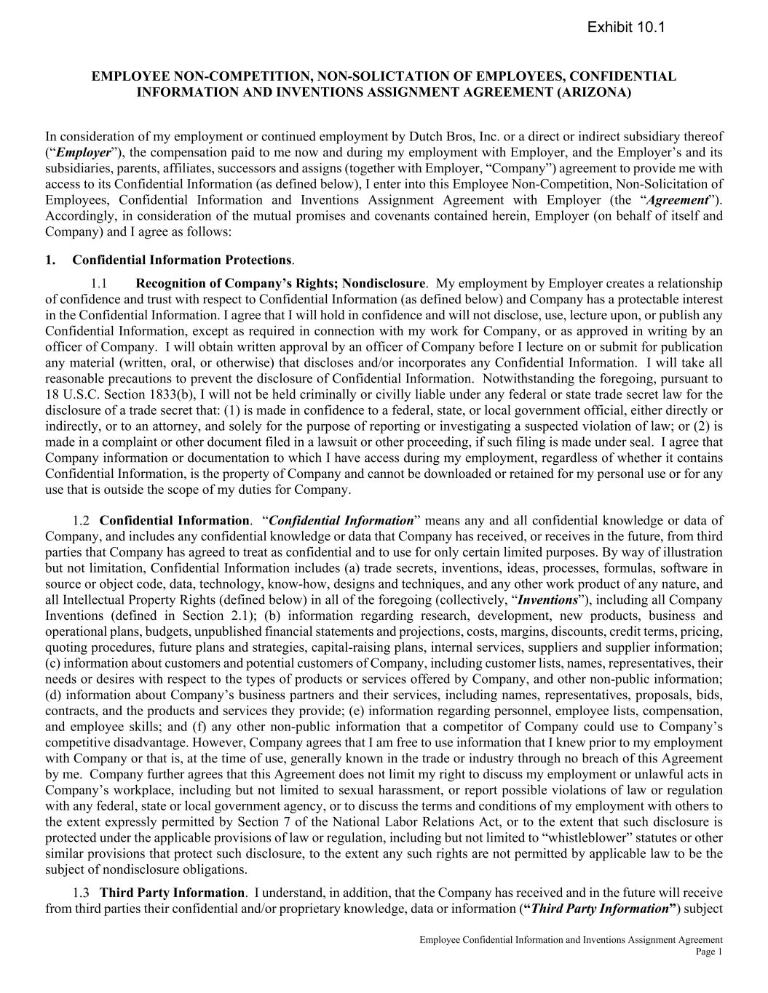
Dutch Bros Inc.| Form 10-Q | 56
Employee Confidential Information and Inventions Assignment Agreement Page 1 EMPLOYEE NON-COMPETITION, NON-SOLICTATION OF EMPLOYEES, CONFIDENTIAL INFORMATION AND INVENTIONS ASSIGNMENT AGREEMENT (ARIZONA) In consideration of my employment or continued employment by Dutch Bros, Inc. or a direct or indirect subsidiary thereof (“Employer”), the compensation paid to me now and during my employment with Employer, and the Employer’s and its subsidiaries, parents, affiliates, successors and assigns (together with Employer, “Company”) agreement to provide me with access to its Confidential Information (as defined below), I enter into this Employee Non-Competition, Non-Solicitation of Employees, Confidential Information and Inventions Assignment Agreement with Employer (the “Agreement”). Accordingly, in consideration of the mutual promises and covenants contained herein, Employer (on behalf of itself and Company) and I agree as follows: 1. Confidential Information Protections. Recognition of Company’s Rights; Nondisclosure. My employment by Employer creates a relationship of confidence and trust with respect to Confidential Information (as defined below) and Company has a protectable interest in the Confidential Information. I agree that I will hold in confidence and will not disclose, use, lecture upon, or publish any Confidential Information, except as required in connection with my work for Company, or as approved in writing by an officer of Company. I will obtain written approval by an officer of Company before I lecture on or submit for publication any material (written, oral, or otherwise) that discloses and/or incorporates any Confidential Information. I will take all reasonable precautions to prevent the disclosure of Confidential Information. Notwithstanding the foregoing, pursuant to 18 U.S.C. Section 1833(b), I will not be held criminally or civilly liable under any federal or state trade secret law for the disclosure of a trade secret that: (1) is made in confidence to a federal, state, or local government official, either directly or indirectly, or to an attorney, and solely for the purpose of reporting or investigating a suspected violation of law; or (2) is made in a complaint or other document filed in a lawsuit or other proceeding, if such filing is made under seal. I agree that Company information or documentation to which I have access during my employment, regardless of whether it contains Confidential Information, is the property of Company and cannot be downloaded or retained for my personal use or for any use that is outside the scope of my duties for Company. Confidential Information. “Confidential Information” means any and all confidential knowledge or data of Company, and includes any confidential knowledge or data that Company has received, or receives in the future, from third parties that Company has agreed to treat as confidential and to use for only certain limited purposes. By way of illustration but not limitation, Confidential Information includes (a) trade secrets, inventions, ideas, processes, formulas, software in source or object code, data, technology, know-how, designs and techniques, and any other work product of any nature, and all Intellectual Property Rights (defined below) in all of the foregoing (collectively, “Inventions”), including all Company Inventions (defined in Section 2.1); (b) information regarding research, development, new products, business and operational plans, budgets, unpublished financial statements and projections, costs, margins, discounts, credit terms, pricing, quoting procedures, future plans and strategies, capital-raising plans, internal services, suppliers and supplier information; (c) information about customers and potential customers of Company, including customer lists, names, representatives, their needs or desires with respect to the types of products or services offered by Company, and other non-public information; (d) information about Company’s business partners and their services, including names, representatives, proposals, bids, contracts, and the products and services they provide; (e) information regarding personnel, employee lists, compensation, and employee skills; and (f) any other non-public information that a competitor of Company could use to Company’s competitive disadvantage. However, Company agrees that I am free to use information that I knew prior to my employment with Company or that is, at the time of use, generally known in the trade or industry through no breach of this Agreement by me. Company further agrees that this Agreement does not limit my right to discuss my employment or unlawful acts in Company’s workplace, including but not limited to sexual harassment, or report possible violations of law or regulation with any federal, state or local government agency, or to discuss the terms and conditions of my employment with others to the extent expressly permitted by Section 7 of the National Labor Relations Act, or to the extent that such disclosure is protected under the applicable provisions of law or regulation, including but not limited to “whistleblower” statutes or other similar provisions that protect such disclosure, to the extent any such rights are not permitted by applicable law to be the subject of nondisclosure obligations. Third Party Information. I understand, in addition, that the Company has received and in the future will receive from third parties their confidential and/or proprietary knowledge, data or information (“Third Party Information”) subject Exhibit 10.1

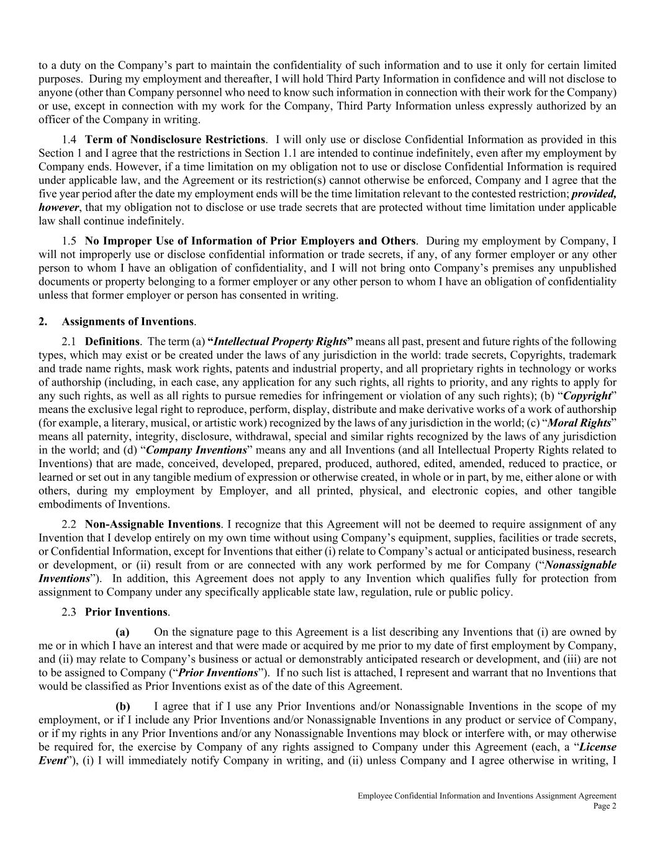
Employee Confidential Information and Inventions Assignment Agreement Page 2 to a duty on the Company’s part to maintain the confidentiality of such information and to use it only for certain limited purposes. During my employment and thereafter, I will hold Third Party Information in confidence and will not disclose to anyone (other than Company personnel who need to know such information in connection with their work for the Company) or use, except in connection with my work for the Company, Third Party Information unless expressly authorized by an officer of the Company in writing. Term of Nondisclosure Restrictions. I will only use or disclose Confidential Information as provided in this Section 1 and I agree that the restrictions in Section 1.1 are intended to continue indefinitely, even after my employment by Company ends. However, if a time limitation on my obligation not to use or disclose Confidential Information is required under applicable law, and the Agreement or its restriction(s) cannot otherwise be enforced, Company and I agree that the five year period after the date my employment ends will be the time limitation relevant to the contested restriction; provided, however, that my obligation not to disclose or use trade secrets that are protected without time limitation under applicable law shall continue indefinitely. No Improper Use of Information of Prior Employers and Others. During my employment by Company, I will not improperly use or disclose confidential information or trade secrets, if any, of any former employer or any other person to whom I have an obligation of confidentiality, and I will not bring onto Company’s premises any unpublished documents or property belonging to a former employer or any other person to whom I have an obligation of confidentiality unless that former employer or person has consented in writing. 2. Assignments of Inventions. Definitions. The term (a) “Intellectual Property Rights” means all past, present and future rights of the following types, which may exist or be created under the laws of any jurisdiction in the world: trade secrets, Copyrights, trademark and trade name rights, mask work rights, patents and industrial property, and all proprietary rights in technology or works of authorship (including, in each case, any application for any such rights, all rights to priority, and any rights to apply for any such rights, as well as all rights to pursue remedies for infringement or violation of any such rights); (b) “Copyright” means the exclusive legal right to reproduce, perform, display, distribute and make derivative works of a work of authorship (for example, a literary, musical, or artistic work) recognized by the laws of any jurisdiction in the world; (c) “Moral Rights” means all paternity, integrity, disclosure, withdrawal, special and similar rights recognized by the laws of any jurisdiction in the world; and (d) “Company Inventions” means any and all Inventions (and all Intellectual Property Rights related to Inventions) that are made, conceived, developed, prepared, produced, authored, edited, amended, reduced to practice, or learned or set out in any tangible medium of expression or otherwise created, in whole or in part, by me, either alone or with others, during my employment by Employer, and all printed, physical, and electronic copies, and other tangible embodiments of Inventions. Non-Assignable Inventions. I recognize that this Agreement will not be deemed to require assignment of any Invention that I develop entirely on my own time without using Company’s equipment, supplies, facilities or trade secrets, or Confidential Information, except for Inventions that either (i) relate to Company’s actual or anticipated business, research or development, or (ii) result from or are connected with any work performed by me for Company (“Nonassignable Inventions”). In addition, this Agreement does not apply to any Invention which qualifies fully for protection from assignment to Company under any specifically applicable state law, regulation, rule or public policy. Prior Inventions. On the signature page to this Agreement is a list describing any Inventions that (i) are owned by me or in which I have an interest and that were made or acquired by me prior to my date of first employment by Company, and (ii) may relate to Company’s business or actual or demonstrably anticipated research or development, and (iii) are not to be assigned to Company (“Prior Inventions”). If no such list is attached, I represent and warrant that no Inventions that would be classified as Prior Inventions exist as of the date of this Agreement. I agree that if I use any Prior Inventions and/or Nonassignable Inventions in the scope of my employment, or if I include any Prior Inventions and/or Nonassignable Inventions in any product or service of Company, or if my rights in any Prior Inventions and/or any Nonassignable Inventions may block or interfere with, or may otherwise be required for, the exercise by Company of any rights assigned to Company under this Agreement (each, a “License Event”), (i) I will immediately notify Company in writing, and (ii) unless Company and I agree otherwise in writing, I

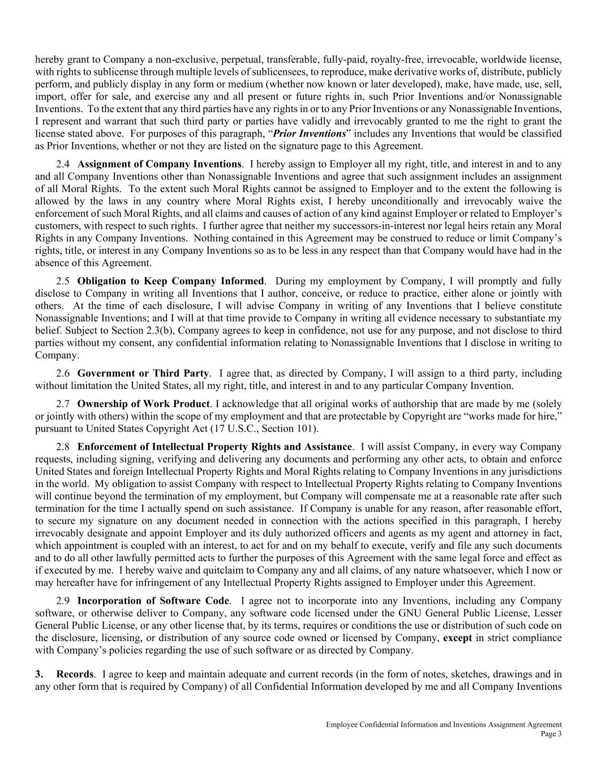
Employee Confidential Information and Inventions Assignment Agreement Page 3 hereby grant to Company a non-exclusive, perpetual, transferable, fully-paid, royalty-free, irrevocable, worldwide license, with rights to sublicense through multiple levels of sublicensees, to reproduce, make derivative works of, distribute, publicly perform, and publicly display in any form or medium (whether now known or later developed), make, have made, use, sell, import, offer for sale, and exercise any and all present or future rights in, such Prior Inventions and/or Nonassignable Inventions. To the extent that any third parties have any rights in or to any Prior Inventions or any Nonassignable Inventions, I represent and warrant that such third party or parties have validly and irrevocably granted to me the right to grant the license stated above. For purposes of this paragraph, “Prior Inventions” includes any Inventions that would be classified as Prior Inventions, whether or not they are listed on the signature page to this Agreement. Assignment of Company Inventions. I hereby assign to Employer all my right, title, and interest in and to any and all Company Inventions other than Nonassignable Inventions and agree that such assignment includes an assignment of all Moral Rights. To the extent such Moral Rights cannot be assigned to Employer and to the extent the following is allowed by the laws in any country where Moral Rights exist, I hereby unconditionally and irrevocably waive the enforcement of such Moral Rights, and all claims and causes of action of any kind against Employer or related to Employer’s customers, with respect to such rights. I further agree that neither my successors-in-interest nor legal heirs retain any Moral Rights in any Company Inventions. Nothing contained in this Agreement may be construed to reduce or limit Company’s rights, title, or interest in any Company Inventions so as to be less in any respect than that Company would have had in the absence of this Agreement. Obligation to Keep Company Informed. During my employment by Company, I will promptly and fully disclose to Company in writing all Inventions that I author, conceive, or reduce to practice, either alone or jointly with others. At the time of each disclosure, I will advise Company in writing of any Inventions that I believe constitute Nonassignable Inventions; and I will at that time provide to Company in writing all evidence necessary to substantiate my belief. Subject to Section 2.3(b), Company agrees to keep in confidence, not use for any purpose, and not disclose to third parties without my consent, any confidential information relating to Nonassignable Inventions that I disclose in writing to Company. Government or Third Party. I agree that, as directed by Company, I will assign to a third party, including without limitation the United States, all my right, title, and interest in and to any particular Company Invention. Ownership of Work Product. I acknowledge that all original works of authorship that are made by me (solely or jointly with others) within the scope of my employment and that are protectable by Copyright are “works made for hire,” pursuant to United States Copyright Act (17 U.S.C., Section 101). Enforcement of Intellectual Property Rights and Assistance. I will assist Company, in every way Company requests, including signing, verifying and delivering any documents and performing any other acts, to obtain and enforce United States and foreign Intellectual Property Rights and Moral Rights relating to Company Inventions in any jurisdictions in the world. My obligation to assist Company with respect to Intellectual Property Rights relating to Company Inventions will continue beyond the termination of my employment, but Company will compensate me at a reasonable rate after such termination for the time I actually spend on such assistance. If Company is unable for any reason, after reasonable effort, to secure my signature on any document needed in connection with the actions specified in this paragraph, I hereby irrevocably designate and appoint Employer and its duly authorized officers and agents as my agent and attorney in fact, which appointment is coupled with an interest, to act for and on my behalf to execute, verify and file any such documents and to do all other lawfully permitted acts to further the purposes of this Agreement with the same legal force and effect as if executed by me. I hereby waive and quitclaim to Company any and all claims, of any nature whatsoever, which I now or may hereafter have for infringement of any Intellectual Property Rights assigned to Employer under this Agreement. Incorporation of Software Code. I agree not to incorporate into any Inventions, including any Company software, or otherwise deliver to Company, any software code licensed under the GNU General Public License, Lesser General Public License, or any other license that, by its terms, requires or conditions the use or distribution of such code on the disclosure, licensing, or distribution of any source code owned or licensed by Company, except in strict compliance with Company’s policies regarding the use of such software or as directed by Company. 3. Records. I agree to keep and maintain adequate and current records (in the form of notes, sketches, drawings and in any other form that is required by Company) of all Confidential Information developed by me and all Company Inventions

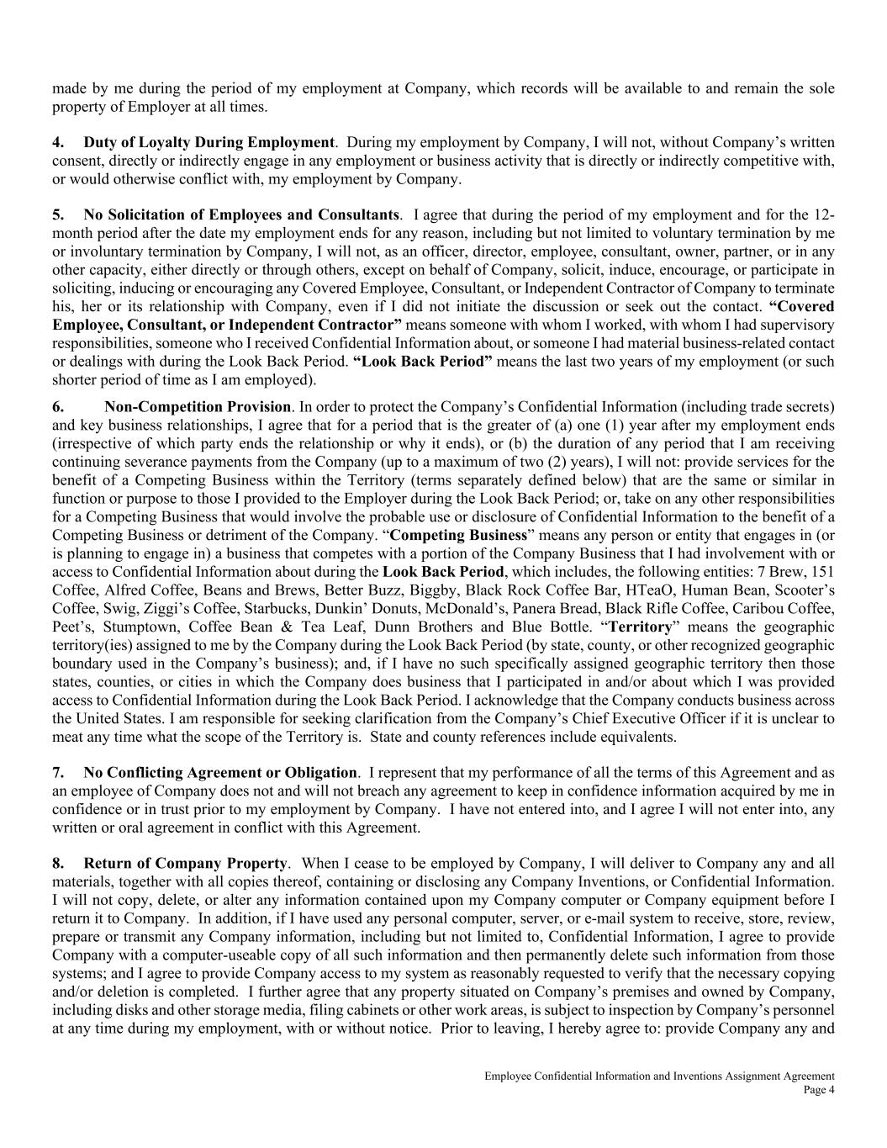
Employee Confidential Information and Inventions Assignment Agreement Page 4 made by me during the period of my employment at Company, which records will be available to and remain the sole property of Employer at all times. 4. Duty of Loyalty During Employment. During my employment by Company, I will not, without Company’s written consent, directly or indirectly engage in any employment or business activity that is directly or indirectly competitive with, or would otherwise conflict with, my employment by Company. 5. No Solicitation of Employees and Consultants. I agree that during the period of my employment and for the 12- month period after the date my employment ends for any reason, including but not limited to voluntary termination by me or involuntary termination by Company, I will not, as an officer, director, employee, consultant, owner, partner, or in any other capacity, either directly or through others, except on behalf of Company, solicit, induce, encourage, or participate in soliciting, inducing or encouraging any Covered Employee, Consultant, or Independent Contractor of Company to terminate his, her or its relationship with Company, even if I did not initiate the discussion or seek out the contact. “Covered Employee, Consultant, or Independent Contractor” means someone with whom I worked, with whom I had supervisory responsibilities, someone who I received Confidential Information about, or someone I had material business-related contact or dealings with during the Look Back Period. “Look Back Period” means the last two years of my employment (or such shorter period of time as I am employed). 6. Non-Competition Provision. In order to protect the Company’s Confidential Information (including trade secrets) and key business relationships, I agree that for a period that is the greater of (a) one (1) year after my employment ends (irrespective of which party ends the relationship or why it ends), or (b) the duration of any period that I am receiving continuing severance payments from the Company (up to a maximum of two (2) years), I will not: provide services for the benefit of a Competing Business within the Territory (terms separately defined below) that are the same or similar in function or purpose to those I provided to the Employer during the Look Back Period; or, take on any other responsibilities for a Competing Business that would involve the probable use or disclosure of Confidential Information to the benefit of a Competing Business or detriment of the Company. “Competing Business” means any person or entity that engages in (or is planning to engage in) a business that competes with a portion of the Company Business that I had involvement with or access to Confidential Information about during the Look Back Period, which includes, the following entities: 7 Brew, 151 Coffee, Alfred Coffee, Beans and Brews, Better Buzz, Biggby, Black Rock Coffee Bar, HTeaO, Human Bean, Scooter’s Coffee, Swig, Ziggi’s Coffee, Starbucks, Dunkin’ Donuts, McDonald’s, Panera Bread, Black Rifle Coffee, Caribou Coffee, Peet’s, Stumptown, Coffee Bean & Tea Leaf, Dunn Brothers and Blue Bottle. “Territory” means the geographic territory(ies) assigned to me by the Company during the Look Back Period (by state, county, or other recognized geographic boundary used in the Company’s business); and, if I have no such specifically assigned geographic territory then those states, counties, or cities in which the Company does business that I participated in and/or about which I was provided access to Confidential Information during the Look Back Period. I acknowledge that the Company conducts business across the United States. I am responsible for seeking clarification from the Company’s Chief Executive Officer if it is unclear to meat any time what the scope of the Territory is. State and county references include equivalents. 7. No Conflicting Agreement or Obligation. I represent that my performance of all the terms of this Agreement and as an employee of Company does not and will not breach any agreement to keep in confidence information acquired by me in confidence or in trust prior to my employment by Company. I have not entered into, and I agree I will not enter into, any written or oral agreement in conflict with this Agreement. 8. Return of Company Property. When I cease to be employed by Company, I will deliver to Company any and all materials, together with all copies thereof, containing or disclosing any Company Inventions, or Confidential Information. I will not copy, delete, or alter any information contained upon my Company computer or Company equipment before I return it to Company. In addition, if I have used any personal computer, server, or e-mail system to receive, store, review, prepare or transmit any Company information, including but not limited to, Confidential Information, I agree to provide Company with a computer-useable copy of all such information and then permanently delete such information from those systems; and I agree to provide Company access to my system as reasonably requested to verify that the necessary copying and/or deletion is completed. I further agree that any property situated on Company’s premises and owned by Company, including disks and other storage media, filing cabinets or other work areas, is subject to inspection by Company’s personnel at any time during my employment, with or without notice. Prior to leaving, I hereby agree to: provide Company any and

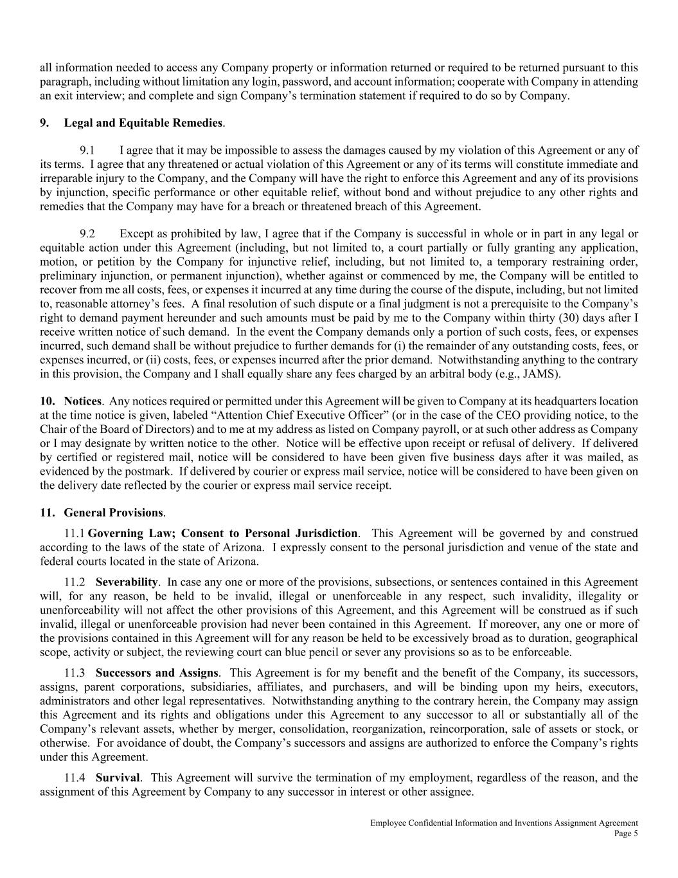
Employee Confidential Information and Inventions Assignment Agreement Page 5 all information needed to access any Company property or information returned or required to be returned pursuant to this paragraph, including without limitation any login, password, and account information; cooperate with Company in attending an exit interview; and complete and sign Company’s termination statement if required to do so by Company. 9. Legal and Equitable Remedies. I agree that it may be impossible to assess the damages caused by my violation of this Agreement or any of its terms. I agree that any threatened or actual violation of this Agreement or any of its terms will constitute immediate and irreparable injury to the Company, and the Company will have the right to enforce this Agreement and any of its provisions by injunction, specific performance or other equitable relief, without bond and without prejudice to any other rights and remedies that the Company may have for a breach or threatened breach of this Agreement. Except as prohibited by law, I agree that if the Company is successful in whole or in part in any legal or equitable action under this Agreement (including, but not limited to, a court partially or fully granting any application, motion, or petition by the Company for injunctive relief, including, but not limited to, a temporary restraining order, preliminary injunction, or permanent injunction), whether against or commenced by me, the Company will be entitled to recover from me all costs, fees, or expenses it incurred at any time during the course of the dispute, including, but not limited to, reasonable attorney’s fees. A final resolution of such dispute or a final judgment is not a prerequisite to the Company’s right to demand payment hereunder and such amounts must be paid by me to the Company within thirty (30) days after I receive written notice of such demand. In the event the Company demands only a portion of such costs, fees, or expenses incurred, such demand shall be without prejudice to further demands for (i) the remainder of any outstanding costs, fees, or expenses incurred, or (ii) costs, fees, or expenses incurred after the prior demand. Notwithstanding anything to the contrary in this provision, the Company and I shall equally share any fees charged by an arbitral body (e.g., JAMS). 10. Notices. Any notices required or permitted under this Agreement will be given to Company at its headquarters location at the time notice is given, labeled “Attention Chief Executive Officer” (or in the case of the CEO providing notice, to the Chair of the Board of Directors) and to me at my address as listed on Company payroll, or at such other address as Company or I may designate by written notice to the other. Notice will be effective upon receipt or refusal of delivery. If delivered by certified or registered mail, notice will be considered to have been given five business days after it was mailed, as evidenced by the postmark. If delivered by courier or express mail service, notice will be considered to have been given on the delivery date reflected by the courier or express mail service receipt. 11. General Provisions. Governing Law; Consent to Personal Jurisdiction. This Agreement will be governed by and construed according to the laws of the state of Arizona. I expressly consent to the personal jurisdiction and venue of the state and federal courts located in the state of Arizona. Severability. In case any one or more of the provisions, subsections, or sentences contained in this Agreement will, for any reason, be held to be invalid, illegal or unenforceable in any respect, such invalidity, illegality or unenforceability will not affect the other provisions of this Agreement, and this Agreement will be construed as if such invalid, illegal or unenforceable provision had never been contained in this Agreement. If moreover, any one or more of the provisions contained in this Agreement will for any reason be held to be excessively broad as to duration, geographical scope, activity or subject, the reviewing court can blue pencil or sever any provisions so as to be enforceable. Successors and Assigns. This Agreement is for my benefit and the benefit of the Company, its successors, assigns, parent corporations, subsidiaries, affiliates, and purchasers, and will be binding upon my heirs, executors, administrators and other legal representatives. Notwithstanding anything to the contrary herein, the Company may assign this Agreement and its rights and obligations under this Agreement to any successor to all or substantially all of the Company’s relevant assets, whether by merger, consolidation, reorganization, reincorporation, sale of assets or stock, or otherwise. For avoidance of doubt, the Company’s successors and assigns are authorized to enforce the Company’s rights under this Agreement. Survival. This Agreement will survive the termination of my employment, regardless of the reason, and the assignment of this Agreement by Company to any successor in interest or other assignee.

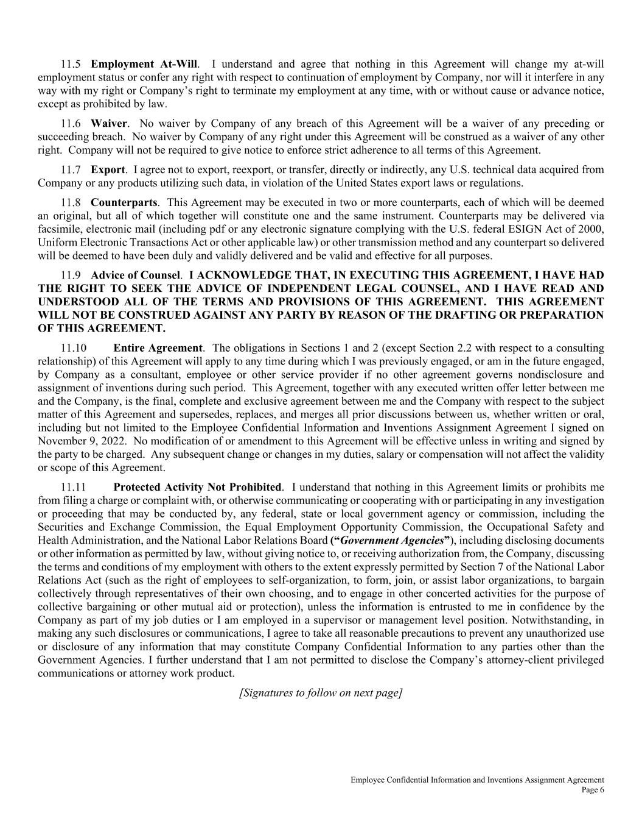
Employee Confidential Information and Inventions Assignment Agreement Page 6 Employment At-Will. I understand and agree that nothing in this Agreement will change my at-will employment status or confer any right with respect to continuation of employment by Company, nor will it interfere in any way with my right or Company’s right to terminate my employment at any time, with or without cause or advance notice, except as prohibited by law. Waiver. No waiver by Company of any breach of this Agreement will be a waiver of any preceding or succeeding breach. No waiver by Company of any right under this Agreement will be construed as a waiver of any other right. Company will not be required to give notice to enforce strict adherence to all terms of this Agreement. Export. I agree not to export, reexport, or transfer, directly or indirectly, any U.S. technical data acquired from Company or any products utilizing such data, in violation of the United States export laws or regulations. Counterparts. This Agreement may be executed in two or more counterparts, each of which will be deemed an original, but all of which together will constitute one and the same instrument. Counterparts may be delivered via facsimile, electronic mail (including pdf or any electronic signature complying with the U.S. federal ESIGN Act of 2000, Uniform Electronic Transactions Act or other applicable law) or other transmission method and any counterpart so delivered will be deemed to have been duly and validly delivered and be valid and effective for all purposes. Advice of Counsel. I ACKNOWLEDGE THAT, IN EXECUTING THIS AGREEMENT, I HAVE HAD THE RIGHT TO SEEK THE ADVICE OF INDEPENDENT LEGAL COUNSEL, AND I HAVE READ AND UNDERSTOOD ALL OF THE TERMS AND PROVISIONS OF THIS AGREEMENT. THIS AGREEMENT WILL NOT BE CONSTRUED AGAINST ANY PARTY BY REASON OF THE DRAFTING OR PREPARATION OF THIS AGREEMENT. Entire Agreement. The obligations in Sections 1 and 2 (except Section 2.2 with respect to a consulting relationship) of this Agreement will apply to any time during which I was previously engaged, or am in the future engaged, by Company as a consultant, employee or other service provider if no other agreement governs nondisclosure and assignment of inventions during such period. This Agreement, together with any executed written offer letter between me and the Company, is the final, complete and exclusive agreement between me and the Company with respect to the subject matter of this Agreement and supersedes, replaces, and merges all prior discussions between us, whether written or oral, including but not limited to the Employee Confidential Information and Inventions Assignment Agreement I signed on November 9, 2022. No modification of or amendment to this Agreement will be effective unless in writing and signed by the party to be charged. Any subsequent change or changes in my duties, salary or compensation will not affect the validity or scope of this Agreement. Protected Activity Not Prohibited. I understand that nothing in this Agreement limits or prohibits me from filing a charge or complaint with, or otherwise communicating or cooperating with or participating in any investigation or proceeding that may be conducted by, any federal, state or local government agency or commission, including the Securities and Exchange Commission, the Equal Employment Opportunity Commission, the Occupational Safety and Health Administration, and the National Labor Relations Board (“Government Agencies”), including disclosing documents or other information as permitted by law, without giving notice to, or receiving authorization from, the Company, discussing the terms and conditions of my employment with others to the extent expressly permitted by Section 7 of the National Labor Relations Act (such as the right of employees to self-organization, to form, join, or assist labor organizations, to bargain collectively through representatives of their own choosing, and to engage in other concerted activities for the purpose of collective bargaining or other mutual aid or protection), unless the information is entrusted to me in confidence by the Company as part of my job duties or I am employed in a supervisor or management level position. Notwithstanding, in making any such disclosures or communications, I agree to take all reasonable precautions to prevent any unauthorized use or disclosure of any information that may constitute Company Confidential Information to any parties other than the Government Agencies. I further understand that I am not permitted to disclose the Company’s attorney-client privileged communications or attorney work product. [Signatures to follow on next page]

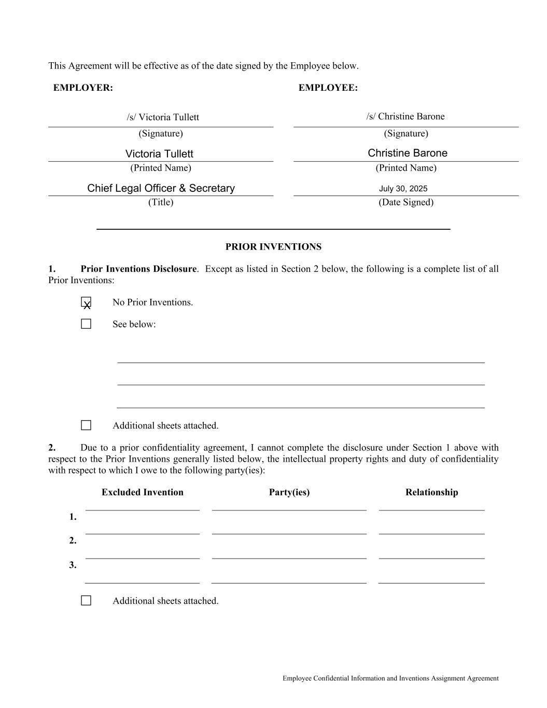
Employee Confidential Information and Inventions Assignment Agreement This Agreement will be effective as of the date signed by the Employee below. EMPLOYER: EMPLOYEE: (Signature) (Signature) (Printed Name) (Printed Name) (Title) (Date Signed) PRIOR INVENTIONS 1. Prior Inventions Disclosure. Except as listed in Section 2 below, the following is a complete list of all Prior Inventions: No Prior Inventions. See below: Additional sheets attached. 2. Due to a prior confidentiality agreement, I cannot complete the disclosure under Section 1 above with respect to the Prior Inventions generally listed below, the intellectual property rights and duty of confidentiality with respect to which I owe to the following party(ies): Excluded Invention Party(ies) Relationship 1. 2. 3. Additional sheets attached. Christine BaroneVictoria Tullett Chief Legal Officer & Secretary X July 30, 2025 /s/ Victoria Tullett /s/ Christine Barone

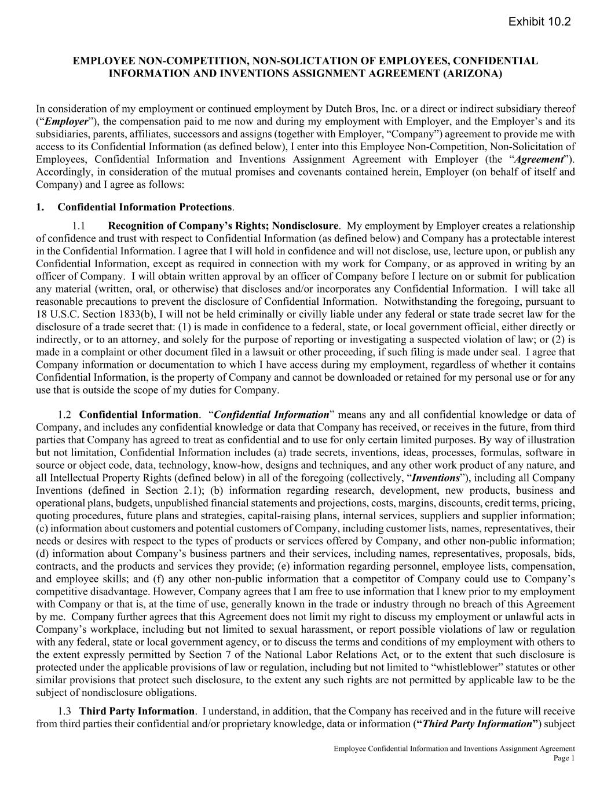
Employee Confidential Information and Inventions Assignment Agreement Page 1 EMPLOYEE NON-COMPETITION, NON-SOLICTATION OF EMPLOYEES, CONFIDENTIAL INFORMATION AND INVENTIONS ASSIGNMENT AGREEMENT (ARIZONA) In consideration of my employment or continued employment by Dutch Bros, Inc. or a direct or indirect subsidiary thereof (“Employer”), the compensation paid to me now and during my employment with Employer, and the Employer’s and its subsidiaries, parents, affiliates, successors and assigns (together with Employer, “Company”) agreement to provide me with access to its Confidential Information (as defined below), I enter into this Employee Non-Competition, Non-Solicitation of Employees, Confidential Information and Inventions Assignment Agreement with Employer (the “Agreement”). Accordingly, in consideration of the mutual promises and covenants contained herein, Employer (on behalf of itself and Company) and I agree as follows: 1. Confidential Information Protections. Recognition of Company’s Rights; Nondisclosure. My employment by Employer creates a relationship of confidence and trust with respect to Confidential Information (as defined below) and Company has a protectable interest in the Confidential Information. I agree that I will hold in confidence and will not disclose, use, lecture upon, or publish any Confidential Information, except as required in connection with my work for Company, or as approved in writing by an officer of Company. I will obtain written approval by an officer of Company before I lecture on or submit for publication any material (written, oral, or otherwise) that discloses and/or incorporates any Confidential Information. I will take all reasonable precautions to prevent the disclosure of Confidential Information. Notwithstanding the foregoing, pursuant to 18 U.S.C. Section 1833(b), I will not be held criminally or civilly liable under any federal or state trade secret law for the disclosure of a trade secret that: (1) is made in confidence to a federal, state, or local government official, either directly or indirectly, or to an attorney, and solely for the purpose of reporting or investigating a suspected violation of law; or (2) is made in a complaint or other document filed in a lawsuit or other proceeding, if such filing is made under seal. I agree that Company information or documentation to which I have access during my employment, regardless of whether it contains Confidential Information, is the property of Company and cannot be downloaded or retained for my personal use or for any use that is outside the scope of my duties for Company. Confidential Information. “Confidential Information” means any and all confidential knowledge or data of Company, and includes any confidential knowledge or data that Company has received, or receives in the future, from third parties that Company has agreed to treat as confidential and to use for only certain limited purposes. By way of illustration but not limitation, Confidential Information includes (a) trade secrets, inventions, ideas, processes, formulas, software in source or object code, data, technology, know-how, designs and techniques, and any other work product of any nature, and all Intellectual Property Rights (defined below) in all of the foregoing (collectively, “Inventions”), including all Company Inventions (defined in Section 2.1); (b) information regarding research, development, new products, business and operational plans, budgets, unpublished financial statements and projections, costs, margins, discounts, credit terms, pricing, quoting procedures, future plans and strategies, capital-raising plans, internal services, suppliers and supplier information; (c) information about customers and potential customers of Company, including customer lists, names, representatives, their needs or desires with respect to the types of products or services offered by Company, and other non-public information; (d) information about Company’s business partners and their services, including names, representatives, proposals, bids, contracts, and the products and services they provide; (e) information regarding personnel, employee lists, compensation, and employee skills; and (f) any other non-public information that a competitor of Company could use to Company’s competitive disadvantage. However, Company agrees that I am free to use information that I knew prior to my employment with Company or that is, at the time of use, generally known in the trade or industry through no breach of this Agreement by me. Company further agrees that this Agreement does not limit my right to discuss my employment or unlawful acts in Company’s workplace, including but not limited to sexual harassment, or report possible violations of law or regulation with any federal, state or local government agency, or to discuss the terms and conditions of my employment with others to the extent expressly permitted by Section 7 of the National Labor Relations Act, or to the extent that such disclosure is protected under the applicable provisions of law or regulation, including but not limited to “whistleblower” statutes or other similar provisions that protect such disclosure, to the extent any such rights are not permitted by applicable law to be the subject of nondisclosure obligations. Third Party Information. I understand, in addition, that the Company has received and in the future will receive from third parties their confidential and/or proprietary knowledge, data or information (“Third Party Information”) subject Exhibit 10.2

Employee Confidential Information and Inventions Assignment Agreement Page 2 to a duty on the Company’s part to maintain the confidentiality of such information and to use it only for certain limited purposes. During my employment and thereafter, I will hold Third Party Information in confidence and will not disclose to anyone (other than Company personnel who need to know such information in connection with their work for the Company) or use, except in connection with my work for the Company, Third Party Information unless expressly authorized by an officer of the Company in writing. Term of Nondisclosure Restrictions. I will only use or disclose Confidential Information as provided in this Section 1 and I agree that the restrictions in Section 1.1 are intended to continue indefinitely, even after my employment by Company ends. However, if a time limitation on my obligation not to use or disclose Confidential Information is required under applicable law, and the Agreement or its restriction(s) cannot otherwise be enforced, Company and I agree that the five year period after the date my employment ends will be the time limitation relevant to the contested restriction; provided, however, that my obligation not to disclose or use trade secrets that are protected without time limitation under applicable law shall continue indefinitely. No Improper Use of Information of Prior Employers and Others. During my employment by Company, I will not improperly use or disclose confidential information or trade secrets, if any, of any former employer or any other person to whom I have an obligation of confidentiality, and I will not bring onto Company’s premises any unpublished documents or property belonging to a former employer or any other person to whom I have an obligation of confidentiality unless that former employer or person has consented in writing. 2. Assignments of Inventions. Definitions. The term (a) “Intellectual Property Rights” means all past, present and future rights of the following types, which may exist or be created under the laws of any jurisdiction in the world: trade secrets, Copyrights, trademark and trade name rights, mask work rights, patents and industrial property, and all proprietary rights in technology or works of authorship (including, in each case, any application for any such rights, all rights to priority, and any rights to apply for any such rights, as well as all rights to pursue remedies for infringement or violation of any such rights); (b) “Copyright” means the exclusive legal right to reproduce, perform, display, distribute and make derivative works of a work of authorship (for example, a literary, musical, or artistic work) recognized by the laws of any jurisdiction in the world; (c) “Moral Rights” means all paternity, integrity, disclosure, withdrawal, special and similar rights recognized by the laws of any jurisdiction in the world; and (d) “Company Inventions” means any and all Inventions (and all Intellectual Property Rights related to Inventions) that are made, conceived, developed, prepared, produced, authored, edited, amended, reduced to practice, or learned or set out in any tangible medium of expression or otherwise created, in whole or in part, by me, either alone or with others, during my employment by Employer, and all printed, physical, and electronic copies, and other tangible embodiments of Inventions. Non-Assignable Inventions. I recognize that this Agreement will not be deemed to require assignment of any Invention that I develop entirely on my own time without using Company’s equipment, supplies, facilities or trade secrets, or Confidential Information, except for Inventions that either (i) relate to Company’s actual or anticipated business, research or development, or (ii) result from or are connected with any work performed by me for Company (“Nonassignable Inventions”). In addition, this Agreement does not apply to any Invention which qualifies fully for protection from assignment to Company under any specifically applicable state law, regulation, rule or public policy. Prior Inventions. On the signature page to this Agreement is a list describing any Inventions that (i) are owned by me or in which I have an interest and that were made or acquired by me prior to my date of first employment by Company, and (ii) may relate to Company’s business or actual or demonstrably anticipated research or development, and (iii) are not to be assigned to Company (“Prior Inventions”). If no such list is attached, I represent and warrant that no Inventions that would be classified as Prior Inventions exist as of the date of this Agreement. I agree that if I use any Prior Inventions and/or Nonassignable Inventions in the scope of my employment, or if I include any Prior Inventions and/or Nonassignable Inventions in any product or service of Company, or if my rights in any Prior Inventions and/or any Nonassignable Inventions may block or interfere with, or may otherwise be required for, the exercise by Company of any rights assigned to Company under this Agreement (each, a “License Event”), (i) I will immediately notify Company in writing, and (ii) unless Company and I agree otherwise in writing, I

Employee Confidential Information and Inventions Assignment Agreement Page 3 hereby grant to Company a non-exclusive, perpetual, transferable, fully-paid, royalty-free, irrevocable, worldwide license, with rights to sublicense through multiple levels of sublicensees, to reproduce, make derivative works of, distribute, publicly perform, and publicly display in any form or medium (whether now known or later developed), make, have made, use, sell, import, offer for sale, and exercise any and all present or future rights in, such Prior Inventions and/or Nonassignable Inventions. To the extent that any third parties have any rights in or to any Prior Inventions or any Nonassignable Inventions, I represent and warrant that such third party or parties have validly and irrevocably granted to me the right to grant the license stated above. For purposes of this paragraph, “Prior Inventions” includes any Inventions that would be classified as Prior Inventions, whether or not they are listed on the signature page to this Agreement. Assignment of Company Inventions. I hereby assign to Employer all my right, title, and interest in and to any and all Company Inventions other than Nonassignable Inventions and agree that such assignment includes an assignment of all Moral Rights. To the extent such Moral Rights cannot be assigned to Employer and to the extent the following is allowed by the laws in any country where Moral Rights exist, I hereby unconditionally and irrevocably waive the enforcement of such Moral Rights, and all claims and causes of action of any kind against Employer or related to Employer’s customers, with respect to such rights. I further agree that neither my successors-in-interest nor legal heirs retain any Moral Rights in any Company Inventions. Nothing contained in this Agreement may be construed to reduce or limit Company’s rights, title, or interest in any Company Inventions so as to be less in any respect than that Company would have had in the absence of this Agreement. Obligation to Keep Company Informed. During my employment by Company, I will promptly and fully disclose to Company in writing all Inventions that I author, conceive, or reduce to practice, either alone or jointly with others. At the time of each disclosure, I will advise Company in writing of any Inventions that I believe constitute Nonassignable Inventions; and I will at that time provide to Company in writing all evidence necessary to substantiate my belief. Subject to Section 2.3(b), Company agrees to keep in confidence, not use for any purpose, and not disclose to third parties without my consent, any confidential information relating to Nonassignable Inventions that I disclose in writing to Company. Government or Third Party. I agree that, as directed by Company, I will assign to a third party, including without limitation the United States, all my right, title, and interest in and to any particular Company Invention. Ownership of Work Product. I acknowledge that all original works of authorship that are made by me (solely or jointly with others) within the scope of my employment and that are protectable by Copyright are “works made for hire,” pursuant to United States Copyright Act (17 U.S.C., Section 101). Enforcement of Intellectual Property Rights and Assistance. I will assist Company, in every way Company requests, including signing, verifying and delivering any documents and performing any other acts, to obtain and enforce United States and foreign Intellectual Property Rights and Moral Rights relating to Company Inventions in any jurisdictions in the world. My obligation to assist Company with respect to Intellectual Property Rights relating to Company Inventions will continue beyond the termination of my employment, but Company will compensate me at a reasonable rate after such termination for the time I actually spend on such assistance. If Company is unable for any reason, after reasonable effort, to secure my signature on any document needed in connection with the actions specified in this paragraph, I hereby irrevocably designate and appoint Employer and its duly authorized officers and agents as my agent and attorney in fact, which appointment is coupled with an interest, to act for and on my behalf to execute, verify and file any such documents and to do all other lawfully permitted acts to further the purposes of this Agreement with the same legal force and effect as if executed by me. I hereby waive and quitclaim to Company any and all claims, of any nature whatsoever, which I now or may hereafter have for infringement of any Intellectual Property Rights assigned to Employer under this Agreement. Incorporation of Software Code. I agree not to incorporate into any Inventions, including any Company software, or otherwise deliver to Company, any software code licensed under the GNU General Public License, Lesser General Public License, or any other license that, by its terms, requires or conditions the use or distribution of such code on the disclosure, licensing, or distribution of any source code owned or licensed by Company, except in strict compliance with Company’s policies regarding the use of such software or as directed by Company. 3. Records. I agree to keep and maintain adequate and current records (in the form of notes, sketches, drawings and in any other form that is required by Company) of all Confidential Information developed by me and all Company Inventions

Employee Confidential Information and Inventions Assignment Agreement Page 4 made by me during the period of my employment at Company, which records will be available to and remain the sole property of Employer at all times. 4. Duty of Loyalty During Employment. During my employment by Company, I will not, without Company’s written consent, directly or indirectly engage in any employment or business activity that is directly or indirectly competitive with, or would otherwise conflict with, my employment by Company. 5. No Solicitation of Employees and Consultants. I agree that during the period of my employment and for the 12- month period after the date my employment ends for any reason, including but not limited to voluntary termination by me or involuntary termination by Company, I will not, as an officer, director, employee, consultant, owner, partner, or in any other capacity, either directly or through others, except on behalf of Company, solicit, induce, encourage, or participate in soliciting, inducing or encouraging any Covered Employee, Consultant, or Independent Contractor of Company to terminate his, her or its relationship with Company, even if I did not initiate the discussion or seek out the contact. “Covered Employee, Consultant, or Independent Contractor” means someone with whom I worked, with whom I had supervisory responsibilities, someone who I received Confidential Information about, or someone I had material business-related contact or dealings with during the Look Back Period. “Look Back Period” means the last two years of my employment (or such shorter period of time as I am employed). 6. Non-Competition Provision. In order to protect the Company’s Confidential Information (including trade secrets) and key business relationships, I agree that for a period that is the greater of (a) one (1) year after my employment ends (irrespective of which party ends the relationship or why it ends), or (b) the duration of any period that I am receiving continuing severance payments from the Company (up to a maximum of two (2) years), I will not: provide services for the benefit of a Competing Business within the Territory (terms separately defined below) that are the same or similar in function or purpose to those I provided to the Employer during the Look Back Period; or, take on any other responsibilities for a Competing Business that would involve the probable use or disclosure of Confidential Information to the benefit of a Competing Business or detriment of the Company. “Competing Business” means any person or entity that engages in (or is planning to engage in) a business that competes with a portion of the Company Business that I had involvement with or access to Confidential Information about during the Look Back Period, which includes, the following entities: 7 Brew, 151 Coffee, Alfred Coffee, Beans and Brews, Better Buzz, Biggby, Black Rock Coffee Bar, HTeaO, Human Bean, Scooter’s Coffee, Swig, Ziggi’s Coffee, Starbucks, Dunkin’ Donuts, McDonald’s, Panera Bread, Black Rifle Coffee, Caribou Coffee, Peet’s, Stumptown, Coffee Bean & Tea Leaf, Dunn Brothers and Blue Bottle. “Territory” means the geographic territory(ies) assigned to me by the Company during the Look Back Period (by state, county, or other recognized geographic boundary used in the Company’s business); and, if I have no such specifically assigned geographic territory then those states, counties, or cities in which the Company does business that I participated in and/or about which I was provided access to Confidential Information during the Look Back Period. I acknowledge that the Company conducts business across the United States. I am responsible for seeking clarification from the Company’s Chief Executive Officer if it is unclear to meat any time what the scope of the Territory is. State and county references include equivalents. 7. No Conflicting Agreement or Obligation. I represent that my performance of all the terms of this Agreement and as an employee of Company does not and will not breach any agreement to keep in confidence information acquired by me in confidence or in trust prior to my employment by Company. I have not entered into, and I agree I will not enter into, any written or oral agreement in conflict with this Agreement. 8. Return of Company Property. When I cease to be employed by Company, I will deliver to Company any and all materials, together with all copies thereof, containing or disclosing any Company Inventions, or Confidential Information. I will not copy, delete, or alter any information contained upon my Company computer or Company equipment before I return it to Company. In addition, if I have used any personal computer, server, or e-mail system to receive, store, review, prepare or transmit any Company information, including but not limited to, Confidential Information, I agree to provide Company with a computer-useable copy of all such information and then permanently delete such information from those systems; and I agree to provide Company access to my system as reasonably requested to verify that the necessary copying and/or deletion is completed. I further agree that any property situated on Company’s premises and owned by Company, including disks and other storage media, filing cabinets or other work areas, is subject to inspection by Company’s personnel at any time during my employment, with or without notice. Prior to leaving, I hereby agree to: provide Company any and

Employee Confidential Information and Inventions Assignment Agreement Page 5 all information needed to access any Company property or information returned or required to be returned pursuant to this paragraph, including without limitation any login, password, and account information; cooperate with Company in attending an exit interview; and complete and sign Company’s termination statement if required to do so by Company. 9. Legal and Equitable Remedies. I agree that it may be impossible to assess the damages caused by my violation of this Agreement or any of its terms. I agree that any threatened or actual violation of this Agreement or any of its terms will constitute immediate and irreparable injury to the Company, and the Company will have the right to enforce this Agreement and any of its provisions by injunction, specific performance or other equitable relief, without bond and without prejudice to any other rights and remedies that the Company may have for a breach or threatened breach of this Agreement. Except as prohibited by law, I agree that if the Company is successful in whole or in part in any legal or equitable action under this Agreement (including, but not limited to, a court partially or fully granting any application, motion, or petition by the Company for injunctive relief, including, but not limited to, a temporary restraining order, preliminary injunction, or permanent injunction), whether against or commenced by me, the Company will be entitled to recover from me all costs, fees, or expenses it incurred at any time during the course of the dispute, including, but not limited to, reasonable attorney’s fees. A final resolution of such dispute or a final judgment is not a prerequisite to the Company’s right to demand payment hereunder and such amounts must be paid by me to the Company within thirty (30) days after I receive written notice of such demand. In the event the Company demands only a portion of such costs, fees, or expenses incurred, such demand shall be without prejudice to further demands for (i) the remainder of any outstanding costs, fees, or expenses incurred, or (ii) costs, fees, or expenses incurred after the prior demand. Notwithstanding anything to the contrary in this provision, the Company and I shall equally share any fees charged by an arbitral body (e.g., JAMS). 10. Notices. Any notices required or permitted under this Agreement will be given to Company at its headquarters location at the time notice is given, labeled “Attention Chief Executive Officer” (or in the case of the CEO providing notice, to the Chair of the Board of Directors) and to me at my address as listed on Company payroll, or at such other address as Company or I may designate by written notice to the other. Notice will be effective upon receipt or refusal of delivery. If delivered by certified or registered mail, notice will be considered to have been given five business days after it was mailed, as evidenced by the postmark. If delivered by courier or express mail service, notice will be considered to have been given on the delivery date reflected by the courier or express mail service receipt. 11. General Provisions. Governing Law; Consent to Personal Jurisdiction. This Agreement will be governed by and construed according to the laws of the state of Arizona. I expressly consent to the personal jurisdiction and venue of the state and federal courts located in the state of Arizona. Severability. In case any one or more of the provisions, subsections, or sentences contained in this Agreement will, for any reason, be held to be invalid, illegal or unenforceable in any respect, such invalidity, illegality or unenforceability will not affect the other provisions of this Agreement, and this Agreement will be construed as if such invalid, illegal or unenforceable provision had never been contained in this Agreement. If moreover, any one or more of the provisions contained in this Agreement will for any reason be held to be excessively broad as to duration, geographical scope, activity or subject, the reviewing court can blue pencil or sever any provisions so as to be enforceable. Successors and Assigns. This Agreement is for my benefit and the benefit of the Company, its successors, assigns, parent corporations, subsidiaries, affiliates, and purchasers, and will be binding upon my heirs, executors, administrators and other legal representatives. Notwithstanding anything to the contrary herein, the Company may assign this Agreement and its rights and obligations under this Agreement to any successor to all or substantially all of the Company’s relevant assets, whether by merger, consolidation, reorganization, reincorporation, sale of assets or stock, or otherwise. For avoidance of doubt, the Company’s successors and assigns are authorized to enforce the Company’s rights under this Agreement. Survival. This Agreement will survive the termination of my employment, regardless of the reason, and the assignment of this Agreement by Company to any successor in interest or other assignee.

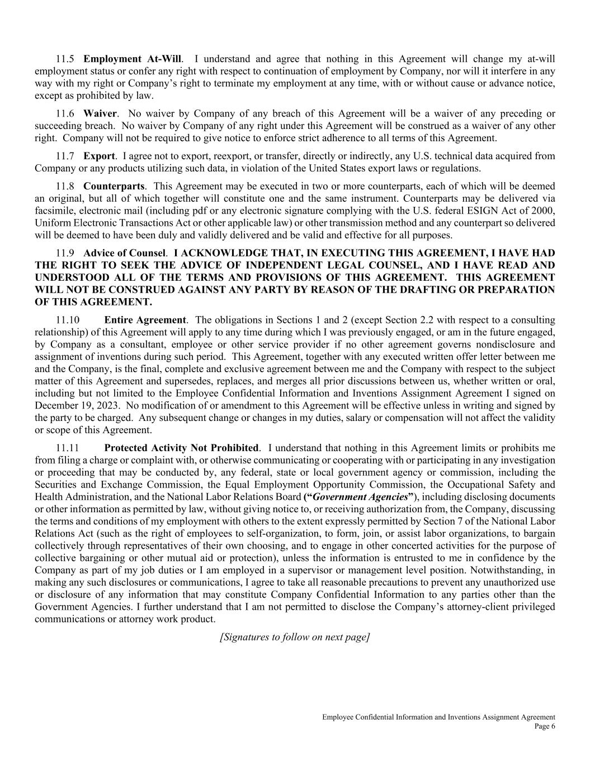
Employee Confidential Information and Inventions Assignment Agreement Page 6 Employment At-Will. I understand and agree that nothing in this Agreement will change my at-will employment status or confer any right with respect to continuation of employment by Company, nor will it interfere in any way with my right or Company’s right to terminate my employment at any time, with or without cause or advance notice, except as prohibited by law. Waiver. No waiver by Company of any breach of this Agreement will be a waiver of any preceding or succeeding breach. No waiver by Company of any right under this Agreement will be construed as a waiver of any other right. Company will not be required to give notice to enforce strict adherence to all terms of this Agreement. Export. I agree not to export, reexport, or transfer, directly or indirectly, any U.S. technical data acquired from Company or any products utilizing such data, in violation of the United States export laws or regulations. Counterparts. This Agreement may be executed in two or more counterparts, each of which will be deemed an original, but all of which together will constitute one and the same instrument. Counterparts may be delivered via facsimile, electronic mail (including pdf or any electronic signature complying with the U.S. federal ESIGN Act of 2000, Uniform Electronic Transactions Act or other applicable law) or other transmission method and any counterpart so delivered will be deemed to have been duly and validly delivered and be valid and effective for all purposes. Advice of Counsel. I ACKNOWLEDGE THAT, IN EXECUTING THIS AGREEMENT, I HAVE HAD THE RIGHT TO SEEK THE ADVICE OF INDEPENDENT LEGAL COUNSEL, AND I HAVE READ AND UNDERSTOOD ALL OF THE TERMS AND PROVISIONS OF THIS AGREEMENT. THIS AGREEMENT WILL NOT BE CONSTRUED AGAINST ANY PARTY BY REASON OF THE DRAFTING OR PREPARATION OF THIS AGREEMENT. Entire Agreement. The obligations in Sections 1 and 2 (except Section 2.2 with respect to a consulting relationship) of this Agreement will apply to any time during which I was previously engaged, or am in the future engaged, by Company as a consultant, employee or other service provider if no other agreement governs nondisclosure and assignment of inventions during such period. This Agreement, together with any executed written offer letter between me and the Company, is the final, complete and exclusive agreement between me and the Company with respect to the subject matter of this Agreement and supersedes, replaces, and merges all prior discussions between us, whether written or oral, including but not limited to the Employee Confidential Information and Inventions Assignment Agreement I signed on December 19, 2023. No modification of or amendment to this Agreement will be effective unless in writing and signed by the party to be charged. Any subsequent change or changes in my duties, salary or compensation will not affect the validity or scope of this Agreement. Protected Activity Not Prohibited. I understand that nothing in this Agreement limits or prohibits me from filing a charge or complaint with, or otherwise communicating or cooperating with or participating in any investigation or proceeding that may be conducted by, any federal, state or local government agency or commission, including the Securities and Exchange Commission, the Equal Employment Opportunity Commission, the Occupational Safety and Health Administration, and the National Labor Relations Board (“Government Agencies”), including disclosing documents or other information as permitted by law, without giving notice to, or receiving authorization from, the Company, discussing the terms and conditions of my employment with others to the extent expressly permitted by Section 7 of the National Labor Relations Act (such as the right of employees to self-organization, to form, join, or assist labor organizations, to bargain collectively through representatives of their own choosing, and to engage in other concerted activities for the purpose of collective bargaining or other mutual aid or protection), unless the information is entrusted to me in confidence by the Company as part of my job duties or I am employed in a supervisor or management level position. Notwithstanding, in making any such disclosures or communications, I agree to take all reasonable precautions to prevent any unauthorized use or disclosure of any information that may constitute Company Confidential Information to any parties other than the Government Agencies. I further understand that I am not permitted to disclose the Company’s attorney-client privileged communications or attorney work product. [Signatures to follow on next page]

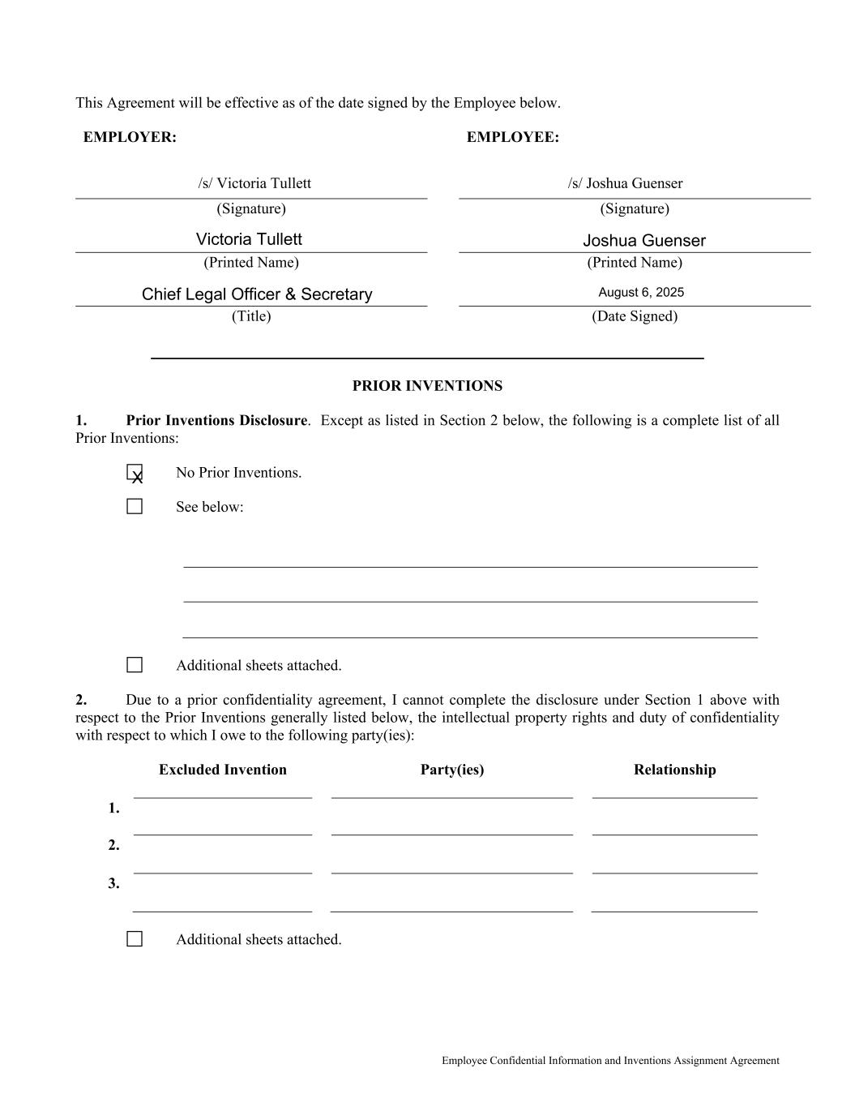
Employee Confidential Information and Inventions Assignment Agreement This Agreement will be effective as of the date signed by the Employee below. EMPLOYER: EMPLOYEE: (Signature) (Signature) (Printed Name) (Printed Name) (Title) (Date Signed) PRIOR INVENTIONS 1. Prior Inventions Disclosure. Except as listed in Section 2 below, the following is a complete list of all Prior Inventions: No Prior Inventions. See below: Additional sheets attached. 2. Due to a prior confidentiality agreement, I cannot complete the disclosure under Section 1 above with respect to the Prior Inventions generally listed below, the intellectual property rights and duty of confidentiality with respect to which I owe to the following party(ies): Excluded Invention Party(ies) Relationship 1. 2. 3. Additional sheets attached. Victoria Tullett Joshua Guenser Chief Legal Officer & Secretary August 6, 2025 X /s/ Victoria Tullett /s/ Joshua Guenser

Exhibit 31.1
DUTCH BROS INC.
CERTIFICATION OF CHIEF EXECUTIVE OFFICER
PURSUANT TO RULE 13a-14(a) AND RULE 15d-14(a) OF
THE SECURITIES EXCHANGE ACT OF 1934
AS ADOPTED PURSUANT TO SECTION 302 OF
THE SARBANES-OXLEY ACT OF 2002

I, Christine Barone, certify that:
1.I have reviewed this Quarterly Report on Form 10-Q for the period ended September 30, 2025 of Dutch Bros Inc.;
2.Based on my knowledge, this report does not contain any untrue statement of a material fact or omit to state a material fact necessary to make the statements made, in light of the circumstances under which such statements were made, not misleading with respect to the period covered by this report;
3.Based on my knowledge, the financial statements, and other financial information included in this report, fairly present in all material respects the financial condition, results of operations and cash flows of the registrant as of, and for, the periods presented in this report;
4.The registrant’s other certifying officer and I are responsible for establishing and maintaining disclosure controls and procedures (as defined in Exchange Act Rules 13a-15(e) and 15d-15(e)) and internal control over financial reporting (as defined in Exchange Act Rules 13a-15(f) and 15d-15(f)) for the registrant and have:
(a)Designed such disclosure controls and procedures, or caused such disclosure controls and procedures to be designed under our supervision, to ensure that material information relating to the registrant, including its consolidated subsidiaries, is made known to us by others within those entities, particularly during the period in which this report is being prepared;
(b)Designed such internal control over financial reporting, or caused such internal control over financial reporting to be designed under our supervision, to provide reasonable assurance regarding the reliability of financial reporting and the preparation of financial statements for external purposes in accordance with generally accepted accounting principles;
(c)Evaluated the effectiveness of the registrant’s disclosure controls and procedures and presented in this report our conclusions about the effectiveness of the disclosure controls and procedures, as of the end of the period covered by this report based on such evaluation; and
(d)Disclosed in this report any change in the registrant’s internal control over financial reporting that occurred during the registrant’s most recent fiscal quarter (the registrant's fourth fiscal quarter in the case of an annual report) that has materially affected, or is reasonably likely to materially affect, the registrant’s internal control over financial reporting; and
5.The registrant’s other certifying officer and I have disclosed, based on our most recent evaluation of internal control over financial reporting, to the registrant’s auditors and the audit committee of the registrant’s board of directors (or persons performing the equivalent functions):
(a)All significant deficiencies and material weaknesses in the design or operation of internal control over financial reporting which are reasonably likely to adversely affect the registrant’s ability to record, process, summarize and report financial information; and
(b)Any fraud, whether or not material, that involves management or other employees who have a significant role in the registrant’s internal control over financial reporting.

November 5, 2025 |  |  |  |  |  |  |  |  | /s/ Christine Barone
Date |  |  |  |  |  |  |  |  | Christine Barone
 |  |  |  |  |  |  |  |  | Chief Executive Officer and President
 |  |  |  |  |  |  |  |  | (Principal Executive Officer)

Exhibit 31.2
Dutch Bros Inc.| Exhibit 31.1
DUTCH BROS INC.
CERTIFICATION OF CHIEF FINANCIAL OFFICER
PURSUANT TO RULE 13a-14(a) AND RULE 15d-14(a) OF
THE SECURITIES EXCHANGE ACT OF 1934
AS ADOPTED PURSUANT TO SECTION 302 OF
THE SARBANES-OXLEY ACT OF 2002

I, Joshua Guenser, certify that:

1.I have reviewed this Quarterly Report on Form 10-Q for the period ended September 30, 2025 of Dutch Bros Inc.;
2.Based on my knowledge, this report does not contain any untrue statement of a material fact or omit to state a material fact necessary to make the statements made, in light of the circumstances under which such statements were made, not misleading with respect to the period covered by this report;
3.Based on my knowledge, the financial statements, and other financial information included in this report, fairly present in all material respects the financial condition, results of operations and cash flows of the registrant as of, and for, the periods presented in this report;
4.The registrant’s other certifying officer and I are responsible for establishing and maintaining disclosure controls and procedures (as defined in Exchange Act Rules 13a-15(e) and 15d-15(e)) and internal control over financial reporting (as defined in Exchange Act Rules 13a-15(f) and 15d-15(f)) for the registrant and have:
(a)Designed such disclosure controls and procedures, or caused such disclosure controls and procedures to be designed under our supervision, to ensure that material information relating to the registrant, including its consolidated subsidiaries, is made known to us by others within those entities, particularly during the period in which this report is being prepared;
(b)Designed such internal control over financial reporting, or caused such internal control over financial reporting to be designed under our supervision, to provide reasonable assurance regarding the reliability of financial reporting and the preparation of financial statements for external purposes in accordance with generally accepted accounting principles;
(c)Evaluated the effectiveness of the registrant’s disclosure controls and procedures and presented in this report our conclusions about the effectiveness of the disclosure controls and procedures, as of the end of the period covered by this report based on such evaluation; and
(d)Disclosed in this report any change in the registrant’s internal control over financial reporting that occurred during the registrant’s most recent fiscal quarter (the registrant's fourth fiscal quarter in the case of an annual report) that has materially affected, or is reasonably likely to materially affect, the registrant’s internal control over financial reporting; and
5.The registrant’s other certifying officer and I have disclosed, based on our most recent evaluation of internal control over financial reporting, to the registrant’s auditors and the audit committee of the registrant’s board of directors (or persons performing the equivalent functions):
(a)All significant deficiencies and material weaknesses in the design or operation of internal control over financial reporting which are reasonably likely to adversely affect the registrant’s ability to record, process, summarize and report financial information; and
(b)Any fraud, whether or not material, that involves management or other employees who have a significant role in the registrant’s internal control over financial reporting.

November 5, 2025 |  |  |  |  |  |  |  |  | /s/ Joshua Guenser
Date |  |  |  |  |  |  |  |  | Joshua Guenser
 |  |  |  |  |  |  |  |  | Chief Financial Officer
 |  |  |  |  |  |  |  |  | (Principal Financial Officer)

Exhibit 32.1
Dutch Bros Inc.| Exhibit 31.2
DUTCH BROS INC.
CERTIFICATIONS OF
CHIEF EXECUTIVE OFFICER AND CHIEF FINANCIAL OFFICER
PURSUANT TO 18 U.S.C. SECTION 1350
AS ADOPTED PURSUANT TO SECTION 906 OF
THE SARBANES-OXLEY ACT OF 2002

In connection with the Quarterly Report of Dutch Bros Inc. (the Company) on Form 10-Q for the period ended September 30, 2025, as filed with the Securities and Exchange Commission on the date of the signatures below (the Report), Christine Barone, Chief Executive Officer and President of the Company, and Joshua Guenser, Chief Financial Officer of the Company, each hereby certifies, pursuant to 18 U.S.C. Section 1350, as adopted pursuant to Section 906 of the Sarbanes-Oxley Act of 2002, that, to the best of their respective knowledge:

1.the Report fully complies with the requirements of Section 13(a) or Section 15(d) of the Securities Exchange Act of 1934; and
2.the information contained in the Report fairly presents, in all material respects, the financial condition and results of operations of the Company.

November 5, 2025 |  |  |  |  |  |  |  |  | /s/ Christine Barone
Date |  |  |  |  |  |  |  |  | Christine Barone
 |  |  |  |  |  |  |  |  | Chief Executive Officer and President
 |  |  |  |  |  |  |  |  | (Principal Executive Officer)
November 5, 2025 |  |  |  |  |  |  |  |  | /s/ Joshua Guenser
Date |  |  |  |  |  |  |  |  | Joshua Guenser
 |  |  |  |  |  |  |  |  | Chief Financial Officer
 |  |  |  |  |  |  |  |  | (Principal Financial Officer)

This certification accompanies the Report to which it relates, is not deemed filed with the Securities and Exchange Commission and is not to be incorporated by reference into any filing of Dutch Bros Inc. under the Securities Act of 1933, as amended, or the Securities Exchange Act of 1934, as amended (whether made before or after the date of the Report), irrespective of any general incorporation language contained in such filing.

Dutch Bros Inc.| Exhibit 32.1

